SECOND PROGRESS REPORT FOR

THE FOURTH ACTION PLAN  
(2019-2022)

National Plan to Reduce Violence Against Women and their Children 2010-2022

Prepared for the Department of Social Services | March 2022

Glossary

|  |  |
| --- | --- |
| Term | Definition |
| 4AP | Fourth Action Plan |
| ABS | Australian Bureau of Statistics |
| ACCO | Aboriginal Community Controlled Organisation |
| ACT | Australian Capital Territory |
| ANROWS | Australia’s National Research Organisation for Women’s Safety |
| CALD | Culturally and linguistically diverse |
| COAG | Council of Australian Governments |
| DFV | Domestic and family violence |
| FDSV | Family, domestic, and sexual violence |
| LGBTIQ+ | Lesbian, gay, bisexual, transgender, intersex, and queer |
| LGBTQ+ | Lesbian, gay, bisexual, transgender, and queer |
| MBCP | Men’s Behaviour Change Program |
| The National Plan | *National Plan to Reduce Violence against Women and their Children 2010-2022* |
| NATSISS | National Aboriginal and Torres Strait Islander Social Survey |
| NCAS | National Community Attitudes Survey |
| NIAA | National Indigenous Australians Agency |
| NIP | National Implementation Plan |
| PSS | Personal Safety Survey |

SECOND PROGRESS REPORT FOR THE   
FOURTH ACTION PLAN (2019-2022)

Contents

Introduction 1

Priority areas of the Fourth Action Plan 5

Overview 6

Priority 1 11

Priority 2 21

Priority 3 29

Priority 4 36

Priority 5 44

National Plan progress 59

Next steps 63

Appendices 64

Appendix A : Approach 65

Appendix B : Details of progress 66

Appendix C : Performance Monitoring and Reporting Framework 77

01

# Introduction

## The National Plan

The *National Plan to Reduce Violence against Women and their Children 2010-2022* (the National Plan) is a collective commitment by all Australian Governments to address violence against women and children, with a vision that “Australian women and their children live free from violence in safe communities.”[1] The vision is underpinned by six National Outcomes:

1. Communities are safe and free from violence.
2. Relationships are respectful.
3. Indigenous communities are strengthened.
4. Services meet the needs of women and their children experiencing violence.
5. Justice responses are effective.
6. Perpetrators stop their violence and are held to account.

The National Planis being implemented via four action plans that each span a three-year period to drive change and respond to emerging priorities. The First Action Plan (2010-2013) laid the foundations for longer-term change while the Second Action Plan (2013-2016) established a strong research and prevention agenda. The Third Action Plan (2016-2019) further strengthened the evidence base and provided greater support for women and children in Australia living with or trying to leave violence.

## The Fourth Action Plan

The Fourth Action Plan (4AP) is the final Action Plan under the National Plan and was endorsed by the Council of Australian Governments (COAG) in August 2019.

The 4AP sets out a range of initiatives to reduce violence against women and their children based around five priority areas:

1. Primary prevention is key.
2. Support Aboriginal and Torres Strait Islander women and their children.
3. Respect, listen and respond to the diverse lived experience and knowledge of women and their children affected by violence.
4. Respond to sexual violence and sexual harassment.
5. Improve support and service system responses.

The 4AP contains 20 actions that sit under the five priorities as detailed in the figure below.



Figure 1: 4AP priorities and actions

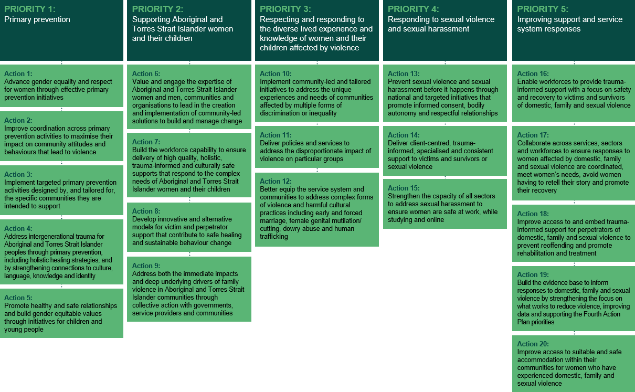

Source: Fourth Action Plan of the National Plan to Reduce Violence against Women and their Children 2010-2022 (2019)

The 4AP is accompanied by a National Implementation Plan (NIP) which outlined the initiatives being delivered to address family, domestic, and sexual violence (FDSV). When the NIP was launched in November 2019, the NIP detailed 164 initiatives across each of the five priority areas being led by the Commonwealth and state and territory governments that align with the 4AP. It is these initiatives which are in scope for this progress report. As new initiatives were announced or as they were combined with others, the exact number changed over time. The NIP was updated on 3 November 2020 with 166 initiatives. On 7 May 2021 the NIP was updated for a second time. There were 167 initiatives detailed in this update which are in scope for this second and final progress report. As this report is finalised around six months before the end of the Fourth Action Plan, 167 is likely the total number of initiatives being implemented under the Fourth Action Plan. The NIP was updated for a third time in November 2021. The implementation of all initiatives under the Fourth Action Plan will be captured in the evaluation of the Fourth Action Plan due May 2022.

It should be noted that, while the 4AP plays a critical role in providing a national approach to addressing violence against women and their children, it does not capture the full range of activities being undertaken across jurisdictions to preventing and responding to FDSV. For example, the Commonwealth is undertaking a series of reforms to the family law system to help families separate in a safe, child-centred, supportive and accessible manner. Reforms will particularly benefit victims of family violence whose matters are often complex, and who may not have access to the financial resources required to undertake a lengthy separation process.

The interplay and connection between the National Plan, the 4AP, the NIP, and progress reporting is shown the figure below.

Figure 2: Connection between the National Plan, 4AP, and the Implementation Plan

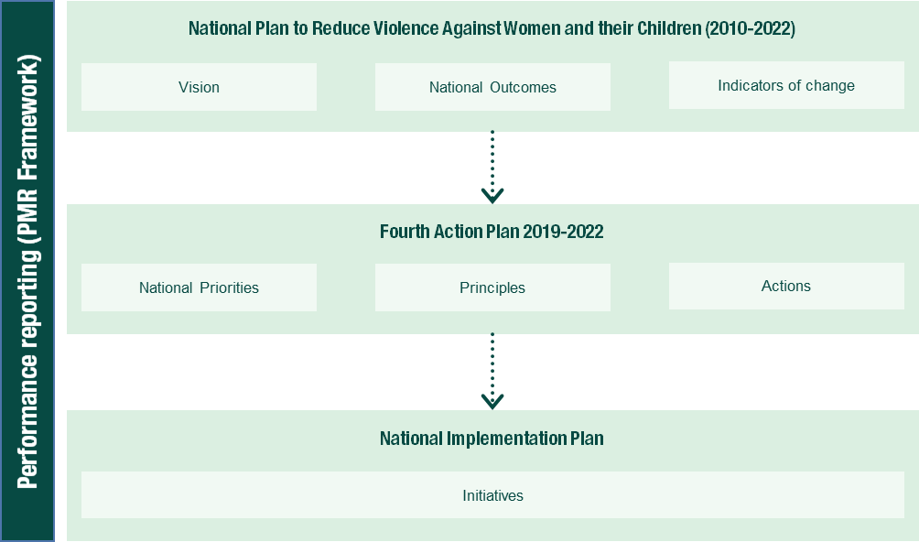

Source: Department of Social Services, National Plan to Reduce Violence against Women and their Children: National Implementation Plan

## Performance monitoring and reporting

A performance monitoring and reporting framework has been finalised and is attached at Appendix C. It sets out program logics for each priority area, including the outputs associated with each action under the five priority areas as well as short- and medium-term outcomes and measures by which success could be assessed. This framework is supporting the broader evaluation of the National Plan, which includes an evaluation of the 4AP. While considerable investment has been made in improving the evidence base, further work is required to improve outcome measurement to support future monitoring and evaluation efforts. This is particularly the case for measuring impacts on vulnerable groups including Aboriginal and Torres Strait Islander women, women from culturally and linguistically diverse (CALD) backgrounds and people who identify as lesbian, gay, bisexual, transgender, intersex, or queer (LGBTIQ+).

The 4AP, which runs from 2019 to 2022, is in its third and final year of implementation with initiatives in various stages of progress. At this point in time, the focus of reporting is on progress of delivery of the initiatives under the NIP (that is, progress on outputs) rather than considering the short and medium-term outcomes. Outcomes will be considered more comprehensively in the evaluation. Outputs are the direct product of actions and measurement is focussed on whether initiatives are in place that will give effect to the action and the extent to which relevant initiatives are reaching their target audience.

In August to September 2021, all jurisdictions provided information on progress of initiatives to support an assessment of progress on delivering outputs. Progress was rated by jurisdictions into the following categories:

* **Completed according to schedule:** The initiative has been fully implemented in line with the anticipated timeframe.
* **Completed (but was delayed):** The initiative has been fully implemented but exceeded the anticipated timeframe.
* **Completed (ahead of schedule):** The initiative has been fully implemented ahead of the anticipated timeframe.
* **In progress on track:** The initiative has commenced, and implementation is progressing within expected timeframes.
* **In progress delayed:** The initiative has commenced but implementation has been impacted and is not progressing within expected timeframes.
* **Stopped:** The initiative has ceased. No initiatives under the 4AP have stopped.

Commonwealth, state, and territory agencies were also asked to provide information on the outputs and some short- and medium-term outcomes outlined in the program logics for each priority area. However, due to the lack of consistent information available across all jurisdictions, analysis of this data was not able to be conducted. Outcomes will be considered more comprehensively in the evaluation of the Fourth Action Plan and National Plan.

Second 4AP Progress Report

This progress report is structured as follows:

* **Priority areas of the 4AP:** This sectionoutlines progress against the initiatives under each of the five priority areas and each of the 20 actions under the 4AP (that is, the outputs of the 4AP).
* **National Plan progress:** This sectionoutlines progress against the agreed indicators of change under the National Plan.
* **Next steps**: This section sets out the next steps in finalising monitoring of performance under the 4AP as well as timing around the evaluation of the National Plan as a whole.
* **Appendix A:** This section provides an overview of the approach to monitoring and reporting under the 4AP.
* **Appendix B**: The appendix outlines in detail each jurisdiction’s initiatives and how each jurisdiction is tracking on implementation of the 4AP.
* **Appendix C:** This section provides the Performance Monitoring and Reporting Framework for the Fourth Action Plan.

02

# Priority areas of the Fourth Action Plan

Overview

Within the five Priority Areas under the NIP, there are 167 initiatives (as detailed in the May 2021 NIP) being delivered by the Commonwealth, state, and territory government agencies to support the objectives and outcomes of the 4AP.

Overall, progress of initiatives under the 4AP has been positive. Thirty-four initiatives have been completed according to schedule, compared with 18 at the time of the first progress report. These include, for example, the South Australian *Aboriginal Affairs Action Plan for 2019-20*, which has seen the South Australian Government engage with Aboriginal and Torres Strait Islander women and their children and their communities to lead in the creation and implementation of community-led solutions to build and manage change. Additionally, the Queensland Government has commenced its domestic and family violence (DFV) specialist positions, with service delivery commencing in 2020. In Victoria, Workplace Equality and Respect standards have been implemented by 19 local councils across Victoria from late 2018 to early 2020.Two initiatives have been completed ahead of schedule. This includes, for example, the Commonwealth implementing new telephony options to streamline customer engagement and access to DFV support, including messaging in 15 different languages. The second program that has been completed ahead of schedule is Tasmania’s family and sexual violence website, with the Safe from Violence website launched in 2020.

Four initiatives were completed after their anticipated timeframe. For example, Western Australia’s *Family Violence Legislation Reform Act 2020*, which was implemented across the state despite challenges experienced relating to COVID-19. Cross-agency collaboration is cited as a major driving factor of this successful implementation.

At the time of reporting, 102 initiatives are in progress and are on track to be delivered. Most ongoing initiatives, which will continue to be in place beyond the lifespan of the 4AP, are in this category. This means that 85 per cent of initiatives are either complete or on track.

This a slight drop on the previous report, where 87 per cent of initiatives were complete or on track. This equates to 25 initiatives in progress but delayed, with the majority citing COVID-19 as the main impacting factor. For example, COVID-19 has impacted on the delivery of the Commonwealth’s initiative regarding resources on technology-facilitated abuse for Aboriginal and Torres Strait Islander women. Social distancing restrictions impacted consultation and the capacity to undertake face-to-face training and presentations. This was compounded by further lockdowns in mid-2021. Another example is the Northern Territory’s Sexual Violence Prevention and Response Framework which was impacted due to the re-prioritisation of work to respond to the pandemic. In the few instances where delays were not the result of COVID-19, implementation has continued despite interruptions. For example, the establishment of Aboriginal-led primary prevention and early intervention projects in Tasmania was delayed due to the Tasmanian Government entering caretaker period during the 2021 State Election. However, these projects were announced in June 2021. None of the delayed initiatives appear to present a significant risk to the successful implementation of the 4AP. No initiatives under the 4AP have stopped.

The implementation status of initiatives is shown in the following figure.

Figure 3: Progress of initiatives under the 4AP

Source: Jurisdictional input

The following sections outline progress against each of the five priority areas under the 4AP. It should be noted that initiatives have been counted more than once if they span multiple priority areas and multiple actions. In the following sections, progress is reported as follows:

* Progress of initiatives under the action with examples provided of achievements to date.
* Case studies illustrating in greater detail the initiatives being implemented under the action.

A complete list of initiatives under the 4AP and their progress in each jurisdiction is available at Appendix B.

COVID-19

The ongoing impact of the COVID-19 pandemic and related lockdown in each jurisdiction has continued to present both challenges and opportunities for implementation of the 4AP.

Due to social distancing and travel restrictions impacting each jurisdiction (each to different extents), there have been reduced opportunities for face-to-face work, and service delivery and access to remote and Aboriginal and Torres Strait Islander communities has been limited. Many government agencies have had to redeploy staff to urgently respond to outbreaks and facilitate the vaccine rollout, impacting on implementation of some initiatives. At the same time, increased vulnerabilities within the population, financial pressures, and mental health impacts have led to pressure on services due to increased demand.[2] In some cases, this has led to increased funding from Commonwealth, state, and territory governments in order to meet this demand.

Government responses to COVID-19

#### Commonwealth

On 29 March 2020, the Prime Minister announced a $150 million Domestic Violence Support Package to respond to expected increase in demand resulting from COVID-19.

Under the package, the Commonwealth provided $130 million through the National Partnership on COVID-19 Domestic and Family Violence Responses to states and territories to invest in services to support women and children who are experiencing or at risk of violence during the pandemic.

The remaining $20 million under the package was directed to boost existing Commonwealth programs such as 1800RESPECT and the Support for Trafficked People Program as well as fund initiatives for families affected by, or at risk of experiencing, DFV during COVID-19.

As part of the $1.1 billion investment in women’s safety announced in the 2021-22 Budget, the Australian Government announced a further $260 million for a new two-year National Partnership. The new National Partnership builds on the $130 million National Partnership on COVID-19 Domestic and Family Violence Responses and supports frontline family, domestic and sexual violence services and trial new initiatives to support women and children experiencing violence.

Other key initiatives announced by the Commonwealth to support victim-survivors of family, domestic and sexual violence both in the context of the pandemic and beyond include the new Escaping Violence Payment and the pilot to support Temporary Visa Holders experiencing violence.

Under the Escaping Violence Payment, the Commonwealth has committed $146.8 million for a two-year trial, commencing in October 2021, to provide financial assistance to eligible individuals seeking to leave a violent relationship. Payments of to $5,000, including cash/cash equivalents of up to $1,500 and the remaining funding in goods, services and supports, are available to all eligible individuals. The objective of the Escaping Violence Payment is to reduce the barrier of financial insecurity individuals face when leaving a violent relationship.

The Commonwealth is also investing $20.3 million over two years to deliver support to Temporary Visa Holders experiencing violence. Under the pilot, temporary visa holders who are escaping violent relationships are being supported with up to $3,000 and assistance to resolve their migration, family law or civil matters.

In addition, the Commonwealth has announced sustainable funding to support 1800RESPECT, Australia’s national 24/7 family, domestic and sexual violence counselling and referral service, continue to meet demand. Telstra Health is the successful provider to deliver 1800RESPECT, following an extensive open and competitive procurement process, for an initial five years with the possibility of extension. The contract is estimated to be valued at around $200 million – noting the service and funding is demand driven.

**NSW**

Between 2019-20 and 2020-21, the NSW Government provided $12.8 million to ensure that FDSV services had the resources to adapt service delivery and support victim-survivors during the pandemic. Funded initiatives included immediate relief to specialist DFV services to respond to the increased demand for services and complexity of cases; funding boosts to NSW DFV telephone support lines; the DFV Pets and Animal Welfare Support program and the launch of the award winning Speakout campaign.

Over two years from 2021-22, the NSW Government has committed an additional $60 million to boost frontline services to support more women and children. This funding continues to build the capacity of frontline specialist FDSV services to respond to increase demand and complexity, holds perpetrators to account, and raise awareness about DFV and available supports.

The NSW Government also released an additional $32.5 million over four years to expand the Staying Home Leaving Violence program to support victim-survivors escape abusive partners while remaining safely at home. $39.2 million of additional support was committed in 2021-2022 for the Start Safely program, increasing the supply and flexibility of temporary accommodation, and building capacity of homelessness providers. NSW Police Force also implemented strategies for monitoring high risk DFV offenders during COVID-19, including focused Police efforts on proactive Apprehended Domestic Violence Order compliance checks.

As the pandemic began to impact on NSW in 2020, the Department of Communities and Justice established and co-chaired the NSW COVID-19 Government Agency DFV Action Group with NSW Police. The group facilitated coordinated government DFV risk mitigation and service delivery to the NSW community through the sharing of data and information on emerging DFV patterns and needs; coordinating agency responses; and addressing emerging operational and service delivery issues, priorities, and challenges in whole of government responses to DFV in the context of COVID-19.

The NSW Government continues regular meetings with the FDSV sector to facilitate information sharing and ensure that funding allocations are based on current needs, expert advice and input from frontline specialist services. These meetings include members of the NSW Women’s Alliance, and representatives from LGBTIQ+, CALD, Aboriginal, and disability focused organisations.

**Victoria**

In April 2020, the Victorian Government invested $40.2 million over two years to help people experiencing family violence and sexual assault during COVID-19. This included:

* $20.2 million to help Victorian family violence and sexual assault services adapt service delivery and meet increased demand during the COVID-19 pandemic and provide help for victim survivors.
* $20 million for short-term accommodation for victim survivors who do not feel safe isolating or recovering from COVID-19 at home.

In response to additional service demand for Aboriginal victim survivors and Aboriginal people using violence, 16 per cent of total COVID response funding in 2020-21 was allocated directly to Aboriginal Community Controlled Organisations (ACCOs) to support a range of family violence and sexual assault service delivery, as well as to support agencies to adapt to COVID safe operations and service delivery.

The Victorian Government’s Multicultural COVID-19 Family Violence Program provides one-off funding to 20 multicultural, faith-based and ethno-specific organisations to raise awareness of the drivers of family violence in multicultural and faith communities and to support early intervention activities as part of Victoria’s COVID-19 response and recovery. Over $2 million in grants have been provided to strengthen the capacity of these organisations to deliver prevention and early intervention activities over two years. This work will support multicultural community members at risk of, or experiencing, family violence to access the support they need, including specialist family violence services through referral by these organisations.

Additional activities were introduced to better support and protect victim survivors and to ensure critical data and information was accessible:

* A Family Violence System and Operations Group was established to monitor the impacts of COVID-19-related family violence responses and to ensure strong information sharing and coordination.
* Victoria Police’s pro‑active family violence operation – Operation Ribbon – was launched to actively reach out to victim survivors and perpetrators during the COVID‑19 pandemic, driven by a recognition that given additional challenges during the COVID‑19 pandemic, victim survivors might find it difficult to report family violence and seek assistance while self‑isolating at home with a perpetrator.
* The COVID-19 Family Violence Data Portal was launched on 2 November 2020 by the Crime Statistics Agency.

Victoria continues to invest with a further $2.4 million announced in the 2021-22 State Budget provided to Victoria’s 12 women’s health services to support the growing demand for gender responsive healthcare, including prevention of family violence support services and women’s mental health services, as the state begins to recover from the effects of the pandemic.

**Queensland**

The Queensland Government has been working closely with funded specialist services to support them to respond to the demands of the pandemic and to track emerging issues. In addition to Commonwealth funding, the Queensland Government provided $7.5 million to boost service capacity and address increasingly complex client needs. Services supported include FDSV support services, Aboriginal and Torres Strait Islander services, women’s shelters and non-accommodation support services, women’s recovery services, and perpetrator intervention programs.

As part of the Commonwealth National Partnership funding, Queensland initially allocated $2 million to support grants aimed at helping FDSV service providers respond to the complexities and challenges resulting from the pandemic. The *Responding to COVID-19 in the FDSV sector grants* attracted a strong response and additional funding was allocated to bring the total pool to $2.5 million. One-off grants of between $50,000 and $150,000 have been allocated to support 23 projects across the state, ranging from delivering bystander training across the Torres Strait Islands, to the provision of additional FDSV support and counselling services, enhancing the primary care response to DFV and adaptation of resources to support online delivery.

A range of measures have also been taken to increase protections for victims of DFV, including:

* Hosting the COVID-19 and DFV Virtual Summit, bringing together experts, organisations and key stakeholders to share ideas on how to support DFV victims through the COVID-19 pandemic
* Amending the Home Confinement, Movement and Gathering Direction to include accessing support from a DFV support service as an example of a permitted reason for leaving the principal place of residence
* Progressing a new COVID-19 and DFV awareness campaign to encourage adults and young people in Queensland to access DFV support, including victims, perpetrators and bystanders
* Implementing regulatory measures to ensure that people experiencing DFV are supported to live securely and leave safely with limited financial hardship
* Activating tailored COVID-19 DFV Emergency Housing Assistance Response, which delivered emergency accommodation to 74 women with 64 children with immediate safety needs, and once safe, into longer-term housing.

Funds were also allocated to support the development of an app to encourage pro-active bystanders, through a partnership with Griffith University’s MATE Bystander Program and Telstra. The app, which will provide information to help people recognise worrying signs in their friend’s relationships, and practical tools, information and support to encourage them to safely offer help, is under development.

**Western Australia**

The Western Australian Government has invested more than $28 million, as part of the Western Australian Recovery Plan, to help address DFV in the community. The support package has been targeted to help keep Western Australia’s most vulnerable community members safe and address the state's immediate social challenges following COVID-19. The support package includes funding to bolster the state's DFV response teams; expand the two new women's refuges recently built by the Western Australian Government; support mobile outreach workers across women’s refuges; increase DFV counselling, advocacy and support services; and implement a program to support women who are living in DFV refuges to gain employment skills, access career training or retraining to support their pathways to employment post-COVID-19. The roll-out of the package has been guided by the recently launched *Path to Safety: Western Australia’s strategy to reduce family and domestic violence 2020-2030* which provides a long-term vision for Western Australia where all people live free from violence.

The Western Australian Government moved swiftly to bring into force important laws to protect victims of DFV during the COVID-19 pandemic. These important reforms enabled the justice system to better respond to the challenges facing victims of family violence during the COVID-19 crisis. The Western Australian Government continues to work with the DFV sector to ensure responses are aimed at supporting women’s safety and continuity of service delivery. The Department of Communities in Western Australia established the ‘You are not alone’ social media campaign which provided timely information about DFV support resources, reminding victims, family and friends that help is available during COVID-19, reinforcing the message that violence is not ok, and letting perpetrators know they can access support to change behaviour throughout the pandemic.

**South Australia**

In South Australia, a series of online roundtables were held to discuss the impacts of the pandemic on services, as well as on the women and children of South Australia. The Minister for Human Services and Assistant Minister for Domestic and Family Violence Prevention hosted these discussions, which built on previous roundtables held across metropolitan and regional South Australia.

Allocation of funding in South Australia has been used to commence important initiatives including: Individual Safety and Support Packages increased the safety of women by providing them with funds to support them and their children to escape violence by allowing immediate expenses to be paid and immediate needs to be fulfilled; increased perpetrator interventions which are essential as an early intervention for people concerned about their use of abusive behaviours; and, the local Break the Cycle media campaign, raising awareness of FDSV throughout South Australia and how to find support services.

South Australia has also focused on supporting vulnerable cohorts by targeted Individual Safety and Support Packages responding to the specific needs of Aboriginal and Torres Strait Islander families, LGBTIQ+ people, women with disabilities, and CALD families.

**Tasmania**

On 26 March 2020, the Tasmanian Government announced dedicated funding to respond to FDSV during the COVID-19 pandemic, as part of the Tasmanian Government’s Social and Economic Support Package. $2.7 million was allocated across the DFV service system, including government and non-government services. The response ensures the service system is well prepared to respond to any future or ongoing impacts of COVID-19 in Tasmania.

Further, the Department of Communities Tasmania established the Family and Sexual Violence COVID-19 Sector Forum to promote information-sharing between the Government and the community sector and to enable the Government to be made aware of emerging issues for the sector.

In 2021-22, the Tasmanian Government has allocated a further $1.1 million to specialist FDSV services. This, together with allocations under the National Partnership, have ensured services can maintain increased operational capacity though to 30 June 2022 to respond to increased demand.

**ACT**

Throughout the pandemic, the ACT Government introduced several measures to ensure people experiencing DFV are able to access support. At the height of social restrictions in 2020, a targeted communication campaign ran from May to August. The campaign advised that services were open and ready to help those who were experiencing or using violence. This was in addition to the new dedicated COVID-19 website, which helped to get the message out to the greater Canberra community that help was still out there and to reassure people the restrictions did not stop them from accessing help. The successful communications campaign was resumed in the 2021 lockdown.

Throughout 2020, the ACT Government announced additional investment to support Canberrans during the COVID-19 crisis, including:

* $3 million in funding for specialist homelessness and DFV sectors to expand their operational capacity and relieve the pressure of additional need during the COVID-19 crisis.
* Allocation of $3.045 million of Commonwealth funding to support services to respond to COVID-19, develop innovative new programs, and address specific needs of diverse groups.
* Additional funding of $7 million for non-government organisation partners to meet increased service demand for emergency relief as part of the Community Support package.

Data from Domestic Violence Crisis Service shows that demand for some services increased even after the 2020 ACT lockdown ended. Overall, the service experienced an 8 per cent increase in the number of contacts in June 2021 compared to June 2020, and a 15 per cent increase in the number of clients supported in June 2021 compared to June 2020. Online engagement increased by 190 per cent over the same period.

In response to the pandemic, the Office of the Coordinator-General for Family Safety, in partnership with the Victims of Crime Commissioner, convened the ACT DFV Sector Roundtable to bring together government agencies and community organisations facilitate sector-wide planning, coordination and collaboration on the ACT’s DFV response. The roundtable has provided leadership in the development of targeted and integrated measures to support victim-survivors throughout COVID-19.

The ACT has announced an additional $8.8 million over the next four years as part of the 2021-22 budget. This investment will expand resourcing for essential FDSV initiatives for the ACT community and will assist organisations such as the Domestic Violence Crisis Service to meet elevated demand for support. This new investment is in addition to existing funding.

**Northern Territory**

The Northern Territory Government responded to the expected increase in demand resulting from COVID-19 through immediate allocation of $300,000 of flexible support funding to services. Weekly meetings with specialist services allowed for resolution of operational issues due to bio-security measures and shared problem solving.

Priority 1: Primary prevention is key

Priority 1 focuses on whole-of-population initiatives that address the underlying drivers of violence. Governments aim to achieve this through changing attitudes and behaviours that justify or excuse violence and promoting positive attitudes of women and their children and gender equality.

There are five actions under this priority that range from primary prevention activities (including those tailored at specific communities including Aboriginal and Torres Strait Islander communities), and healthy relationship education for children and young people.

Figure 4 outlines the program logic for Priority 1. It shows the outputs that can be observed through implementation of the various NIP initiatives as well as proposed short- and medium-term outcomes that can be expected to be achieved over the next three to five years.

Figure 4: Priority 1 program logic

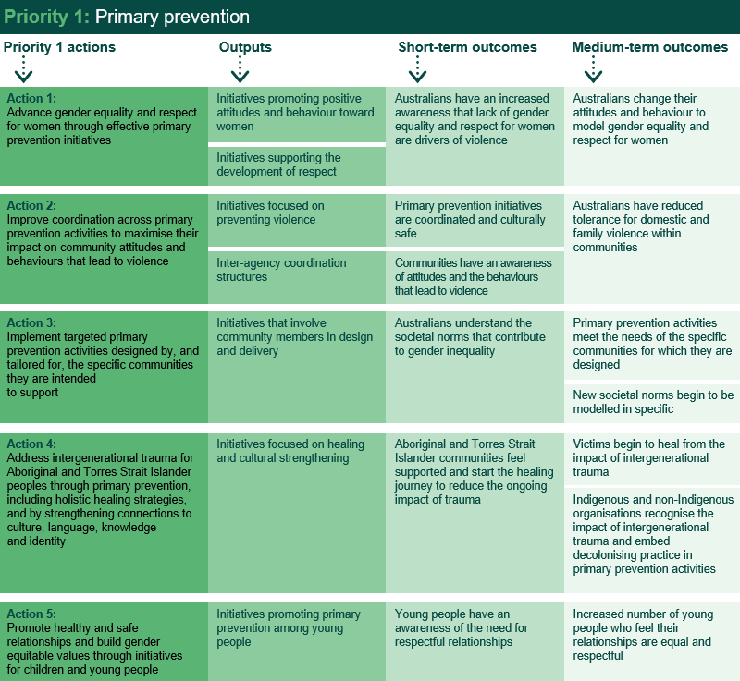

Source: Performance Monitoring and Reporting Framework

There are 45 initiatives that align to Priority 1. As demonstrated in the figure below, the majority of initiatives under Priority 1 are on track, with some delays primarily due to the impact of COVID-19. This year, 80 per cent of initiatives under Priority 1 are completed or on track, compared with 83 per cent in the previous year. Highlights of achievements and case studies under each action are provided in the sub-sections below.

Figure 5: Progress of initiatives under priority 1

Source: Jurisdictional input

Action 1:   
Advance gender equality and respect for women through effective primary prevention initiatives

There are 17 initiatives from the NIP that relate to Action 1 including initiatives related to financial abuse, community awareness raising activities, and the development of statewide frameworks to guide activities and focus efforts. The outputs associated with Action 1 are initiatives promoting positive attitudes and behaviours towards women. Of these initiatives, five have been completed (as per schedule), 10 are in progress (on track), and two are in progress (delayed).

Key achievements

Some highlights of initiatives being delivered by jurisdictions under this action include:

* In 2021, 16 journalists were selected as Our Watch fellows as part of the Commonwealth’s National Media Engagement Project to build and refine their knowledge of best practice reporting on violence against women. Three intensive workshops with journalists to build these skills have been held.
* Website metrics have shown a 200 per cent increase in traffic to Media Making Change website (January to August 2021).
* Two communities of practice sessions have taken place with Our Watch’s women in sports media group, which consists of female journalists and media professionals in sport.
* On 14 March 2021, Phase three of the Commonwealth’s Stop it at the Start Campaign was launched, which ran to 31 July 2021. The campaign, which aimed to encourage adults to model respectful relationships to young people, has seen strong engagement across social media advertising. Phase three social media advertisements have received over 106,000 likes and reactions, more than 24,000 shares, and more than 17,000 comments.
* In the ACT, foundation and manager training has been made available to all ACT Government Directorates under the ACT Government’s DFV Training Strategy.
* The Victorian Government has invested $82 million in the Respectful Relationships initiative. More than 1,950 Victorian schools are signed on to the whole school approach to Respectful Relationships, including all government schools. The initiative also includes professional learning for early childhood to strengthen their capacity to promote respectful relationships, positive attitudes and behaviours within their integrated teaching approach.
* The Victorian Curriculum provides the basis for teaching and learning about respectful relationships and identifies the knowledge, skills and understanding for students to be able to engage in respectful relationships. Schools are supported to deliver this curriculum through the optional Resilience, Rights and Respectful Relationships, and Building Respectful Relationships teaching and learning resources.
* Since the launch of *Stronger Together: WA’s Plan for Gender Equality* in March 2020, state government resources have focussed on women’s social and economic recovery, recognising the disproportionate gendered impacts of COVID-19.
* The *Northern Territory Gender Equality Statement of Commitment* was released in July 2020.
* Twenty-four South Australian Government agencies have achieved White Ribbon Workplace re-accreditation.
* Under the Preventing Financial Abuse Against Women project, Harmony Alliance’s financial literacy e-learning tool, which aims to improve financial literacy among CALD women and enhance CALD community understanding of financial abuse, was translated in ten languages (Arabic, Chinese (Simplified), Dari, Hazaragi, Karen, Korean, Nepali, Punjabi, Thai, Vietnamese). The Preventing Financial Abuse Against Women Project also supported the development of the Guide to the Treatment of Relationship Debt in Family Law, which is available on the Attorney-General’s Department’s website.

Case studies

|  |  |  |
| --- | --- | --- |
| Campaign to Stop it at the Start |  |  |

The Commonwealth *Stop it at the Start* campaign partnered with Nova Entertainment to launch a five part children’s podcast to encourage respectful attitudes in the next generation. The podcast series was delivered as part of the national campaign’s third phase which focuses on prevention approach to end violence against women and their children by encouraging adults to promote positive attitudes around respectful relationships in young people. Titled ‘Project ARI’ and written by popular children’s author Nat Amoore, the podcast focuses on a young robot named Ari (short for Artificial Intelligence) who is sent to live with the Warner family to learn the ‘human experience’. Well known Nova Radio talent have lent their voices to the project, including presenters Kate Ritchie, Cam Daddo, Byron Webb and Michael "Wippa" Wipfli. It also included special guest cameos from popular sports commentator Mel McLaughlin and Matildas’ soccer star Kyah Simon. The five-part series was released weekly during June and July 2021 and can be downloaded free from all popular podcast streaming services, including Spotify and Apple Podcasts.

For more information, visit [www.respect.gov.au](http://www.respect.gov.au).

|  |  |  |
| --- | --- | --- |
| Training the public sector in DFV |  |  |

The ACT Government’s DFV Training Strategy is a comprehensive capability framework and training strategy developed to ensure a sustainable approach to uplift the capabilities of the ACT Public Service in the area of DFV.

The strategy aims to equip all staff with the ability to recognise, respond and refer staff or clients who are experiencing DFV. Importantly, the strategy recognises and builds upon existing training structures and workforce needs with tiered training according to role and specialist level.

Foundation and manager training have been delivered to all ACT Government Directorates, shifting to an e-learn format in response to COVID-19 restrictions. As of 31 August 2021, 10,112 ACT government employees had engaged with the foundation training (designed for all staff) under the ACT Government DFV Training Program since it began in 2019.

Staff with limited access to technology and other challenges can access an alternative face to face foundation training product, which will continue to be rolled out in 2021.

Action 2:   
Improve coordination across primary prevention activities to maximise their impact on community attitudes and behaviours that lead to violence

Eleven initiatives under Action 2 focus on consolidated and coordinated primary prevention activities. These include development of primary prevention models and hubs, proactive policies, and statewide frameworks. The relevant outputs associated with Action 2 are initiatives focussed on preventing violence and initiatives on inter-agency supporting structures. Of these initiatives, two are completed as per schedule, one is completed but was delayed, five are in progress (on track), and three are in progress (delayed).

Key achievements

Key achievements under this action include:

* Our Watch published two reports on primary prevention. The first report was published in February 2021, provided an overview of prevention around Australia and the impact of the coronavirus pandemic on prevention. The second report, published in September 2021, focused on exploring collaboration, networks and techniques for effective practice. A further two reports are being finalised.
* Our Watch held five National Primary Prevention Hub Sector forums between December 2020 and June 2021, with over 75 participants from across the sector and government at each event. The most recent forum in June 2021, was attended by more than 250 participants from across Australia. The forums covered a range of topics including promising practice in prevention, primary prevention in Queensland and the role of men and masculinities in prevention.
* Respect Victoria, in partnership with the Crime Statistics Agency, led the development and delivery of the Prevention of Family Violence Data Platform
* The South Australian Government has provided $1.8 million over three years to the development of the next phase of the Stop it at the Start campaign and new sexual violence prevention initiatives.
* The Queensland Government is forming partnerships with organisations such as Telstra, the Local Government Association of Queensland, and the National Retail Association to initiate projects to further create awareness of DFV and its impacts within their workplaces and networks.

Case study

|  |  |  |
| --- | --- | --- |
| Monitoring primary prevention data |  |  |

Respect Victoria, in partnership with the Crime Statistics Agency, has led the development and delivery of the Prevention of Family Violence Data Platform. The Data Platform draws together a wide range of Victorian-level, primary prevention-focused data against a common framework to enable the tracking of Victoria’s progress toward the prevention of DFV and violence against women across a range of dimensions. This includes data on the prevalence and prevention of violence, community attitudes towards gender equality and violence against women, and other markers of gender inequality and discrimination at the interpersonal, community, organisational and structural levels. Respect Victoria released the Data Platform in June 2021.

To enable monitoring of population-level progress towards the primary prevention of family violence and violence against women in Victoria, the Data Platform draws from 34 data instruments which collect data at regular intervals — from annual to every four or five years. Data sources range from surveys, administrative data collections, longitudinal studies and published research reports. In addition, a small number of one-off data sets have been included for topics or sub-population groups where trend data were not available.

Currently, the Data Platform contains data sources collected between 2009 and 2020, and will be updated systematically as more data becomes available. This provides an ability to baseline Victoria’s status prior to significant investment in primary prevention endeavours.

Action 3:  
Implement targeted primary prevention activities designed by, and tailored for, the specific communities they are intended to support.

Key achievements

A total of 12 initiatives from the NIP related to this action including grants programs and community-led projects such as awareness raising campaigns. The relevant outputs associated with Action 3 are initiatives focussed on engaging with specific communities to ensure messaging is relevant and appropriate. Progress has been positive, with 10 of the 12 initiatives in progress and on track, one initiative completed (as per schedule) and one initiative completed (but was delayed).

Key achievements under this action include:

* The Northern Territory Government is providing $1.8 million to the NO MORE Campaign from 2019-20 to 2023-24 to work with men, women, boys, girls, sporting groups and others in the community to reduce FDSV through raising awareness and developing local responses to effect social change.
* The Northern Territory Government provided funding for localised projects to challenge and change social and cultural norms, structures, and attitudes that drive FDSV through the Safe, Respected and Free from Violence Prevention grants program.
* The Queensland Government delivered advertising to raise awareness of DFV within LGBTIQ+ communities and remove barriers to people reporting violence and seeking help.
* The Victorian Government has continued to deliver the Free From Violence Local Government Grants Program across 35 local government councils. A review found that participating councils have demonstrated increased capacity to be leaders in primary prevention; there has been growth in the number and expertise of the prevention workforce; and high-quality prevention programs are being delivered.
* As part of a broader refresh of family violence governance arrangements, the Victorian Government has also established a new Primary Prevention Sector Reference Group, which provides strategic advice to government agencies – particularly the Department of Families, Fairness and Housing and Respect Victoria – on current and emerging issues relevant to the primary prevention of family violence and violence against women, and on government policy, programs and services to address those issues.
* Victoria enshrined gender equality in legislation with the Gender Equality Act.
* From 1 June 2019, Respect Victoria has now delivered eight evidence informed behaviour change campaigns. Each of these campaigns was developed in consultation with key stakeholders including government departments, Victorian communities, and members of the public.
* The Preventing the Cycle of Violence Aboriginal Fund was established in 2018 and supported Aboriginal-led family violence prevention and early intervention initiatives. $2.7 million was invested over two years to support 11 projects with a reach of at least 50,000 people across Victoria.
* Work is now underway to map all Aboriginal-specific family violence prevention initiatives and investment across Victoria to provide the Dhelk Dja Partnership Forum with a strategic overview across both Aboriginal and mainstream prevention programs to support targeted investment in prevention and early intervention activities.

Case studies

|  |  |  |
| --- | --- | --- |
| Grants to support localised projects to address the drivers of FDSV |  |  |

The Northern Territory Government established the Safe, Respected and Free from Violence Prevention grants program which supports localised projects to challenge and change social and cultural norms, structures, and attitudes that drive FDSV.

The grants program commenced in 2018 with a funding pool of $300,000. In 2019-2020, the total grant funding pool was increased to $1 million. Since 2018, 36 violence prevention projects have been supported by the grant program. Grant recipients include community-developed and community-led projects, social media campaigns, workshops, focus groups, pilot programs, and informational resources targeted at community members and young people across the Territory. A full list of projects funded under the grant program is [available online](https://tfhc.nt.gov.au/domestic,-family-and-sexual-violence-reduction/preventingviolence).

The grants program originally funded the Tangentyere Council Aboriginal Corporation to develop the Mums Can, Dads Can project in 2018. This is an Aboriginal and Torres Strait Islander-specific FDSV primary prevention pilot project developed by Alice Springs Town Camp community members. The project aims to challenge rigid gender stereotypes regarding the roles of men and women in regard to parenting and builds on work being carried out by the Tangentyere Family Violence Prevention Program. The project works with community members to identify unhelpful stereotypes and promote key alternative messages that are culturally appropriate and truly resonate with the Alice Springs Town Camps communities.

The grants program enabled the organisation to further develop and expand the Mums Can, Dads Can project into the early childhood space with families, parents and children, creating the Boys Can, Girls Can project. This is a partnership between the Tangentyere Family Violence Prevention Program and the Larapinta Child and Family Centre.

|  |  |  |
| --- | --- | --- |
| Enshrining gender equality in legislation |  |  |

Victoria’s Gender Equality Act requires over 300 public sector employers, including local councils and universities, to report on and improve gender equality in the workplace.

Defined entities under the Gender Equality Act are required to conduct workplace gender audits to inform the development of strategies and measures as part of Gender Equality Action Plans every four years. Defined entities must also apply a gender lens when developing or reviewing policies, programs and services that have a direct and significant impact on the public, as well as report on progress against their obligations every two years.

In preparation for the commencement of the Gender Equality Act, the Commission for Gender Equality in the Public Sector developed a series of guidance materials on the Act’s core obligations, including instructions on undertaking a Workplace Gender Audit and Gender Impact Assessments, as well as developing a Gender Equality Action Plan. A Panel of Providers was also established to provide sector-level support to entities, and a Reporting Platform is in development. Since the Act’s commencement further targeted guidance materials have been developed and a significant program of engagement with defined entities is ongoing.

Dr Niki Vincent was appointed Victoria’s first Public Sector Gender Equality Commissioner under the Act in September 2020.

Due to the exceptional circumstances of COVID-19, the Commissioner will allow defined entities to submit their Gender Equality Action Plans in two stages. Data from workplace gender audits must be delivered in December 2021. Defined entities will now have the option to submit the strategies and measures they develop (based on the audit data) for promoting gender equality in their workplaces by 31 March 2022.

Action 4:   
Address intergenerational trauma for Aboriginal and Torres Strait Islander peoples through primary prevention, including holistic healing strategies, and by strengthening connections to culture, language, knowledge and identity.

Key achievements

There are five initiatives under the NIP relating to this Action, the outputs of which are initiatives that aim to address intergenerational trauma for Aboriginal and Torres Strait Islander peoples through primary prevention including holistic healings and cultural connections. Of these, one is in progress (on track), and four are in progress but have been delayed.

Key achievements under this action include:

* The Commonwealth Government continued to elevate Aboriginal and Torres Strait Islander women’s voices through the Wiyi Yani U Thangani national conversation.
* Multisystemic Therapy for Child Abuse and Neglect and Functional Family Therapy through Child Welfare have been fully implemented in NSW. An initial independent outcome evaluation was completed in late 2020 and found that, although the programs are in the early stages, entries to care are substantially lower for families who have successfully completed programs, a significant cohort of which are Aboriginal.
* The Tasmanian Government is working with Tasmanian Aboriginal communities to support delivery of primary prevention, early intervention and improved service delivery for Aboriginal people affected by FDSV.
* *Path to Safety: Western Australia’s* *strategy to reduce family and domestic violence* sets out a whole of government and community plan to reduce DFV over the next 10 years. This includes the establishment of two new women’s refuges with capacity to deliver culturally appropriate accommodation for Aboriginal and CALD women and children.

Case studies

|  |  |  |
| --- | --- | --- |
| Supporting Aboriginal communities with targeted primary prevention, early intervention and service delivery |  |  |

The Tasmanian Government is working with Tasmanian Aboriginal communities to support delivery of primary prevention, early intervention and improved service delivery for Aboriginal people affected by FDSV. This action aligns with the Closing the Gap Refresh, which recognises that in order to effect real change, governments must work collaboratively and in genuine partnership with Aboriginal and Torres Strait Islander people

Under this initiative, the South East Tasmanian Aboriginal Corporation will deliver the Bark Hut primary prevention and early intervention project in the south of the state.

The project commenced in October 2021 and will engage Aboriginal community members and families affected or at-risk of family violence through the building of traditional Tasmanian Aboriginal bark huts. The activity will explore the purpose a home serves, what makes a safe home, what values are required to create a safe space and culture of respect for all family members. Through engaging in this activity, issues impacting family violence in the Aboriginal context will be explored and deconstructed. The project aligns with Our Watch’s Changing the Picture, the national framework for the prevention of violence against Aboriginal and Torres Strait Islander women and their children and as part and as part of the initiative, Our Watch will provide support for the project evaluation.

|  |  |  |
| --- | --- | --- |
| Elevating Aboriginal and Torres Strait Islander women’s voices |  |  |

Since 2018, the Aboriginal and Torres Strait Islander Social Justice Commissioner June Oscar AO has led the Wiyi Yani U Thangani (Women’s Voices) national conversation. Working with 2,300 Aboriginal and Torres Strait Islander women and girls, the Commissioner has sought to engage on the issues that matter to them, their families, and communities.

The Commissioner’s consultations have explored Indigenous women and girls’ experiences, including their strengths, challenges and aspirations for the future. The consultations have informed the delivery of the Wiyi Yani U Thangani (Women’s Voices) Report which was tabled in Parliament on 9 December 2020.

The Hon Ken Wyatt AM MP and the National Indigenous Australians Agency (NIAA) are leading the Australia Government’s response to the Report. The NIAA is also supporting the Commissioner to build on the national conversation in collaboration with other Commonwealth agencies to continue to drive change in this critical area.

The Australian Government has provided $2.8 million for the delivery of Stage 3 of the Wiyi Yani U Thangani (Women’s Voices) Project, which includes the delivery of a National Aboriginal and Torres Strait Islander Women’s Leadership Summit and a research project to identify effective strengths-based programs and approaches for Aboriginal and Torres Strait Islander women and girls.

Action 5:   
Promote healthy and safe relationships and build gender equitable values through initiatives for children and young people

Under the NIP, 12 initiatives focus on education programs for children and young people under Action 5. The relevant outputs associated with this action are initiatives focussed on promoting healthy relationships and embed messages of gender equality. Of these initiatives, two have been completed (as per schedule) and 10 are in progress (on track).

Key achievements

Key achievements under this action include:

* In June 2020, the Tasmanian Government signed a Memorandum of Understanding to support development and delivery of national prevention activities, including a new sexual violence campaign.
* The Western Australian Government continued piloting its Respectful Relationships Teaching Support Program.
* The NSW Government has rolled out a child protection education program for all schools in NSW.
* In Queensland, work to revise and enhance the state’s respectful relationships education program is currently underway. The update will include age-appropriate, real life scenarios that support students in building respectful, safe relationships.
* An evaluation ofOur Watch’s No Excuse for Abuse campaign, which delivered two bursts in May and September 2020, showed the campaign achieved its objectives in raising awareness of 18-44 year old Australians of non-physical forms of violence are harmful, serious and inexcusable.
* Our Watch has partnered with the South East Tasmanian Aboriginal Cooperation, Fijian Association of Victoria and Lebanese Muslim Association of NSW to engage in its Connected Communities project which will support the development of skills and expertise to understand the drivers of violence against women and encourage community-led or tailored approaches to prevention.

Case studies

|  |  |  |
| --- | --- | --- |
| Community awareness and outreach prevention activities |  |  |

As part of the Commonwealth’s Community awareness and outreach prevention activities initiative, Our Watch delivered two bursts of No Excuse for Abuse in May and September 2020 to support the Government’s pandemic response.

A final evaluation report was provided in June 2021, comprising evaluation findings across both campaign bursts.

The evaluation found:

* The campaign achieved its objectives of raising awareness/recognition by its target audience of 18–44-year-old Australians of non-physical forms of violence, and increasing belief that these forms of violence are harmful, serious and inexcusable.
* The overall 2020 campaign achieved approximately 46.3 million individual exposures
* Approximately 59% of the combined market research sample reported increased knowledge of non-physical forms of violence from seeing the ads.
* Approximately 63% of the combined market research sample reported changed attitudes regarding non-physical forms of violence after seeing the ads in terms of increased belief that these forms are harmful, serious and inexcusable.

|  |  |  |
| --- | --- | --- |
| Respectful relationships teaching support |  |  |

The Western Australian Government has continued the pilot Respectful Relationships Teaching Support Program, which was informed by a growing body of research and policy and practice in primary prevention in school settings. The Program is specifically tailored to Western Australia’s educational context and curriculum, with delivery including e-learning, face-to-face workshops, and ongoing program support, including an online forum and resources, email, phone and school visits tailored to the specific needs of participating schools.

Program delivery and support is provided by a local DFV organisation with experience in violence prevention education.

The pilot program commenced in the 2019 school year with 42 primary and secondary schools, from across the state selecting to participate to date. As of July 2021, 21 schools have completed the program in full. The pilot was due for completion in mid-2022, however the Western Australian Government committed to continuing the program past June 2022 and expanding its reach to an additional 12 schools per year. An independent evaluation of the Respectful Relationships Teaching Support Program is being undertaken and will inform the program expansion.

|  |  |  |
| --- | --- | --- |
| Child protection education in schools |  |  |

The NSW Government has provided a proactive and comprehensive program for child protection education which is taught in all schools in NSW as part of the mandatory Kindergarten to Year 10 Personal Development, Health and Physical Education syllabus. This syllabus was updated in 2018 and implemented for students in Years 7 and 9 in 2019 and Kindergarten to Year 10 in 2020. The syllabus provides opportunities for students to learn the knowledge, understanding, and skills needed to protect themselves and others from abuse in an online environment and strategies for building respectful relationships and resilience, as well as building skills in recognising and responding to unsafe situations and effectively seeking assistance appropriate to their age and stage of learning.

The NSW Department of Education allocated $160,000 for the review and redevelopment of child protection education materials to support effective teaching and student learning. These Child Protection Education curriculum support materials provide explicit instruction for teaching concepts related to respectful relationships, abuse, power and protective strategies, including in online environments.

The trialling and finalisation of these materials were completed in 2020. These updated resources were launched in September 2020 and are publicly available for all schools to access in 2021 from the NSW Department of Education website.

The Department of Education’s Regulatory Authority for early childhood education and care has led the development of new resources on the child safe standards and has had a seminar with sector leaders to ensure they understand their obligations.

Annual mandatory child protection training has been delivered for all staff in 2021, including staff who have no contact with children and staff in non-child related positions. Principals in schools and Directors in non-school settings monitor staff completion of training. In 2021, a dashboard to assist principals to monitor staff completion of mandatory training has been developed. In 2021, one of those focus areas of the training was DFV, as a response to recommendation 24 of NSW’s 2017-2019 Domestic Violence Death Review Team report.

|  |  |  |
| --- | --- | --- |
| Focus on respectful relationships education |  |  |

In March 2021, the Queensland Government tasked the Queensland Department of Education with reviewing respectful relationships education to ensure it adequately addressed the issues of sexual consent, help-seeking, and reporting of sexual assault.

Extensive consultation was undertaken with a range of internal and external stakeholders.

Support was provided to strengthen content on these topics, ensuring that materials also examined the drivers that underpin gender-based violence.

Work to revise and enhance Queensland’s Respectful relationships education program to include age-appropriate, real life scenarios that support students in building respectful, safe relationships is currently underway.

A range of strategies to strengthen school and teacher capability to deliver respectful relationships education have also been identified and are being developed.

These strategies have been informed by opportunities identified in the Our Watch report, *Respectful relationships education to prevent gender-based violence: Lessons from a multi-year pilot in primary schools*, released in September 2020.

Priority 2: Support Aboriginal and Torres Strait Islander women and their children

Priority 2 of the 4AP aims to better support Aboriginal and Torres Strait Islander women and children impacted by violence. There are four actions under this priority which acknowledge the disproportionately high rates of violence for Aboriginal and Torres Strait Islander women, children, and communities and the ongoing impact of discrimination, racism and intergenerational trauma on Indigenous communities.

Figure 6 outlines the program logic for Priority 2. Success under this priority will be seen in strong partnerships and collaborations between Aboriginal and Torres Strait Islander communities and services, with initiatives being co-designed and community-led in providing culturally safe supports for victims, their children and perpetrators.

Figure 6: Priority 2 Program logic

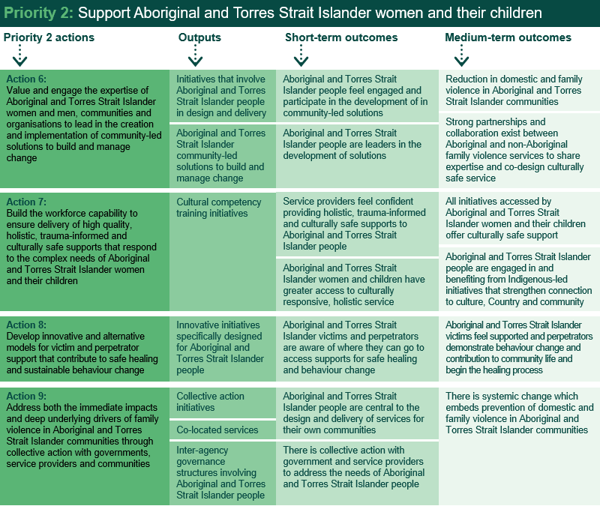

Source: Performance Monitoring and Reporting Framework

There are 30 initiatives relating to the second priority. Initiatives under this priority seek to involve Aboriginal and Torres Strait Islander people and communities in the design and delivery and governance of programs, as well as focus on collective action and the co-location of services for greater access. As noted previously, for each priority, it is expected that progress will primarily be observed in outputs; that is, implementation of initiatives under the NIP.

As demonstrated in Figure 7, 63 per cent of initiatives have been completed or are on track, down from 77 per cent in the previous year. Initiatives that have been delayed largely attribute this to COVID-19, with restrictions impacting on working closely with Aboriginal and Torres Strait Islander communities.

The figure highlights the achievements, and examples of progress under each action are provided in the sub-sections below.

Figure 7: Progress of initiatives under priority 2

Source: Jurisdictional input

Action 6:   
Value and engage the expertise of Aboriginal and Torres Strait Islander women and men, communities and organisations to lead in the creation and implementation of community-led solutions to build and manage change

Initiatives under this action include efforts to better engage Aboriginal and Torres Strait Islander communities in the responses that impact them. Under the NIP, 12 initiatives relate to Action 6, with one being completed (as per schedule), four being in progress (on track) and seven are in progress (delayed). The associated outputs in this action are initiatives that involve Aboriginal and Torres Strait Islander people in the design and delivery and Aboriginal and Torres Strait Islander led community solutions to build and manage change.

Key achievements

Achievements under this action include a range of initiatives to empower Aboriginal and Torres Strait Islander people and communities in developing and implementing solutions that impact their communities:

* Eight ACCOs across Australia are helping to raise awareness of, and address, technology-facilitated abuse in their communities through the eSafety Commissioner’s Dedicated Project Officer grants.
* Following a co-design process, the NIAA continues to work with Aboriginal and Torres Strait Islander service providers to implement family safety activities.
* The Queensland Government has committed to supporting the development of community-led DFV action plans in Aboriginal and Torres Strait Islander communities.
* In October 2020, the ACT Domestic Violence Prevention Council supported the Aboriginal and Torres Strait Islander Domestic Violence Prevention Council Reference Group to hold community consultations with Aboriginal and Torres Strait Islander community members. The aim was to identify priority areas for action to strengthen responses to DFV experienced by members of the Aboriginal and Torres Strait Islander community. To support community-led development and implementation of initiatives to respond to these recommendations, the ACT Government has committed $790,000 over four years from the 2021-22 budget. An additional $198,000 has also been rolled over from 2020-21 to further boost delivery against the recommendations.

Case study

|  |  |  |
| --- | --- | --- |
| Resources on technology-facilitated abuse for Aboriginal and Torres Strait Islander women |  |  |

Eight community-led projects are raising awareness of how to identify and seek help for technology-facilitated abuse. Under the program, each ACCO engages a project officer. The project officer works within their community to co-design culturally appropriate resources and training to support Aboriginal and Torres Strait Islander women experiencing technology-facilitated abuse as an extension of domestic and family violence. The resources being developed are place-based, designed by and for Aboriginal and Torres Strait Islander communities.

The eSafety Commissioner supports the organisations by providing best practice advice on addressing technology-facilitated abuse, delivering capacity-building training to each organisation, and commissioning research to support the evidence-base. For example, in August 2021 eSafety released research into the experiences of technology-facilitated abuse among Aboriginal and Torres Strait Islander women from regional and remote areas.

Action 7:   
Build the workforce capability to ensure delivery of high quality, holistic, trauma-informed and culturally safe supports that respond to the complex needs of Aboriginal and Torres Strait Islander women and their children

Under the NIP, nine initiatives sit within this action, the outputs of which aim to build workforce capability and capacity sit under Action 7. Six of these initiatives are in progress (on track) and three are in progress (delayed).

Key achievements

Highlights under this action include:

* Between 1 July 2013 and 30 June 2021, Lifeline trained over 39,810 frontline workers through over 2,655 workshops and awareness sessions, as part of the Commonwealth’s DV-Alert program. This includes up-to 830 sessions to over 12,480 frontline workers since 1 July 2019 to 30 June 2021.
* Of those who attended training between 1 July 2019 to 30 June 2021, 1,202 attended awareness training on DFV and how it affects Aboriginal and Torres Strait Islander families.
* In March 2021, the Minister for Territory Families launched the Northern Territory Domestic, Family, and Sexual Violence Workforce and Sector Development Plan, which sets out goals and priority actions aimed at strengthening and supporting the FDSV workforce and sector.
* The Western Australian Government has provided $1.5 million for the Culturally Appropriate Family and Domestic Violence Support Services Grants Program.
* The NSW Government co-design is a program for children under 10 years of age with problematic or harmful sexual behaviours and their families, called Safe Wayz.
* WorkUP Queensland hosted a series of knowledge circles with Aboriginal and Torres Strait Islander service providers, focusing on collaboratively sharing and building knowledge on topics such as professional development and self-care, workforce planning, and responding to the impacts of COVID-19.
* The Victorian Government continues to implement *Building from Strength – 10-Year Industry Plan for Family Violence Prevention and Response*. Achievements include the Victorian Census of Workforces that Intersect with Family Violence to build an evidence base to inform workforce and sector planning and development; development of the first accredited vocational education and training courses that deliver family violence response knowledge and skills; and the commencement of the Family Violence Graduate Program.

Case studies

|  |  |  |
| --- | --- | --- |
| Grants to support culturally appropriate DFV programs |  |  |

The Western Australian Government has provided $1.5 million for the Culturally Appropriate Family and Domestic Violence Support Services Grants Program. Two organisations were successful in securing this grant funding, which will support them to improve service pathways and reduce barriers to access support services for women and children from Aboriginal and CALD backgrounds experiencing DFV, provide training to increase competency levels for service providers who are likely to come into contact with potential or possible CALD victims of DFV and build the capacity of community leaders and elders in Western Australia’s Aboriginal and CALD communities to help address DFV.

One program being delivered is the Family Safety project, aiming to improve the safety and wellbeing of Aboriginal women experiencing family violence using a co-designed approach to build cross-cultural awareness of DFV and help victims get the support they need, through the development of an Aboriginal Family Safety program. The Aboriginal Family Safety Project has delivered a total of 14 workshops with 101 participants.

|  |  |  |
| --- | --- | --- |
| Culturally safe responses for children with problematic or harmful sexual behaviours |  |  |

Safe Wayz is a program for children under 10 years of age with problematic or harmful sexual behaviours and their families.

The Safe Wayz program model was developed through co-design with key stakeholders, including consultation with an Aboriginal Expert Group convened by the NSW Health Education Centre Against Violence. This co-design process has embedded principles of cultural safety in each of the elements of the Safe Wayz program, including prevention, early support and specialist counselling. The Aboriginal Expert Group provides leadership on the ongoing maturation and implementation of work to improve access and workforce capacity within NSW Health Sexual Assault Services.

All NSW Local Health Districts have developed Safe Wayz Program Implementation Plans and begun to conduct readiness activities before this program's launch. The NSW Ministry of Health has also funded the Sydney Children's Hospitals Network to recruit two clinical advisor positions to provide statewide clinical support and leadership to the Districts. One of these positions will be Aboriginal-identified and will focus on cultural as well as clinical support.

Action 8:   
Develop innovative and alternative models for victim and perpetrator support that contribute to safe healing and sustainable behaviour change

Under the NIP, 11 initiatives relate to Action 8, ranging from culturally appropriate programs to the establishment of specialist positions. These initiatives aim to enable behaviour change through innovative interventions. Of these, three have been completed (as per schedule), five being in progress (on track) and three in progress (delayed).

Key achievements

Some key achievements under this action include:

* The Kimberley Family Violence Service model has been refined in partnership with ACCOs and pathways established to promote collaboration towards outcomes-based, regionally informed investment, through the two Kimberley District Leadership Groups and the Family and Domestic Violence Priority Working Groups. Two Kimberley based community service providers will partner with ACCOs to provide localised programs for DFV intervention and support.
* The Queensland Government has embedded DFV specialist positions within community-controlled Aboriginal and Torres Strait Islander Family Wellbeing Services.
* In South Australia, the Tiraapendi Wodli Port Adelaide Justice reinvestment project provides culturally connected and coordinated support to Aboriginal women, men, children, young people and families.
* The Tangentyere Council Aboriginal Corporation in Alice Springs has been running the men’s behaviour change program since 2015. In 2018, the Northern Territory Government expanded the men’s behaviour change program to Darwin by funding a perpetrator intervention service run by CatholicCare NT. Since 2018, 413 men have engaged in the men’s behaviour change programs in Alice Springs and Darwin and 81 have completed the program.

Case studies

|  |  |  |
| --- | --- | --- |
| DFV specialist positions in Aboriginal and Torres Strait Islander Family Wellbeing Services |  |  |

DFV specialist positions are embedded within community-controlled Aboriginal and Torres Strait Islander Family Wellbeing Services in Queensland, which work with families that may be experiencing vulnerability to assist them through access to culturally responsive support. The specialist positions commenced in June 2020, with service delivery trials commencing in the Gold Coast, Toowoomba, Rockhampton, Townsville and the Bowen regions.

The services established under this initiative have experienced an increase in demand for DFV support since COVID-19, and has received an additional $2.7million across 33 Aboriginal and Torres Strait Islander Family Wellbeing Services as part of the COVID-19 response to enable temporary appointment of additional DFV specialist positions.

A reference group has been formed, and comprises five Family Wellbeing Service providers, the Department of Children, Youth Justice and Multicultural Affairs, and the Queensland Aboriginal and Torres Strait Islander Child Protection Peak. The Reference Group meets to ensure effective ongoing co-design of the model and progresses agree initiative intent, and clarification of outcomes for service delivery, determination of best approach for reporting to ensure case studies and other reports are capturing information on achievements, in keeping with the development of an evaluation plan and captures learnings to inform the development of a culturally appropriate DFV framework for working with Aboriginal and Torres Strait Islander families and communities.

|  |  |  |
| --- | --- | --- |
| Justice reinvestment |  |  |

The Tiraapendi Wodli Port Adelaide Justice reinvestment project provides culturally connected and coordinated support to Aboriginal women, men, children, young people and families to improve outcomes across education, child protection, justice and family safety.

The Tiraapendi Wodli Port Adelaide Justice reinvestment project will develop the next iteration of the Action Plan (2021-23), with a focus on strengthening community governance and local decision making, elevating the profile of the Community Hub, and further developing Aboriginal Community Advocates as part of the peer based Aboriginal Families Thrive Program.

Action 9:   
Address both the immediate impacts and deep underlying drivers of family violence in Aboriginal and Torres Strait Islander communities through collective action with governments, service providers and communities

Under the NIP, nine initiatives under Action 9 aim to better engage and support Aboriginal and Torres Strait Islander communities in addressing the drivers of violence. Of these, four are in progress (on track) and five in progress (delayed).

Key achievements

Achievements under this action have included:

* The NIAA worked with nine service providers across eight regional and remote areas to co-design family safety services working with Aboriginal and Torres Strait Islander families.
* Victoria’s Dhelk Dja Family Violence Fund provided $13.8 million in funding to more than 45 Aboriginal-led initiatives and services. This funding supports Victorian Aboriginal organisations to deliver culturally appropriate, Aboriginal-led tailored responses across victim survivors and people who use violence, including for women, men, children and young people.
* The Preventing the Cycle of Violence Aboriginal Fund was established in 2018 and supported Aboriginal-led family violence prevention and early intervention initiatives. $2.7 million was invested over two years to support 11 projects with a reach of at least 50,000 people across Victoria.
* Implementation continues against Queensland’s *Framework for Action – Reshaping our approach to Aboriginal and Torres Strait Islander Domestic and Family Violence*, which outlines the state’s commitment to a new way of working in genuine partnership and collaboration with Aboriginal and Torres Strait Islander peoples, families and communities to address the causes, prevalence and impacts of DFV.

Case study

|  |  |  |
| --- | --- | --- |
| Greater support for Aboriginal and Torres Strait Islander women and children in remote areas of high need |  |  |

In 2020, the Australian Government through the NIAA worked with nine service providers across eight regional and remote areas to co-design family safety services working with Aboriginal and Torres Strait Islander families. The Service Providers are located in Port Augusta and Ceduna (South Australia); Gove Peninsula, Darwin, and Katherine (Northern Territory); Townsville and Mackay (Queensland); and Kununurra (Western Australia).

Australian Government representatives joined service providers in facilitated workshops to develop locally tailored, culturally safe, trauma-informed service delivery models that met the intent of the Indigenous-specific measures under the 4AP. Due to the impacts of COVID-19, the co-design workshops were delivered virtually, and every effort was made to ensure the participants’ experience was inclusive, safe and supportive, engaging and as ‘real’ as possible.

Service providers have commenced delivering co-designed early intervention and prevention family safety activities, including programs such as Women's Healthy Relationships Groups, education and early intervention support for young people aged 12 to 18 years, community awareness and education activities, men's behaviour change programs, Women's and Men's Healing Programs, Safe-House Partnership Programs, trauma-informed case management and early intervention rehabilitation, and a Gay Men and Sister-Girls program.

The Gay Men and Sister-Girls program operates weekly group yarning circles and provides general support, mentoring and case management to 17 clients. Ten of those clients are receiving mentoring and case management, and eight are receiving individual counselling. Over a six-month period, there have also been 196 interactions with the service by telephone, email, social media and messenger as word about the project spread quickly amongst the gay community as it has linked in with the local private gay social media network to engage LGBTIQ+ people.

Priority 3: Respect, listen and respond to the diverse lived experience and knowledge of women and their children affected by violence

Race, sexuality, gender, and disability, amongst other forms of identity, can impact the way a woman experiences violence. In recognition of this, the three actions sitting within this priority area range from community-led initiatives, services that respond to high-risk groups, and sector capacity building initiatives to respond to cultural and complex forms of violence.

Figure 8 outlines the program logic for Priority 3. Priority 3 will be successful when people from different communities and at-risk groups are empowered to lead and develop their own initiatives to address FDSV, with access to culturally appropriate and safe supports. The actions in Priority 3 seek to implement tailored initiatives to address the unique experiences and needs of communities affected by multiple forms of discrimination and inequality, deliver policies to address this disproportionate impact, and better equip the service system to respond to the unique needs of these groups. This figure also notes the outputs or initiatives that are observable when these actions are put in into place as well as identifying short- and medium-term outcomes.

Figure 8: Priority 3 Program logic

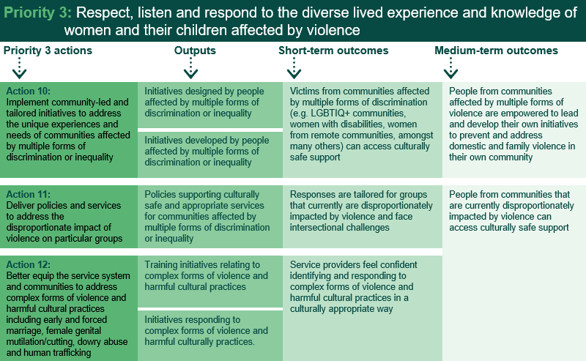

Source: Performance Monitoring and Reporting Framework

Thirty-four initiatives are aligned to Priority 3. Initiatives under this priority aim to encourage the establishment of programs that are designed and developed by the communities they are targeting to help them develop culturally appropriate and culturally safe services and better equip services to deal with complex forms of violence and harmful cultural practices. As noted previously, for each priority, it is expected that progress will primarily be observed in outputs; that is, implementation of initiatives under the NIP.

As demonstrated in the figure below, the vast majority (85 per cent) of initiatives under this priority are on track or have been completed, slightly down from 89 per cent last year. Some initiatives have experienced delays due to COVID-19 and its resulting resourcing impacts on government agencies

Highlights of achievements and examples of progress under each action are provided in the sub-sections below.

Figure 9: Progress of initiatives under priority 3

Source: Jurisdictional input

Action 10:   
Implement community-led and tailored initiatives to address the unique experiences and needs of communities affected by multiple forms of discrimination or inequality

Initiatives under this action support people from diverse groups at risk of violence, such as children and young people, people with disability, and people who identify as LGBTIQ+. Under the NIP, 12 initiatives relate to action 10, with nine being in progress (on track) and three being in progress (delayed). The associated outputs for Action 10 are initiatives designed by people affected by multiple forms of discrimination or inequality.

Key achievements

Achievements to date under this action by jurisdictions include:

* The ACT’s Family Safety Hub is piloting a new health justice partnership to provide early intervention for pregnant women and new parents experiencing or at risk of DFV.
* In Tasmania, the Safe Choices Local Support Coordinator service delivers support for women with disability experiencing DFV.
* In South Australia, Child and Family Safety Networks – which bring together government non-government services – are in place in regions across the state to identify and support families with young children at high risk of FDSV.
* The NSW Government has engaged ACON to support frontline professionals working with people from the lesbian, gay, bisexual, transgender, and queer (LGBTQ+) communities regarding sexual assault.
* Victoria’s NDIS Family Violence Workforce Capacity Building project has been funded to deliver tailored learning and resources and to build the capacity of the family violence sector to support clients with disabilities and to work with the NDIS.
* Also in Victoria, 26 family violence services – including six Aboriginal services – were funded to undertake Rainbow Tick accreditation aimed at assisting organisations to become safer and more inclusive of LGBTIQ+ communities.

Case studies

|  |  |  |
| --- | --- | --- |
| Addressing intersecting health and legal issues |  |  |

Beginning in 2019, the ACT’s Family Safety Hub piloted a new health justice partnership to provide early intervention for pregnant women and new parents experiencing or at risk of DFV. The pilot embedded lawyers into health care sites across Canberra to provide free access to legal information. A review of the initial six-month pilot identified the service reached people who would otherwise not receive any support, was supporting people with complex and intersecting health and legal problems and was more effective than an outreach model where a lawyer is only onsite irregularly.

The services were extended and have now become embedded in the ACT service system, with strong relationships between healthcare professionals and legal staff. The partnerships put help right in front of those who need it, in a place they are comfortable and have established and trusted relationships. So far, over 500 people have been supported through the partnerships.

Additionally, the legal staff have provided training to healthcare workers on the complexities of DFV, family law, and care and protection. This has given healthcare staff a greater awareness of legal issues and options for their patients, and a confidential source of advice and support while working with women who may be at risk of DFV and dealing with intersecting health and legal issues.

|  |  |  |
| --- | --- | --- |
| Improving services working with LGBTQ+ communities |  |  |

The NSW Government has engaged ACON to support frontline professionals to work meaningfully and effectively with people from LGBTQ+ communities regarding sexual assault. This initiative is part of the *NSW Sexual Assault Strategy 2018-2021*.

ACON has progressed a number of activities relating to this initiative, including:

* Completed a policy and practice review project to build the capacity of a frontline DFV service in regional NSW
* Advised on policy through ACON’s active involvement in both the NSW DFV and Sexual Assault Council, and monthly meetings between the sector and the NSW Government.
* Partnered with the University of Tasmania on a research project to build an understanding of the nature and dynamics of sexual assault in LGBTQ+ communities. As part of this work, they are preparing to conduct a community survey.
* Developed a Sexual Assault toolkit, which focuses on assisting LGBTQ+ communities to recognise and respond to sexual assault with a focus on dating apps, sex on premises venues, and the party scene.
* Developed the Sexual Assault in LGBTQ+ Communities e-learning in collaboration with professionals working in the sector and LGBTQ+ community members who have experienced sexual assault.
* Finalised the Proud Partners Program which will be rolled out in the first quarter of 2022.
* Implemented support groups for LGBTQ+ victim/survivors of sexual assault, intimate partner and/or family violence in Sydney, Hunter and Northern Rivers.
* Continuing to work with frontline DFV services to build the capacity of staff and improve their organisations’ policies and practices to better serve the LGBTQ community.

Action 11:   
Deliver policies and services to address the disproportionate impact of violence on particular groups

Under the NIP, 23 initiatives relate to Action 11 ranging from innovation funds and program extensions, service gap identification, and program redesigns. These aim to deliver supports to communities and groups that are particularly vulnerable to violence. Three of these initiatives have been completed according to schedule, two completed ahead of schedule, 14 are in progress (on track), and four are in progress (delayed).

Key achievements

Achievements under this action include:

* The NSW Government allocated $10 million in recurrent annual funding for the Violence, Abuse and Neglect Redesign Program to enhance the capacity of the NSW public health system to provide 24-hour trauma-informed and trauma-specific integrated psychosocial, medical and forensic responses to sexual assault, DFV, child physical abuse and neglect, and children and young people with problematic or harmful sexual behaviour.
* Under the DFV Innovation Fund, the NSW Government has funded 20 projects over two rounds, including 14 projects focused on prevention and early intervention, and six projects focused on crisis response.
* The Northern Territory Gender Equality Statement of Commitment was released in July 2020.
* In Victoria, LGBTIQ+ DFV applicant and respondent practitioners have been funded at the Magistrates’ Court of Victoria to ensure an inclusive service where LGBTIQ+ people have the information, advice and support they require when they come into contact with the court due to family violence.
* Youth on Track, a NSW early intervention scheme for 10-17 year olds that identifies and responds to young people at risk of long-term involvement in the criminal justice system, continued to support young people who are victims of DFV, who comprise 36 per cent of participants in 2020-21.
* The Queensland Government is delivering seven signature initiatives and 15 supporting initiatives as part of implementing *Queensland’s plan to respond to domestic and family violence against people with disability*. This includes DFV high risk teams accessing disability service providers and/or professionals with appropriate levels of expertise to support multi-agency complex risk assessment and safety management planning.
* In 2019 the ACT held in-depth consultations with children and young people with lived experiences of DFV. Insights, expressed in the voices of children and young people, were distilled into a listening and learning report, which is informing further policy and program development.
* In 2020 and 2021, the ACT Government allocated Commonwealth funds to support the Got Your Back group therapy program with Relationships Australia, for young people living with domestic and family violence. The format and content of the group sessions are decided by the young people participating, ensuring a response that is tailored to – and directed by – young people.
* Between 1 July 2019 and 31 December 2020, NSW’s Ageing and Disability Commission received 16,653 calls to the NSW Ageing and Disability Abuse Helpline and handled 6,240 matters. Of the 3,899 reports of abuse, neglect and exploitation of adults with disability and older people.
* Between 1 July 2019 and 30 June 2021, 1800RESPECT – the national sexual assault, domestic and family violence counselling service – answered over 550,000 contacts (telephone and online chats).
* In 2020-21, Specialised Family Violence Services saw 7,923 individual clients attending 34,998 sessions. This is an increase on 2019-20 when 6,313 individual clients attended 25,758 sessions.
* Successful extension of eligibility for Partner Service Pension to those who were a de facto partner of a veteran, including:
* Continued eligibility for 12 months past the separation, and/or
* Continued eligibility for those who are leaving their relationship with the veteran due to family and/or domestic violence.

Case studies

|  |  |  |
| --- | --- | --- |
| Preventing, addressing and reducing the impact of DFV on people with disability |  |  |

The Queensland Government has invested $1.51 million since May 2019 to deliver *Queensland’s plan to respond to DFV against people with disability* and drive actions to increase the awareness of, and better respond to, people with disability experiencing DFV. The plan’s implementation approach specifically identified and established opportunities for people with lived experience of disability and DFV to be involved in the design and development of practical solutions.

As part of the implementation of the plan, the Queensland Government has released accessible and inclusive DFV information and awareness resources for women with disability to improve the information available to people with disability about accessing DFV support. The resources are available online and in Easy-English formats to ensure accessibility for people of all abilities.

To supplement these resources, training modules have been developed for the disability workforce to enable any person working with or supporting people with disability, to be DFV informed and capable of recognising the signs of DFV and referring to appropriate supports.

These actions reflect a genuine co-design approach – working with women with disability, disability and DFV service sectors – to guide the development of these valuable resources to raise awareness and breakdown stereotypes.

|  |  |  |
| --- | --- | --- |
| Development of a Gender Equality Framework |  |  |

The development and implementation of a Northern Territory Gender Equality Statement of Commitment and First Action Plan 2021 – 2024 sits under the Northern Territory’s *Domestic, Family and Sexual Violence Reduction Framework 2018- 2028 Safe, respected and free from violence*. The Commitment was developed following extensive consultations with over 300 women, men and gender diverse people across the Northern Territory.

The Northern Territory Gender Equality Statement of Commitment was released in July 2020 and focuses on five key areas to improve gender equality: community engagement; health and wellbeing; safety; economic security; and leadership and participation.

It is expected that the first Gender Equality Action Plan will be released in late 2021 and deliver actions that respond to the five key areas to improve gender equality outcomes in the Northern Territory.



|  |  |  |
| --- | --- | --- |
| Grants to support innovation DFV projects |  |  |

The $20 million DFV Innovation Fund is a commitment under the *NSW Domestic and Family Violence Blueprint for Reform 2016-2021: Safer Lives for Women, Men and Children*. The Innovation Fund supports innovative early intervention, prevention and crisis solutions to DFV. It targets projects which focus on at-risk and diverse communities, including CALD communities, Aboriginal and Torres Strait Islander communities and people with disability.

Twenty projects were funded over two rounds, including 14 projects focused on prevention and early intervention, and six projects focused on crisis response. Projects are being independently evaluated and preliminary results have been positive.

One funded project, the ReThink! Anti-Violence Project, aims to prevent violence amongst school aged children and young people.

Peer educators from the project have found training valuable for both themselves and other young people. Peer educators have noted they have learned more about healthy relationships and how to identify toxic behaviours as a result of their participation in the project. This is being recognised locally, with one peer educator winning the Bayside Council Young Citizen of the Year Award for 2021.

A number of projects from both funding rounds have been extended. Nine Round 2 projects and one Round 1 project have been extended until 31 March 2022, one Round 2 project has been extended until 30 June 2022, and one Round 1 project has been extended until 30 June 2023.

|  |  |  |
| --- | --- | --- |
| Extending the Partner Service Pension |  |  |

The Department of Veterans’ Affairs has seen an increase in the number of de facto partners obtaining or remaining on the Partner Service Pension, allowing them to have financial support that would previously not have been available.

For example, a female pension recipient and her three school age children had moved back in with her mother while awaiting dialysis for a kidney condition. The woman was expecting she would have to apply for a Social Security payment through Services Australia as her primary income. Upon further investigation by the Department, it identified the woman had been in a long-term de facto relationship with a veteran. The woman disclosed the reason for relationship breakdown was due to ongoing DFV. When the woman was told about her ongoing entitlement to the pension, she was incredibly grateful as she was expecting to lose access to any kind of support. The Department also provided other wrap around support including referral to Open Arms – Veteran & Families Counselling for ongoing counselling for her and her children.

Action 12:   
Better equip the service system and communities to address complex forms of violence and harmful cultural practices including early and forced marriage, female genital mutilation/cutting, dowry abuse and human trafficking

Under the NIP, six initiatives relate to Action 12, including partnerships with cultural leaders, and extending specialist programs. These aim to support professionals and communities to better respond to complex and/or cultural forms of violence. Of these, one has been completed (as per schedule), one has been completed (but was delayed), two were completed ahead of schedule and two are in progress (on track).

Key achievements

Achievements under this action include:

* The SA Government has developed a network of faith and community leaders to promote understanding of the relevance of primary prevention and women’s experience of FDSV in the community.
* On 16 June 2020, the Tasmanian Government launched the Safe from Violence website, Tasmania’s central point of information for FDSV ([www.safefromviolence.tas.gov.au](http://www.safefromviolence.tas.gov.au)). In July 2020, a series of fact sheets in five community languages were uploaded to the website providing information for those experiencing violence and for those using violence in Arabic, Karen, Nepali, Oromo and Tigrinya. This was followed by publication of five more community languages (Amharic, Burmese, Dari, Farsi and Hakha Chin) and audio recordings of all 10 languages in February 2021.
* The Tasmanian Government has established a range of training initiatives, including a comprehensive package for ongoing statewide training for the Child Safety Service, the Family and Sexual Violence and Emergency Events training module which is freely available on the State Emergency Service website, training for Community Corrections staff working with family violence offenders, and workshops for translators on interpreting in family violence settings.

Case study

|  |  |  |
| --- | --- | --- |
| Building partnerships with faith and community leaders |  |  |

The South Australian Government has worked with faith and community leaders, discussing the relevance of primary prevention and understanding women’s experience of FDSV. The SA Government has developed a network of faith and community leaders to promote understanding of the relevance of primary prevention and women’s experience of FDSV in the community. Engagement activities will occur to hear from community leaders and learn which initiatives and resources would best help to support individual communities.

An information package has been developed in conjunction with specialist women’s DFV services and the Multicultural Communities Council of SA about FDSV. This information package has been translated in to 25 community languages and is available on the Break the Cycle campaign website: <https://breakthecycle.sa.gov.au>.

The package also includes fact sheets on FDSV for use by diverse community groups covering topics such as promotion of general equality and respect, recognising FDSV and how to broach the if you recognise that someone is at-risk, and the steps you can take to help.

Priority 4: Respond to sexual violence and sexual harassment

Priority 4 aims to respond better to sexual violence and sexual harassment. The three actions in this initiative range from prevention activities, client-centred support for victims, and strengthening the capacity of the sector.

Figure 10 outlines the program logic for Priority 4. It shows that responding to sexual violence and sexual harassment will be successful when there are sustained attitudinal changes and new societal norms, when victims are empowered through timely and appropriate service responses, and when there is a sustained reduction in sexual harassment in the workplace, schools and other settings. The actions in Priority 4 seek to promote informed consent, bodily autonomy and respectful relationships to prevent sexual violence before it happens, deliver client-centred, trauma-informed specialist supports, and strengthen the capacity of all sectors to ensure women are safe from sexual harassment in all settings. This figure also notes the outputs or initiatives are observable when these actions are put in place as well as identifying the short- and medium-term outcomes expected to be achieved.

Figure 10: Priority 4 Program logic

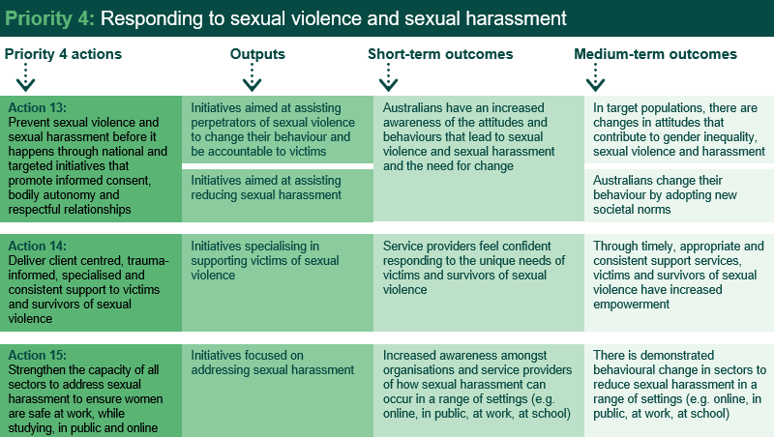

Source: Performance Monitoring and Reporting Framework

There are 29 initiatives aligned under this priority, which aims to assist perpetrators in taking accountability, establish programs to reduce and address sexual harassment, and provide specialist support for victims of sexual violence.

As demonstrated in the figure below, 79 per cent of initiatives are on track or have been completed. This is less than the previous year when 85 per cent of initiatives were complete or on track. COVID-19 is the cause of most delayed initiatives due to staff being redeployed to support the pandemic response or impacts on consultation.

Highlights of achievements and examples of progress under each action are provided in the sub-sections below.

Figure 11: Progress of initiatives under priority 4

Source: Jurisdictional input

Action 13:   
Prevent sexual violence and sexual harassment before it happens through national and targeted initiatives that promote informed consent, bodily autonomy and respectful relationships

Nine initiatives from the NIP relate to Action 13. These aim to prevent sexual violence and sexual harassment from occurring. Initiatives under this action range from statewide policy frameworks, community awareness activities, and sector training. The associated outputs under this action include initiatives aimed at assisting perpetrators of sexual violence to change their behaviour and be accountable to victims and initiatives that aim at reducing sexual harassment. Of these, two have been completed (as per scheduled), five are in progress (on track) and two are in progress (delayed).

Key achievements

Achievements under this action have included:

* From July 2021, a $6.5 million package of sexual violence prevention activities were implemented under the Commonwealth’s Sexual Violence and Community awareness activities initiative will provide:
* $2.3 million for Our Watch to expand the Respect and Equality in TAFE initiative, currently funded by the Victorian Government. This expansion will employ, train and support Primary Prevention Officers to deliver local prevention activities at TAFE campuses across Australia.
* $2.5 million for White Ribbon Australia to implement prevention activities in local communities.
* $1.5 million for Universities Australia to develop a comprehensive package of sexual harassment and violence prevention materials to distribute to its member universities.
* $158,000 for LGBTIQ+ Health Australia and University of New South Wales to co-design pilot primary prevention projects and design research and evaluation tools in LGBTIQA+ communities.
* Under the Commonwealth’s Sexual Violence and Community awareness activities initiative, extensive research was conducted over 2019-20 and 2020-21 by Deloitte and La Trobe University to strengthen the evidence base in relation to sexual harassment and violence prevention, including identifying cohorts at greatest risk of sexual violence. These reports are available at <https://plan4womenssafety.dss.gov.au/resources/research>.
* In July 2020, the Northern Territory Government released the *Sexual Violence Prevention and Response Framework* and its Priority Action Plan.
* The Tasmanian Government will work with the eSafety Commissioner to deliver education and training in response to technology-facilitated abuse.
* The Queensland Government has made significant progress implementing *Prevent. Support. Believe – Queensland’s Framework to address sexual violence* and on 26 October 2021, launched the first action plan to implement the Framework.
* In Queensland, three place-based prevention trials are underway in Toowoomba, Yarrabah, and Bundaberg which involve working with young people and community stakeholders to co-design initiatives to prevent youth sexual violence and abuse.
* In addition, in 2021, the Queensland Government established the independent and consultative Women’s Safety and Justice Taskforce. The Taskforce is to provide its recommendations to Government on how to best legislate against coercive control by November 2021, and to deliver recommendations on how to best improve women’s experience in the criminal justice system by June 2022.
* In April 2021, the ACT announced a Sexual Assault Prevention and Response Program Steering Committee and Aboriginal and Torres Strait Islander Consultation Committee. The Committees are listening to local experts, survivors, and their advocates to set key priorities for government action around prevention, response and law reform.

Case study

|  |  |  |
| --- | --- | --- |
| Education on technology-facilitated abuse |  |  |

Recognising the increase of technology-facilitated abuse, the Tasmanian Government will support and promote eSafety education and training opportunities in Tasmania by working with the eSafety Commissioner to deliver education and training in response to technology-facilitated abuse.

This initiative is an action under the *Safe Homes, Families, Communities: Tasmania’s action plan for family and sexual violence 2019-2022*, which commenced on 1 July 2019 and has invested $26 million over three years to prevent and respond to FDSV in Tasmania.

Workshops were held statewide in 2019 and 2020 with participants including specialist FDSV services, mainstream services and industry organisations. The workshops informed participants about the role of technology facilitated abuse in violence against women and how to help clients protect themselves.

In addition to this initiative, Safe Homes, Families, Communities has introduced several other actions to respond to technology facilitated abuse, including strengthening mechanisms for schools to respond to technology-facilitated abuse (such as image-based abuse) and the Department of Education has developed a suite of protective behaviours and personal safety online resources for students and staff.

The Tasmanian Government will continue to liaise with the eSafety Commissioner to identify training opportunities in 2021-22. Communities Tasmania continues to promote online training opportunities offered by the eSafety Commissioner, including through the Events and Training page on the Safe from Violence website.

Action 14:   
Deliver client-centred, trauma-informed, specialised and consistent support to victims and survivors of sexual violence

Sixteen initiatives from the NIP relate to Action 14. These aim to deliver specialist support for victims of sexual violence and range from service improvement, development and reviews of standards, and improving service access. Of these initiatives, three are completed (as per schedule), 10 are in progress (on track) and three are in progress (delayed).

Key achievements

Achievements under this action have included:

* The Commonwealth’s *National Standards for Sexual Violence Responses* initiative comprises a range of activities including national standards related to perpetrator intervention outcomes and sexual violence response. In September 2021, the National Association of Services Against Sexual Violence published the Third Edition of the *National Standards of Practice Manual for Services against Sexual Violence* to support specialist sexual violence services across Australia to provide high quality and evidence based care. The new Standards are available at www.nasasv.org.au.
* The South Australian Government is currently developing the cohort-specific risk factors which will be included in risk assessments provided by agencies for women experiencing FDSV who can then be referred to the Family Safety Framework if found to be at high risk of violence.
* NSW’s Child Sexual Offence Evidence Program has been fully implemented, introducing witness intermediaries to facilitate communication with child witnesses through the trial process and expand the use of pre-recorded evidence in criminal court proceedings.
* In NSW, South Eastern Sydney and Mid North Coast Local Health Districts have been funded for three years to develop, pilot and evaluate a new integrated service for adult survivors of child sexual abuse with complex needs. These pilots will inform development of a state-wide specialist integrated service model that will be rolled out across local health districts from 2022-2023.
* NSW’s Education Centre Against Violence has developed and launched the Adult Survivors of Sexual Assault Pilot Online Training Strategy to build capacity in the workforce to recognise, respond and support adult survivors of sexual assault.
* In Victoria, three Aboriginal sexual assault services tailored for Aboriginal people have been established, which will be delivered by Aboriginal service providers. Practice will be informed by Nargneit Birrang, the Aboriginal Holistic Health Framework.
* The NSW Government has allocated $37.7 million over five years from 2018-19 to improve the prevention of and responses to children and young people with problematic or harmful sexual behaviours.
* The ACT’s Safer Families Package initiative has been expanded to include an increase in frontline DFV and rape crisis services, additional lawyers to support the Health Justice Partnership program, expansion of the Family Violence Safety Action Pilot and a continuation of funding for the Women’s Safety Grant.

Case studies

|  |  |  |
| --- | --- | --- |
| **N**ational Standards for Sexual Violence Responses |  |  |

The National Association of Services Against Sexual Violence published the *National Standards of Practice Manual for Services against Sexual Violence (Third Edition)* in September 2021.

The purpose of these Standards is to promote accessible, high quality and consistent service provision in responding to sexual violence across Australia. The development of these new Standards has been informed by an extensive literature review, in line with previous versions, and in addition to consultation with sexual violence and other family violence and community services such as police. Key features include a focus on children and young people who have experienced sexual assault and responding to children and young people with harmful sexual behaviours. Given these new advances, these Standards provide guidance to practitioners on the provision of services to adults, children and young people who have experienced violence or are exhibiting harmful behaviours.

The new Standards are available at nasasv.org.au and the plan4womenssafety website.



|  |  |  |
| --- | --- | --- |
| Responses to children and young people with problematic and harmful sexual behaviours |  |  |

The NSW Government has allocated $37.7 million over five years from 2018-19 to improve the prevention of and responses to children and young people with problematic or harmful sexual behaviours. This forms part of the NSW Government response to the recommendations of the Royal Commission into Institutional Responses to Child Sexual Abuse.

NSW Government is developing a whole of government and whole of community framework for preventing and responding to children and young people with problematic and harmful sexual behaviours through a public health approach. This will support families, communities and professionals to identify problematic or harmful sexual behaviours and respond early to ensure the safety and wellbeing of all children. The framework will be accompanied by an implementation plan and a prevention strategy that responds to the contemporary issues facing our children and young people as they develop and negotiate relationships co-design activities for the framework and supporting projects commenced in October 2020 and have continued through the first half of 2021.This has included quantitative and qualitative research and iterative product design through workshops and stakeholder interviews.

NSW Government is improving access to specialist counselling services to support children and young people to cease their problematic or harmful sexual behaviours. The Office of the Children’s Guardian has reviewed and is making improvements to the Child Sex Offender Counsellors Accreditation Scheme, which will support counsellors to ensure they have the appropriate skills and confidence to undertake the work and publish a list of accredited counsellors and services.

NSW Health is also expanding its specialist treatment services:

* New Street Services have been expanded and are now available across the state. New Street provides a specialised, community-based child protection and therapeutic service to address harmful sexual behaviours displayed by young people aged 10 to 17 years. New Street works with the child and caregivers, as well as other agencies and community services. The program focuses on safety, restitution and wellbeing. This helps the young person to understand, acknowledge, take responsibility for and cease the harmful sexual behaviour while also addressing their other support, wellbeing and development needs. All New Street Services have identified Aboriginal counsellors and are supported through statewide clinical and cultural advisors. In April-June of 2021, New Street Services provided counselling for 203 children and young people with harmful sexual behaviours.
* NSW Health has developed a new program model, Safe Wayz, for children under the age of criminal responsibility (currently 10 years of age in NSW) with problematic or harmful sexual behaviours and their families. The model was developed through a co-design process that embedded principles of cultural safety in each of the elements of the Program including prevention, early support and specialist counselling. Like New Street, the Program is supported by a centralised team of clinical and cultural advisors. All Local Health Districts have developed Safe Wayz Program Implementation Plans and begun to conduct readiness activities prior to the launch of this Program in 2022.

Action 15:   
Strengthen the capacity of all sectors to address sexual harassment to ensure women are safe at work, while studying, in public and online

Twelve initiatives from the NIP relate to Action 15 including sector training, statewide frameworks, and the development of educational resources aimed at addressing sexual harassment. Of these, three have been completed (as per schedule), one was completed (but was delayed), six are in progress (on track), and two are in progress (delayed).

Key achievements

Achievements under this action have included:

* The Victorian Government provided $435,000 in 2019-2020 to fund the implementation of the Workplace Equality and Respect program in government departments. The program seeks to embed best-practice workplace programs promoting gender equality and respectful cultures in public sector workplaces.
* In December 2020, the Tasmanian Premier announced that all Tasmanian Government departments would adopt the Our Watch Workplace Equality and Respect Standards.
* Monash University was selected as the successful applicant through an open competitive grant round to undertake accredited training for sexual violence responses. Monash University has partnered with the Victorian Institute of Forensic Medicine and will be engaging with relevant organisations across Australia to develop two streams of training. One stream will be for frontline workers and a separate, more specialised stream will be available for health professionals.
* The first unit of the doctors and nurses stream commenced on 16 August 2021. Enrolments included 15 doctors, eight nurses and two midwives. Fifteen of the cohort were metropolitan based, with the remainder working in rural/regional settings.
* Tailored training and resources have been developed and implemented which aim to build the capacity of disability and domestic and family violence services to identify technology-facilitated abuse and assist their clients to seek pathways to support. This program will help women with intellectual or cognitive disability be aware of abuse through technology and of how to get help.

Case study

|  |  |  |
| --- | --- | --- |
| Formalising the role of  Our Watch in Tasmania |  |  |

In October 2019, the Tasmanian Government launched a nation-first partnership with Our Watch to establish a primary prevention officer in Tasmania (known as the Senior Advisor Tasmania).

The Senior Advisor Tasmania commenced in March 2020 and is tasked to coordinate and support primary prevention efforts across Tasmania, working closely with government and non-government services to implement key Our Watch projects in Tasmania and to work with Our Watch Ambassadors to promote primary prevention activities in Tasmania. The Officer provides organisations with technical advice and expertise on building primary prevention in their organisations and communities.

Despite the challenges that COVID-19 has presented the Senior Adviser has undertaken significant engagement with key stakeholders during 2020-21, including:

* Establishing relationships with the community sector.
* Supporting Tasmanian Government departments to implement the Our Watch Workplace Equality and Respect Standards.
* Working with the Local Government Association of Tasmania to identify ways to support local governments, including promoting the Our Watch Local Government Toolkit.
* Engaging in targeted activities with Tasmanian Aboriginal organisations, which has resulted in South East Tasmanian Aboriginal Corporation receiving Our Watch Connected Communities funding for the Tegganaha Palawa project (Strong Men, Strong Futures) to work with Aboriginal men to prevent violence against women.
* Provided advice on the design and content of the Tasmanian Government’s primary prevention grants program for Aboriginal organisations.
* Advised the community sector on primary prevention initiatives and resources.

|  |  |  |
| --- | --- | --- |
| Resources on technology-facilitated abuse for women with disability |  |  |

Tailored training and resources have been developed and implemented which aim to build the capacity of disability and domestic and family violence services to identify technology-facilitated abuse and assist their clients to seek pathways to support. Program resources include training webinars, case study videos, conversation starters, posters and wallet cards.

eSafety also commissioned research into the experiences and impacts of technology-facilitated abuse on Australian women with intellectual or cognitive disability. This was released in September 2021.

An important element of this resource suite is the series of case study videos demonstrating ways a woman with intellectual or cognitive disability might experience different forms of online abuse, such as technology-facilitated abuse and image-based abuse. eSafety commissioned the production of three personal stories using an inclusive film-making model (working in partnerships with Fusion Theatre) to ensure that as well as raising awareness about the important issue of technology abuse, the resources are authentic and elevate the voices and faces of women with intellectual or cognitive disability. The videos are available in accessible formats and are closed-captioned, AUSLAN interpreted and audio-described.

Priority 5: Improve support and service system responses

This priority aims to improve support and service system responses for women and their children affected by violence. The five actions under this priority area relate to sector development, collaboration between and integration of services, and improving access to services.

Figure 12 outlines the proposed program logic for Priority 5. It shows that improving support and service system responses will be successful when women and their children affected by FDSV have their needs met by services that deliver trauma-informed support that focus on safety and recovery. Success will also be seen when perpetrators have timely access to rehabilitative services, and victims are safely housed in their communities. The actions in Priority 5 seek to enable workforces to provide trauma-informed supports, improve collaboration across services, improve access to and embed trauma-informed support for perpetrators, build the evidence-base, and improve access to safe and suitable accommodation for women (and their children) who have experienced FDSV. This figure also notes the outputs are observable when these actions are put in place as well as identifying the short- and medium-term outcomes expected to be achieved.

Figure 12: Priority 5 Program logic

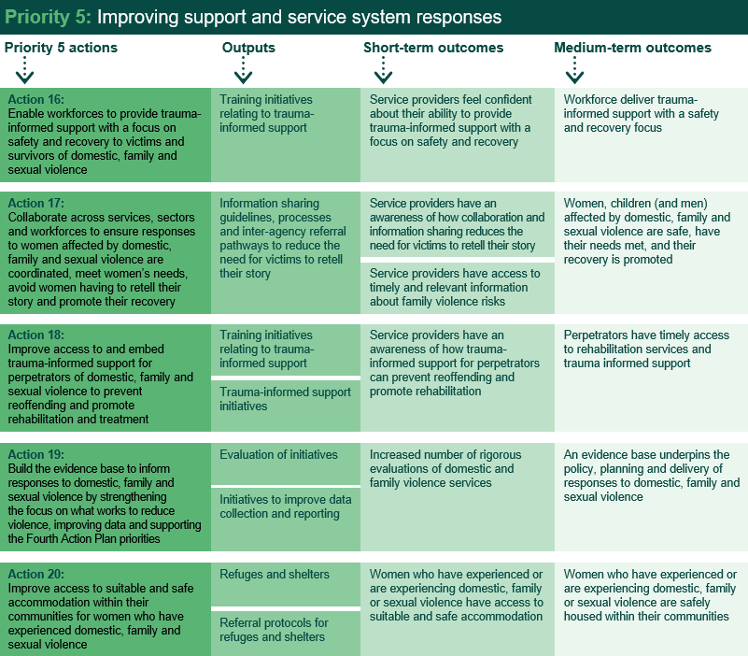

Source: Performance Monitoring and Reporting Framework

There are 87 initiatives relating to Priority 5. Initiatives under this priority aim to train professionals in delivering trauma-informed support, improve information sharing, and establish referral protocols with refuges. As noted previously, for each priority, it is expected that progress will primarily be observed in outputs; that is, implementation of initiatives under the NIP.

As demonstrated in the figure below, progress under Priority 5 is positive, with 89 per cent of initiatives on track or complete, slightly down from 91 per cent last year. Similar to the other priorities, delays to these initiatives have largely been caused by COVID-19 and its resulting impacts

Highlights of achievements and examples of progress under each action are provided in the sub-sections below.

Figure 13: Progress of initiatives under priority 5

Source: Jurisdictional input

Action 16:   
Enable workforces to provide trauma-informed support with a focus on safety and recovery to victims and survivors of domestic, family and sexual violence

Twenty-five initiatives from the NIP relate to Action 16 including projects that aim to develop and improve risk assessment processes and provide strengthened sector education. The outputs associated with these initiatives are training initiatives relating to trauma informed support. Of these, three have been completed (as per schedule), two are completed (but was delayed), 13 are in progress (on track), and seven are in progress (delayed).

Key achievements

Achievements under this action include:

* The Commonwealth Government is providing a total of $9.5 million over four years to improving health system responses to DFV.
* Our Watch’s Expression of Interest process selected two universities (Deakin University and Western Sydney University) to participate in the Commonwealth’s University Based learning and development prevention pilot, which will develop and deliver resources, curriculum and workshops relating to the prevention of violence against women.
* Workshops with teaching staff from both universities were conducted in February 2021, with approximately 40 participants. The first of three community of practice sessions were held with each discipline group in June 2021, to review teaching resources and discuss their implementation. Delivery of teaching resources developed under the pilot is taking place in the second semester of 2021.
* The Western Australian Government has introduced a mediated ‘shuttle conferencing’ model for contested family violence restraining order proceedings. Shuttle conferencing involves the parties to a family violence restraining order attending the court in separate rooms with a mediation registrar ‘shuttling’ between the two in an attempt to finalise conditions that are agreeable to both parties. This removes the need for the parties to participate in an adversarial, face-to-face court hearing.
* The Western Australian Government co-designed and launched two DFV One Stop Hubs.
* In consultation with the DFV sector, the ACT Government has developed a draft DFV Risk Assessment and Management Framework. The Framework aims to support all services to consistently and effectively identify DFV with a view to earlier intervention and improved access to support and information. The draft Framework has been trialled in health settings and is now being finalised for release with supporting training.
* The ACT is developing a Child Safe Standards Scheme following community consultation. The Scheme will operate across government with policies, resources, tools and business processes that build capacity to keep children and young people safe. The ACT is also implementing the Safe and Supportive Schools policy, Positive Behaviour for Learning and is embedding trauma-informed practices within schools.
* The Northern Territory Government has released a Common Risk Assessment Tool and framework to enable a consistent and evidence-based approach to identifying, assessing, responding to and managing DFV risk for all workers.
* The South Australian Government is working to raise awareness among professionals in Children’s Centres, preschools and schools and emergency departments, so that teachers, student support services and allied health professionals know how to best recognise and respond to violence against women and their children.
* In 2020/21, NSW’s Women's Domestic Violence Court Advocacy Services assisted 55,341 women experiencing DFV across the state, and provided services including referrals to key supports (e.g. housing, counselling, legal advice), safety planning and help through the court process.

Case studies

|  |  |  |
| --- | --- | --- |
| One Stop Hubs for DFV |  |  |

In late 2019, the Western Australian Government conducted a comprehensive co-design process involving more than 130 participants to inform the model design and procurement for special DFV One Stop Hubs.

Two Hubs were officially launched in December 2020: one in Perth and the other in regional Western Australia.

The Hubs aim to provide an integrated specialist service for victims of DFV and also aim to simplify access to services, reduce trauma for victims re-telling their stories, and supporting a comprehensive wrap-around approach to supporting victims in multiple aspects of their life. The Hubs will also focus on perpetrators of DFV, to keep them in view and to connect them to services that assist in holding them accountable for their actions.

Current activities include staff being trained in a case management system, with full implementation to be expected in late 2021.

The Western Australian Government has committed to two additional Hubs: another in metropolitan Perth and one in a regional location. When operational, the four Hubs will represent a significant commitment to providing innovative wrap-around support for victims of DFV in Western Australia.

|  |  |  |
| --- | --- | --- |
| Integrated health response to DFV |  |  |

The Commonwealth Government is providing a total of $9.5 million over four years to the improving health system responses to DFV, announced as part of the 2019/20 Federal Budget. Inclusive in this funding is $1.5 million for Brisbane South Primary Health Network to expand its existing Recognise, Respond and Refer pilot.

DFV Local Link forms part of this pilot. It provides general practices with access to a dedicated DFV specialist for their local area. The DFV Local Link is general practices’ single-point of referral for patients affected by DFV and can provide support and advice to general practice staff about all DFV related matters.

Between December 2019 to June 2021:

* All 337 general practices in the Brisbane south region have access to a DFV Local Link worker based in their local area
* 216 people have been referred to the DFV Local Link service by general practice staff
* 257 general practices and 477 general practice staff have used the DFV Local Link service for support, such as case consultations, debriefing, and advice on organisational level DFV measures
* 14 general practices have their DFV Local Link co-located at their practices on a regular basis.

There has been positive feedback for this service, with network staff noting that DFV Local Link provides specialised DFV support in managing risk and safety, as well as looking after the wellbeing of both the patient and the practice team.

|  |  |  |
| --- | --- | --- |
| Assessing and managing DFV risk |  |  |

The Northern Territory Government contracted Australia’s National Research Organisation for Women’s Safety (ANROWS) and Jackie Burke Consulting who supported development of the risk assessment and management framework, which includes the Common Risk Assessment Tool. The framework provides a consistent and evidence-based practice framework to identify, assess, respond to and manage DFV risk for all workers in the Northern Territory. The development and implementation of the framework and tool are initiatives under the first action plan of the Northern Territory’s *Domestic, Family and Sexual Violence Reduction Framework 2018-2028*.

In October 2020, the Northern Territory Government published the framework and tool. A website including all tools, practice guides, factsheets, training links and orientation and implementation resources was developed along with an orientation program delivered to services and leadership groups in the last quarter of 2020 to overview the framework and tool.

Activities conducted this year have included:

* In February, the tool commenced as the tool for assessments and referrals to the Family Safety Framework.
* A training program on the framework has commenced across the Northern Territory, with over 250 workers trained in the first round of workshops. The program includes a train the trainer model to ensure sustainability and local accessibility for ongoing training delivery systems.
* To support implementation, two training modules have been developed to enable workers from both universal and specialist organisations to understand and use the framework and tool to provide a consistent, coherent and evidence-based framework that guides workers in identifying, assessing, responding to and managing DFV risk.
* Two further rounds of training are being delivered in August and October, with future rounds planned for 2022.
* The Northern Territory Government has partnered with the Northern Territory Council of Social Service to support the logistical roll out of the training.
* An orientation video to introduce the framework was [published on the website](https://kpmgaust.sharepoint.com/sites/AU-NationalPlanEvaluation/Shared%20Documents/General/4AP%20Progress%20Report%20(2)/•%09https:/tfhc.nt.gov.au/domestic,-family-and-sexual-violence-reduction/ramf?SQ_VARIATION_940869=0) in September.

Action 17:   
Collaborate across services, sectors and workforces to ensure responses to women affected by domestic, family and sexual violence are coordinated, meet women’s needs, avoid women having to retell their story and promote their recovery

Initiatives under this action aim to improve collaboration across services, sectors and workforces and range from specialist integrated services, co-location of services and the establishment of service hubs, and information sharing. There are 35 initiatives from the NIP that relate to Action 17. Of these, six have been completed (as per schedule), two have been completed (but was delayed), 21 are in progress (on track), and six are in progress (delayed).

Key achievements

Key achievements under this action to date include:

* In Tasmania, Forensic Medical Examinations for adult victim-survivors of FDSV commenced at the North West Regional Hospital in December 2020, filling a service gap and providing statewide coverage.
* In South Australia, the Domestic Violence Disclosure Scheme is now a permanent part of the Government’s response to FDSV.
* In 2020-21 the ACT Government used ACT and Commonwealth funds to trial the Family Violence Safety Action Pilot. The pilot provides integrated risk assessment, case management and coordination for high-risk families. Following a successful trial, $249,000 was committed to continue and expand the program in the ACT’s 2021-22 budget.
* In 2021, the number of NSW correctional centres that offer free counselling to assist women in custody to recover from the psychological and emotional impacts of the crime expanded from four to nine locations.
* In 2020, the NSW DV Line undertook a project with Dillwynia prison (in partnership with Corrections NSW and the Community Restorative Centre) to offer support to incarcerated women, by adding the NSW DV Line number to the free call list. Corrections NSW and the CRC are now in the process of expanding this across all women's prisons in NSW.
* The Queensland Government has invested $8.1 million over four years from 2018-19 to expand Specialist DFV Courts, which are currently operating at Southport, Beenleigh, Townsville, Mount Isa, and Palm Island.
* The Queensland Government continues to deliver Skilling Queenslanders for Work, which funds training and support for unemployed or underemployed people, with a focus on young people, Aboriginal people and Torres Strait Islander people, people with disability, mature-age jobseekers, women re-entering the workforce, veterans and ex-service personnel, and people from CALD backgrounds.
* In Victoria, following implementation of the Family Violence Multi-Agency Risk Assessment and Management Framework (known as MARAM), evidence that has been gathered to date indicates an increase in information sharing across the family violence service system and increased completions of risk assessments in online client record management systems.
* Victoria’s Specialist Family Violence Courts deliver trauma informed family violence court services. These courts give families access to specialist support and services, including a dedicated service for Aboriginal Victorians, as well as giving Magistrates the ability to order respondents to complete men’s behaviour change programs under a Court Mandated Counselling Order. Five courts are now operational in Shepparton, Ballarat, Moorabbin, Heidelberg, and Frankston.
* Victoria’s Orange Door networks are on track to be operational across the state by the end of 2022. The Orange Door network involves a partnership approach, bringing together specialist family violence, child and family, Aboriginal and perpetrator services, sharing specialist expertise within multidisciplinary teams to support people who have experienced or are experiencing family violence and families who need support with the wellbeing and development of their children.
* Since commencing in 2018, Victoria’s Central Information Point has provided over 10,700 reports to support frontline practitioners in family violence risk assessment and management, including safety planning.
* Family Safety Victoria and the Department of Families, Fairness and Housing have expanded the delivery of therapeutic services to victim survivors of family violence across the state. This includes services specifically for Aboriginal communities and families, delivered by Aboriginal Community Controlled Organisations.
* Services Australia has implemented new telephony options to streamline customer engagement and access to DFV support, including messaging in 15 different languages on the Multilingual Phone Service. These options include enhancements to interactive voice response system to identify customers impacted by DFV in order to refer them to appropriate support services.

Case studies

|  |  |  |
| --- | --- | --- |
| Supporting employment for people who have experienced DFV |  |  |

Skilling Queenslanders for Work was established in 2015, with 38 projects having been identified as providing customised support to Queenslanders experiencing DFV. Skilling Queenslanders for Work funds training and support for unemployed or underemployed people, with a focus on young people (including those in and transitioned from out-of-home care), Aboriginal people and Torres Strait Islander people, people with disability, mature-age jobseekers, women re-entering the workforce, veterans and ex-service personnel, and people from CALD backgrounds.

One specific example of Skilling Queenslanders for Work includes the program being rolled out in Rockhampton and receiving $77,600 to deliver a Community Work Skills project.

This project has assisted 20 disadvantaged women to gain the necessary skills and experience to enable them to find employment in the aged care, disability care and nursing sectors. One participant has described that she is now working in an industry that she enjoys, and that she “plan(s) on going far with my (her) newly acquired skills, knowledge and abilities”.

Skilling Queenslanders for Work has been extended with a commitment of $320 million over four years, with an $80 million annual ongoing permanent funding from 2021-22 to assist up to 15,000 Queenslanders each year.

|  |  |  |
| --- | --- | --- |
| Domestic Violence Disclosure Scheme |  |  |

The Domestic Violence Disclosure Scheme trial enables individuals or their loved ones to enquire about their current or former partner’s criminal history. The disclosure of information by South Australia Police allows individuals who are potentially at risk to make an informed decision about their safety and the safety of their children. The scheme also provides the opportunity for applicants to receive risk assessment, safety planning and ongoing support where required from a specialist domestic violence worker.

The extension of the trial means that the South Australian Government has ensured that the DVDS is now a permanent part of South Australia’s responses to FDSV.

Promotion of the scheme is occurring through community engagement and campaigns linked to COVID-19 responses including promotion to education and health professionals. Further opportunities are being explored including promotion to other non-sector service providers who may hear disclosures of possible FDSV such as hairdressers.

Since scheme became operational in October 2018, to 30 June 2021 964 applications for the scheme have been received and 675 of these applications were found eligible to apply for a disclosure. Additionally, 363 disclosure meetings have been held, and 65 per cent of applicants had children in their care. People who have used the scheme said that the initiative helped them "make positive choices for my future" and "Without the disclosure scheme I would not have the extremely important information that has helped me immeasurably".

|  |  |  |
| --- | --- | --- |
| Central Information Point for risk assessment and management |  |  |

The Central Information Point consolidates information about a perpetrator of family violence into a single report, bringing together workers and information from Courts Services Victoria, Victoria Police, Corrections Victoria and the Department of Families, Fairness and Housing.

Since commencing in 2018, the Central Information Point has provided over 11,400 reports to support frontline practitioners in family violence risk assessment and management, including safety planning.

The service is currently available to The Orange Door Network and to nine Risk Assessment and Management Panels. The Central Information Point has become a critical practice tool for The Orange Door network and panels to access timely and consolidated information to support and facilitate service response, including proactive responses with victim survivors and perpetrators of family violence.

In particular, The Orange Door network has found value in receiving information in a way that shows a perpetrator/alleged perpetrator’s pattern and history of family violence, supports and validates a victim survivor’s story or experience, and empowers decision-making and self-determination for victim survivors.

A survey of practitioners at The Orange Door network conducted in mid-2021 found that:

* 100 per cent of practitioners responding to the survey said that the report helped them better understand the perpetrator's family violence history and current risk
* 79 per cent said that they assessed the victim survivor to be at a higher risk level based on the report, and
* 78 per cent said that they used the report to support a referral or update risk management plans (including safety plans).

|  |  |  |
| --- | --- | --- |
| The Orange Door Network |  |  |

The $448 million Orange Door network is the first of its kind, bringing together intake for specialist family violence, child and family, Aboriginal and perpetrator services to deliver accessible and safe services for people experiencing family violence and for children, young people, and families in need of support. The Orange Door network is delivered in partnership between community service organisations, Aboriginal services, and the Victorian government.

The rollout of The Orange Door network will be completed in all 17 Department of Families, Fairness and Housing areas by the end of 2022. As of November 2021, 12 Orange Door networks are operational, with implementation well underway in the remaining areas. The Orange Door network includes a number of ways to access services that are based on client and community needs. This includes through a primary site, a number of access points, outreach support, outposted workers and in-posted services as well as access via telephone and email.

Since first opening in May 2018 and up to 30 June 2021, The Orange Door network has helped more than 150,000 Victorians, including more than 58,000 children, access immediate and longer term supports that range from crisis support to case management and counselling.

Priority pieces of work to the end of 2022 include:

* Commencing operations in all remaining areas completing the roll out of The Orange Door network
* Expanding access networks across the state so that people can access support in ways that suit them.
* Embedding an approach to continuous improvement including a focus on cultural safety, inclusion, practice guidance, expanded service offerings, performance management and IT systems.

Action 18:   
Improve access to and embed trauma-informed support for perpetrators of domestic, family and sexual violence to prevent reoffending and promote rehabilitation and treatment

There are 17 initiatives from the NIP relating to Action 18. These initiatives aim to improve access to trauma-informed support for perpetrators and range from projects aimed at strengthening perpetrator interventions, the development of statewide frameworks, and hotlines which provide support for men concerned about their behaviour. Of these, five have been completed (as per schedule) and 12 are in progress (on track).

Key achievements

Achievements under this action have included:

* Since commencing nationally in 2019/20, dedicated men’s support workers in Family Advocacy and Support Services have provided referral and support services for over 2,707 men.
* In Western Australia, Communicare’s second Breathing Space (a residential therapeutic men’s behaviour change program) has been in operation since July 2019, assisting a total of 51 men with nearly half identifying as Aboriginal and Torres Strait Islander.
* The South Australian Government established the Statewide Perpetrator Response in July 2021, an early intervention phone service.
* Tasmania’s Defendant Health Liaison Service offers comprehensive assessments of perpetrators to determine their individual health and welfare needs to reduce the risk of reoffending.
* In NSW, during 2020-21, 1,837 domestic violence offenders participated in any of the EQUIPS suite of programs, to address the criminogenic needs of offenders while in custody. Additional EQUIPS program content was developed to better target all perpetrators of family violence, regardless of gender and whether the offence related to an intimate partner or other family member.
* Also in NSW, two multidisciplinary court-based pilots intended to reduce re-offending and improve outcomes for children and young people in the justice system (Broadmeadow Children’s Court Pilot and A Place to Go) have been evaluated and have been extended until 31 December 2021.
* The Queensland Government has invested $10.3 million over four years from 2016-17 for perpetrator interventions, including men’s behaviour change programs in the community, to enhance and expand programs and respond to an increase in demand for services.
* The Victorian Government has provided significant funding to support and strengthen perpetrator interventions.
* The ACT Government has provided funding until 30 June 2023 for the Room4Change program, which supports men through a nine to 12 month therapeutic residential men’s behaviour change program. Funding will be considered beyond 2023 in the context of findings of an independent evaluation and broader responses to perpetrators in the ACT.
* In 2020-21, 643 clients participated in the Commonwealth’s MensLine Changing for Good program, attending 2,804 sessions. This is an increase on 2019-20 in which 443 clients participated in 1,440 sessions.

Case studies

|  |  |  |
| --- | --- | --- |
| Health and welfare assessments for perpetrators of violence |  |  |

Tasmania’s Defendant Health Liaison Service is for people who have been involved in a family violence incident and have been issued with a Police Family Violence Order or a Family Violence Order. It offers comprehensive assessments of perpetrators to determine their individual health and welfare needs, as well as their suitability and motivation for change, to reduce the risk of a perpetrator reoffending. Referrals can be to a wide range of services determined by client need, including mental health, alcohol and other drug services, support services and counselling. The service supports clients to navigate service engagement and collaboration, the legal process, other service engagement processes and the individual’s personal recovery journey. Clients can choose to receive ongoing support during the process of behaviour change and recovery transitions.

The service works in partnership with Safe at Home, Tasmania’s integrated criminal justice response to family violence, to manage the ongoing risk and safety of victims, with all new incidents of family violence triaged on a daily basis. A performance review of Safe at Home found the service has the most potential to provide early intervention to offenders to assist them to change their behaviour and reduce recidivism.

Additional funding for this initiative is an action under *Safe Homes, Families, Communities: Tasmania’s action plan for family and sexual violence 2019-2022*, which invests $26 million over three years from 2019-20 to 2021-22 to prevent and respond to FDSV in Tasmania.

|  |  |  |
| --- | --- | --- |
| Strengthened perpetrator interventions |  |  |

The Victorian Government has provided significant funding across multiple budgets to support perpetrator interventions that seek to change and challenge violent behaviour, keep perpetrators in view and hold them accountable for their behaviour, including through behaviour change programs and intensive engagement of perpetrators with complex needs.

The Victorian Government allocated $85 million over four years in the 2019-20 State Budget for perpetrator responses, which includes maintaining access to community-based interventions for people who use violence. The 2020-21 State Budget committed $10.7 million over four years to continue to deliver vital perpetrator interventions. The 2021-22 Budget included $18.1 million over four years for perpetrator initiatives, including the continuation of Men’s Behaviour Change Programs (MBCP), culturally safe responses for Aboriginal people, trials for perpetrators from diverse cohorts and longer-term accommodation and support options.

Two initiatives that aim to broaden the range and reach of perpetrator interventions, case management trials and perpetrator program cohort trials, have been implemented as a result of the above funding.

Case management trials provide a more tailored service response through the coordination of specialist services, including mental health, alcohol and other drug, and housing services, assist in engagement with programs that aim to stop family violence, including but not limited to MBCPs.

Perpetrator program cohort trials, which are building the evidence for trauma-informed practice and include the development and evaluation of new interventions for perpetrators from diverse backgrounds and with complex needs and also underway. In addition, partner safety contact, a component of perpetrator interventions which provides support to current or previous victim survivors including children, is being also being trialled, along with the development and implementation of improved minimum standards for MBCPs and associated practice guidance.

|  |  |  |
| --- | --- | --- |
| Early intervention for men’s behaviour change |  |  |

The Room4Change program commenced service delivery on 1 April 2017 and has been fully operational since July 2018. Following significant initial investment, the ACT Government is providing $1.229 million in 2021-22 to fund the continuation of Room4Change.

The program supports men through a nine to 12 month therapeutic residential men’s behaviour change program, consisting of one-on-one case management, group work and residential accommodation, to stop their use of violence and controlling behaviours and build healthy, respectful relationships. Room4Change is delivered in partnership with Domestic Violence Crisis Service, ACT’s specialist DFV organisation.

In 2020-21, 66 men engaged with Room4Change, eight of whom received accommodation-based support. Sixty-four partners and ex-partners consented to partner support, who collectively had a total of 118 children under 18 in their care. This is an increase on the 2019-20 figures of men and partners supported.

A 2021 independent evaluation by the Australian National University found that the program has been implemented well and has successfully activated a number of key cognitive and behavioural mechanisms that serve as the foundation for change.

Action 19:   
Build the evidence base to inform responses to domestic, family and sexual violence by strengthening the focus on what works to reduce violence, improving data and supporting the Fourth Action Plan priorities

There are 16 initiatives from the NIP relating to Action 19. These initiatives aim to improve the evidence base on FDSV and include evaluations and activities which will lead to enhanced data collection and reporting processes. Of these, five have been completed (as per schedule), one has been completed (but was delayed), nine are in progress (on track), and one is in progress (delayed).

Key achievements

Achievements under this action include:

* ANROWS is continuing to progress the dedicated research program on the priorities of the 4AP. Reports are being released publicly. For example, in July 2021, ANROWS released findings from Stage 1 of a technology-facilitated abuse research project under the Commonwealth’s research program on the priorities of the 4AP. Stage 1 involved a national survey of 338 support workers across Australia on the impacts and nature of technology-facilitated abuse and current responses and prevention to this type of violence.
* In the ACT, legislative amendments to establish a DFV Death Review passed the Legislative Assembly in 2021. All DFV related deaths in the ACT, and incidents resulting in serious harm can be reviewed and recommendations made to improve system-wide policy, services, data collection and legislation. Insights from the Death Review can also inform other policy areas, such as a shared Risk Assessment and Management Framework.
* Victoria’s Family Violence Perpetrator Interventions Grants Program has funded 10 program trials across the state’s family violence system, including five funded and managed by the Department of Justice and Community Safety and five funded and managed by Family Safety Victoria. Funding has also been provided for programs to be delivered through courts.
* Under the Commonwealth’s Enhancing data and reporting initiative the Australian Bureau of Statistics (ABS) and the Australian Institute of Health and Welfare (AIHW) have undertaken a range of data and research projects to enhance the evidence base including:
* The ABS Disability and violence data “deep dive”: The ABS produced four research papers for the department covering data issues and analysis of persons with disability experiences of violence. On 13 April 2021, the ABS publicly released Disability and Violence - In Focus: Crime and Justice Statistics. (ref: ABS Disability and Violence).
* The ABS work on Enhancement of the Recorded Crime -Victims and Recorded Crime - Offenders collections to include FDSV data. The FDSV information includes homicide and related offences and assault, including sexual assault.[3]
* In NSW, agencies responsible for the program Safer Pathway have progressed a number of recommendations made through an evaluation of the program, including enhancements to improve administration of the risk assessment, and enhanced data collection of safety actions plans.
* The Queensland Social Survey builds the evidence base regarding Queenslanders’ attitudes and behaviours towards DFV. The 2020 survey included new questions to measure awareness of different forms of violence, bystander responsibilities, and attitudes towards gender equality. Results were positive with, for example, most respondents agreeing that that an attitude of gender superiority in a domestic relationship can increase the likelihood of DFV, and most correctly identifying that preventing a partner in a domestic relationship from seeing family and friends was a form of DFV.
* The Western Australian Government has committed to establishing two purpose-built cluster models with independent units providing culturally appropriate accommodation for Aboriginal and CALD women and children.
* The Commonwealth’s impact evaluation of the National Plan, inclusive of the 4AP, is currently underway. The evaluation is being guided by an Expert Advisory Group comprised of states and territories and key research and data organisations. To date, KPMG who are undertaking the evaluation have completed a desktop review, survey of frontline FDSV services on their views of the implementation and impact of National Plan and 4AP, and consultations and focus groups with key stakeholders. The evaluation is expected to be finalised in May 2022.

Case studies

|  |  |  |
| --- | --- | --- |
| Enhancing data and reporting |  |  |

Under the Commonwealth’s *Enhancing data and reporting initiative*, the Australian Bureau of Statistics (ABS) and Australian Institute of Health and Welfare are undertaking a range of data and research projects to improve the FDSV evidence base.

In 2021, the ABS produced four research papers for the Commonwealth covering data issues and analysis of persons with disability experiences of violence. These papers include key research questions, a review of available data and analysis of data gaps and collection limitations. The research papers were provided to the Royal Commission into Violence, Abuse, Neglect and Exploitation of People with Disability in January 2021.

On 13 April 2021, the ABS publicly released *Disability and Violence - In Focus: Crime and Justice Statistics*. This analytical paper provides key statistics, analysis of the risk of violence and detailed analysis, including demographic breakdown and other information. This paper directly contributes to the FDSV evidence base and enhances our knowledge of the experience of violence for people with a disability (ref: ABS Disability and Violence paper 2021).

|  |  |  |
| --- | --- | --- |
| Researching into technology-facilitated abuse |  |  |

In July 2021, ANROWS released a report presenting the findings from Stage 1 of the Fourth Action Plan research project *Technology-facilitated abuse: Extent, nature and responses in the Australian community*.

The report provides a summary of the findings from a survey of 338 support services workers across Australia on their experiences supporting victims and perpetrators of technology-facilitated abuse. It reports on the views of support services workers regarding the nature and impacts of technology-facilitated abuse; the contexts and motivations of technology-facilitated abuse perpetration; challenges for workers in responding to technology-facilitated abuse; obstacles to preventing, responding to and addressing technology-facilitated abuse (both in relation to support services workers and within the justice context); and reflections on technology-facilitated abuse during times of crisis.



|  |  |  |
| --- | --- | --- |
| Additional services to support women escaping DFV |  |  |

The Western Australian Government has committed to the establishment of two purpose-built cluster models utilising independent units to deliver culturally appropriate accommodation for Aboriginal and CALD women and children.

A comprehensive stakeholder engagement and co-design process was undertaken from late 2019 to March 2020 to develop the therapeutic service model. In late 2020, two new women’s refuges in Kwinana and the Peel region were officially opened.

The Warlang Bidi – Supporting Women and Children refuge in Peel is an innovation for Western Australia, as it’s the state’s first therapeutic women’s refuge and is tailored to provide specialist, person-centred responses for women escaping DFV, presenting with or without children, who also have mental health concerns and/or harm from alcohol and other drugs. The therapeutic service model for this facility was developed in March 2020 following a comprehensive stakeholder engagement and co-design process.

The second women’s refuge, in south metropolitan Perth ‘Andrea Mia’, is a purpose-built facility designed to offer greater flexibility to meet the needs of women with disability, older women, women from Aboriginal and CALD communities, and women with larger families, including older boys. The Western Australian Government has provided an addition $2 million in funding for each refuge for the building of additional units.

An outcomes and evaluation framework for this initiative will be developed in consultation with the service providers and key stakeholders.

Action 20:   
Improve access to suitable and safe accommodation within their communities for women who have experienced domestic, family and sexual violence

There are 15 initiatives from the NIP that relate to Action 20 which aim to improve access to accommodation for people escaping FDSV. These range from greater investment in crisis accommodation, building new refuges and expanding programs to allow victims of violence to remain in their home. Of these, two are completed (as per schedule),12 are in progress (on track) and one is in progress (delayed).

Key achievements

Achievements under this action have included:

* In March 2021, the Queensland Government rolled-out DFV Helping Hand Headlease, which establishes subleasing arrangements of private rental properties for women experiencing barriers to entering the private rental market.
* As noted above, in Western Australia, two new women’s refuges in Kwinana and the Peel region were officially opened in December 2020.
* In August 2021, Toora Women Incorporated opened the first Safe Places emergency accommodation facility under the Commonwealth’s Safe Places Emergency Accommodation Program and began delivering housing services to women and children experiencing DFV in the Canberra region.
* In the 2020-21 financial year, the Commonwealth’s Keeping Women Safe in Their Homes initiative supported 5,318 women and their children nationally. This brings the total number of women and children supported by the initiative under the 4AP to 7,945, as at 30 June 2021.
* The University of New South Wales completed research into the initiative and broader Safe at Home activities, which supported the development of best-practice principles for safe at home responses.
* NSW’s Rent Choice Start Safely has consistently increased the number of households assisted each year. Further, deeper subsidies are available for clients living in higher cost locations and brokerage of up to $2,000 is available to support a client’s independence.
* In NSW, Staying Home Leaving Violence commenced as a pilot in two locations, and is now delivered in 33 locations across NSW. The program supports women and children to stay safely in their own home, or a home of their choice to enable them to maintain connections to their local community and support network.
* On 15 November 2020, the Victorian Government announced the $5.3 billion ‘Big Housing Build’ initiative. This includes a commitment to increase the supply of safe and affordable social and public housing for as many as 1,000 victim survivors of family violence across Victoria.
* As at August 2021, nine new core and cluster refuges are completed and operational in Victoria. A further site is also anticipated to be operational by the end of 2021.
* The South Australian Government has introduced a new Alliance model for delivering homelessness and DFV services, ensuring a safety first response in supporting at-risk women and children into safe accommodation.

Case studies

|  |  |  |
| --- | --- | --- |
| Emergency and crisis accommodation for women and children experiencing DFV |  |  |

On 6 August 2021, Toora Women Incorporated's Safe Places project was launched. Toora Women Incorporated used its Commonwealth Safe Places Emergency Accommodation Program funding to purchase and renovate two properties in the greater Canberra region. The accommodation includes security features and is designed to be fully accessible. Both properties have been specifically designed to be accessible to women and children with disabilities and/or chronic health conditions and are also pet friendly. This will assist around 60 women and children in Canberra experiencing DFV each year.



|  |  |  |
| --- | --- | --- |
| Enhanced DFV Housing Response |  |  |

The Queensland Government has delivered an enhanced housing response for individuals experiencing DFV, which is person-centred and responsive to housing and support needs through coordinated referrals, assistance and services. Activity under this initiative includes:

* In March 2021, rolled-out Domestic and Family Violence Helping Hand Headlease, launched in March 2021, which establishes subleasing arrangements of private rental properties for women experiencing barriers to entering private rental market. As at 30 June 2021, 58 families have been assisted to secure private rental accommodation through head lease arrangements.
* A Flexible Assistance Package which provides brokerage assistance to purchase goods and services to meet immediate needs to maintain or access safe housing. Between July 2020 and 30 June 2021, 221 families were assisted including with rent arrears, removals and relocation costs, emergency accommodation and to buy furniture and whitegoods.

In one example of how this funding can provide assistance, when the abusive ex-partner of a woman with a chronic health condition on a bridging visa learned her address, the Queensland Government agency helped her to access supported housing. Flexible Assistance Package funding paid for outstanding rental arrears to ensure she could exit her private rental property safely, with dignity, and ensure clean rental record for any future private rental tenancies.

03

# National Plan progress

At the commencement of the National Plan, a series of national outcomes were identified and agreed on by the Commonwealth, state and territory governments. These outcomes have been used to track progress over the span of the National Plan.

The national outcomes are:

1. Communities are safe and free from violence.
2. Relationships are respectful.
3. Indigenous communities are strengthened.
4. Services meet the needs of women and their children experiencing violence.
5. Justice responses are effective.
6. Perpetrators stop their violence and are held to account.

Measures of progress on the national outcomes can be obtained through indicators of change, extracted from a suite of national time series data collections including for example, the National Community Attitudes Survey (NCAS), Personal Safety Survey (PSS), and the National Aboriginal and Torres Strait Islander Social Survey (NATSISS):

1. Communities are safe and free from violence, as measured by increased intolerance of violence against women and their children (NCAS).
2. Relationships are respectful, as measured by improved knowledge, skills and behaviour of respectful relationships by young people (NCAS).
3. Indigenous communities are strengthened, as measured by the reduction in the proportion of Aboriginal and Torres Strait Islander women who consider that family violence, assault, and sexual assault are problems for their communities and neighbourhood, and increased proportions of Aboriginal and Torres Strait Islander women are able to have their say within community on important issues including violence (NATSISS).
4. Services meet the needs of women and their children experiencing violence, as measured by increased access to, and responsiveness of services for victims of FDSV (PSS).
5. Justice responses are effective, as measured by increased rates of women reporting FDSV (PSS).
6. Perpetrators stop their violence and are held to account, as measured by a decrease in repeated partner victimisation (PSS).

However, monitoring change relies on the availability of national data which is not captured regularly for all measures.

In addition to the six outcome measures, there are four headline measures which indicate change under the National Plan:

1. Reduced prevalence of domestic violence and sexual assault.
2. Increased proportion of women who feel safe in their communities.
3. Reduced deaths related to domestic violence and sexual assault.
4. Reduction in the proportion of children exposed to their mother’s or carer’s experiences of violence.

The most recent data of measures of success and indicators of change against the national outcomes measures was reported in the evaluation of the Third Action Plan.[4] At the time of this progress report, there is no new data available since the Third Action Plan evaluation to provide an update on progress against the six national outcomes. Reporting on outcome measures will be addressed in the evaluation of the National Plan, including the 4AP.

However, there have been promising results across three of the four national indicators, with data trending in the intended direction. Data on the available indicators of change is provided in the following section.

Reduced prevalence of domestic violence and sexual assault

The figure below shows the proportion of women who self-report sexual violence, cohabiting partner violence, and emotional abuse from a current partner in the last 12 months (as identified in the ABS Personal Safety Survey from 2005 to 2016). There have been statistically significant increases in the proportion of women who report sexual violence and emotional abuse from 2012 to 2016, with the proportion experiencing cohabiting violence remaining stable. Increases in self-reports of emotional abuse may be related to a greater understanding that non-physical forms of violence are also unacceptable.

Figure 14: Prevalence (per cent) of sexual violence and partner violence, Australia

Source: Australian Bureau of Statistics, Personal Safety Survey

Increased proportion of women who feel safe in their communities

Findings from the PSS show that a greater proportion of women reported feeling safe in their communities from initial reports in 1996 through to the most recent survey in 2016 (see figure below). Most women did not use public transport at night, but of those who did, there have been sustained increases in the proportion of women who felt safe doing so at night and being home alone after dark. Between 2012 and 2016, there were statistically significant increases in the proportion of women who reported feeling safe being home alone after dark, using public transport at night alone, and waiting for public transport alone at night.

Figure 15: Women’s feelings of safety in the last 12 months in selected situations, proportion (per cent) who felt safe, Australia

Source: Australian Bureau of Statistics, Personal Safety Survey

Reduced deaths related to domestic violence and sexual assault

In many circumstances, DFV will feature an enduring pattern of controlling behaviours which will prompt contact with formal and informal supports and offer opportunities for intervention.[5] In other cases, a fatal incident may be the first recorded episode of DFV, recognising that DFV remains under-reported in the community among formal and informal supports.

Data from the National Homicide Monitoring Program, managed by the Australian Institute of Criminology, captures details of all homicides in a domestic relationship. From 2009-10 to 2018-19, there were 859 domestic homicides recorded in Australia, three-fifths featuring intimate partner homicides. As shown in the figure below, there is considerable variability in the total number of domestic homicides each year, particularly among sub-sets of family homicides. Variability in the data somewhat limits the ability to detect trends.

Figure 16: Domestic homicides, by homicide type, Australia, FY 2009-10 to 2018-19

Source: Australian Institute of Criminology, National Homicide Monitoring Program (Bricknell & Doherty, 2021)

Reduction in proportion of children exposed to their mother’s or carer’s experiences of domestic violence

Data from the PSS from 2005 to 2016 shows that, of women with children in their care at the time they were subjected to violence from an intimate partner, the proportion who self-reported that their children heard or saw the violence has decreased over time for both current and former partners (as shown in the figure below).

Figure 17: Children who were exposed to violence against their mother or carer, proportion, Australia

Source: Australian Bureau of Statistics, Personal Safety Surveys

04

# Next steps

This is the second and final annual progress report produced under the 4AP and NIP. The report provides an overview of progress as a whole under the 4AP. The next time the implementation of the 4AP will be reported on is under the evaluation of the 4AP due in May 2022.

This report has found that implementation is on track despite some initiatives having to adapt to the challenges presented by COVID-19 with some initiatives previously delayed now back on track. The vast majority of initiatives and actions are either complete or underway under the 4AP. There have been significant achievements with programs established in each of the priority areas.

The evaluation of the National Plan, inclusive of an evaluation of the 4AP, will be delivered in 2022. The evaluation will assess the impact of the National Plan and its effectiveness in meeting its objectives and outcomes and will inform the new National Plan to end violence against women and children. .

# Appendices

: Approach

To support monitoring of progress under the 4AP, Commonwealth, state, and territory government agencies were asked for information on the progress of initiatives as well as information on service usage, case studies and commentary on the impact of the COVID-19 pandemic.

In addition, Commonwealth, state, and territory government agencies were consulted on the use of case studies relevant to their initiatives in this report; agencies provided written feedback on the wording of these.

In monitoring the National Plan, when available, time series data is reported with changes over time highlighted. Key data sources that were accessed in preparing this progress report include:

* PSS - the ABS conducts this survey every four years (most recently in 2016) to explore experiences of violence and safety, including partner violence in the past 12 months. The 2020 PSS has been delayed due to COVID-19, with data collection occurring in 2021.[6]
* Other data reports from the ABS (including for example, Recorded Crime Offenders, Criminal Courts) and the Australian Institute of Health and Welfare (for example, Specialist Homelessness Services).



: Details of progress

Table 1: NIP initiatives by priority area

| Jurisdiction | Priority area | Action | Initiative | Status |
| --- | --- | --- | --- | --- |
| ACT | Primary prevention | 1 | ACT Government Domestic and Family Violence Training Strategy | In progress delayed |
| ACT | Improving support and service system responses | 16, 17 | ACT Government Response to the Domestic Violence Prevention Council Report from the Extraordinary meeting 2018 | In progress delayed |
| ACT | Responding to sexual violence and sexual harassment | 14, 20 | Additional investment and support for Domestic and Family Violence Women’s safety | In progress on track |
| ACT | Supporting Aboriginal and Torres Strait Islander women and their children | 6, 8, 9 | Co-Design of family-centred responses for Aboriginal and Torres Strait Islander families | In progress delayed |
| ACT | Improving support and service system responses | 16, 17 | Domestic and Family Violence Risk Assessment and Management Framework | In progress delayed |
| ACT | Improving support and service system responses | 17, 19 | Family Safety Hub | In progress delayed |
| ACT | Respecting and responding to diverse lived experience and knowledge of women and their children affected by violence | 10, 11 | Family Safety Hub - Health Justice Partnership | In progress on track |
| ACT | Improving support and service system responses | 19 | Family Violence Death Review | In progress on track |
| ACT | Improving support and service system responses | 16, 18 | Room4Change program | In progress on track |
| ACT | Respecting and responding to diverse lived experience and knowledge of women and their children affected by violence | 10, 11 | Supporting Children and Young People Affected by Domestic and Family Violence | In progress delayed |
| Commonwealth | Responding to sexual violence and sexual harassment  Improving support and service system responses | 14, 15, 16 | Accredited training for sexual violence responses  *Initially, the requirement was for a mix of face-to-face training and other delivery modes. However, due to COVID-19, it was agreed that the delivery method would be online in the first instance, with the potential to change to face-to-face training at a later date. This adjustment delayed contract negotiations, and the project commenced in April 2020 as a result. | In progress delayed* |
| Commonwealth | Respecting and responding to diverse lived experience and knowledge of women and their children affected by violence  Responding to sexual violence and sexual harassment  Improving support and service system responses | 11, 14, 17 | Additional funding for 1800RESPECT | In progress on track |
| Commonwealth | Respecting and responding to diverse lived experience and knowledge of women and their children affected by violence | 11, 18 | Additional Specialised Family Violence Services | In progress on track |
| Commonwealth | Primary prevention  Respecting and responding to diverse lived experience and knowledge of women and their children affected by violence | 1, 2, 11 | Preventing financial abuse | In progress on track |
| Commonwealth | Improving support and service system responses | 17 | Co-location of state and territory child protection and policing officials in Family Law Court Registries | In progress on track |
| Commonwealth | Primary prevention | 1, 5 | Community awareness and outreach prevention activities | In progress on track |
| Commonwealth | Primary prevention  Respecting and responding to diverse lived experience and knowledge of women and their children affected by violence | 3, 10 | Community-led prevention projects *Some activities have delays with delivery due to COVID-19. The department is working with these activities identified to assist the delivery of services in a safe and appropriate way. | In progress on track* |
| Commonwealth | Supporting Aboriginal and Torres Strait Islander women and their children  Respecting and responding to diverse lived experience and knowledge of women and their children affected by violence | 6, 7, 9, 10 | Continuation of Indigenous specific Third Action Plan projects | In progress on track |
| Commonwealth | Improving support and service system responses | 18 | Dedicated men's support workers in Family Advocacy and Support Services | Is completed according to schedule |
| Commonwealth | Supporting Aboriginal and Torres Strait Islander women and their children  Improving support and service system responses  Respecting and responding to diverse lived experience and knowledge of women and their children affected by violence | 7, 16, 12 | DV-alert | In progress on track |
| Commonwealth | Improving support and service system responses | 19 | Enhancing data and reporting | In progress on track |
| Commonwealth | Improving support and service system responses | 19 | Evaluation of Our Watch | In progress on track |
| Commonwealth | Improving support and service system responses | 19 | Evaluation of the National Plan | In progress on track |
| Commonwealth | Improving support and service system responses | 16 | Expansion of the Recognise, Respond and Refer Pilot and National Training for the Primary Health Care Workers | In progress on track |
| Commonwealth | Respecting and responding to diverse lived experience and knowledge of women and their children affected by violence | 11, 12 | Extend the Support for Trafficked People program | Is completed ahead of schedule |
| Commonwealth | Improving support and service system responses | 17 | Faster access to payments and supports | Is completed according to schedule |
| Commonwealth | Primary prevention  Supporting Aboriginal and Torres Strait Islander women and their children  Respecting and responding to diverse lived experience and knowledge of women and their children affected by violence | 4, 6, 8, 9, 10 | Greater support for Aboriginal and Torres Strait Islander women and children in remote areas of high need and Practical intervention programs to work with Aboriginal and Torres Strait Islander people  *Some activities have implementation delays due to impacts of COVID-19 in remote communities. | In progress delayed* |
| Commonwealth | Respecting and responding to diverse lived experience and knowledge of women and their children affected by violence  Improving support and service system responses | 11, 19 | Identification of service gaps for people of diverse sexual orientation, gender identity or intersex status | In progress on track |
| Commonwealth | Improving support and service system responses | 20 | Keeping Women Safe in their Homes program (KWSITH) | In progress on track |
| Commonwealth | Improving support and service system responses | 18 | MensLine Australia’s Changing for Good Program | In progress on track |
| Commonwealth | Primary prevention | 1 | National Media Engagement Project | In progress on track |
| Commonwealth | Primary prevention | 2 | National Primary Prevention Hub | In progress on track |
| Commonwealth | Responding to sexual violence and sexual harassment  Improving support and service system responses | 14, 18, 19 | National standards for sexual violence responses | In progress on track |
| Commonwealth | Respecting and responding to diverse lived experience and knowledge of women and their children affected by violence | 11 | Partner Service Pension extension | Is completed according to schedule |
| Commonwealth | Improving support and service system responses | 19 | Research on Fourth Action Plan priorities | In progress on track |
| Commonwealth | Supporting Aboriginal and Torres Strait Islander women and their children  Respecting and responding to diverse lived experience and knowledge of women and their children affected by violence  Responding to sexual violence and sexual harassment | 6, 11, 15 | Resources on technology-facilitated abuse (TFA) for Aboriginal and Torres Strait Islander women | In progress delayed |
| Commonwealth | Respecting and responding to diverse lived experience and knowledge of women and their children affected by violence  Responding to sexual violence and sexual harassment | 11, 15 | Resources on technology-facilitated abuse for women with disability | In progress on track |
| Commonwealth | Primary prevention | 5 | Respect Matters | In progress on track |
| Commonwealth | Improving support and service system responses | 20 | Safe Places Emergency Accommodation program | In progress on track |
| Commonwealth | Responding to sexual violence and sexual harassment | 13, 15 | Sexual violence community awareness activities | In progress on track |
| Commonwealth | Primary prevention  Supporting Aboriginal and Torres Strait Islander women and their children | 4, 6, 9 | Stage 2 of the Wiyi Yani U Thangani (Women's Voices) project  *The development of some tools had implementation delays due to the impacts of COVID-19. | In progress delayed* |
| Commonwealth | Primary prevention | 1 | Stop it at the Start campaign | In progress on track |
| Commonwealth | Improving support and service system responses | 16 | University-based learning and development prevention pilot | In progress on track |
| NSW | Primary prevention | 1 | Ageing and Disability Commissioner | In progress on track |
| NSW | Primary prevention | 5 | Child protection education in schools | Is completed according to schedule |
| NSW | Responding to sexual violence and sexual harassment | 14 | Child Sexual Offence Evidence Program | Is completed according to schedule |
| NSW | Improving support and service system responses | 17 | Counselling in Prison Program | In progress on track |
| NSW | Primary prevention  Respecting and responding to diverse lived experience and knowledge of women and their children affected by violence | 3, 5, 11 | Domestic and Family Violence Innovation Fund | In progress on track |
| NSW | Improving support and service system responses | 16, 17 | Domestic and Family Violence Leave | In progress on track |
| NSW | Improving support and service system responses | 16, 17 | Domestic Violence Line | In progress on track |
| NSW | Primary prevention  Supporting Aboriginal and Torres Strait Islander women and their children  Respecting and responding to diverse lived experience and knowledge of women and their children affected by violence | 5, 8, 11 | Functional Family Therapy - Child Welfare (FFT-CW) and Multisystemic Therapy, Child Abuse and Neglect (MST-CAN) | Is completed according to schedule |
| NSW | Respecting and responding to diverse lived experience and knowledge of women and their children affected by violence  Responding to sexual violence and sexual harassment | 10, 11, 14 | Improving services working with LGBTIQ communities | In progress on track |
| NSW | Responding to sexual violence and sexual harassment | 14 | Improving specialist Sexual Assault Services | In progress on track |
| NSW | Improving support and service system responses | 17 | Integrated Domestic and Family Violence Services Program | In progress on track |
| NSW | Responding to sexual violence and sexual harassment | 13, 14 | NSW Sexual Assault Strategy 2018-2021 | In progress on track |
| NSW | Primary prevention | 1, 5 | NSW Women's Strategy 2018-2022 | In progress on track |
| NSW | Improving support and service system responses | 18, 19 | Premiers Priority to Reduce Domestic Violence Reoffending | In progress on track |
| NSW | Primary prevention  Improving support and service system responses | 2, 17 | Proactive policing to hold perpetrators accountable and support victim-survivors | Is completed according to schedule |
| NSW | Improving support and service system responses | 20 | Rent Choice Start Safely | In progress on track |
| NSW | Primary prevention  Supporting Aboriginal and Torres Strait Islander women and their children  Responding to sexual violence and sexual harassment | 2, 7, 14 | Responses to children and young people with problematic and harmful sexual behaviours | In progress on track |
| NSW | Improving support and service system responses | 17, 19 | Safer Pathway | Is completed according to schedule |
| NSW | Primary prevention  Supporting Aboriginal and Torres Strait Islander women and their children | 3, 6, 8 | Services for Male Perpetrators | In progress on track |
| NSW | Improving support and service system responses | 20 | Specialist Homelessness Services | In progress on track |
| NSW | Improving support and service system responses | 20 | Staying Home Leaving Violence | In progress on track |
| NSW | Respecting and responding to diverse lived experience and knowledge of women and their children affected by violence  Responding to sexual violence and sexual harassment  Improving support and service system responses | 11, 14, 16 | Violence, Abuse and Neglect Health Redesign Program | In progress delayed |
| NSW | Improving support and service system responses | 16 | Women's Domestic Violence Court Advocacy Program | Is completed according to schedule |
| NSW | Improving support and service system responses  Respecting and responding to diverse lived experience and knowledge of women and their children affected by violence | 11, 16, 18 | Youth Justice Domestic and Family Violence Strategy and support programs | In progress on track |
| Northern Territory | Primary prevention  Respecting and responding to diverse lived experience and knowledge of women and their children affected by violence | 1, 11 | Development of a Gender Equality Statement of Commitment | Is completed according to schedule |
| Northern Territory | Primary prevention  Supporting Aboriginal and Torres Strait Islander women and their children | 2, 7 | Development of a primary prevention model and community of prevention practice | In progress delayed |
| Northern Territory | Improving support and service system responses | 17 | Information sharing scheme | In progress on track |
| Northern Territory | Supporting Aboriginal and Torres Strait Islander women and their children  Improving support and service system responses | 8, 17, 18 | Men's behaviour change programs | In progress on track |
| Northern Territory | Primary prevention  Supporting Aboriginal and Torres Strait Islander women and their children | 3, 6 | NO MORE Campaign | In progress on track |
| Northern Territory | Supporting Aboriginal and Torres Strait Islander women and their children  Improving support and service system responses | 7, 16 | Northern Territory Workforce and Sector Development Plan | In progress delayed |
| Northern Territory | Supporting Aboriginal and Torres Strait Islander women and their children  Improving support and service system responses | 8, 17, 20 | Reform the service system model for women experiencing domestic, family and sexual violence in remote communities | In progress on track |
| Northern Territory | Improving support and service system responses | 16 | Risk assessment and management framework | Is completed according to schedule |
| Northern Territory | Responding to sexual violence and sexual harassment  Improving support and service system responses | 13, 16, 17 | Sexual Violence Prevention and Response Framework | In progress delayed |
| Northern Territory | Primary prevention  Respecting and responding to diverse lived experience and knowledge of women and their children affected by violence | 3, 5, 10 | The Safe, Respected and Free from Violence Prevention Grants program | In progress on track |
| Queensland | Primary prevention  Respecting and responding to diverse lived experience and knowledge of women and their children affected by violence | 3, 11 | Community and Engagement response | In progress on track |
| Queensland | Supporting Aboriginal and Torres Strait Islander women and their children | 6 | Community-led DFV Action Plans in Aboriginal and Torres Strait Islander communities | In progress delayed |
| Queensland | Primary prevention | 2 | Corporate and Community Engagement Framework | In progress delayed |
| Queensland | Improving support and service system responses | 18 | DFV Perpetrator Program Innovation | In progress on track |
| Queensland | Supporting Aboriginal and Torres Strait Islander women and their children | 8 | DFV specialist positions in Aboriginal and Torres Strait Islander Family Wellbeing Services | Is completed according to schedule |
| Queensland | Respecting and responding to diverse lived experience and knowledge of women and their children affected by violence  Improving support and service system responses | 11, 16 | Queensland’s plan to respond to DFV against people with disability | In progress on track |
| Queensland | Improving support and service system responses | 20 | Enhanced DFV Housing Response | In progress on track |
| Queensland | Improving support and service system responses | 17 | Integrated Service Responses | In progress on track |
| Queensland | Improving support and service system responses | 17 | New DFV Shelters | In progress on track |
| Queensland | Supporting Aboriginal and Torres Strait Islander women and their children | 9 | Reshaping our Approach to Aboriginal and Torres Strait Islander domestic and family violence | In progress on track |
| Queensland | Primary prevention | 5 | Respectful Relationships Education | In progress on track |
| Queensland | Responding to sexual violence and sexual harassment | 13, 14, 15 | *Prevent. Support. Believe. Queensland’s framework to address sexual violence* | Is completed according to schedule |
| Queensland | Improving support and service system responses | 17 | Skilling Queenslanders for Work initiative | In progress on track |
| Queensland | Improving support and service system responses | 17 | Specialist DFV Court Model | In progress on track |
| Queensland | Improving support and service system responses | 19 | Strengthening the Queensland Social Survey | Is completed (but was delayed) |
| Queensland | Supporting Aboriginal and Torres Strait Islander women and their children  Improving support and service system responses | 7, 16 | Workforce Capacity and Capability Building Service | In progress on track |
| Queensland | Responding to sexual violence and sexual harassment | 14 | Youth sexual violence responses | In progress on track |
| South Australia | Primary prevention  Supporting Aboriginal and Torres Strait Islander women and their children | 3, 6 | Aboriginal Affairs Action Plan 2019-20 | Is completed according to schedule |
| South Australia | Responding to sexual violence and sexual harassment | 14 | Access to forensic sexual violence services | Is completed according to schedule |
| South Australia | Responding to sexual violence and sexual harassment | 15 | Ask for Angela | In progress on track |
| South Australia | Improving support and service system responses | 16 | Awareness raising for health and education professionals in recognising domestic and family violence | In progress on track |
| South Australia | Respecting and responding to diverse lived experience and knowledge of women and their children affected by violence | 12 | Building partnerships with faith and community leaders | Is completed according to schedule |
| South Australia | Respecting and responding to diverse lived experience and knowledge of women and their children affected by violence | 10 | Child and family support system | In progress on track |
| South Australia | Supporting Aboriginal and Torres Strait Islander women and their children | 8 | Culturally appropriate women's safety contact program | In progress delayed |
| South Australia | Improving support and service system responses | 17 | Establishing safety hubs in South Australia | In progress on track |
| South Australia | Improving support and service system responses | 17 | Extension of the Domestic Violence Disclosure Scheme trial | Is completed according to schedule |
| South Australia | Improving support and service system responses | 17, 18, 20 | First or crisis response reform | Is completed according to schedule |
| South Australia | Primary prevention  Responding to sexual violence and sexual harassment | 2, 13 | Primary Prevention Plan | In progress delayed |
| South Australia | Primary prevention | 1, 2 | Reframed Violence Against Women Collaborations | In progress on track |
| South Australia | Responding to sexual violence and sexual harassment   * Improving support and service system responses | 14, 17 | Refreshing the Family Safety Framework | In progress delayed |
| South Australia | Improving support and service system responses | 18 | Statewide perpetrator response framework | Is completed according to schedule |
| South Australia | Supporting Aboriginal and Torres Strait Islander women and their children | 8, 9 | Tiraapendi Wodli Port Adelaide justice reinvestment project | In progress on track |
| South Australia | Primary prevention | 1 | Women's Employment and Leadership Strategy | In progress delayed |
| South Australia | Primary prevention | 1 | Workplace Equality and Respect project | Is completed according to schedule |
| Tasmania | Improving support and service system responses | 17 | Centralise management of family and sexual violence services within the Department of Communities Tasmania | In progress on track |
| Tasmania | Primary prevention  Responding to sexual violence and sexual harassment | 1, 13, 15 | Continue to ensure that gender equality and respect are at the centre of all Tasmanian State Service workplaces | In progress on track |
| Tasmania | Improving support and service system responses | 18 | Deliver perpetrator programs for low, medium and high-risk perpetrators | In progress on track |
| Tasmania | Respecting and responding to diverse lived experience and knowledge of women and their children affected by violence | 10 | Deliver Safe Choices | In progress on track |
| Tasmania | Improving support and service system responses | 20 | Deliver the Keeping Women Safe in their Homes program | In progress on track |
| Tasmania | Improving support and service system responses | 18 | Deliver the Men's Referral Service | In progress on track |
| Tasmania | Improving support and service system responses | 20 | Deliver the Rapid Rehousing Program for people experiencing family violence | In progress on track |
| Tasmania | Respecting and responding to diverse lived experience and knowledge of women and their children affected by violence | 11, 12 | Develop a family and sexual violence website | Is completed (ahead of schedule) |
| Tasmania | Supporting Aboriginal and Torres Strait Islander women and their children  Respecting and responding to diverse lived experience and knowledge of women and their children affected by violence  Improving support and service system responses | 7, 12, 16 | Develop and deliver training across identified Tasmanian Government services to respond to family and sexual violence | In progress on track |
| Tasmania | Primary prevention | 5 | Embed Respectful Relationship education in all Tasmanian Government schools | In progress on track |
| Tasmania | Primary prevention  Responding to sexual violence and sexual harassment | 2, 3, 15 | Establish an Our Watch Primary Prevention Officer in Tasmania | Completed but was delayed |
| Tasmania | Improving support and service system responses | 16, 17 | Extend forensic medical examinations for adult victim-survivors of family and sexual violence to a statewide service | Completed but was delayed |
| Tasmania | Improving support and service system responses | 16 | Introduce standardised risk assessment processes across government and non-government family and sexual violence services | In progress on track |
| Tasmania | Improving support and service system responses | 20 | Invest in crisis accommodation through the *Affordable Housing Action Plan 2019-2023* | In progress on track |
| Tasmania | Improving support and service system responses  Primary prevention | 19, 1 | Membership of Australia's National Research Organisation for Women's Safety | Is completed according to schedule |
| Tasmania | Primary Prevention | 1 | Membership of Our Watch | Is completed according to schedule |
| Tasmania | Supporting Aboriginal and Torres Strait Islander women and their children | 9 | Resetting the Relationship with the Tasmanian Aboriginal Community Agenda | In progress on track |
| Tasmania | Responding to sexual violence and sexual harassment | 14 | Review the regional sexual assault protocols | In progress on track |
| Tasmania | Improving support and service system responses | 17 | Safe at Home | Is completed according to schedule |
| Tasmania | Improving support and service system responses | 18 | Strengthen the Defendant Health Liaison Service (DHLS) to provide early intervention to offenders | Is completed according to schedule |
| Tasmania | Improving support and service system responses | 19 | Strengthen the Safe Families Coordination Unit (SFCU) | Is completed according to schedule |
| Tasmania | Supporting Aboriginal and Torres Strait Islander women and their children | 8 | Support Aboriginal families through the Aboriginal Family Safety Workers in Child and Family Centres | Is completed according to schedule |
| Tasmania | Primary prevention  Supporting Aboriginal and Torres Strait Islander women and their children | 4, 6, 9 | Support Tasmanian Aboriginal communities with targeted primary prevention, early intervention and service delivery | In progress delayed |
| Tasmania | Primary prevention  Responding to sexual violence and sexual harassment | 5, 13 | Support the implementation of the new National Sexual Violence Campaign | In progress on track |
| Tasmania | Respecting and responding to diverse lived experience and knowledge of women and their children affected by violence | 10 | Support women with disability through the Local Support Coordinator | In progress on track |
| Tasmania | Responding to sexual violence and sexual harassment | 13, 15 | Work with the eSafety Commissioner to deliver education and training in response to technology-facilitated abuse | In progress on track |
| Victoria | Supporting Aboriginal and Torres Strait Islander women and their children  Improving support and service system responses | 7, 16, 17 | Building from strength: 10-Year Industry Plan for Family Violence Prevention and Response | In progress delayed |
| Victoria | Improving support and service system responses | 17 | Central Information Point | In progress on track |
| Victoria | Primary prevention  Supporting Aboriginal and Torres Strait Islander women and their children | 4, 6, 9 | Dhelk Dja: Safe Our Way - Strong Culture, Strong People, Strong Families | In progress delayed |
| Victoria | Respecting and responding to diverse lived experience and knowledge of women and their children affected by violence | 10, 11 | Everybody Matters: Inclusion and Equity Statement | In progress delayed |
| Victoria | Primary prevention  Improving support and service system responses | 2, 3, 19 | Free From Violence - First Action Plan 2018-2021; and building the capacity of diverse communities | In progress on track |
| Victoria | Primary prevention  Responding to sexual violence and sexual harassment | 1, 3, 15 | Gender Equality Act 2020 | In progress on track |
| Victoria | Improving support and service system responses | 19 | Perpetrator Interventions in the Justice System | Is completed according to schedule |
| Victoria | Primary prevention | 3 | Primary Prevention Behaviour Change Campaigns | In progress on track |
| Victoria | Primary prevention | 2 | Primary Prevention Data Platform | Is completed according to schedule |
| Victoria | Responding to sexual violence and sexual harassment | 13, 15 | Raise It! Conversation Starter Toolkits | Is completed according to schedule |
| Victoria | Improving support and service system responses | 20 | Refuges / housing | In progress delayed |
| Victoria | Primary prevention | 1 | Respectful Relationships | Is completed according to schedule |
| Victoria | Improving support and service system responses | 17 | Risk assessment and management | In progress on track |
| Victoria | Responding to sexual violence and sexual harassment | 14 | Sexual Assault Support Services | In progress on track |
| Victoria | Improving support and service system responses | 17 | Specialist Family Violence Courts and Contact Centre | In progress on track |
| Victoria | Improving support and service system responses | 18 | Strengthened perpetrator interventions | In progress on track |
| Victoria | Improving support and service system responses | 17 | The Orange Door | In progress on track |
| Victoria | Improving support and service system responses | 17 | Therapeutic responses | In progress on track |
| Victoria | Primary prevention  Responding to sexual violence and sexual harassment | 1, 15 | Workplace Equality and Respect in the public sector | Is completed according to schedule |
| Victoria | Improving support and service system responses | 17 | Supporting the specialist family violence service system | In progress on track |
| Western Australia | Supporting Aboriginal and Torres Strait Islander women and their children  Respecting and responding to diverse lived experience and knowledge of women and their children affected by violence | 7, 11 | Culturally Appropriate Family and Domestic Violence Services | In progress on track |
| Western Australia | Improving support and service system responses | 18 | Develop a second residential men's behaviour change program | Is completed according to schedule |
| Western Australia | Improving support and service system responses | 16 | Family and Domestic Violence "One Stop Hubs" | Is completed according to schedule |
| Western Australia | Supporting Aboriginal and Torres Strait Islander women and their children | 8 | Kimberley Family Violence Service | In progress on track |
| Western Australia | Primary prevention | 1, 3, 5 | Respectful Relationships Teaching Support Program | In progress on track |
| Western Australia | Improving support and service system responses | 19, 20 | Two additional women's refuges | Is completed according to schedule |
| Western Australia | Supporting Aboriginal and Torres Strait Islander women and their children | 6 | Valuing and engaging the expertise of Aboriginal and Torres Strait Islander peoples | In progress on track |
| Western Australia | Primary prevention | 1 | Stronger Together: WA’s Plan for Gender Equality | In progress on track |
| Western Australia | Respecting and responding to diverse lived experience and knowledge of women and their children affected by violence  Improving support and service system responses | 4, 5,10, 11, 16, 17, 18, 20 | Path to Safety Western Australia’s Strategy to Reduce Family and Domestic Violence | In progress on track |
| Western Australia | Respecting and responding to diverse lived experience and knowledge of women and their children affected by violence  Improving support and service system responses | 12, 16, 17 | Family Violence Legislation Reform Act 2020 | Is completed (but was delayed) |

Source: Jurisdictional reporting

: Performance Monitoring and Reporting Framework

Performance Monitoring and Reporting Framework

Fourth Action Plan (2019-2022)

Commonwealth Department of Social Services

13 August 2020

Contents

Introduction 1

1.1 Background and context 1

1.2 Purpose and scope 5

Methodology for developing the Framework 8

Approach 8

1.3 Program logics 10

1.4 Priorities, actions and indicators 15

Introduction

* 1. Background and context
     1. Overview of the Fourth Action Plan

The National Plan to Reduce Violence against Women and their Children 2010 – 2022 (the National Plan) is being implemented via four action plans, that each span a three year period, with the Fourth Action Plan, the final action plan under the National Plan. The National Plan is a collective commitment by all Australian Governments to address violence against women and children. It aims to connect work being done across government, the community sector, business and individuals to bring about lasting change and reduce violence against women and their children.

The Fourth Action Plan was endorsed by the Council of Australian Governments (COAG) in August 2019, following an extensive consultation process across the country which culminated in a COAG National Summit on Reducing Violence against Women and their Children, held in October 2018.

As the final plan, the Fourth Action Plan sets out a range of initiatives to reduce violence against women and their children.

The Fourth Action Plan is based around five priority areas:

* **Priority 1:** primary prevention is key;
* **Priority 2:** support Aboriginal and Torres Strait Islander women and their children;
* **Priority 3:** respect, listen and respond to the diverse lived experience and knowledge of women and their children affected by violence;
* **Priority 4:** respond to sexual violence and sexual harassment; and
* **Priority 5:** improve support and service system responses.

The priorities are further defined by eight guiding principles:[7]

* reducing violence against women and their children is everyone’s business and we all have a role to play;
* we must address gender inequality to stop violence – women will never be safe if they are not equal;
* the voices of Aboriginal and Torres Strait Islander peoples must inform responses to the family and sexual violence experienced in their communities;
* we must address the diversity and lived experiences of women and their children affected by violence;
* where children are involved, responses must be age appropriate, child-centred, and tailored to their specific needs and stages of development;
* actions must be evidence-based and help build an understanding of what works to respond effectively to, and prevent, violence against women and their children;
* system and service responses must work to end the cycle of violence, keep people safe and prevent domestic, family and sexual violence; and
* a holistic approach to working with perpetrators of domestic, family and sexual violence is needed across all actions –prevention, deterrence, rehabilitation, and ensuring accountability.

The Fourth Action Plan contains 20 actions that sit under the five priorities and support the principles outlined above, as detailed in Figure 18.

*Figure 18: Fourth Action Plan priorities and actions*

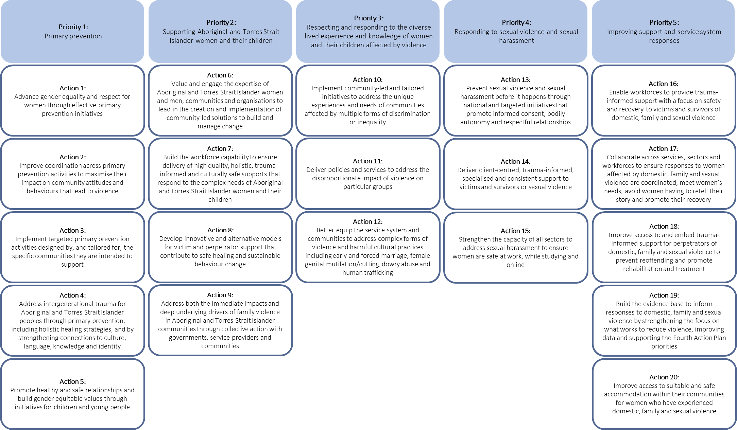

* + 1. Context

The National Plan aims to reduce violence against women and their children in Australia, with a vision that “Australian women and their children live free from violence in safe communities”.[8] The vision is underpinned by six National Outcomes:

* communities are safe and free from violence;
* relationships are respectful;
* Indigenous communities are strengthened;
* services meet the needs of women and their children experiencing violence;
* justice responses are effective; and
* perpetrators stop their violence and are held to account.

These outcomes have been tracked through progress reports which have also reported on the outcomes identified in previous Action Plans. To date, five progress reports have been released tracking progress on the National Plan. The reports have monitored progress with the:

First Action Plan (2010-12 Progress Report);

Second Action Plan (2014-15 and 2015-16 Annual Progress Reports); and

Third Action Plan (2016-17 and 2017-18 Annual Progress Reports).

In addition to Progress Reports, monitoring and assessment of progress of the National Plan and Action Plans has been undertaken through a range of reviews and evaluation activity, including:

* the Progress Review of the First Action Plan;
* the Process Evaluations of the Second and Third Action plans; and
* evaluations of flagship initiatives (including the Respectful Relationships, the review of ANROWS and 1800 RESPECT).

Monitoring and reporting on the National Plan has been challenged with the need to recognise the diverse range of initiatives undertaken, including at the State and Territory level, some of which are captured under the Plan and some of which are not.

To support implementation of the Fourth Action Plan, the Department of Social Services developed a National Implementation Plan which sets out the various initiatives that the Commonwealth, States and Territories will deliver under the Fourth Action Plan and provides information on funding, milestones and intended outcomes. This will assist in more targeted monitoring and reporting of the more than initiatives contained in the Fourth Action Plan and form the basis of future annual progress reporting.

The Department’s National Implementation Plan also responds to the findings of the Australian National Audit Office’s (ANAO) June 2019 Performance Audit Report[9] which noted that performance monitoring and reporting under the National Plan was not sufficient to provide assurance that governments are on track to achieve the National Plan’s objectives and outcomes.

The interplay and connection between the National Plan, the Fourth Action Plan and the National Implementation Plan is outlined in Figure 19.

*Figure 19: Connection between the National Plan, Fourth Action Plan and the Implementation Plan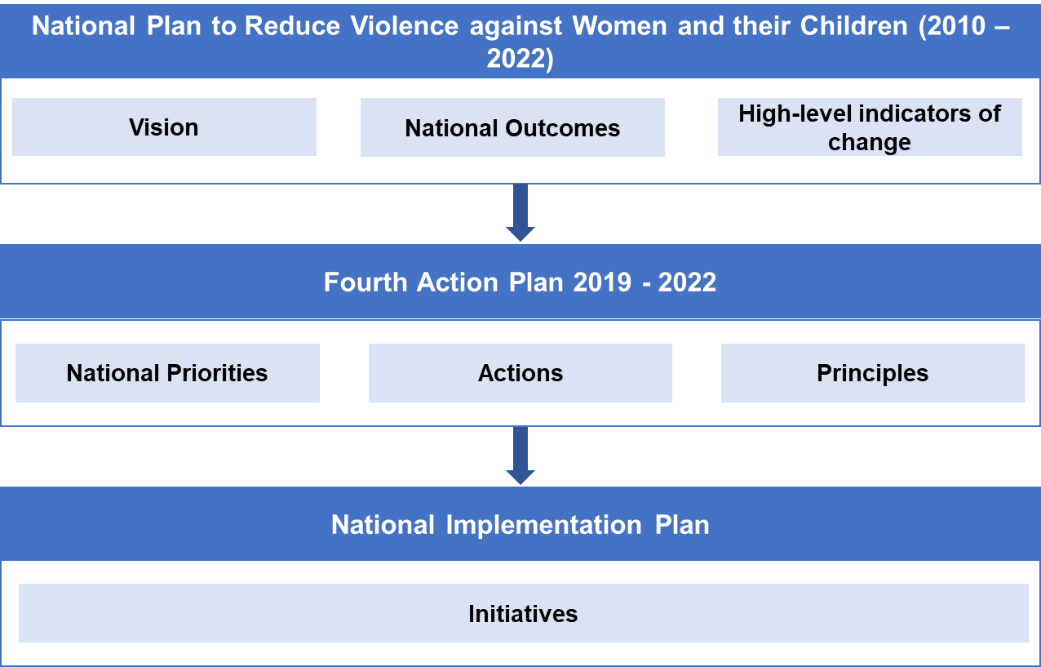*

*Source: Department of Social Services, National Plan to Reduce Violence against Women and their Children: Implementation Plan*

* 1. Purpose and scope
     1. Purpose of the Performance Monitoring and Reporting Framework

Performance monitoring and reporting frameworks are key to promoting transparency and accountability for the expenditure of public funds on services and programs provided to the general community. Performance monitoring frameworks support the evaluation of the Fourth Action Plan and measuring and monitoring of progress with implementation of initiatives which supports continual improvement, informs future policy development and helps create value for all stakeholders and the broader community.

The objectives of this Performance Monitoring and Reporting Framework are to:

* support the evaluation of the National Plan, which incorporates an evaluation of the Fourth Action Plan
* support an assessment of progress in a public annual progress report in relation to the priorities and actions outlined in the Fourth Action Plan;
* enable monitoring of a diverse range of initiatives funded under the Fourth Action Plan including large scale prevention campaigns and direct service provision;
* report the development of the evidence base for violence against women and their children and specific evaluations that are underway to inform the evidence;
* facilitate a consistent approach to the collection, monitoring and analysis of reporting data; and
* report on outcomes under the National Plan.

This objectives of the Frameworks also align to the three key recommendations contained in the 2019 Performance Audit Report:

* the Department identify and develop new measures of success, data sources and specific outcomes for the Fourth Action Plan, and any future National Plan;
* that the Department works with the states and territories to plan evaluations of individual services and programs funded across jurisdictions under action plans to inform an outcome evaluation of the Fourth Action Plan and overall National Plan; and
* that public annual progress reports for the Fourth Action Plan document the status of each action item and the outcomes of the National Plan as a whole.[10]
  + 1. Scope of the Performance Monitoring and Reporting Framework

The Performance Monitoring and Reporting Framework has been developed to provide a more comprehensive view of the various contributions of specific activities to achieving the objectives set out in the Fourth Action Plan. The Framework clearly sets out the outputs associated with each action, allowing an assessment to be made as to whether something has been implemented. In addition, for the first time, the Framework steps through the short-term and medium-term outcomes that are associated with each action, articulating the results that are expected if the action is successfully achieved. The categories include:

* Priorities – set out broad objectives- description in 4AP
* Actions, which are the processes, tools and events that are used to bring about a program’s identified changes – which are mapped to priorities
* Outputs which are the direct product of actions and may include “types, levels and targets of services to be delivered by the program;”[11] and
* Outcomes which relate to the intended achievements of a program, with this Framework setting out short-term (one to three year period) and medium-term outcomes (three to five year period).

It also considers the high-level outcomes that have been in place since the commencement of the National Plan.

The complete mapping of actions under the Fourth Action Plan to their respective outputs, short- and medium-term outcomes, and National Plan outcomes can be found in a series of program logics at 1.3 Program Logics.

The components of the Performance Monitoring and Reporting Framework are detailed in Figure 20 below.

*Figure 20: Components of the Fourth Action Plan Monitoring and Reporting Framework*

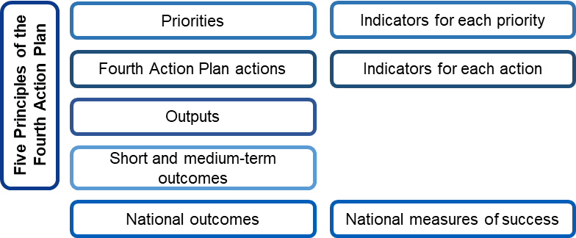

The scope of the Framework includes: :

* the five priorities outlined in the Fourth Action Plan including actions aligned with the priority areas under the National Implementation Plan and the 164 initiatives, headline indicators, measures and indicators for each action;
* financial investment under the Fourth Action Plan (where data is available); and
* outcomes and indicators of success under the National Plan.

Methodology for developing the Framework

Approach

* + 1. Engagement with national data custodians

Reflecting the breadth of activities covered under the Fourth Action Plan, a large number of outputs and outcomes were initially developed and then refined.

Consultation was facilitated with a range of government stakeholders from all jurisdictions to seek feedback on the logic underpinning the preliminary Performance and Monitoring Framework, identify gaps, and understand any suggested refinements.

A corresponding set of measures is under development and will be available following further refinement. This work includes considering new and emerging data sources. The measures and associate data sources are being worked up in consultation with major national research institutes, including:

* Australian Institute of Health and Welfare (AIHW);
* Australian Bureau of Statistics (ABS); and
* Australian Institute of Criminology (AIC).
* Australia's National Research Organisation for Women's Safety (ANROWS).
  + 1. Data availability and sources

The Framework will feature a range of data, including administrative quantitative data as well as other information and data sources obtained from Commonwealth, state and territory governments and major data organisations.

It is anticipated that there will be comprehensive qualitative data from the National Implementation Plan which details over 160 initiatives (at November 2019, 164 initiatives[12]) under the Fourth Action Plan across jurisdictions. Data collection will evolve over the course of monitoring the Fourth Action Plan. For quantitative data, the most contemporaneous data will be relied upon. Where available, time series data will be used, ideally stretching back to five years before the commencement of the National Plan (i.e. 2005). Changes over time will be reported, including statistically significant changes where this is possible to identify.

In its compendium of domestic, family and sexual violence data, the AIHW identified various gaps in the data which means that the knowledge base is still under-developed and the collective understanding of domestic, family and sexual violence and what works is incomplete.[13] While there are robust and timely metrics for measuring the prevalence of intimate partner violence, existing data sources are more limited when exploring issues such as:

* violence in a family relationship;
* sexual violence;
* prevalence and impact on vulnerable populations; and
* more complex forms of domestic, family and sexual violence (such as violence affecting Aboriginal and Torres Strait Islander women and children, and women with a disability).

Data and research on victims (and perpetrators) access to generalist and specialist services also remains an underdeveloped area. It is anticipated that data gaps will be identified through the framework.

* + 1. Refining the Framework

It should be noted that consultation is an ongoing and iterative process which will assist in further refining number of indicators and in finalising the measures and data sources. Reporting will also need to be cognisant of the availability of data noting that not all the proposed measures and indicators have data available to support reporting.

* 1. Program logics

The program logics that have undergone a process of refinement following discussion with state and territory stakeholders are detailed below.

*Figure* 21*: Interim outcomes and outputs for Actions 1 - 5 under Priority 1 of the Fourth Action Plan*

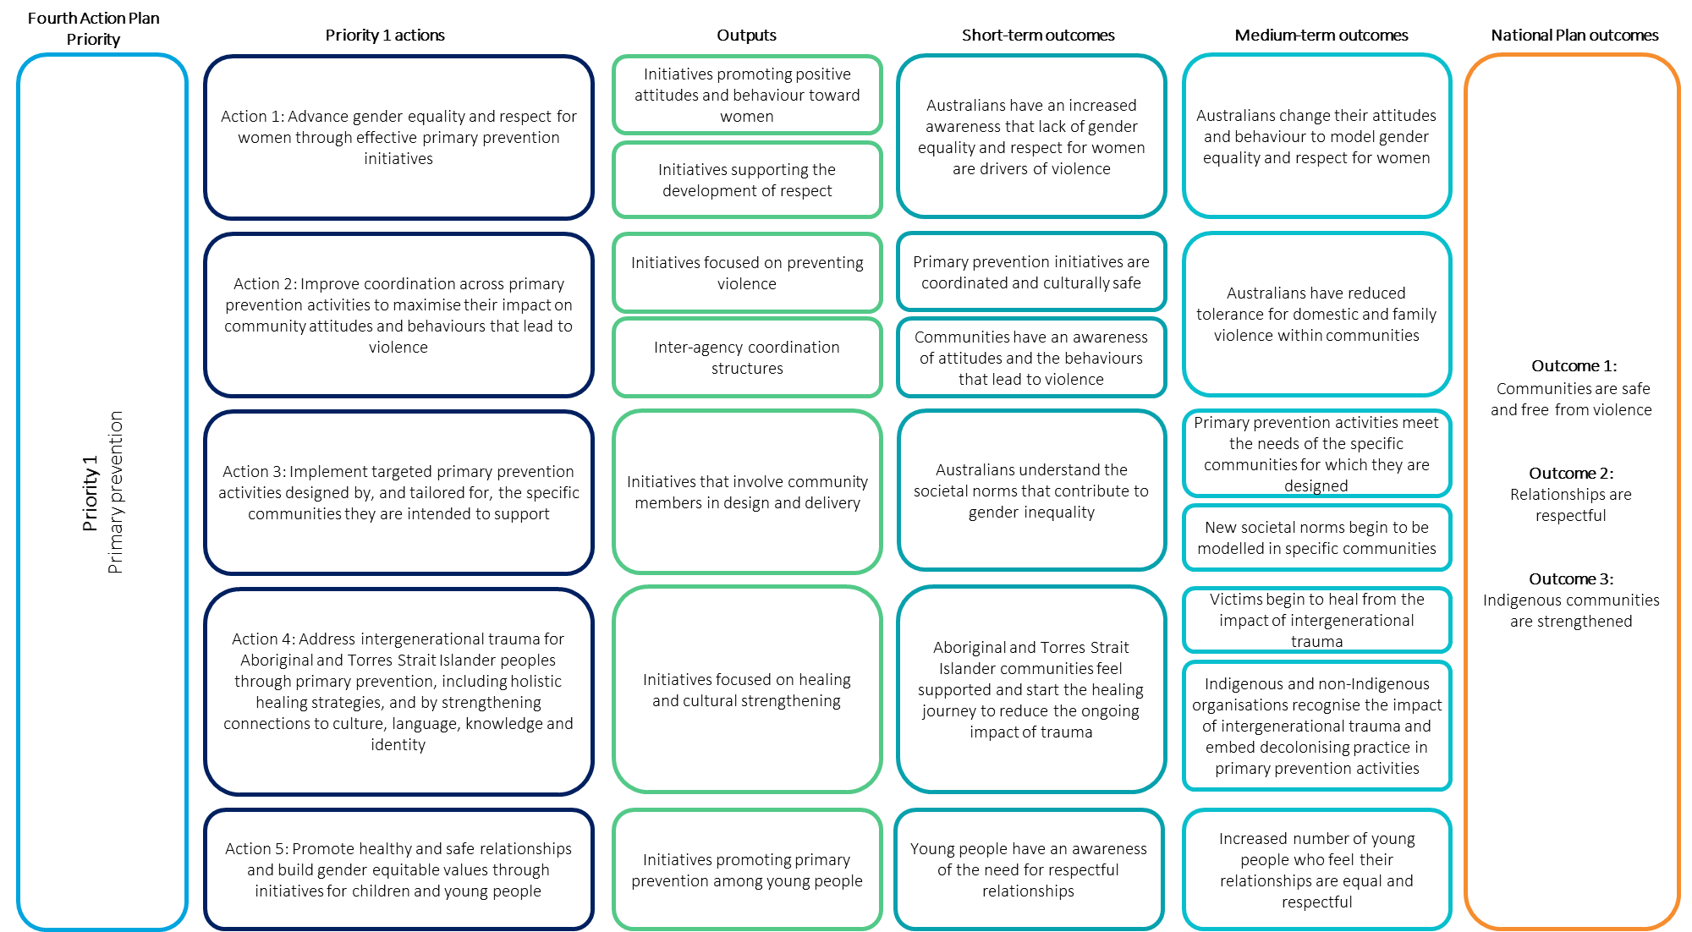

*Figure 22: Interim outcomes and outputs for Actions 6-9 under Priority 2 of the Fourth Action Plan*

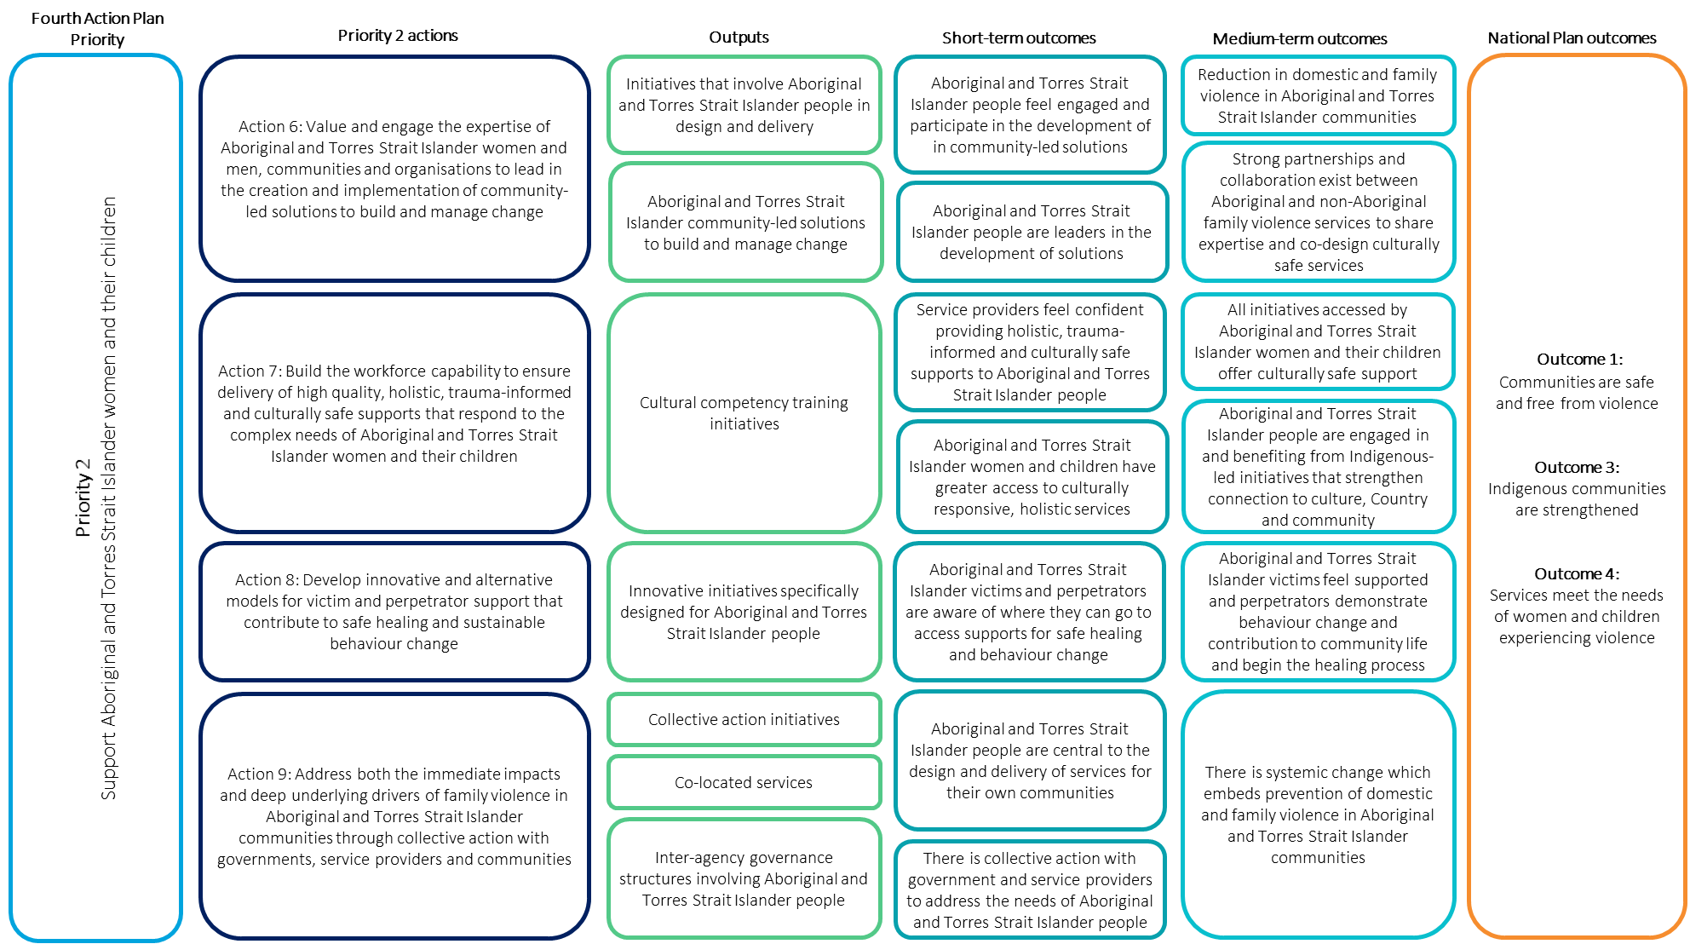

*Figure 23: Interim outcomes and outputs for Actions 10-12 under Priority 3 of the Fourth Action Plan*

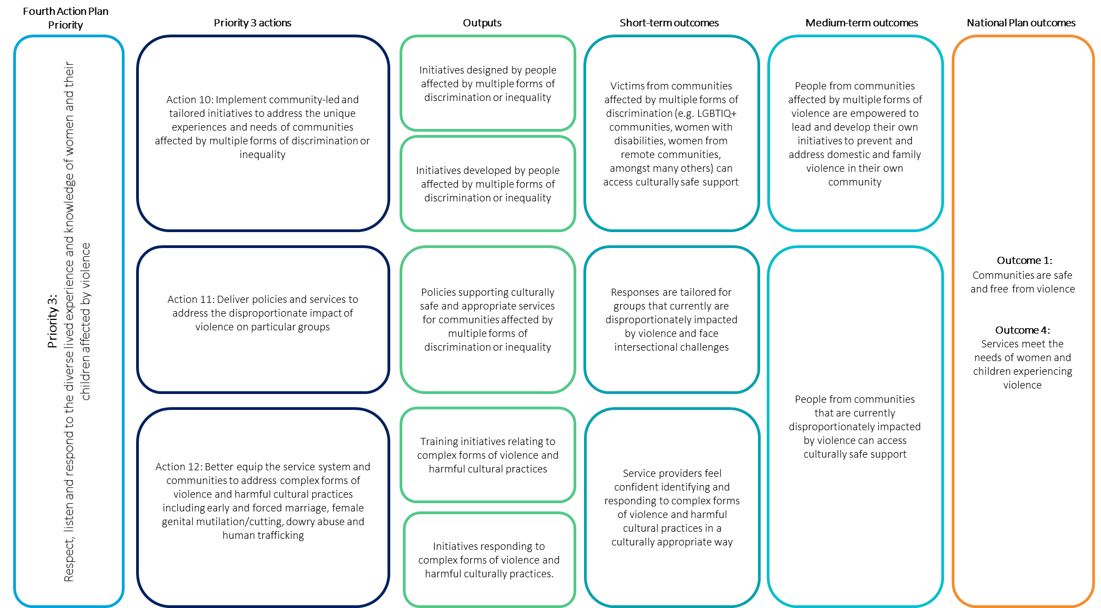

*Figure 24: Interim outcomes and outputs for Actions 13-15 under Priority 4 of the Fourth Action Plan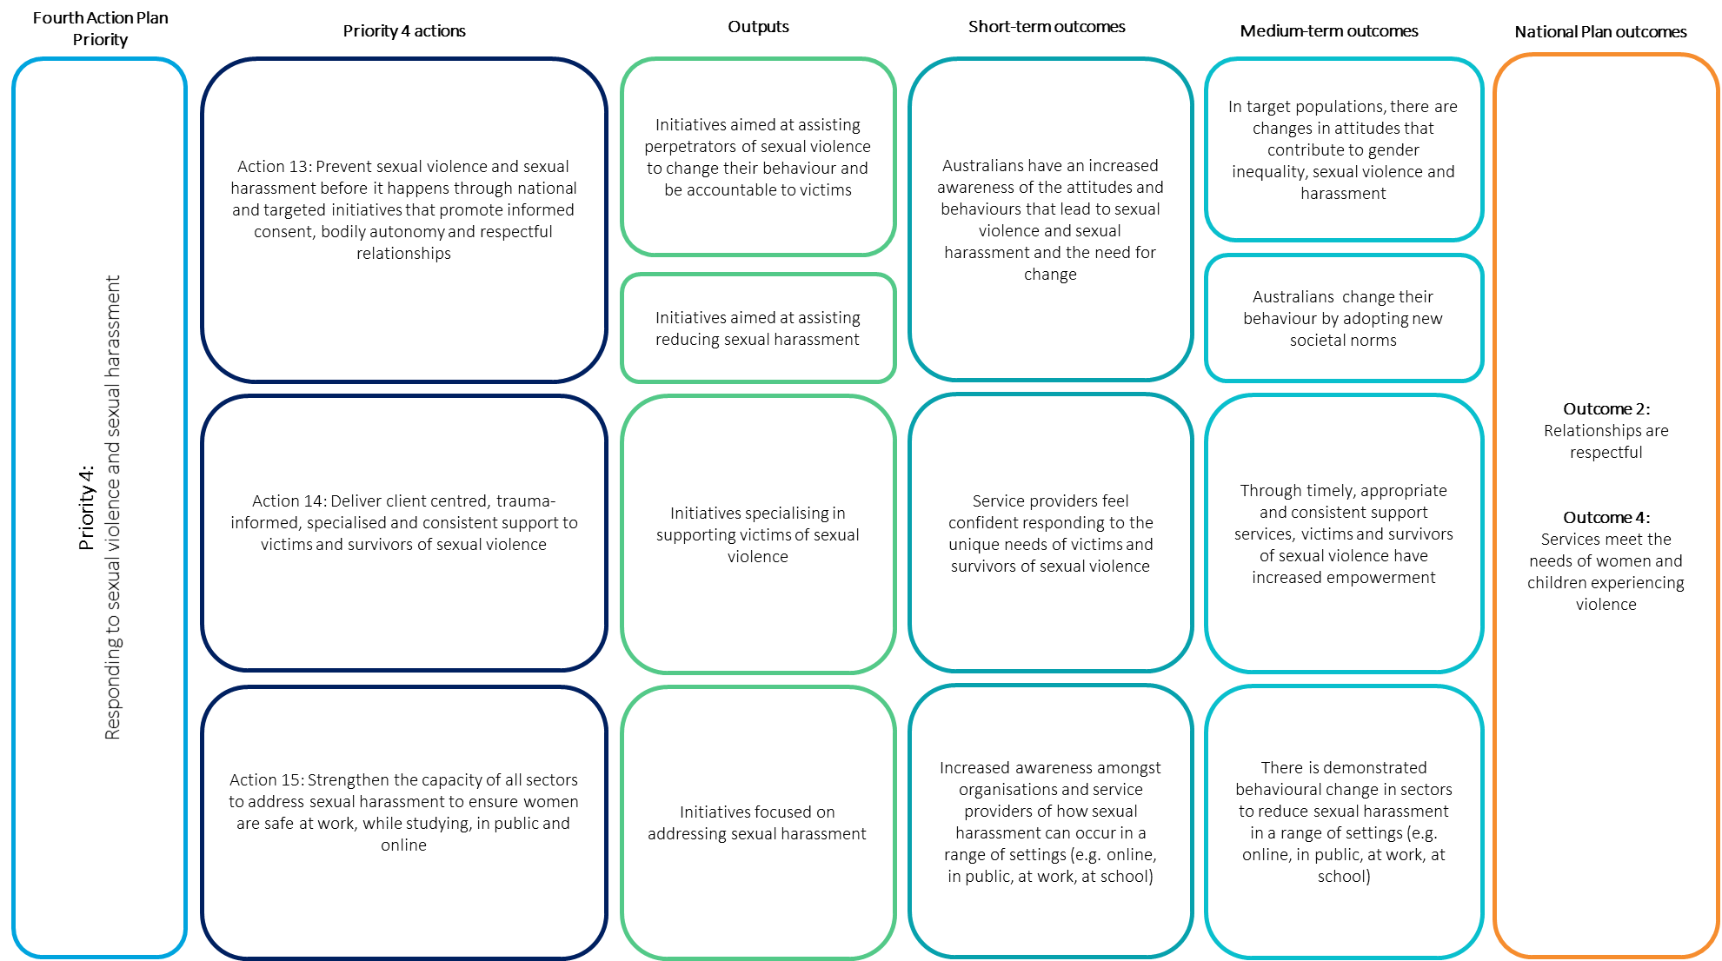*

*Figure 25: Interim outcomes and outputs for Actions 16-20 under Priority 5 of the Fourth Action Plan*

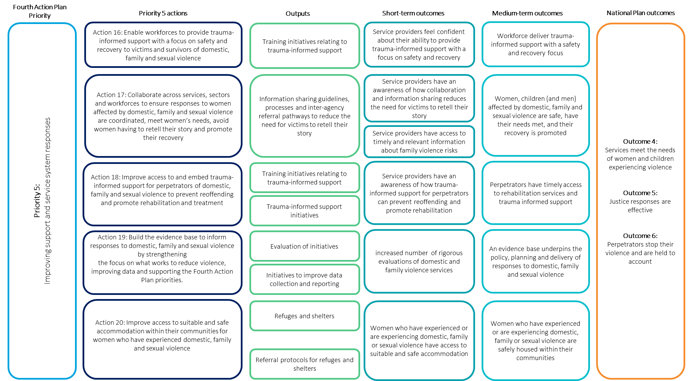

* 1. Priorities, actions and indicators

This section details each of the priority areas as well as the associated actions and indicators.

The process for identifying appropriate indicators for monitoring of each action in this Framework considered the limitations in the evidence base and current data collection practices, as this was crucial to the development of an effective and practical Framework that could be used to support progress reporting over the rest of the term of the Fourth Action Plan. The Framework also considered the recommendations of the ANAO Performance Audit Report and includes new outcomes and measures of success. Once the measures are finalised it will include new data sources.

The tables below highlight each priority and the associated action and indicators. It also highlights the type of whether this relates to outputs or outcomes. This will be worked-up further to include measures and data sources.

*Table 2: Priority 1 actions and indicators underpinning the Framework*

| **Priority** | **Action** | **Indicator** | **Type of measure** |
| --- | --- | --- | --- |
| Primary prevention is key | Advance gender equality and respect for women through effective primary prevention initiatives | Effective initiatives are in place promoting positive (i.e. supportive and respectful) attitudes and behaviour towards women | Output |
| Output |
| Effective initiatives are in place promoting gender equality | Output |
| Increase in positive attitudes and respectful behaviour towards women | Short-term outcome |
| Decrease in negative attitudes towards gender equality | Short-term outcome |
| Short-term outcome |
| Decrease in violence enabling attitudes (e.g. condoning violence against women, rigid gender stereotypes) | Short-term outcome |
| Short-term outcome |
| Increase in awareness of the various forms of domestic, family and sexual violence | Short-term outcome |
| Short-term outcome |
| Increase in gender equality, including an increase in the number and quality of opportunities afforded to women | Medium-term outcome |
| Medium-term outcome |
| Medium-term outcome |
| Improve coordination across primary prevention activities to maximise their impact on community attitudes and behaviours that lead to violence | Effective services that have and use formal inter-agency and network coordination structures are in place | Output |
| Output |
| Medium-term outcome |
| Implement targeted primary prevention activities designed by, and tailored for, the specific communities they are intended to support | Effective primary prevention activities that are designed and tailored to meet the needs of communities are in place | Output |
| Output |
| Address intergenerational trauma for Aboriginal and Torres Strait Islander peoples through primary prevention, including holistic healing strategies, and by strengthening connections to culture, language, knowledge | Effective healing and cultural strengthening initiatives (e.g. women’s groups, arts and crafts activities, storytelling and facilitating taking people out on country) are in place | Output |
| Short-term outcome |
| Promote healthy and safe relationships and build gender equitable values through initiatives for children and young people | Effective prevention initiatives targeted at children and young people are in place | Output |
| Output |
| Increase in positive attitudes and respectful behaviour towards women among young people | Short-term outcome |
| Short-term outcome |
| Decrease in the proportion of children and young people behaving abusively in relationships with their family, peers and colleagues | Medium-term outcome |

*Table 3: Priority 2 actions and indicators underpinning the Framework*

| **Priority** | **Action** | **Indicator** | **Type of measure** |
| --- | --- | --- | --- |
| Supporting Aboriginal and Torres Strait Islander women and their children | Value and engage the expertise of Aboriginal and Torres Strait Islander women and men, communities and organisations to lead in the creation and implementation of community-led solutions to build and manage change | Effective initiatives that are designed and/or implemented with members of Aboriginal and Torres Strait Islander organisations and communities are in place | Output |
| Output |
| Build the workforce capability to ensure delivery of high quality, holistic, trauma-informed and culturally safe supports that respond to the complex needs of Aboriginal and Torres Strait Islander women and their children | Increase in the capability of the workforce to provide high quality, holistic, trauma-informed and culturally safe support that effectively services the needs of Aboriginal and Torres Strait Islander women and children | Output |
| Output |
|
| Develop innovative and alternative models for victim and perpetrator support that contribute to safe healing and sustainable behaviour change | Effective initiatives that use innovative approaches to meet the needs of Aboriginal and Torres Strait Islander victims are in place | Output |
| Output |
| Effective initiatives that use innovative approaches to meet the needs of Aboriginal and Torres Strait Islander perpetrators are in place | Output |
| Effective culturally safe supports for Aboriginal and Torres Strait Islander women and their children are in place | Output |
| Output |
| Sustained behaviour change in service users resulting from their involvement in innovative initiatives | Medium-term outcome |
| Address both the immediate impacts and deep underlying drivers of family violence in Aboriginal and Torres Strait Islander communities through collective action with governments, service providers and communities | Effective collective action initiatives that support empowerment of Aboriginal and Torres Strait Islander communities and people are in place | Output |
| Output |
| Output |
| Output |

*Table 4: Priority 3 actions and indicators underpinning the Framework*

| **Priority** | **Action** | **Indicator** | **Type of measure** |
| --- | --- | --- | --- |
| Respecting and responding to the diverse lived experience and knowledge of women and their children affected by violence | Implement community-led and tailored initiatives to address the unique experiences and needs of communities affected by multiple forms of discrimination or inequality | Effective initiatives that are designed and/or implemented for people affected by multiple forms of discrimination or inequality are in place | Output |
| Output |
| Increased capability of workers to meet the needs of clients | Output |
| Output |
| Increase in the proportion of the domestic, family and sexual violence workers who feel well equipped to meet client needs | Short-term outcome |
| Short-term outcome |
| Short-term outcome |
| Deliver policies and services to address the disproportionate impact of violence on particular groups | Decrease in the prevalence of violence among particular groups affected by multiple forms of discrimination or inequality | Output |
| Output |
| Medium-term outcome |
| Medium-term outcome |
| Decrease in the number of victims who have a reported domestic and family violence incident within 12 months of the first reported incident | Medium-term outcome |
| Better equip the service system and communities to address complex forms of violence and harmful cultural practices including early and forced marriage, female genital mutilation/cutting, dowry abuse and human trafficking | Increase in the capacity of the service system to understand and respond to complex forms of violence and harmful cultural practices | Output |
| Output |
| Output |
| Output |
| Output |
| Short-term outcome |

*Table 5: Priority 4 actions and indicators underpinning the Framework*

| **Priority** | **Action** | **Indicator** | **Type of measure** |
| --- | --- | --- | --- |
| Responding to sexual violence and sexual harassment | Prevent sexual violence and sexual harassment before it happens through national and targeted initiatives that promote informed consent, bodily autonomy and respectful relationships | Effective national and targeted initiatives that aim to reduce prevalence of sexual violence and harassment are in place | Output |
|
| Short-term outcome |
| Output |
| Output |
| Output |
| Increase in the proportion of workers who identify as feeling confident that they can recognise signs of sexual abuse | Output |
| Decrease in the prevalence of attitudes that support sexual violence and/or sexual harassment | Short-term outcome |
| Short-term outcome |
| Short-term outcome |
| Short-term outcome |
| Deliver client-centred, trauma-informed, specialised and consistent support to victims and survivors of sexual violence | Victims and survivors can access specialised, timely and consistent support | Output |
|
| Output |
|
| Output |
| Strengthen the capacity of all sectors to address sexual harassment to ensure women are safe at work, while studying, in public and online | Increase in the capacity of all sectors to prevent, address and respond to sexual harassment | Output |
|
| Output |
|

*Table 6: Priority 5 actions and indicators underpinning the Framework*

| **Priority** | **Action** | **Indicator** | **Type of measure** |
| --- | --- | --- | --- |
| Improving support and service system responses | Enable workforces to provide trauma-informed support with a focus on safety and recovery to victims and survivors of domestic, family and sexual violence | Effective services equipped to provide trauma-informed support to victims and survivors of family, domestic and sexual violence are in place | Output |
| Output |
| Output |
| Output |
| Short-term outcome |
| Short-term outcome |
| Short-term outcome |
| Collaborate across services, sectors and workforces to ensure responses to women affected by domestic, family and sexual violence are coordinated, meet women’s needs, avoid women having to retell their story and promote their recovery | Improve system responses for victims and their children through the use of interagency and collaborative network structures | Output |
|
| Output |
| Output |
| Output |
| Output |
| Increase in the positive experience of users accessing support services for domestic, family and sexual violence | Output |
| Short-term outcome |
| Improve access to and embed trauma-informed support for perpetrators of domestic, family and sexual violence to prevent reoffending and promote rehabilitation and treatment | Increase in the availability of trauma-informed support for perpetrators of domestic, family and sexual violence | Output |
|
| Increase in the number of perpetrators of domestic, family and sexual violence accessing trauma-informed support | Output |
|
| More perpetrators seek help and receive an intervention | Output |
| Increase in the proportion of workers in the domestic, family and sexual violence support services who are in contact with perpetrators and feel well equipped to for various aspects of their practice with perpetrators | Short-term outcome |
| Decrease in reoffending rates for perpetrators of domestic, family and sexual violence | Medium-term outcome |
|
| More perpetrators face a consequence when they commit violence | Medium-term outcome |
| Medium-term outcome |
| Medium-term outcome |
| Increase in perpetrators who successfully complete a behaviour change initiative | Output |
| Medium-term outcome |
| Medium-term outcome |
| Decrease in re-victimisation rates | Medium-term outcome |
|
|
| Build the evidence base to inform responses to domestic, family and sexual violence by strengthening the focus on what works to reduce violence, improving data and supporting the Fourth Action Plan priorities | Increase in level of evidence available which underpins the design of effective responses to domestic, family and sexual violence | Output |
|
| Output |
| Output |
| Short-term outcome |
| Short-term outcome |
| Improve access to suitable and safe accommodation within their communities for women who have experienced domestic, family and sexual violence | Increase in the number of available, local, suitable, and safe accommodation options for women who have experienced domestic, family, and sexual violence | Output |
| Output |
| Increase in the number of victims and families who progress from crisis supports for homelessness to stable accommodation | Short-term outcome |
| Short-term outcome |
| Short-term outcome |

Glossary

|  |  |
| --- | --- |
| Acronym | Definition |
| ABS | Australian Bureau of Statistics |
| AIC | Australian Institute of Criminology |
| AIHW | Australian Institute of Health and Welfare |
| ANAO | Australian National Audit Office |
| BOCSAR | Bureau of Crime Statistics and Research |
| COAG | Council of Australian Governments |
| Department | Department of Social Services |
| DFV | Domestic and Family Violence |
| ImpEG | National Plan Implementation Executive Group |
| LGBTIQ | Lesbian, gay, bisexual, transgender, intersex or queer |
| National Plan | National Plan to Reduce Violence against Women and their Children 2010–2022 |

1. Australian Government, Department of Social Services, 2020, National Plan to Reduce Violence against Women and their Children, available at: <https://plan4womenssafety.dss.gov.au/the-national-plan/what-is-the-national-plan/>
2. Australian Institute of Family Studies (2021), ‘Responding to increasing and changing client needs in crises’, 3 June, available at <https://aifs.gov.au/cfca/2021/06/03/responding-increasing-and-changing-client-needs-crises>.
3. The latest Recorded Crime -Victims publication was released 24/06/2021. Experimental FDSV data is publicly reported, the most recent Recorded Crime - Offenders publication was released 11/02/2021.
4. Quadara, A., El-Murr, A., Douglas, W., & Muir, S. (2019). *Process Evaluation of the Third Action Plan 2016-19.* Canberra: Australian Institute of Family Studies.
5. Research from the Queensland Domestic and Family Violence Death Review and Advisory Board indicates that a history of violence may have been established in about three-fifths of domestic and family homicides. The Australian Domestic and Family Violence Death Review Network released a data report in 2018 examining 152 intimate partner homicides that occurred in the context of domestic violence between 2010 and 2014.
6. Australian Bureau of Statistics. (2017). Personal Safety Survey (cat. no. 4906.0). Canberra: ABS.
7. Department of Social Services, Fourth Action Plan, National Plan to Reduce Violence against Women and their Children 2010 – 2022, 2019, <https://www.dss.gov.au/sites/default/files/documents/08_2019/fourth_action-plan.pdf>
8. Australian Government, Department of Social Services, 2020, National Plan to Reduce Violence against Women and their Children, available at: <https://plan4womenssafety.dss.gov.au/the-national-plan/what-is-the-national-plan/#:~:text=Its%20vision%20is%20that%3A,against%20women%20and%20their%20children.>
9. Australian National Audit Office, Auditor General Report No. 45 2018-19, Coordination and Targeting of Domestic Violence Funding and Actions
10. Australian National Audit Office, Auditor General Report No. 45 2018-19, Coordination and Targeting of Domestic Violence Funding and Actions
11. NSW Government, Evidence and Evaluation Guidance Series Population and Public Health Division, Develop and Using Program Logic: A Guide, available at: <https://www.health.nsw.gov.au/research/Publications/developing-program-logic.pdf>
12. Australian Government, National Plan to Reduce Violence Against Women and their Children, Implementation Plan Initiatives, available at: <https://plan4womenssafety.dss.gov.au/implementation-plan/initiatives/>
13. Australian Institute of Health and Welfare. (2019). *Family, domestic and sexual violence in Australia: continuing the national story 2019*. Cat. no. FDV 3. Canberra: AIHW.