JUDITH LUMLEY CENTRE
for mother, infant and family health research

Department of nursing
and midwifery

Primary Prevention of Sexual Violence and Harassment Against Women and Girls: Combining Evidence and Practice Knowledge

Final Report and Theory of Change

Dr Leesa Hooker
Dr Jessica Ison
Assoc. Professor Nicola Henry
Assoc. Professor Christopher Fisher
Dr Kirsty Forsdike
Felicity Young
Hannah Korsmeyer
Dr Grant O’Sullivan
Professor Angela Taft

 | ENQUIRIES  Dr Leesa Hooker  Senior Research Fellow  La Trobe University  Victoria 3086 | T + 61 3 5444 7984  E l.hooker@latrobe.edu.au  latrobe.edu.au

Acknowledgement of country
The researchers would like to acknowledge the Traditional Owners of the lands across Australia on which we live and work. We pay respect to Elders past and present.
Funding acknowledgement
This material was produced with funding from the Australian Government Department of Social Services in 2020-21. The researchers would like to express gratitude for the funding and the ongoing commitment to sexual violence primary prevention. The findings and views reported in this paper are those of the authors and cannot be attributed to the Australian Government Department of Social Services.
Suggested citation: Hooker, L., Ison, J., Henry, N., Fisher, C., Forsdike, K., Young, F., Korsmeyer, H., O’Sullivan, G., & Taft, A. (2021). Primary Prevention of Sexual Violence and Harassment Against Women and Girls: Combining Evidence and Practice Knowledge - Final Report and Theory of Change. La Trobe University.

Contents
Project Team Members 5
Research Team 5
Advisory Group 5
List of Acronyms 6
Definitions 7
Note on Terminology 8
Introduction & Aims 9
Understanding SVH in Australia 10
What is Primary Prevention? 11
Putting a Spotlight on the Primary Prevention of SVH 12
Scope of the Project 13
Sector Consultations 13
Key findings – Evidence Review and Data Analysis/Synthesis 14
Key Findings – Sector and Expert Consultation 17
Theory of Change 22
Why a Theory of Change? 22
Guiding Principles to SVH Primary Prevention Research 23
Problem Statement 24
Barriers to Primary Prevention 25
Narrative Theory of Change 27
Conceptual Framework 28
Promoting Early Supportive Relationships 30
Education for Behaviour Change 34
Safe Environments 38
Transform Social Norms 42
Policy and Reform 46
Conclusion 49
Future Research Recommendations 50
Appendices 52
Appendix I – Gendered Drivers and Reinforcing Factors 52
References 53

List of Figures
Figure 1 - Theory of Change 27
Figure 2 - Early supportive relationships 29
Figure 3 - Education for behaviour change 33
Figure 4 - Safe environments 37
Figure 5 - Transform social norms 41
Figure 6 - Policy and reform 45

Project Team Members
Research Team
- Dr Leesa Hooker, Lead Investigator
- Dr Jessica Ison, Project Manager
- Associate Professor Nicola Henry, Investigator
- Associate Professor Christopher Fisher, Investigator
- Dr Kirsty Forsdike, Investigator
- Felicity Young, Sector Consultation Manager
- Hannah Korsmeyer, Co-Design
- Dr Grant O’Sullivan, Research Assistant
- Professor Angela Taft, Investigator
Advisory Group
- Dr Adele Murdolo, Multicultural Centre for Women’s Health
- Claire Pirrett, NT Working Women’s Centre
- Dagmar Jenkins, South East CASA
- Associate Professor Debbie Ollis, Deakin University
- Dr Dominiek Coates, ANROWS
- Emily Corbett, PhD Student, La Trobe University
- Dr Emma Fulu, The Equality Institute
- Dr Emma Partridge, Our Watch
- Heather Clarke, National Association of Services Against Sexual Violence (NASASV)
- Dr Laura Tarzia, Melbourne University
- Lauren Jones, Australian Human Rights Commission
- Associate Professor Michael Flood, Queensland University of Technology
- Associate Professor Michael Salter, University of New South Wales
- Samantha Fredericks, On the Line/ MensLine Australia
- Starlady, Zoe Belle Gender Collective – cohealth
- Tina Dixson, Australian Women Against Violence Alliance (AWAVA)
- Professor Victoria Hovane, Psychologist and Consultant

List of Acronyms
Acronym
ABS | Australian Bureau of Statistics
AHRC | Australian Human Rights Commission
AIHW | Australian Institute of Health and Welfare
ANROWS | Australia’s National Research Organisation for Women’s Safety
LGBTIQ | Lesbian, Gay, Bisexual, Transgender, Intersex, Queer
PSS | Personal Safety Survey
RRE | Respectful Relationships Education
SVH | Sexual violence and harassment
VAW | Violence against women
WHO | World Health Organization
Definitions
This project will use the following definitions:
Sexual Violence
Sexual violence may include (but is not limited to) rape, sexual assault, indecent assault, sexual coercion, being forced to watch or engage in pornography, enforced prostitution, sex trafficking, unwanted touching, and the non-consensual sharing of intimate images (Australian Institute of Health and Welfare [AIHW], 2019).
Sexual Harassment
The Sex Discrimination Act 1984 (Cwlth) defines sexual harassment as any unwelcome sexual advance, request for sexual favours or conduct of a sexual nature in relation to the person harassed in circumstances where a reasonable person would have anticipated the possibility that the person harassed would be offended, humiliated or intimidated (Australian Human Rights Commission [AHRC], 2020b).
Technology-Facilitated Sexual Violence
Technology-facilitated sexual violence (TFSV) involves the use of digital technologies and platforms to perpetrate sexually aggressive or harassing behaviours. It includes rape threats, online stalking, the use of an app or platform to set up an in-person rape or sexual assault, and image-based sexual abuse (Henry & Powell, 2018; Powell & Henry, 2017). Image-based sexual abuse refers to the non-consensual taking or sharing of nude or sexual images. It can include: taking a sexually intrusive photograph up someone’s skirt (commonly referred to as “upskirting”); threats to share nude or sexual images to obtain money or sexual images (known as “sextortion”); the use of artificial intelligence or other digital tools to make fake pornography (to make it look as if the person is engaging in a sexual act or posing nude (Henry et al., 2020). TFSV is a common tactic used by perpetrators of family violence (Douglas et al., 2019). It can also be perpetrated by strangers, friends, colleagues or others known to the victim–survivor (Powell & Henry, 2017).

Primary Prevention
This report uses the definition of primary prevention outlined in Change the Story: A shared framework for the primary prevention of violence against women and their children in Australia, which defines primary prevention as “whole-of-population initiatives that address the primary (‘first’ or underlying) drivers of violence” (Our Watch et al., 2015, p. 15)
Note on Terminology
The terminology in this report is as inclusive as possible. However, as with any national report that uses collective terms, the range of people and identities across Australia are not captured in their entirety. Unless referring to research that uses different terminology, this report will use the following:
- Aboriginal and Torres Strait Islander: This report follows the definition laid out in Changing the Picture (Our Watch, 2018) where the term ‘Aboriginal and Torres Strait Islander people’ includes “Aboriginal peoples, Torres Strait Islander peoples and people with both Aboriginal and Torres Strait Islander heritage... [or] [o]n occasion, in keeping with international human rights language … the term ‘Indigenous’ to include both Aboriginal and Torres Strait Islander people and communities, or to differentiate between Indigenous and non-Indigenous people and organisations”.
- Cisgender: A person who identifies as the gender they were assigned at birth.
- Family/families: Someone of significance in a person's life. This includes any person identified as a member of someone's family, including people who are not legally related.
- LGBTIQ: Used to refer to the broader lesbian, gay, bisexual, transgender, intersex and queer communities. However, we note that some communities may have different ways of describing themselves or their communities. Where appropriate, the chosen term for any identity will be used.
- Transgender: A person who identifies as a gender other than that assigned at birth.
- Women/woman/girl: Anyone who identifies as female.
- Women and girls with disabilities: this recognises the social model of disability—that people are disabled by social barriers—as well as a ‘person-first’ approach (i.e., “women and girls with disabilities”).

Introduction & Aims
‘Sexual violence’ is an umbrella term used to describe physical and non-physical forms of violence of a sexual nature, carried out against a person’s will. Sexual violence and harassment (SVH) exist on a spectrum of violence against women and girls. SVH can be a single instance, or it can be experienced in a variety of ways across a woman’s life, and the perpetrator is most often known to the woman, including, for example, from a family member, acquaintance or partner (AIHW, 2018). Intimate partner sexual violence can be used alongside other tactics of family violence (Australia’s National Research Organisation for Women’s Safety [ANROWS], 2019). The risk of SVH over a woman’s life can impact on her mobility, how she navigates within the community, the workplace, and in the family and relationships. To engage with this complexity, it is necessary for research to consider options for SVH primary prevention across all the mechanisms that drive, facilitate and support SVH offending within a wide range of settings. Primary prevention of SVH refers to a whole-of-population approach that addresses the underlying causes of SVH and stopping it before it starts.
Under the National Plan to Reduce Violence against Women and Their Children 2010–2022 (Council of Australian Governments, 2011), the Australian Government is committed to a program of work focused on the prevention of violence against women (VAW), with sexual violence as a key priority in The Fourth Action Plan (2019–2022).
The Australian Government Department of Social Services commissioned this project to identify effective primary prevention SVH interventions and analyse other forms of data that may inform a Theory of Change and future research on the primary prevention of SVH. This project aimed to:
- identify, from the international and national literature, a broad range of high quality evaluated and effective primary prevention strategies that address key drivers and risk factors (at all levels) for sexual violence
explore and prioritise high-risk cohorts/target audience (perpetrators and victims) for policy intervention, assessing barriers and enablers to engaging with primary prevention work
synthesise data to identify the extent of sexual violence, levels of awareness, and attitudes and behaviours in relation to sexual violence
identify Australian SVH data collection and reporting gaps
consult widely with specialist organisations to ensure findings and recommendations are suitable and meaningful to sexual violence service users and providers
develop a SVH primary prevention Theory-of-Change framework with stakeholders and Department of Social Services, including short- and long-term activities.
This research aimed to build on foundational work by Our Watch et al., Change the Story: A shared framework for the primary prevention of violence against women and their children in Australia (2015), Changing the Picture: A national resource to prevent violence against Aboriginal and Torres Strait Islander women and their children (2018) and Men in Focus: Unpacking masculinities and engaging men in the prevention of violence against women (2019b).
One in five women have experienced sexual violence from 15 and fifty-three per cent have experienced sexual harassment in their lifetime (ABS, 2017).
Understanding SVH in Australia
In Australia, the 2016 Personal Safety Survey (PSS) found that one in five women have experienced sexual violence since the age of 15, compared to one in 20 men (Australian Bureau of Statistics [ABS], 2017). Fifty-three per cent of women have experienced sexual harassment in their lifetime compared to 25% of men (ABS, 2017).
Given the gendered nature of sexual violence, this report situates SVH as a gender-based issue. While men do experience SVH from other men and in some instances from women, the majority of SVH is experienced by women and perpetrated by men (Our Watch et al., 2015; World Health Organization, 2013). The most recent report from the AIHW (2020b) stated that up to 97% of perpetrators of sexual violence are men. The report also notes that women account for nine in 10 (93%) cases where the sexual violence victim–survivor was hospitalised (AIHW, 2020b).
Our Watch (2019b, p. 13) states that “gender inequality underpins violence against women. Thus, primary prevention efforts aim to address the gendered drivers of VAW, including the structures, norms and practices that maintain a gender unequal society”. A gender-based approach is warranted to explore interventions to prevent SVH. Therefore, this research focuses on men’s perpetration of SVH towards women and girls from the age of five years. Child sexual abuse prevention for under-fives is an important topic, with far-reaching consequences across a person's life. However, the scope of the work is not focusing on the prevention of child sexual abuse.
The term ‘women and girls’ relates to anyone female-identified, and is used as broadly and inclusively as possible. There is a high prevalence of sexual violence across all settings and intersections of Australian society and one of the leading drivers of sexual violence is gender inequality. However, while it is true that all women and girls can experience sexual violence, women and girls who face intersecting structural inequality can be at heightened risk.
Given the need to address the diversity of women and their breadth of experience, any research into sexual violence must include an intersectional analysis. Specifically, VAW is a gendered issue, however “gender inequality can never be considered in isolation from the other intersecting forms of systemic social, political and economic discrimination and disadvantage that characterise our society, such as racism, ableism, homophobia and transphobia” (Our Watch, 2019a, p. 36). Intersectionality is an important approach for research, as well as a lens through which data can be analysed.
What is Primary Prevention?
Primary prevention is a public health approach designed to prevent violence before it occurs. It comprises whole-of-population initiatives that address the underlying “drivers” or risk factors for VAW including cultural norms, attitudes and behaviours around gender, structural inequalities (e.g., gender inequality, discrimination and poverty) as well as individual-level and community factors (e.g., alcohol and other drug abuse; World Health Organization, 2019). The ‘ecological’ model can be used to frame primary prevention approaches which recognise multiple and interacting factors at the individual/relational, community, organisational and societal level (Heise, 1998; Krug et al., 2002).
This report follows the Change the Story definition for primary prevention, which is: “whole-of-population initiatives that address the primary (“first” or underlying) drivers of violence” (Our Watch et al., 2015, p. 15). While this definition is straightforward, the interpretation of what primary prevention means can vary, and can sit across the broader population, community and individual levels. There can be a fine line between primary and secondary prevention, with the latter referring to prevention among high-risk population groups and approaches that focus on immediate responses to violence (also known as “early intervention”); thereby preventing progression (Flood, 2013; García-Moreno et al., 2015; Krug et al., 2002). However, our focus is on primary prevention. We therefore examined interventions and explored approaches that aim to prevent violence before it occurs and to change the broader societal norms that create gender inequality (Krug et al., 2002).
Putting a Spotlight on the Primary Prevention of SVH
“Preventing sexual violence and harassment needs a comprehensive approach – similar to what we are working towards with domestic and family violence prevention.”
-- Participant
The Fourth Action Plan (2019–2022) of the National Plan outlines five priority areas, one of which is “respond to sexual violence and sexual harassment”. The Fourth Action Plan has a focus on primary prevention and advocating for ending all forms of SVH. To achieve this, the Fourth Action Plan outlines three actions:
- prevent sexual violence and sexual harassment before it happens through national and targeted initiatives that promote informed consent, bodily autonomy and respectful relationships;
- deliver client-centred, trauma-informed, specialised and consistent support to victim–survivors of sexual violence; and
- strengthen the capacity of all sectors to address sexual harassment to ensure women are safe at work, while studying, in public spaces including online.
To achieve primary prevention, we must address the gendered drivers of VAW. To address SVH specifically, stopping perpetration is the central goal. Therefore, “Prevention efforts with a focus on addressing masculinities and engaging men should aim to be gender transformative and actively challenge dominant forms of masculinity rather than reinforcing and maintaining them” (Our Watch, 2019b, p. 13). Men and boys need to be engaged in primary prevention efforts. Primary prevention interventions need to challenge issues such as male belief in their entitlement to sexual gratification, rigid gender roles and male peer-group behaviours. Primary prevention also needs to address broader systemic issues that support individual actions. It is important to note, however, that just as victim–survivors are from across all walks of life, so too are perpetrators. All actions to address perpetration should be intersectional, co-designed and adaptable to the needs of each community.

Scope of the Project
Research Process
To build the evidence base, we drew on our expert Advisory Group, an evidence review, data analysis/synthesis and extensive sector consultation to guide development of this Theory of Change. The evidence showed few effective SVH primary prevention interventions exist (Hooker et al., 2020). With a clear understanding of the global evidence, the research progressed to explore the primary prevention of SVH within the Australian context.
Sector Consultations
To gain a stronger understanding of key factors, we conducted consultations with specialist sexual violence services, women’s sector and key organisations/experts across Australia to gain further insight into SVH primary prevention activities, the experiences and the suggested SVH prevention priorities of service users and providers.
- Targeted areas, in addition to the specialist sexual and family violence sector, were across diverse groups with stakeholders invited to interactive online workshops according to their primary prevention expertise and knowledge, rather than geographical location.
The final 10 key areas of consultation included:
- Sexual Violence Services
- Early Education and Young People (under 18 years old)
- Higher Education and Youth (18–25-year-olds)
- Technology
- Workplace
- Community Groups
- Bystander and Perpetrators
- Legal and Human Rights
- Women’s Health
- National Organisations
Sector consultations were conducted via online co-design workshops. The co-design workshops followed a pre-designed structure, activity tasks, and expert facilitation (Blomkamp, 2018). Remote team collaborative software—Miro—was used. This software allows for visual and interactive collaboration through an online whiteboard platform.
“Actively challenging violence-supporting narratives and culture includes education about respectful relationships, raising awareness about rigid gender norms and supporting a wide range of gender expression as well as ensuring women and people in groups who experience marginalisation are in positions of leadership and decision making.”
--Survey respondent

Key findings – Evidence Review and Data Analysis/Synthesis
This Evidence Review and Data Analysis/Synthesis summary fact sheet (below) should be read in conjunction with Primary prevention of sexual violence and harassment against women and girls: Combining evidence and practice knowledge (Hooker et al., 2020), the background document to the development of the Theory of Change.

Summary
Primary Prevention of Sexual Violence and Harassment Against Women and Girls: Combining Evidence and Practice Knowledge
The aim of the project is to identify effective primary prevention sexual violence and harassment (SVH) interventions at all levels of the ecological model and develop a Theory of Change to guide future research and policy in the primary prevention of SVH.
Evidence Review
Extensive searching identified 4,156 records with 203 relevant records assessed for final inclusion. Following full text review, 97 studies in total met our inclusion criteria, 86 peer-reviewed and 11 from grey literature.
Almost three quarters of the identified evidence (73%) was from the United States of America (USA) primary and secondary interventions combined.
Bystander and dating violence prevention initiatives for young people dominated the field (57%). Only 17% of papers were classified as primary prevention studies.
Peer review findings were synthesised and reported according to the following groups:
- Education-based bystander and other relationship interventions in universities/colleges and schools
- Workplace prevention programs
- Specific men’s programs
- Targeted alcohol interventions
- Parenting interventions
- No Australian-only studies were identified in the peer reviewed literature
- Seven studies were deemed effective at reducing or preventing sexual violence and harassment
- US bystander type education or relationship programs involving young people were the most common intervention evaluated
- Only two studies evaluated sexual harassment
- Aboriginal and Torres Strait Islander women and girls, women and girls with disabilities or migrant and refugee women and girls and LGBTIQ communities were missing from the evidence
Survey Data Analysis
In the 6th National Survey of Australian Secondary Students and Sexual Health almost one third of participants had experienced an unwanted sexual event in their lifetime.
Those more likely to report having had unwanted sex were female, trans and gender diverse and non-heterosexual young people.
Experiences among Australian young people, 14-18 years old, have not yet been examined in depth.
What works to prevent sexual violence and harassment?
- University based bystander program aimed at male students
- University based-single sex women’s empowerment and resistance programs
- Bystander approaches that enhance prosocial intervening behaviours, paired with other SVH education
- Challenging rape myths
- Comprehensive, ‘whole of organisation’ interventions with multi sessions
There is a significant lack of community or societal level interventions, such as whole of community mobilisation programs or government policy to prevent or
reduce SVH.
Funding and investment in longitudinal evaluation studies are needed in future to measure sustained prevention and change.
One in six Australian women over the age of 15 have experienced physical and/or sexual violence by a current or previous partner
Common reasons why students engaged in unwanted sex:
“My partner thought I should”
“I was too drunk at the time”
“I was frightened”

Monitoring sexual violence and harassment
The goal of SVH primary prevention is to reduce the levels of SVH behaviours in the community. Beyond this, primary prevention can target factors that influence SVH behaviours. These factors can include underlying drivers that initiate these behaviours and reinforcing factors that perpetuate them.
Monitoring of SVH prevention strategies through national surveys is preferred.
The National Community Attitudes towards Violence against Women Survey (NCAS), Personal Safety Survey (PSS) and Australian Longitudinal Study on Women's Health (ALSWH) were identified as most effective in monitoring SVH.
Suggest implementing the ABS framework for optimising data collection and reporting for SVH.
Gaps
The following items are missing from the global evidence on the primary prevention of SVH:
- Australian evaluations of primary prevention interventions
- Process evaluations to understand why programs succeed or fail
- Community and society level interventions
- Interventions for specific populations at highest risk —elderly, migrant and refugee population, LGBTIQ communities, Aboriginal and Torres Strait Islander women and girls, women and girls with disabilities, rural and remote women and girls
- Behaviour change measurement rather than knowledge and beliefs
- Perpetrator interventions aimed at adult males
- Evidence on sexual harassment, especially outside the workplace setting
Recommendations
- Effective programs
- Earlier engagment
- Explore sexual harassment
- Improve monitoring
- Further research

Key Findings – Sector and Expert Consultation
Education
Based on the Advisory Group input, sector survey and workshop consultations, it is evident that education is a key priority for the primary prevention of SVH. There was agreement that education about SVH needed to start early with parents/caregivers and their primary school children, and that education should then be consistently delivered across the student journey. Such education would need to have a level of national standardisation, while also being adaptable to specific needs and diverse communities with intersections acknowledged. There was also agreement that education should focus on age-appropriate positive messaging, not just looking at negative outcomes such as sexual assault. The need for an understanding of affirmative consent was also emphasised.
While students are a key priority, education should not end after school or tertiary education, particularly because not everyone completes tertiary education. There need to be diverse ways of continuing education after school (e.g., workplace). Across settings, a life-course, whole-of-system approach was favoured alongside funding for a suite of interventions that went beyond just awareness-raising. Here schools would have a supportive structural base for teachers to deliver this education, such as informed leadership, space for this work, methods of engagement with parents and caregivers, ample resources and practice guidelines, practice champions and supportive referral staff such as school nurses.
Pornography
A topic of concern that frequently emerged across the workshops and in the Advisory Group was pornography, including access to pornography and educating people on pornography. Participants raised concern about young people using pornography for their sex education and the lack of education around critical media engagement, including pornography. Such concern extended beyond just students who consume pornography, but also across society. There was general agreement that education on engaging with media critically, including pornography, was the best approach. This education would need to target young people and adults who consume pornography, as well as to reduce stigma for those who work in the sex industry. An intersecting issue is technology-facilitated abuse, including image-based sexual abuse (the non-consensual taking or sharing of intimate images), and the need for primary prevention to address this issue, both to stop perpetration and victimisation.
“Primary prevention includes saturation of messaging across all settings, ongoing education beyond schools including in universities, police, legal systems as well as for teachers etc.”
--Survey respondent

Community-Level Interventions
Participants discussed a variety of interventions that we have loosely categorised as community. We use the term ‘community’ as broadly as possible. Such interventions were also considered viable if they worked across various settings, such as public transport, workplaces and sporting organisations; in short, a whole-of-community response. Such responses would also intersect with the life-course approach to education.
Settings
Participants outlined some priority settings across all the workshops. For example, participants across all workshops considered the legal sector and legal system as a priority setting. Much of the discussion centred on response rather than primary prevention. However, participants generally linked primary prevention with secondary and tertiary responses, noting that they are difficult to separate, should work in collaboration and that organisations often worked across all three. Participants also acknowledged that while changing the law or other issues might not be primary prevention, without societal acknowledgement of the harms of SVH, primary prevention would be difficult.
As such, participants argued for a need to change laws that diminished victim–survivors and to overhaul the processes that victim–survivors endure in the courts. The lack of accountability faced by perpetrators was also a concern. With regard to the broader criminal justice system, participants identified changes to policing and prosecution as also being necessary.
The workplace was another key setting identified. Participants noted that workplaces are settings where various forms of SVH can occur and are often poorly dealt with. However, the workplace also offers a range of opportunities for primary prevention, such as implementing training, working with a range of sectors, and challenging cultural norms.
Life-course, whole-of-system approach
Participants discussed how change would not happen quickly and needed to involve a range of different approaches. Rather than one setting or intervention type, change would happen through many settings that spanned across the life course. This must include policy, education, training, and early childhood support.

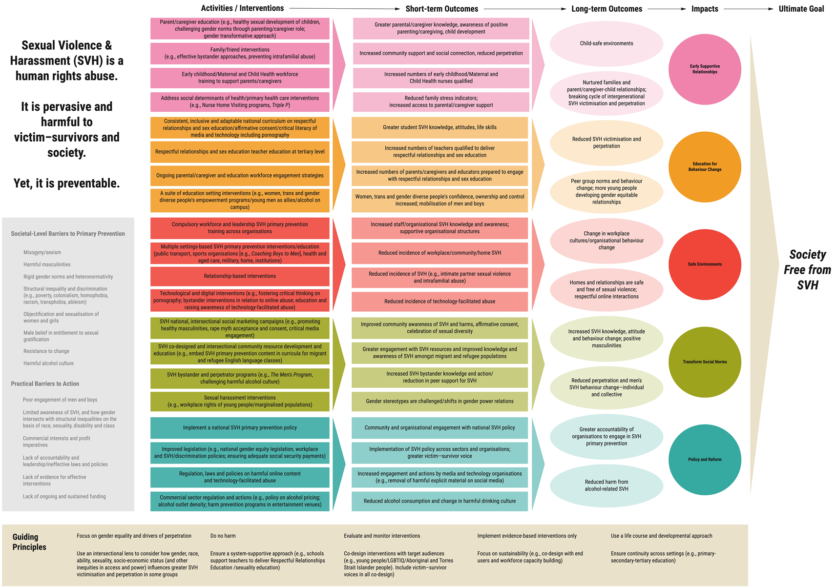
Theory of Change
Why a Theory of Change?
Sexual violence and harassment is pervasive and needs a comprehensive plan for how to prevent it from occurring. A Theory of Change is “an ongoing process of reflection to explore change and how it happens—and what that means for the part organisations play in a particular context, sector and/or group of people” (James, 2011). To date, a specific Theory of Change that focuses on both sexual violence and sexual harassment in Australia has not been developed.
This Theory of Change builds on the framework laid out by Our Watch et al. (2015) and other prevention of VAW change theories such as the RESPECT framework (World Health Organization, 2019), A framework to underpin action to prevent violence against women (UN Women, 2015), STOP SV (Basile et al., 2016) and Pride in prevention (Carman et al., 2020).
Guiding Principles to SVH Primary Prevention Research
A Theory of Change is by necessity generalised, in order to be adaptable to a range of contexts and needs. When using the Theory of Change to consider future research, pilot interventions or for any other use, we recommend following these guiding principles:
- Focus on gender equality and drivers of perpetration
- Use an intersectional lens to consider how gender, race, ability, sexuality, socio-economic status (and other inequities in access and power) influences greater SVH victimisation and perpetration in some groups
- Co-design interventions with target audiences (e.g., young people/LGBTIQ/Aboriginal and Torres Strait Islander people). Include victim–survivor voices in all co-design
- Implement evidence-based interventions only
- Use a life-course and developmental approach
- Do no harm
- Ensure continuity across settings (e.g., primary–secondary–tertiary education)
- Ensure a system-supportive approach (e.g., schools support teachers to deliver Respectful Relationships Education /sexuality education)
- Focus on sustainability (e.g., co-design with end users and workforce capacity building)
- Evaluate and monitor interventions
“Community-led, co-designed approaches that take into account cultural, social and other differences, that use language and ideas that can resonate.”
--Workshop participant
All approaches must be intersectional, with a focus on the drivers of SVH perpetration and behaviour change, in order to prevent SVH before it starts. Where possible, interventions should form part of a larger suite of approaches that are across all levels of the ecological model (Heise, 1998).
In addition, the drivers and reinforcing factors of SVH may also be the influencers of other common social and health-related issues. Working collaboratively across sectors (e.g., family violence, sexual assault, health) on issues of common concern may be mutually beneficial, reduce costs and have more impact and long-term change. Sectors working together can leverage resources, facilitate data-sharing and communication, and align work that has the largest impact across sectors (Dills et al., 2019)
PROBLEM STATEMENT
Sexual violence and harassment is a human rights abuse. It is pervasive and harmful to victim–survivors and society. Yet, it is preventable.
Barriers to Primary Prevention
Our Watch et al. (2015) describe factors that influence the perpetration of VAW and classifies them into “gendered drivers” and “reinforcing factors” (Appendix I). Gender inequality is a driving factor behind VAW yet each of the gendered drivers can manifest in ways that drive sexual violence. There are certain reinforcing factors that can increase the severity and frequency of sexual violence (e.g., alcohol). Experiencing one or all of these gendered drivers/reinforcing factors does not necessarily lead to SVH but may increase the chance of SVH occurring (Gibbs et al., 2020).
We outline some of the specific gendered drivers and reinforcing factors that relate to SVH. These are categorised into societal-level and action barriers. The societal-level barriers go beyond individual responsibility and are part of the larger societal-level issues relating to SVH. Not all barriers are equal; some have a larger impact than others, but here we draw out those that relate to SVH specifically.
Societal-level barriers to primary prevention are:
- Misogyny/Sexism
- Harmful masculinities
- Rigid gender norms and heteronormativity
- Structural inequality and discrimination (e.g., poverty, colonialism, homophobia, racism, transphobia, ableism)
- Objectification and sexualisation of women and girls
- Male belief in entitlement to sexual gratification
- Resistance to change
- Harmful alcohol culture

Along with the societal-level barriers to the primary prevention of SVH, there are more practical barriers at an individual or organisational level that require action.
Practical barriers to action include:
- Poor engagement of men and boys
- Limited awareness of SVH, and how gender intersects with structural inequalities on the basis of race, sexuality, disability and class
- Commercial interests and profit imperatives
- Lack of accountability and leadership/Ineffective laws and policies
- Lack of evidence for effective interventions
- Lack of ongoing and sustained funding

Narrative Theory of Change
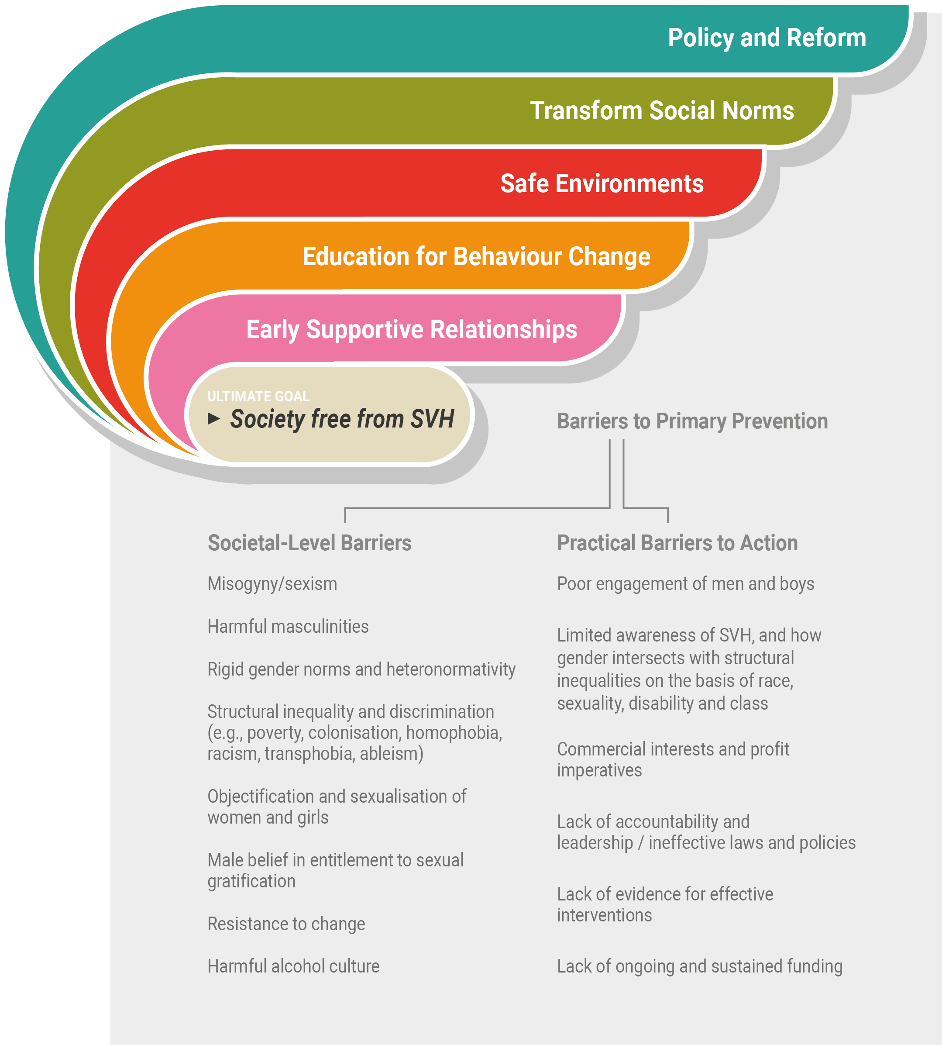
Figure 1: Theory of Change
Conceptual Framework
The proposed Theory of Change includes the schematic pictured above (Figure 1), which indicates the socioecological level impacts of activities outlined in the Theory of Change.
Each tier of the Theory of Change feeds into the other tiers—they are not separate. However, for ease of reading, they are depicted as separate tiers to draw out nuances of the primary prevention of SVH.
The process for primary prevention is circular, not linear, and should consider other levels of prevention. An expansion of each tier of the Theory of Change is provided below in tables, followed by a narrative summary. The summary includes a rationale for the tier, a description of suggested activities or interventions, proposed outcomes, and select examples of available evidence. An additional flow-chart or framework (page 25) outlines the flow of events from problem statement through to impact.
Different prevention strategies are needed to respond to the continuum of contexts in which SVH occurs, from familial relationships to intimate partners, education settings, and institutions as well as the broader social context of SVH. Primary prevention must focus on ending perpetration as well as challenging systems that condone and create social conditions that justify perpetration. Primary prevention must work across the life course, with early parenting/caregiving and supportive relationships as the foundation. The earlier the investment, the greater the return (Doyle et al., 2009).

Intervention Evidence Legend
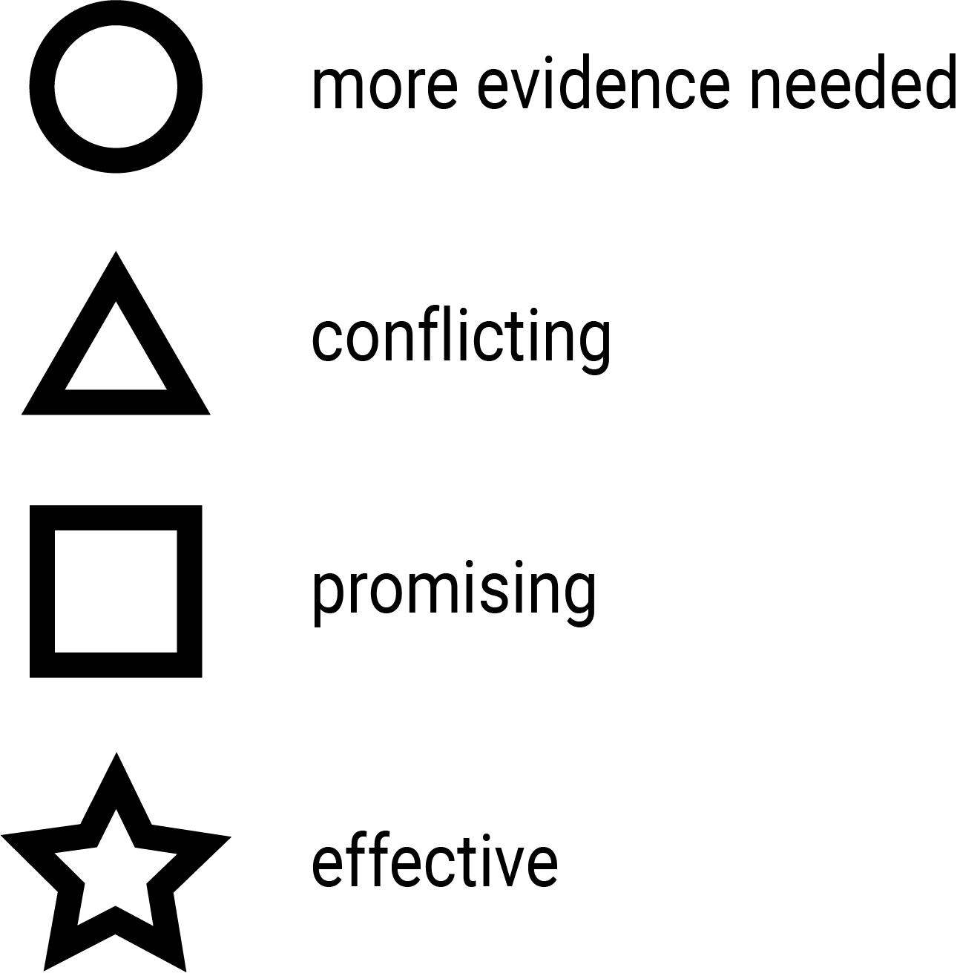

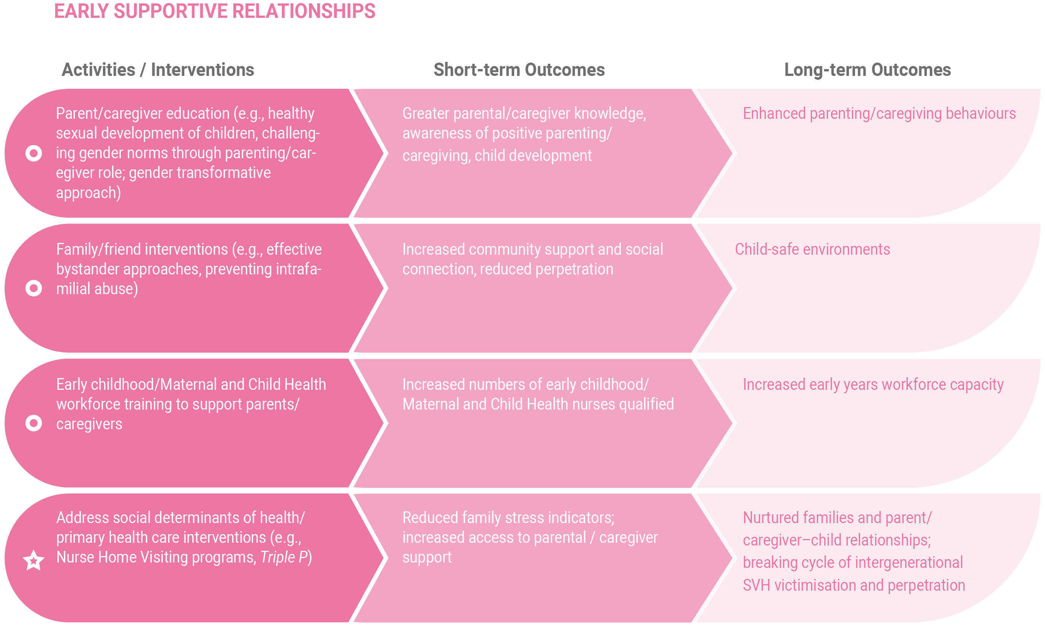
Figure 2: Early supportive relationships
Promoting Early Supportive Relationships
Rationale
Sexual violence and harassment start early in life, with one in five Australian girls and one in 25 boys sexually abused before they turn 15 years (Australian Bureau of Statistics, 2017). Police reports of child sexual assault in those aged 0–14 are twice that of people 15 years and over (AIHW, 2020b). Risk of child sex abuse is greater if the child is exposed to domestic violence, with most sexual abuse happening in the home, by someone they know (AIHW, 2020a). Those who are exposed to adverse childhood experiences are at heightened risk of sexual violence revictimisation (Ports et al., 2016). Preventing this violence means early childhood relationships with parents, caregivers and other family members need to be supported. In the early years, conditions that impact on parenting affect children’s ability to reach their full potential and are the major determinants of early child health and development (Marmot, 2015). Understanding protective factors and the conditions in which people live, work and play—termed the “social determinants of health” (employment, education, housing)—can help inform decision-making and support pro-active practices like navigating personal safety and strengthening supportive relationships and environments (Dills et al., 2019). In the long term, supporting families/parents or caregivers and addressing social inequities can improve social cohesion—an important primary prevention aim, and a protective factor against SVH. Implementing supportive parenting/caregiving interventions may reduce the prevalence of child maltreatment, including child sex abuse.
How to do it? Activities/interventions
- Parent/caregiver education (e.g., healthy sexual development of children, challenging gender norms through parenting/caregiver role; gender transformative approach)
- Family/friend interventions (e.g., effective bystander approaches, preventing intrafamilial abuse)
- Early childhood/Maternal and Child Health workforce training to support parents/caregivers
- Address social determinants of health/primary health care interventions (e.g., Nurse Home Visiting programs, Triple P)
We have to address the causes of the causes—the social conditions acting through the life course that both affect exposures and people’s behaviour (Marmot, 2015)

What will happen? Short-term outcomes
- Greater parental/caregiver knowledge, awareness of positive parenting/caregiving, child development
- Increased community support and social connection, reduced perpetration
- Increased numbers of early childhood/Maternal and Child Health nurses qualified
- Reduced family stress indicators; increased access to parental/caregiver support
What you are measuring? Long-term outcomes
- Enhanced parenting/caregiving behaviours
- Child-safe environments
- Increased early years workforce capacity
- Nurtured families and parent/caregiver–child relationships; breaking cycle of intergenerational SVH victimisation and perpetration
What evidence is there?
A comprehensive evidence review of effective, evaluated SVH evaluations has been completed as part of this project and readers are directed to this document for detailed information (Hooker et al., 2020). Interventions mentioned here are examples only and not exhaustive. The following approaches aim to support parents and caregivers to protect children and prevent SVH.
Parenting programs: Parents and caregivers play a key role in protecting children, either directly through parental and caregiver supervision and involvement, and indirectly, by promoting child self-efficacy, competence, wellbeing and self-esteem. These attributes help children become less likely targets for abuse and more able to respond appropriately and disclose abuse if it occurs (Rudolph et al., 2018). Programs that combine positive parenting/caregiving (e.g., Triple P) with parent–/caregiver–child discussion of child sex abuse may have the greatest impact. Triple P (Prinz et al., 2009) has been shown to reduce child maltreatment, and may reduce child sex abuse, although further research is needed.
Nurse home visiting programs: There is strong evidence for nurse home visiting programs with vulnerable groups. Parenting and caregiver support or outreach programs such as Nurse Family Partnership (NFP; US) home visiting intervention can improve a range of maternal and child health, development, wellbeing, parenting/caregiving and child safety outcomes, including reduced intimate partner violence (Mejdoubi et al., 2013) and child maltreatment (T. R. Miller, 2015; Olds, 2008). Nurse home visiting programs like NFP are often delivered over a sustained period to first-time, vulnerable parents and caregivers and are provided by qualified nurse midwives. These programs work to reduce abuse by facilitating parenting/caregiver self-efficacy, addressing the social determinants of health (e.g., access and support with everyday household stressors, which lead to greater parental/caregiver competence and sensitive care).
Example:
- Nurse home visiting programs
- Triple P

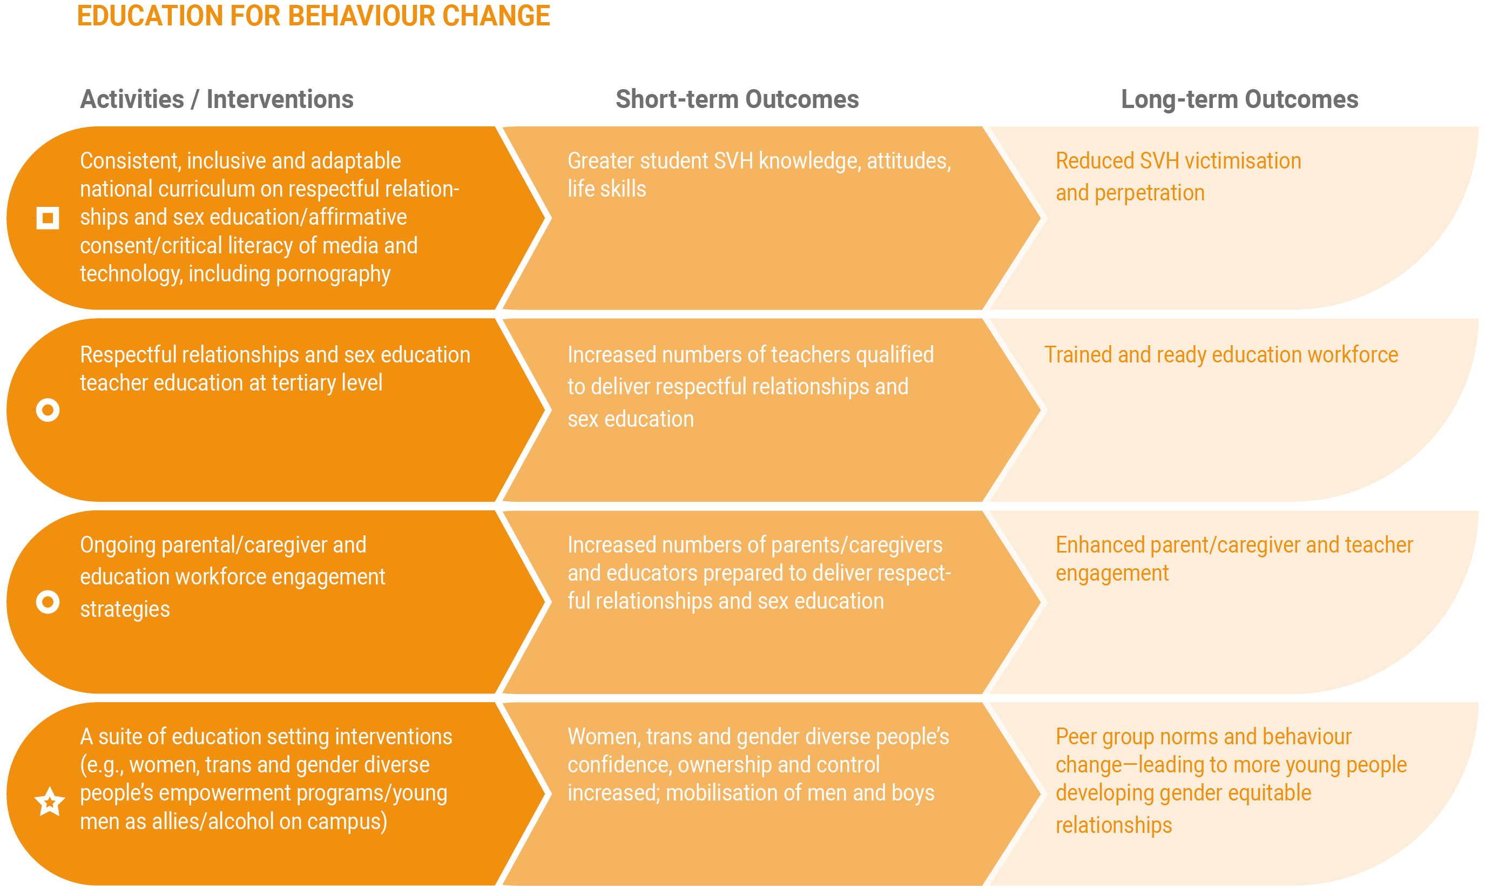
Figure 3: Education for behaviour change
Education for Behaviour Change
Rationale
Education is a logical method of changing relationship and SVH knowledge, attitudes, and behaviours. Programs that support schools and educators and promote gender equality, healthy masculinities and safe and respectful relationships among young people can influence individuals and future generations. Although many of these school-based education programs exist in Australia, there is a lack of consistency across school and university settings, with varied or no curricula for some educational institutions. Despite existing education programs, Australian evidence on community attitudes towards VAW suggests young people’s knowledge of VAW has declined rather than improved (Webster et al., 2017). Confusion about consent and coercion remain, with 33% of people believing that “rape results from men being unable to control their need for sex” and 28% believe that when sexually aroused “men may be unaware a woman does not want to have sex” (Webster et al., 2017). These pervasive attitudes reinforce the need for further school- and community-level education in this area. Sexual violence and harassment at Australian universities is prevalent, with one in five students being sexually harassed in a university setting (AHRC, 2017). A consistent predictor of poor attitudes to VAW and gender equality is low levels of education about SVH (Webster et al., 2017).
How to do it? Activities/interventions
- Consistent and adaptable national curriculum on respectful relationships and sex education/affirmative consent/critical literacy of media and technology, including pornography
- Respectful relationships and sex education teacher education at tertiary level
- Ongoing parental/caregiver and education workforce engagement strategies
- A suite of education setting interventions (e.g., women, trans and gender diverse people’s empowerment programs/young men as allies/alcohol on campus)

What will happen? Short-term outcomes
- Greater student SVH knowledge, attitudes, life skills
- Increased numbers of educators qualified to deliver respectful relationships and sex education
- Increased numbers of parents/caregivers and educators prepared to engage with respectful relationships and sex education
- Women, trans and gender diverse people’s confidence, ownership and control increased; mobilisation of men and boys
What are you measuring? Long-term outcomes
- Reduced SVH victimisation and perpetration
- Trained and ready education workforce
- Enhanced parent/caregiver and teacher engagement
- Peer group norms and behaviour change—leading to more young people developing gender equitable relationships
What evidence is there?
Well-evaluated and effective programs are available, such as women’s empowerment programs Enhanced Assess, Acknowledge, Act (EAAA) in Canada (Senn et al., 2015, 2017) and men’s bystander approaches like Real Consent (Salazar et al., 2014, 2019) in the USA. The EAAA program, based in university settings, combines women’s education and skill development to reduce SVH. Evaluation of EAAA showed reduced campus completed and attempted rape by 50% (Senn et al., 2015), sustained two years post-training (Senn et al., 2015, 2017).
While relationship education in schools has been occurring for many years in Australia, there is limited rigorous or controlled trial-level evidence of its impact (Hooker et al., 2020). The Resilience, Rights and Respectful Relationships program, designed to improve attitudes and respectful peer relationships in secondary schools, is currently undergoing outcome evaluation. The intervention includes Year 7 students in 12 schools across states—compared with schools yet to receive the intervention. This study is funded by Australia’s National Research Organisation for Women’s Safety (ANROWS, 2021).
In the Picture is an Australian framework and resource for secondary schools that can be tailored to address the influence of explicit sexual imagery like pornography (Crabbe & Flood, 2021). This program is yet to be evaluated.
Examples:
- EAAA
- Real consent
- Resilience, rights and respectful relationships
- In the picture

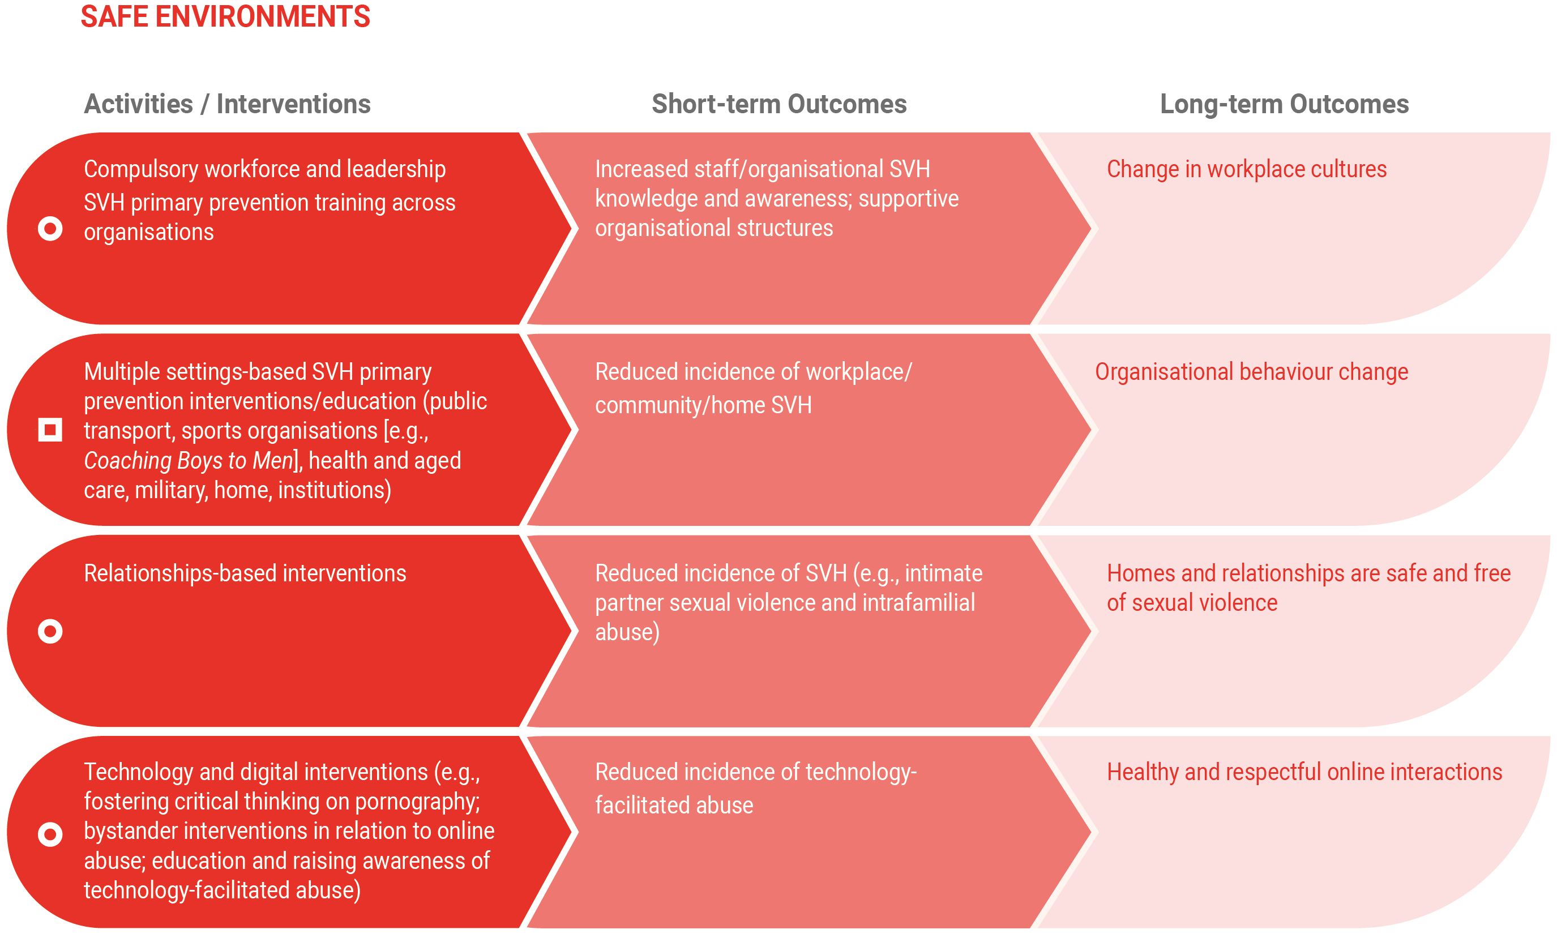
Figure 4: Safe environments
Safe Environments
Rationale
All community members deserve to be safe from SVH in any environment or setting, including at school, work, online and at home. In the workplace, women disproportionately experience sexual harassment and face major barriers to reporting the abuse (AHRC, 2020a). The prevalence of sexual harassment is particularly high for young women, especially those in the information, media and telecommunications industry (AHRC, 2018). In 2018, workplace sexual harassment cost the Australian economy approximately $3.8 billion dollars. Workplace SVH ranges from sexually suggestive “jokes” and intrusive questions about women’s private lives, to sexual assault, including rape. Technology is often used to perpetrate this harassment (AHRC, 2020a).
High rates of harassment and assault also occur on and around public transport, including trains, buses and taxis (Plan International & Monash University, 2018; Whitzman et al., 2019). Women use public transport more often and in differing ways to men, making them more vulnerable to abuse (Ceccato, 2017). This is particularly heightened for women and girls with disabilities. In addition, women are at higher risk of SVH in organisations with hierarchical structures, dominated by men, and that potentially foster harmful masculinities (e.g., military, police force, legal and medical professions; AHRC, 2020a).
When these harmful settings (for women) combine alcohol at work, perpetration of sexual assault and rape is heightened.
These settings and others make ideal locations for a range of different, tailored interventions to reduce and prevent SVH.
How to do it? Activities/interventions
- Compulsory workforce and leadership SVH primary prevention training across organisations
- Multiple settings-based SVH primary prevention interventions/education (public transport, public service, sports organisations [e.g., Coaching Boys to Men], health and aged care, military, home, institutions)
- Relationship-based interventions
- Technological and digital interventions (e.g., fostering critical thinking on pornography; bystander interventions in relation to online abuse; education and raising awareness of technology-facilitated abuse)
What will happen? Short-term outcomes
- Increased staff/organisational SVH knowledge and awareness; supportive organisational structures
- Reduced incidence of workplace/community/home SVH
- Reduced incidence of SVH (e.g., intimate partner sexual violence and intrafamilial abuse)
- Reduced incidence of technology-facilitated abuse
What are you measuring? Long-term outcomes
- Change in workplace cultures
- Organisational behaviour change
- Homes and relationships are safe and free of sexual violence
- Healthy and respectful online interactions
What evidence is there?
In a community sports setting, programs like Coaching Boys to Men (E. Miller et al., 2012) engage men and influential mentors such as sports coaches to change social and peer norms-strong (factors associated with Australian secondary school boys reports of unwanted sexual experiences [Hooker et al., 2020]). Coaching Boys to Men has been extensively evaluated in the USA and shows mixed results (Jaime et al., 2016; E. Miller et al., 2013, 2016, 2020).
The USA Department of Defense (2014) has effectively reduced unwanted sexual contact—sustained over two years, with the implementation of a complex, whole-of-organisation intervention at primary, secondary and tertiary levels of prevention. The intervention included a comprehensive prevention and response system to empower victim–survivors and support recovery—including a sexual assault awareness month, a prevention innovation award and an active bystander intervention.
Interventions for street-based SVH are limited, including those to prevent SVH on public transport; however, some research in this area is emerging. Primary and secondary prevention interventions like local government structural changes, a trained and bystander ready public transport workforce, surveillance at known SVH hot spots and improved reporting avenues and responses, may prove promising (Taft et al., 2020).
Interventions to prevent SVH that occurs in the home, such as intimate partner sexual violence and intrafamilial sexual violence, are lacking (Hegarty et al., 2016; McKibbin & Humphreys, 2020).
Examples:
- Coaching boys to men
- Whole-of-system interventions

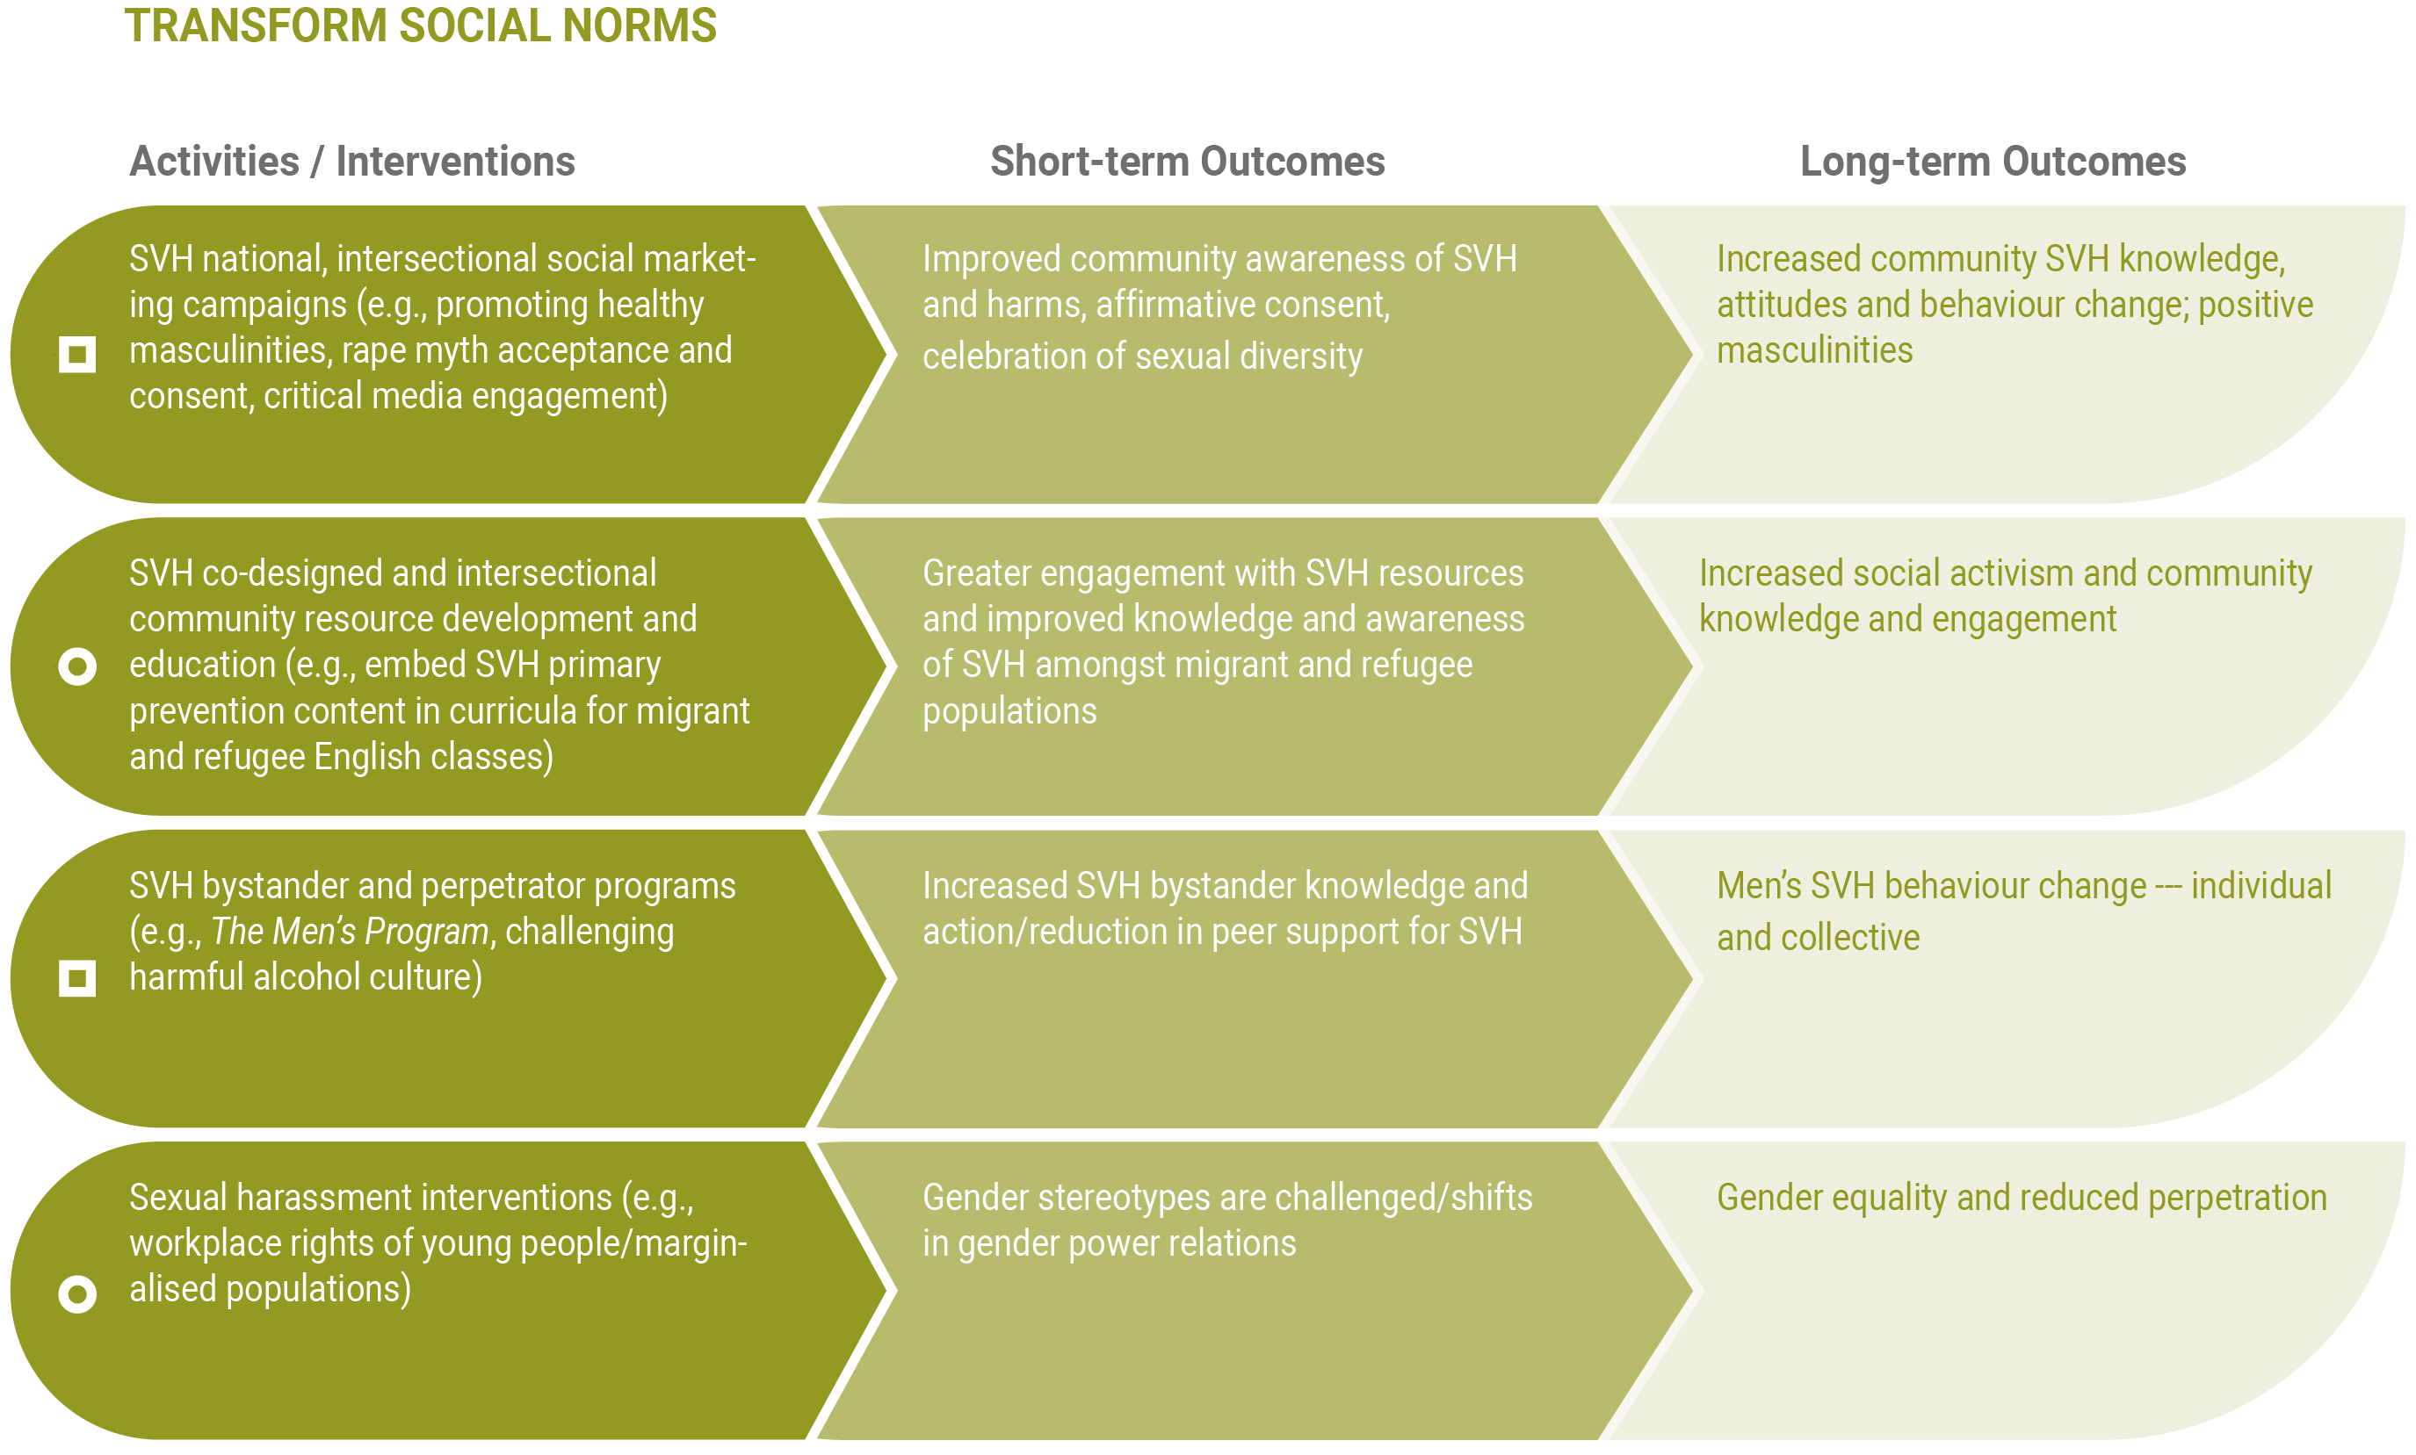
Figure 5: Transform social norms
Transform Social Norms
Rationale
Social norms are the broad attitudes and cultures within society that condone all forms of VAW, including SVH. National population surveys continue to indicate that SVH is prevalent (Australian Bureau of Statistics, 2017) and causes substantial stress and poor mental and physical health, with very low rates of reporting by victim–survivors. Community SVH attitudes, beliefs and behaviours are difficult to shift, with a significant proportion of Australians believing that gender inequality is exaggerated and that women make up claims of abuse to suit their circumstances (Webster et al., 2017). Actions such as bystander activities have declined, with sexual harassment bystander actions reported less often in 2018, compared to reports from 2012 (AHRC, 2018). A long-term, sustained approach to primary prevention, with ongoing investment, is needed.
Along with individual and relational approaches to the primary prevention of SVH, whole-of-population interventions can transform key gendered drivers and the reinforcing factors that contribute to SVH, leading to greater gender equality. Building strong and inclusive social movements that can facilitate men’s engagement as allies, enhance women, trans and gender diverse people’s voices and social activism will sustain change.
How to do it? Activities/interventions
- SVH national, intersectional social marketing campaigns (e.g., promoting healthy masculinities, rape myth acceptance and consent, critical media engagement)
- SVH co-designed and intersectional community resource development and education (e.g., embed SVH primary prevention content in curricula for migrant and refugee English classes)
- SVH bystander and perpetrator programs (e.g., The Men’s Program, challenging an alcohol abuse culture)
- Sexual harassment interventions (e.g., workplace rights of young people/marginalised populations)

What will happen? Short-term outcomes
- Improved community awareness of SVH and harms, affirmative consent, celebration of sexual diversity
- Greater engagement with SVH resources and improved knowledge and awareness of SVH amongst migrant and refugee populations
- Increased SVH bystander knowledge and action/reduction in peer support for SVH
- Gender stereotypes are challenged/shifts in gender power relations
Examples:
- The Men’s Program
- Bringing in the Bystander
- The Line
What you are measuring? Long-term outcomes
- Increased community SVH knowledge, attitudes and behaviour change; positive masculinities
- Increased social activism and community knowledge and engagement
- Men’s SVH behaviour change—individual and collective
- Gender equality and reduced perpetration
What evidence is there?
The evidence base for these wider community-level interventions is limited. However, social marketing and bystander programs such as The Men’s Program (Langhinrichsen-Rohling et al., 2011; Lawson et al., 2012) and Bringing in the Bystander (Hines & Reed, 2017; Peterson et al., 2018) have shown promise. The Men’s Program has been evaluated across a range of USA locations (university, workplace–military) and cultural groups (Lawson et al., 2012) and aims to increase bystander activity and reduce men’s defensiveness through men engaging with other men to discuss rape-supportive behaviours and beliefs. Similarly, Bringing in the Bystander (Hines et al., 2019; Inman et al., 2018; Palm Reed et al., 2015) encourages effective bystander behaviour, teaches participants about rape myths and structural inequalities, and has shown to be LGBTQ inclusive.
From the evidence review, school- and university-based social marketing campaigns have reported promising (Mennicke et al., 2018) but sometimes conflicting results. Broadening the approach to combine promising interventions, such as bystander programs with sustained social marketing strategies, may improve program effectiveness and participant outcomes (Fenton & Mott, 2018). The Our Watch (2017) campaign – The Line targeted young people and the development of healthy, respectful peer and intimate relationships and covered topics like attitudes on consent, equality and gender roles. Parents and caregivers reported greater confidence to discuss topics with children; while some positive changes were noted, results varied and some effects were not sustained (Our Watch, 2017). The mixed results of these community-level programs indicate the need for more rigorous research on these types of programs. In addition, more varied, national-level social marketing activities are required (e.g., campaigns promoting healthy masculinities, critical engagement with media [pornography] and affirmative consent).

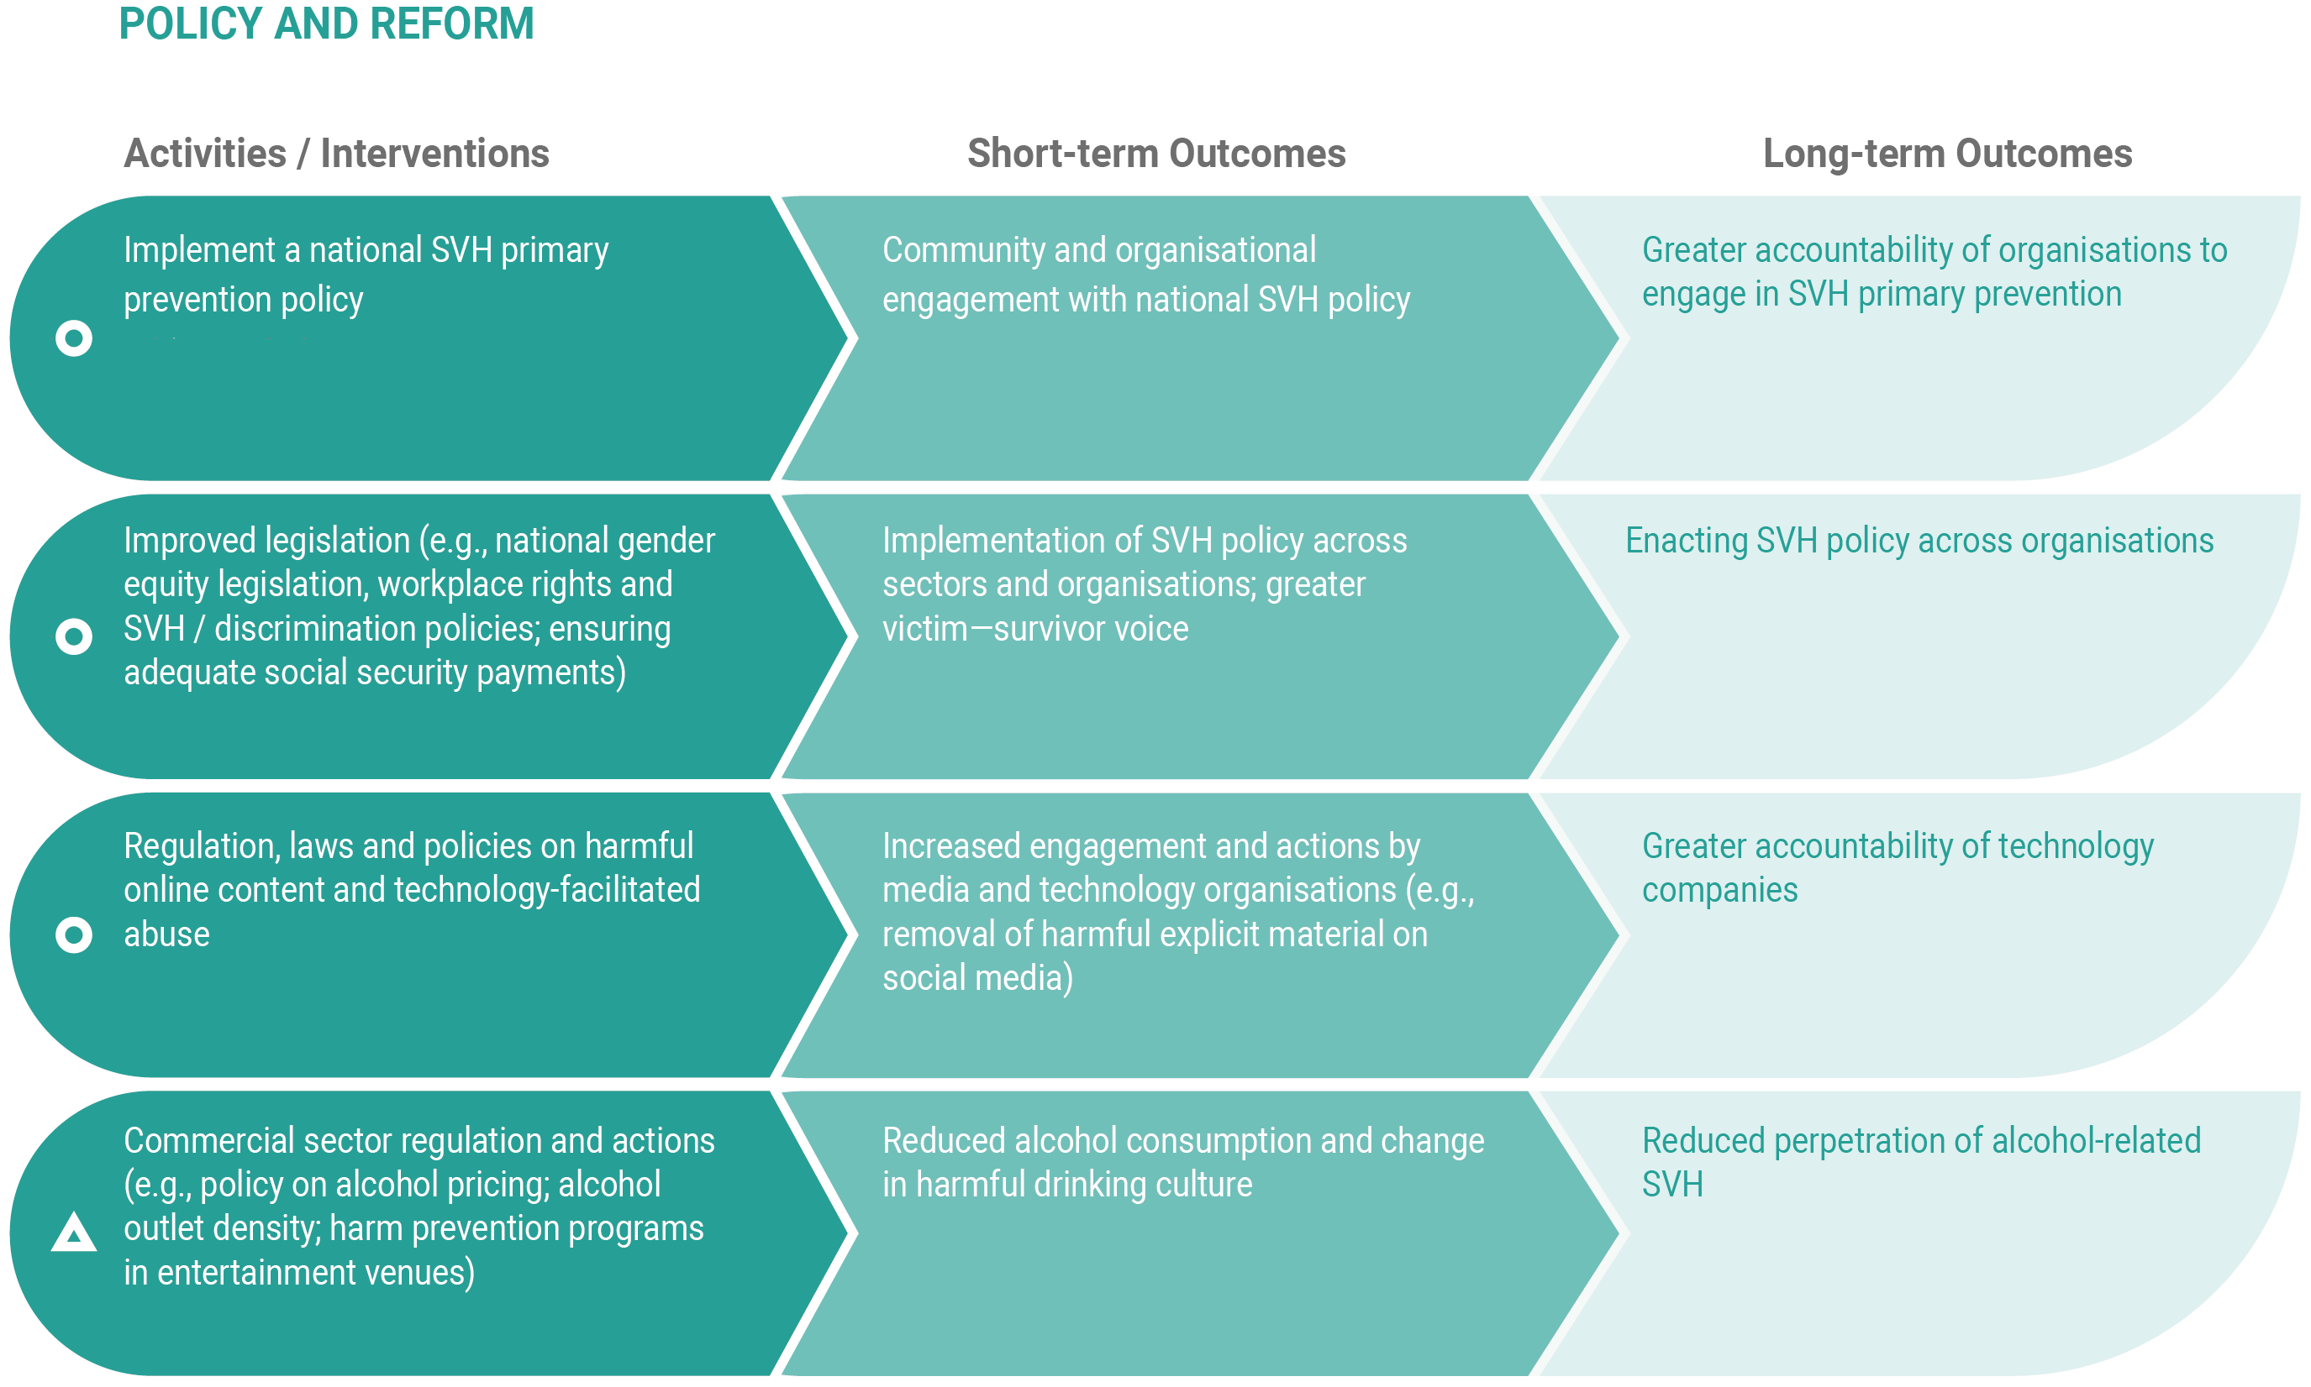

Figure 6: Policy and reform

Policy and Reform
Rationale
SVH policy development, with successful implementation, can be a cost-effective primary prevention strategy to foster the positive change in SVH attitudes and behaviours of large populations. Policy strategies include influential laws and/or guidelines at organisational, local, state and national levels that can efficiently change large and complex systems (e.g., sexual harassment and anti-discrimination laws that enhance the safety of the community and wider population [Dills et al., 2019]). Australia has a national policy on the prevention of VAW and children (National Council to Reduce Violence against Women and their Children, 2009), yet this is not specific to SVH. A national SVH policy and the revision of other supportive legislation and reform is recommended. This policy needs to go beyond workplace rights and sex discrimination—including consideration of recommendations of the recent Respect@Work (AHRC, 2020a) report—to enhanced social policy and support for families (e.g., policy that addresses the social determinants of SVH, such as poverty). Other commercial determinants of SVH also need regulation and reform—such as Big alcohol, ethical media reporting and accountability for technology companies (social media/online dating sites/pornography industry) that profit from the exploitation and abuse of women. Alcohol is a significant reinforcing factor in the perpetration of SVH. From our research, Australian secondary school students report being “too drunk” to stop unwanted sexual attention/behaviours in the 6th National Survey of Secondary Students and Sexual Health (Hooker et al., 2020).
“Research tells us that the media is a powerful driver of social change and can positively influence the culture, behaviours and attitudes that drive violence against women and their children” (Our Watch 2019b, p. 2)

How to do it? Activities/interventions
- Implement a national SVH primary prevention policy
- Improved legislation (e.g., national gender equity legislation, workplace and SVH/discrimination policies; ensuring adequate social security payments)
- Regulation, laws and policies on harmful online content and technology-facilitated abuse
- Commercial sector regulation and actions (e.g., policy on alcohol pricing; alcohol outlet density; harm prevention programs in entertainment venues)
What will happen? Short-term outcomes
- Community and organisational engagement with national SVH policy
- Implementation of SVH policy across sectors and organisations; greater victim–survivor voice
- Increased engagement and actions by media and technology organisations (e.g., removal of harmful explicit material on social media)
- Reduced alcohol consumption and change in harmful drinking culture
What you are measuring? Long-term outcomes
- Greater accountability of organisations to engage in SVH primary prevention
- Enacting SVH policy across organisations
- Greater accountability of technology companies
- Reduced perpetration of alcohol-related SVH
What evidence is there?
While it is logical to assume that there are benefits to introducing widespread policy and law reform which can impact on the perpetration of SVH, evidence on the effectiveness of policy in this area is limited. One exception to this is alcohol policy.
Alcohol policy reform and sales regulation could be a relatively simple and economic strategy to implement with immediate and significant impact on the reduction and prevention of SVH (Lippy & DeGue, 2014).
This includes effective policy and measures to reduce consumption, such as restricting the number of neighbourhood outlets selling alcohol, ensuring supportive environments such as bar room management, and restrictions of alcohol on university campus. Our evidence review identified one alcohol-focused intervention—BarTAB (Powers & Leili, 2018)—which is a bystander and training program that includes organisational guidelines on preventing and addressing alcohol-related SVH. Results were mixed but showed improved staff attitudes about rape, concerns for customers and reduced barriers to intervening.
Examples:
- BarTab
- Alcohol regulation
Prior political will to address profitable “Big” organisations and encourage organisational accountability for public health (e.g., Big tobacco companies through increased cigarette pricing and plain packaging), have shown to be very successful at influencing behaviour and reducing smoking rates. This example could be applied to alcohol regulation and SVH prevention (Bond et al., 2010).

Conclusion
Sexual violence and harassment is pervasive and harmful to many members of society. A clear pathway to preventing SVH is needed. The evidence review completed for this project showed that SVH primary prevention scholarship and research is in its infancy, and that few effective interventions exist, especially at the community level. Individual, relationship and complementary whole-of-community initiatives (that reinforce messages and shift social norms) are required to positively shift attitudes and behaviours.
The Theory of Change diagram and accompanying narrative presented here aims to inform research and strategic government action to stop SVH in Australia. The framework provides an overview of the activities/interventions with short- and long-term outcomes that can reduce and prevent SVH. The framework was developed after reviewing global evidence on what works to reduce and prevent SVH and extensive national consultation with experts and practitioners. The SVH Theory of Change outlines effective and promising interventions at all levels of the social ecology, with a focus on intersectional and structural inequalities. The framework is not designed to be interpreted as linear or prescriptive; more so, as an early, intersecting roadmap or guide to tackling SVH.
Primary prevention is difficult to measure, as success can occur when nothing harmful happens. Sustained investment in future research and program evaluation is required to measure long-term outcomes and the successful indicators of reduced or eliminated SVH in Australia.

Future Research Recommendations
- Evidence gaps exist in understanding the most appropriate interventions for priority populations at highest risk of SVH perpetration and victimisation. This proposed Theory of Change may not be suitable for all groups. There are still gaps in our knowledge about how drivers influence certain groups and the complex and causal or associated pathways. Further research is needed to work with Aboriginal and Torres Strait Islander populations to develop a specific theory of change that addresses their unique needs. Structural inequalities may be a more relevant/stronger driver of SVH in these communities, rather than the overarching gender inequality proposed here.
- More research on understanding SVH perpetration is needed, including the context of perpetration and the drivers of perpetration through data collected from perpetrators rather than victim–survivors. This must include an intersectional approach.
- Research and interventions to address sexual harassment specifically is limited. More research and interventions are needed that align with the Respect@Work report (AHRC, 2020a).
- Any adaption of existing evidence-based SVH primary prevention interventions must include qualitative evaluation of implementation science outcomes (process evaluation) to understand the contextual influences of program success or failure in a new setting. Co-design with diverse communities needs to be at the core of any adaption. New interventions must be comprehensive (beyond single, one-off, short programs aimed only at the individual level), sustainable, and part of a larger suite of whole-of-system approaches.
- More qualitative research is needed to better understand the nuances of SVH and how it may differ from the drivers and reinforcing factors of VAW. Deep exploration and rigorous methods (e.g., long-term ethnographic studies) are needed to understand the varied influences and factors in people’s lives that can result in SVH. This can then inform intervention development to prevent SVH.
- Future program evaluations to incorporate rigorous designs must have adequately powered samples, with control or comparison groups, include validated behaviour outcomes measures (rather than individual attitudes and intentions) and be funded to allow for longer follow-up periods (beyond 6–12 months), that can assess sustainable behaviour change.

Appendices
Appendix I – Gendered Drivers and Reinforcing Factors
Our Watch et al. (2015) outline these gendered drivers and reinforcing factors, with the following actions to address them.
Gendered Drivers | Essential Actions to Address  Gendered Drivers
Condoning of violence against women | Challenge condoning of VAW
Men’s control of decision-making and limits to women’s independence in public and private life | Promote women’s independence and decision-making in public life and relationships
Rigid gender roles and stereotyped constructions of masculinity and femininity | Foster positive personal identities and challenge gender stereotypes and roles
Male peer relations that emphasise aggression and disrespect towards women | Strengthen positive, equal and respectful relations between and among women and men, girls and boys
 | Promote and normalise gender equality in public and private life

Reinforcing Factors | Supporting Actions to Address  Reinforcing Factors
Condoning of violence in general | Challenge the normalisation of violence as an expression of masculinity or male dominance
Experience of, and exposure to, violence | Prevent exposure to violence and support those affected to reduce its consequences
Weakening of pro-social behaviour, especially harmful use of alcohol | Address the intersections between social norms relating to alcohol and gender
Socio-economic inequality and discrimination | Reduce backlash by engaging men and boys in gender equality, building relationship skills and social connections
Backlash factors (increases in violence when male dominance, power or status is challenged) | Promote broader social equality and address structural discrimination and disadvantage

References
Australia’s National Research Organisation for Women’s Safety (ANROWS). (2019). Intimate partner sexual violence: Research synthesis (2nd ed.). ANROWS.
Australia’s National Research Organisation for Women’s Safety (ANROWS). (2021). Respectful relationships in secondary schools: A control trial study and network evaluation of a classroom program for prevention of gender-based violence. https://www.anrows.org.au/project/respectful-relationships-in-secondary-schools-a-control-trial-study-and-network-evaluation-of-a-classroom-program-for-prevention-of-gender-based-violence/
Australian Bureau of Statistics. (2017). Personal safety survey. ABS.
Australian Human Rights Commission. (2017). Change the course: National report on sexual assault and sexual harassment at Australian universities. https://humanrights.gov.au/sites/default/files/document/publication/AHRC_2017_ChangeTheCourse_UniversityReport.pdf
Australian Human Rights Commission. (2018). Everyone’s business: The fourth national survey on sexual harassment in Australian workplaces. https://humanrights.gov.au/our-work/sex-discrimination/publications/everyones-business-fourth-national-survey-sexual
Australian Human Rights Commission. (2020a). Respect@work: National inquiry into sexual harassment in Australian workplaces. Australian Human Rights Commission.
Australian Human Rights Commission. (2020b). Sexual harassment in the workplace - The legal definition of sexual harassment. https://humanrights.gov.au/our-work/sexual-harassment-workplace-legal-definition-sexual-harassment
Australian Institute of Health and Welfare. (2018). Family, sexual and domestic violence in Australia, 2018. AIHW.
Australian Institute of Health and Welfare. (2019). Family, domestic and sexual violence in Australia: Continuing the national story 2019-In brief. AIHW.
Australian Institute of Health and Welfare. (2020a). Australia’s children. Cat. no: CWS69. https://www.aihw.gov.au/reports/children-youth/australias-children/contents/health/the-health-of-australias-children
Australian Institute of Health and Welfare. (2020b). Sexual assault in Australia. AIHW. https://www.aihw.gov.au/reports/domestic-violence/sexual-assault-in-australia/contents/summary
Basile, K. C., DeGue, S. A., Jones, K., Freire, K., Dills, J., Smith, S. G., & Raiford, J. L. (2016). STOP SV: A technical package to prevent sexual violence. Centers for Disease Control. https://www.cdc.gov/violenceprevention/pub/technical-packages.html
Blomkamp, E. (2018). The promise of co-design for public policy. Australian Journal of Public Administration, 77(4), 729–743. https://doi.org/10.1111/1467-8500.12310
Bond, L., Daube, M., & Chikritzhs, T. (2010). Selling addictions: Similarities in approaches between big tobacco and big booze [Article]. Australasian Medical Journal, 3(6), 325–332. https://doi.org/10.4066/AMJ.2010.363
Carman, M., Fairchild, J., Parsons, M., Farrugia, C., Power, J., & Bourne, A. (2020). Pride in Prevention.
Ceccato, V. (2017). Women’s victimisation and safety in transit environments. Crime Prevention and Community Safety, 19(3–4), 163–167.
Council of Australian Governments. (2011). National plan to reduce VAW and their children: Including the first three-year action plan. COAG.
Crabbe, M., & Flood, M. (2021). School-dased education to address pornography’s influence on young people: A proposed practice framework. American Journal of Sexuality Education. https://doi.org/10.1080/15546128.2020.1856744
Dills, J., Jones, K., & Brown, P. (2019). Continuing the dialogue: Learning from the past and looking to the future of intimate partner violence and sexual violence prevention. National Center for Injury Prevention and Control, Centers for Disease Conrol and Prevention.
Douglas, H., Harris, B. A., & Dragiewicz, M. (2019). Technology-facilitated domestic and family violence: Women’s experiences. The British Journal of Criminology, 59(3), 551–570. https://doi.org/10.1093/bjc/azy068
Doyle, O., Harmon, C. P., Heckman, J. J., & Tremblay, R. E. (2009). Investing in early human development: Timing and economic efficiency [Article]. Economics and Human Biology, 7(1), 1–6. https://doi.org/10.1016/j.ehb.2009.01.002
Fenton, R. A., & Mott, H. L. (2018). Evaluation of the intervention initiative: A bystander intervention program to prevent violence against women in universities. Violence & Victims, 33(4), 645–662. https://doi.org/10.1891/0886-6708.VV-D-16-00074
Flood, M. (2013). Evaluation capacity building in the Respect, Responsibility and Equality program: Report on Stage 1 (2008–2010). VicHealth.
García-Moreno, C., Hegarty, K., D’Oliveira, A. F. L., Koziol-Mclain, J., Colombini, M., & Feder, G. (2015). The health-systems response to violence against women. The Lancet, 385(9977), 1567–1579. https://doi.org/10.1016/S0140-6736(14)61837-7
Gibbs, A., Dunkle, K., Ramsoomar, L., Willan, S., Jama Shai, N., Chatterji, S., Naved, R., & Jewkes, R. (2020). New learnings on drivers of men’s physical and/or sexual violence against their female partners, and women’s experiences of this, and the implications for prevention interventions. Global Health Action, 13(1), 1739845. https://doi.org/10.1080/16549716.2020.1739845

Hegarty, K., Tarzia, L., Hooker, L., & Taft, A. (2016). Interventions to support recovery after domestic and sexual violence in primary care. International Review of Psychiatry, 28(5), 519–532. https://doi.org/10.1080/09540261.2016.1210103
Heise, L. L. (1998). Violence against women: An integrated, ecological framework. Violence Against Women, 4(3), 262–290. https://doi.org/10.1177/1077801298004003002
Henry, N., McGlynn, C., Flynn, A., Johnson, K., Powell, A., & Scott, A. J. (2020). Image-based Sexual Abuse. A Study on the Causes and Consequences of Non-Consensual Nude or Sexual Imagery [Book]. Routledge.
Henry, N., & Powell, A. (2018). Technology-facilitated sexual violence: A literature review of rmpirical research. Trauma, Violence, and Abuse, 19(2), 195–208. https://doi.org/10.1177/1524838016650189
Hines, D. A., Bishop, L. R. S., & Palm Reed, K. M. (2019). Differential gender responses to an empathy component of a sexual assault prevention program. Violence & Victims, 34(3), 397–413. https://doi.org/10.1891/0886-6708.VV-D-18-00046
Hines, D. A., & Reed, K. M. P. (2017). Bystander prevention of sexual and dating violence: An experimental evaluation of online and in-person bystander intervention programs. Partner Abuse, 8(4), 331–346. https://doi.org/10.1891/1946-6560.8.4.331
Hooker, L., Ison, J., O’Sullivan, G., Fisher, C., Henry, N., Forsdike, K., Young, F., & Taft, A. (2020). Primary prevention of sexual violence and harassment against women and girls: Combining evidence and practice knowledge - Research report. Australian Government Department of Social Services.
Inman, E. M., Chaudoir, S. R., Galvinhill, P. R., & Sheehy, A. M. (2018). The effectiveness of the bringing in the bystanderTM program among first-year students at a religiously-affiliated liberal arts college. Journal of Social and Political Psychology, 6(2), 511–525. https://doi.org/10.5964/jspp.v6i2.971
Jaime, M. C. D., Stocking, M., Freire, K., Perkinson, L., Ciaravino, S., & Miller, E. (2016). Using a domestic and sexual violence prevention advocate to implement a dating violence prevention program with athletes. Health Education Research, 31(6), 679–696. https://doi.org/10.1093/her/cyw045
James, C. (2011). Theory of Change review: A report commissioned by Comic Relief. https://www.actknowledge.org/resources/documents/James_ToC.pdf
Krug, E. G., Dahlberg, L. L., Mercy, J. A., Zwi, A. B., & Lozano, R. (2002). World report on violence and health. World Health Organization.
Langhinrichsen-Rohling, J., Foubert, J. D., Brasfield, H. M., Hill, B., & Shelley-Tremblay, S. (2011). The Men’s Program: Does it impact college men’s self-reported bystander efficacy and willingness to intervene? Violence Against Women, 17(6), 2011, 743-759. https://doi.org/http://dx.doi.org/10.1177/1077801211409728
Lawson, S. L., Munoz-Rojas, D., Gutman, L. S., & Siman, M. N. (2012). Changing attitudes and perceptions of Hispanic men ages 18 to 25 about rape and rape prevention. Issues in Mental Health Nursing, 33(12), 864–870. https://doi.org/10.3109/01612840.2012.728279
Lippy, C., & DeGue, S. (2014). Exploring alcohol policy approaches to prevent sexual violence perpetration. Trauma, Violence, & Abuse, 17(1), 26–42. https://doi.org/10.1177/1524838014557291
Marmot, M. (2015). The health gap: The challenge of an unequal world. The Lancet, 386(10011), 2442–2444. https://doi.org/10.1016/S0140-6736(15)00150-6
McKibbin, G., & Humphreys, C. (2020). Future directions in child sexual abuse prevention: An Australian perspective. Child Abuse and Neglect, 105(104422), 1–8. https://doi.org/10.1016/j.chiabu.2020.104422
Mejdoubi, J., van den Heijkant, S. C., van Leerdam, F. J., Heymans, M. W., Hirasing, R. A., & Crijnen, A. A. (2013). Effect of nurse home visits vs. usual care on reducing intimate partner violence in young high-risk pregnant women: A randomized controlled trial. PLoS ONE, 8(10), e78185. https://doi.org/10.1371/journal.pone.0078185
Mennicke, A., Kennedy, S. C., Gromer, J., & Klem-O’Connor, M. (2018). Evaluation of a Social Norms Sexual Violence Prevention Marketing Campaign Targeted Toward College Men: Attitudes, Beliefs, and Behaviors Over 5 Years. Journal of Interpersonal Violence. https://doi.org/10.1177/0886260518780411
Miller, E., Jaime, M. C. D., & McCauley, H. M. (2016). “Coaching boys into men”: A social norms change approach to sexual violence prevention. In E. Jeglic & C. Calkins (Eds.), Sexual Violence: Evidence Based Policy and Prevention (pp. 227–248). Springer International Publishing. https://doi.org/10.1007/978-3-319-44504-5_13
Miller, E., Jones, K. A., Ripper, L., Paglisotti, T., Mulbah, P., & Abebe, K. Z. (2020). An athletic coach-delivered middle school gender violence prevention program: A cluster randomized clinical trial. JAMA Pediatrics, 174(3), 241–249. https://doi.org/10.1001/jamapediatrics.2019.5217
Miller, E., Tancredi, D. J., McCauley, H. L., Decker, M. R., Virata, M. C. D., Anderson, H. A., O’Connor, B., & Silverman, J. G. (2013). One-year follow-up of a coach-delivered dating violence prevention program. American Journal of Preventive Medicine, 45(1), 108–112. https://doi.org/10.1016/j.amepre.2013.03.007
Miller, E., Tancredi, D. J., McCauley, H. L., Decker, M. R., Virata, M. C. D., Anderson, H. A., Stetkevich, N., Brown, E. W., Moideen, F., & Silverman, J. G. (2012). “Coaching Boys into Men”: A cluster-randomized controlled trial of a dating violence prevention program. Journal of Adolescent Health, 51(5), 431–438. https://doi.org/10.1016/j.jadohealth.2012.01.018
Miller, T. R. (2015). Projected outcomes of nurse-family partnership home visitation during 1996–2013, USA. Prevention Science, 16(6), 765–777. https://doi.org/10.1007/s11121-015-0572-9
National Council to Reduce Violence against Women and their Children. (2009). Time for action: The National Council’s plan for Australia to reduce violence against women and their children 2009–2021. Department of Social Services.
Olds, D. L. (2008). Preventing child maltreatment and crime with prenatal and infancy support of parents: The Nurse–Family Partnership. Journal of Scandinavian Studies in Criminology and Crime Prevention, 9(sup1), 2–24. https://doi.org/10.1080/14043850802450096
Our Watch. (2017). Tracking change: Snapshot evaluation findings for The Line campaign 2015 to 2017. Our Watch.
Our Watch. (2018). Changing the picture: A national resource to prevent violence against Aboriginal and Torres Strait Islander women and their children. Our Watch.
Our Watch. (2019a). Change the story three years on: Reflections on uptake and impact, lessons learned and Our Watch’s ongoing work to embed and expand the evidence on prevention. Our Watch.
Our Watch. (2019b). Men in focus: Unpacking masculinities and engaging men in the prevention of violence against women. Our Watch. https://doi.org/10.1177/030619739700600208
Our Watch, VicHealth, & Australia’s National Research Organisation for Women’s Safety (ANROWS). (2015). Change the story: A shared framework for the primary prevention of violence against women and their children in Australia. Our Watch.
Palm Reed, K. M., Hines, D. A., Armstrong, J. L., & Cameron, A. Y. (2015). Experimental evaluation of a bystander prevention program for sexual assault and dating violence. Psychology of Violence, 5(1), 95–102. https://doi.org/10.1037/a0037557
Peterson, K., Sharps, P., Banyard, V. L., Powers, R. A., Kaukinen, C., Gross, D., Decker, M. R., Baatz, C., & Campbell, J. C. (2018). An evaluation of two dating violence prevention programs on a college campus. Journal of Interpersonal Violence, 33(23), 3630–3655. https://doi.org/10.1177/0886260516636069
Plan International, & Monash University. (2018). Unsafe in the City - The everyday experiences of girls and young women. https://www.monash.edu/__data/assets/pdf_file/0006/1572747/unsafeinthecity-en.pdf
Ports, K. A., Ford, D. C., & Merrick, M. T. (2016). Adverse childhood experiences and sexual victimization in adulthood. Child Abuse and Neglect, 51, 313–322. https://doi.org/10.1016/j.chiabu.2015.08.017
Powell, A., & Henry, N. (2017). Sexual violence in a digital age. In Sexual Violence in a Digital Age. Palgrave Macmillan. https://doi.org/10.1057/978-1-137-58047-4

Powers, R. A., & Leili, J. (2018). Bar training for active bystanders: Evaluation of a community-based bystander intervention program. Violence Against Women, 24(13), 1614–1634. https://doi.org/10.1177/1077801217741219
Prinz, R. J., Sanders, M. R., Shapiro, C. J., Whitaker, D. J., & Lutzker, J. R. (2009). Population-based prevention of child maltreatment: The U.S. triple P system population trial [Article]. Prevention Science, 10(1), 1–12. https://doi.org/10.1007/s11121-009-0123-3
Rudolph, J., Zimmer-Gembeck, M. J., Shanley, D. C., & Hawkins, R. (2018). Child sexual abuse prevention opportunities: Parenting, programs, and the reduction of risk [Article]. Child Maltreatment, 23(1), 96–106. https://doi.org/10.1177/1077559517729479
Salazar, L. F., Vivolo-Kantor, A., Hardin, J., & Berkowitz, A. (2014). A web-based sexual violence bystander intervention for male college students: Randomized controlled trial. Journal of Medical Internet Research, 16(9), e203. https://doi.org/10.2196/jmir.3426
Salazar, L. F., Vivolo-Kantor, A., & Schipani-McLaughlin, A. M. (2019). Theoretical mediators of RealConsent: A web-based sexual violence prevention and bystander education program. Health Education and Behavior, 46(1), 79–88. https://doi.org/10.1177/1090198118779126
Senn, C. Y., Eliasziw, M., Barata, P. C., Thurston, W. E., Newby-Clark, I. R., Radtke, H. L., & Hobden, K. L. (2015). Efficacy of a sexual assault resistance program for university women. New England Journal of Medicine, 372(24), 2326–2335. https://doi.org/10.1056/NEJMsa1411131
Senn, C. Y., Eliasziw, M., Hobden, K. L., Newby-Clark, I. R., Barata, P. C., Radtke, H. L., & Thurston, W. E. (2017). Secondary and 2-year outcomes of a sexual assault resistance program for university women. Psychology of Women Quarterly, 41(2), 147–162. https://doi.org/10.1177/0361684317690119
Taft, A., Kalms, N., Hooker, L., Forsdike, K., Henry, N., Matthewson, G., Ison, J., Bawden, G., Webb, I., & Korsmeyer, H. (2020). Improving the safety of women and girls on public transport (TramLab).
UN Women. (2015). A framework to underpin action to prevent violence against women. https://www.unwomen.org/-/media/headquarters/attachments/sections/library/publications/2015/prevention_framework_unwomen_nov2015.pdf?la=en&vs=5223
US Department of Defense. (2014). Report to the president of the United States on sexual assault prevention and response. Department of Defense.

Webster, K., Diemer, K., Honey, N., Mannix, S., Mickle, J., Morgan, J., Parkes, A., Politoff, V., Powell, A., Stubbs, J., & Ward, A. (2017). Australians’ attitudes to violence against women and gender equality. Findings from the 2017 National Community Attitudes Survey towards Violence against Women Survey. ANROWS. https://ncas.anrows.org.au/wp-content/uploads/2019/04/300419_NCAS_Summary_Report.pdf
Whitzman, C., Marathe, R., & Thompson, J. (2019). Tertiary students’ public transport safety in Melbourne, Australia part of a 17-city international study (Issue January).
World Health Organization. (2013). Responding to intimate partner violence and sexual violence against women WHO clinical and policy guidelines. WHO.
World Health Organization. (2019). RESPECT women: Preventing violence against women (Issue WHO/RHR/18.19). WHO.

