FIRST PROGRESS  
REPORT FOR

THE FOURTH ACTION PLAN (2019-2022)

National Plan to Reduce Violence Against Women and their Children

Prepared for the Department of Social Services

November 2020

FIRST PROGRESS REPORT FOR THE   
FOURTH ACTION PLAN (2019-2022)

Contents

33TIntroduction33T 1

33TPriority areas of the Fourth Action Plan33T 5

33TOverview33T 6

33TPriority One33T 9

33TPriority Two33T 17

33TPriority Three33T 25

33TPriority Four33T 30

33TPriority Five33T 35

33TNational Plan progress33T 44

33TNext steps33T 48

33TAppendix A : Approach33T 50

33TAppendix B : Details of progress33T 51

# 01 Introduction

The National Plan

The *National Plan to Reduce Violence against Women and their Children 2010-2022* (the National Plan) is a collective commitment by all Australian Governments to address violence against women and children, with a vision that “Australian women and their children live free from violence in safe communities.”P0F[1]P The vision is underpinned by six National Outcomes:

1. Communities are safe and free from violence.
2. Relationships are respectful.
3. Indigenous communities are strengthened.
4. Services meet the needs of women and their children experiencing violence.
5. Justice responses are effective.
6. Perpetrators stop their violence and are held to account.

The National Planis being implemented via four action plans that each span a three-year period to drive change and respond to emerging priorities. The First Action Plan (2010-2013) laid the foundations for longer-term change while the Second Action Plan (2013-2016) established a strong research and prevention agenda. The Third Action Plan (2016-2019) further strengthened the evidence base and provided greater support for women and children in Australia living with or trying to leave violence.

The Fourth Action Plan

The Fourth Action Plan (4AP) is the final Action Plan under the National Plan and was endorsed by the Council of Australian Governments (COAG) in August 2019. This followed an extensive consultation process across the country which culminated in a COAG National Summit on Reducing Violence against Women and their Children, held in October 2018. The 4AP sets out a range of initiatives to reduce violence against women and their children based around five priority areas:

1. Primary prevention is key.
2. Support Aboriginal and Torres Strait Islander women and their children.
3. Respect, listen and respond to the diverse lived experience and knowledge of women and their children affected by violence.
4. Respond to sexual violence and sexual harassment.
5. Improve support and service system responses.

The 4AP contains 20 actions that sit under the five priorities as detailed in the figure below.



Figure 1: 4AP priorities and actions

This image aligns each action under its relevant priority. Priority 1 concerns actions 1 to 5, priority 2 actions 6 to 9, priority 3 actions 10 to 12, priority 4 actions 13 to 15, and priority 5 actions 16 to 20.

Source: Fourth Action Plan of the National Plan to Reduce Violence against Women and their Children 2010-2022 (2019)

The National Plan connects the important work being done by all Australian Governments, community organisations and individuals to ensure that fewer women experience violence and more women and their children can live safely.

The 4AP is accompanied by a National Implementation Plan (NIP) which outlines the initiatives currently being delivered to address domestic, family and sexual violence. In November 2019, the NIP detailed 164 initiatives across each of the five priority areas being led by the Commonwealth and state and territory governments that align with the 4AP. It is these initiatives which are in scope for this progress report. Due to changes over time, as new initiatives are announced or initiatives are combined with other initiatives, this number may change as the 4AP is implemented and in future reports the number of initiatives may vary. These initiatives form the basis of annual progress reporting under the 4AP. It should be noted that while the 4AP plays a critical role in providing a national approach to addressing violence against women and their children, it does not capture the full range of activities being undertaken across jurisdictions to support women and their children to live safely. For example, the Commonwealth is undertaking a series of reforms to the family law system to help families separate in a safe, child-centred, supportive and accessible manner. Reforms will particularly benefit victims of family violence whose matters are often complex, and who may not have access to the financial resources required to undertake a lengthy separation process.

The interplay and connection between the National Plan, the Fourth Action Plan, the National Implementation Plan and progress reporting is shown the figure below.

Figure 2: Connection between the National Plan, Fourth Action Plan and the Implementation Plan

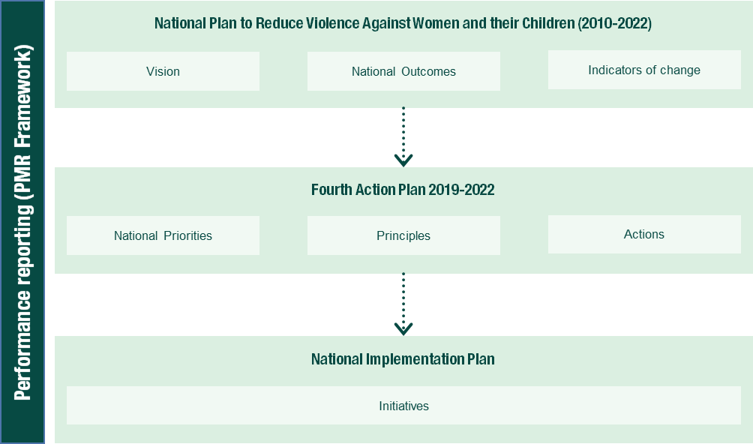

Source: Department of Social Services, National Plan to Reduce Violence against Women and their Children: Implementation Plan

Performance monitoring and reporting

A performance monitoring and reporting framework is under development. The draft document sets out program logics for each priority area including the outputs associated with each action under the five priority areas as well as short- and medium-term outcomes and measures by which success could be assessed. Development of a framework will support the broader evaluation of the National Plan which includes an evaluation of the Fourth Action Plan.

There will be iterative refinement of the draft framework and further work will be undertaken on mapping of measures, particularly in relation to outcomes. While considerable investment has been made in improving the evidence base, further work is required to improve outcome measurement to support future monitoring and evaluation efforts. This is particularly the case for measuring impacts on vulnerable groups including Aboriginal and Torres Strait Islander women, women from culturally and linguistically diverse (CALD) backgrounds and people who identify as lesbian, gay, bisexual, transgender, intersex, or queer (LGBTIQ).

The 4AP, which runs from 2019 to 2022, is in its second year of implementation with initiatives in various stages of progress. At this point in time, the focus of reporting is on progress of delivery of the initiatives under the National Implementation Plan (NIP) (that is, progress on outputs) rather than considering the short and medium-term outcomes. Outcomes will be considered more comprehensively in the evaluation. Outputs are the direct product of actions and measurement is focussed on whether initiatives are in place that will give effect to the action and the extent to which relevant initiatives are reaching their target audience.

In August 2020, all jurisdictions provided information on progress with initiatives to support an assessment of implementation status and progress on delivering outputs. Progress of initiatives was rated by jurisdictions into the following categories:

* **Completed according to schedule:** The initiative has been fully implemented in line with the anticipated timeframe.
* **Completed (but was delayed):** The initiative has been fully implemented but exceeded the anticipated timeframe.
* **Completed (ahead of schedule):** The initiative has been fully implemented ahead of the anticipated timeframe.
* **In progress on track:** The initiative has commenced, and implementation is progressing within expected timeframes.
* **In progress delayed:** The initiative has commenced but implementation has been impacted and is not progressing within expected timeframes.
* **Stopped:** The initiative has ceased.

This is the first progress report under the 4AP (which spans approximately the first 12 months) with the second report due in 2021.

In addition to the two progress reports for the 4AP, as noted previously, an evaluation of the National Plan is underway and due to be delivered in early 2022. The evaluation will assess the impact of the National Plan and its effectiveness in meetings its objectives and outcomes

First 4AP Progress Report

This progress report is structured as follows:

* **Priority areas of the Fourth Action Plan:** This sectionoutlines progress against the initiatives under each of the five priority areas and each of the 20 actions under the 4AP (that is, the outputs of the 4AP).
* **National Plan progress:** This sectionoutlines progress against the agreed indicators of change under the National Plan.
* **Next steps**: This section sets out the next steps in finalising monitoring of performance under the 4AP as well as timing around the evaluation of the National Plan as a whole.
* **Appendix A:** This section provides an overview of the approach to monitoring and reporting under the 4AP.
* **Appendix B**: The appendix outlines in detail each jurisdiction’s initiatives and how each jurisdiction is tracking on implementation of the 4AP.

# 02 Priority areas of the Fourth Action Plan

Overview

Within the five Priority Areas under the NIP (dated November 2019), there are a total of 164 in scope initiatives being delivered by the Commonwealth, state, and territory governments to support the objectives and outcomes of the 4AP. These initiatives span a broad range of areas including changes in legislation; prevention campaigns; expansion of services and access to remote technology; workforce development; healthy relationships education; and initiatives to improve collaboration between government, non-government organisations, and communities.

Overall, progress in the first year of the 4AP has been positive. Eighteen initiatives have been completed as per their original schedule and one initiative has been completed ahead of schedule. These include the establishment of men’s behaviour change programs, expansion of services for high-risk groups, new positions to support Aboriginal and Torres Strait Islander families, and training on technology-facilitated abuse. In addition to the completed initiatives, 86 per cent (124 of 144) of the remaining initiatives are in progress and on track to be delivered.

At the time of reporting, 20 of 164 initiatives were in progress but delayed and one initiative was completed behind schedule. The majority of these initiatives have been delayed as a result of COVID-19. For example, the Commonwealth’s Stop it at the Start Campaign was paused and a new campaign, *Help is Here*, for the COVID-19 pandemic was rolled out. The Stop it at the Start campaign will recommence later in the implementation of the Fourth Action Plan. Further, a number of state and territory initiatives were limited in their capacity to undertake community consultation as a result of COVID -19. None of the delayed initiatives appear to present a significant risk to the successful implementation of the 4AP. The implementation status of initiatives is shown in the following figure.

Figure 3: Progress of initiatives under the 4AP

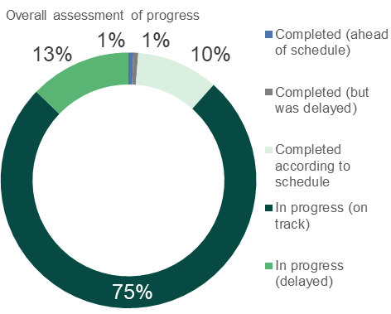

Source: Jurisdictional input

The following sections outline progress against each of the five priority areas under the 4AP. It should be noted that initiatives have been counted more than once if they span multiple priority areas and multiple actions. In the following sections, progress is reported as follows:

* Progress of initiatives under the action with examples provided of achievements to date.
* Case studies illustrating in greater detail the initiatives being implemented under the action.

A complete list of initiatives under the 4AP and their progress in each jurisdiction is available at Appendix B.

COVID-19

While the COVID-19 pandemic has impacted all jurisdictions in new and challenging ways, it has also presented unique opportunities to adjust the way services are delivered, and as such, how initiatives under the 4AP have been implemented.

Due to social distancing and travel restrictions, there have been reduced opportunities for face to face consultations and service delivery and access to remote and Aboriginal communities has been limited. This has led to the emergence of adaptive service models, including a shift to online service delivery, consultations and training which in some cases has enabled broader access to services.

At the same time, increased vulnerabilities within the population, escalating unemployment, and mental health impacts have led to pressure on services due to increased demand. In some cases, this has led to increased funding from Commonwealth, state, and territory governments in order to meet this demand.

Government responseS to COVID-19

On 29 March 2020, the Prime Minister announced a $150 million Domestic Violence Support Package to respond to expected increase in demand resulting from COVID-19.

Under the Package, the Commonwealth has provided $130 million through the National Partnership on COVID-19 Domestic and Family Violence (DFV) Responses to states and territories to invest in services to support women and children who are experiencing or at risk of violence during the pandemic.

The remaining $20 million under the Domestic Violence Support Package was directed to boost existing Commonwealth programs such as 1800RESPECT and the Support for Trafficked People Program as well as fund initiatives for families affected by, or at risk of experiencing, domestic and family violence during COVID-19.

In addition to the Domestic Violence Support Package, the ACT contributed an additional $3 million in funding to support people facing homelessness or DFV arising from the COVID-19 pandemic. The funding allows for specialist homelessness and DFV services to expand their operational capacity and relieve the pressure of additional need during COVID-19 health crisis.

The Western Australian Government has invested more than $28 million, as part of the WA Recovery Plan, to help address DFV in the community. The support package has been targeted to help keep WA’s most vulnerable community members safe and address the State's immediate social challenges following COVID-19. The support package includes funding to bolster the State's DFV response teams; expand the two new women's refuges being built by the State Government; support mobile outreach workers across women’s refuges; increase family and domestic violence counselling, advocacy and support services; and implement a program to support women who are living in DFV refuges to gain employment skills, access career training or retraining to support their pathways to employment post-COVID-19.

The Northern Territory Government responded to the expected increase in demand resulting from COVID-19 through immediate allocation of $300,000 of flexible support funding to services. Weekly meetings with specialist services allowed for resolution of operational issues due to bio-security measures and shared problem solving.

In South Australia, under COVID-19, a series of online roundtables were held to discuss the impacts of the pandemic on services, as well as on the women and children of South Australia. The Minister for Human Services and Assistant Minister for Domestic and Family Violence Prevention hosted these roundtables that built on previous roundtables held across metropolitan and regional South Australia.

The Victorian Government’s Multicultural COVID-19 Family Violence Program provides one-off funding to 20 multicultural, faith-based and ethno-specific organisations to raise awareness of the drivers of family violence in multicultural and faith communities and to support early intervention activities as part of Victoria’s COVID-19 response and recovery. Over $2 million in grants have been provided to strengthen the capacity of these organisations to deliver prevention and early intervention activities over two years. This work will support multicultural community members at risk of, or experiencing, family violence to access the support they need, including specialist family violence services through referral by these organisations.

The Queensland Government has been working closely with funded specialist services to support them to respond to the demands of the pandemic and to track emerging issues. In addition to Commonwealth funding received, the Queensland Government provided $7.5 million to boost service capacity and address increasingly complex client needs. Services supported include DFV and sexual violence (SV) support services, Aboriginal and Torres Strait Islander services, Women’s shelters and non-accommodation support services, women’s recovery services, and perpetrator intervention programs.

A range of measures have also been taken to increase protections for victims of DFV, including hosting the COVID-19 DFV Virtual Summit. This brought together experts, organisations and key stakeholders to share ideas on how to support DFV victims through the COVID-19 pandemic.

The Queensland Government also amended the Home Confinement, Movement and Gathering Direction to include accessing support from a DFV support service as an example of a permitted reason for leaving the principal place of residence, and progressed a new COVID-19 DFV awareness campaign to encourage adults and young people in Queensland to access DFV support, including victims, perpetrators and bystanders.

Additional measures include working in partnership with Telstra to explore a new digital platform to empower bystanders to recognise the signs of DFV and safely provide support, developing resources to support health workers and clinicians to understand and respond to increased DFV risk during COVID-19, and improving the police response to DFV in the context of challenges posed by COVID-19.

On 26 March 2020, the Tasmanian Government announced dedicated funding to respond to family and sexual violence during the COVID-19 pandemic, as part of the Tasmanian Government’s Social and Economic Support Package. $2.7 million was allocated across the family violence service system, including government and non-government services. The response ensures the service system is well prepared to respond to any future or ongoing impacts of COVID-19 in Tasmania.

Further, the Department of Communities Tasmania established the Family and Sexual Violence COVID-19 Sector Forum to promote information-sharing between the Government and the community sector and to enable the Government to be made aware of emerging issues for the sector.

The NSW Government has invested an additional $12.8 million for the sexual, domestic and family violence sector to respond to COVID-19. This funding builds the capacity of frontline specialist sexual, domestic and family violence services to respond to increase demand and complexity, supports victim-survivors to escape violent homes and to remain safely at home, holds perpetrators to account, and raises awareness about domestic and family violence and available supports. In addition, the NSW Government released a $34.3 million housing stimulus package that includes providing additional support to victim-survivors through the Start Safely program, increasing the supply and flexibility of temporary accommodation, and building capacity of homelessness providers. NSW Police Force also implemented strategies for monitoring high risk domestic violence offenders during COVID. The NSW Government continues weekly COVID meetings with the sexual, domestic and family violence sector to ensure responses are informed by the needs of the sector, as well as regular cross-agency meetings to ensure a coordinated whole-of-government response.

Priority One: Primary prevention is key

As stated in the Fourth Action Plan, prevention is the most effective way to eliminate violence against women and their children. This is achieved through changing attitudes and behaviours that justify or excuse violence and promoting positive attitudes of women and their children and gender equality. Priority One focuses on whole-of-population initiatives that address the underlying drivers of violence. There are five actions under this priority that range from primary prevention activities (including those tailored at specific communities including Aboriginal and Torres Strait Islander communities), better and more targeted coordination of primary prevention activities, and healthy relationship education for children and young people.

Figure 4 outlines the proposed program logic for Priority one. It shows the outputs that can be observed through implementation of the various NIP initiatives as well as proposed short term and medium-term outcomes that can be expected to be achieved over the next three to five years. As noted, it is too early to consider short and medium-term outcomes associated with 4AP initiatives. Significant investments in research and data have been made over the period of the National Plan and data development activities are continuing to support the improved measurement of outcomes including in the area of primary prevention area. Outcomes and measures will continue to be developed further as part of the evaluation of the National Plan.

Figure 4: Priority 1 DRAFT program logic

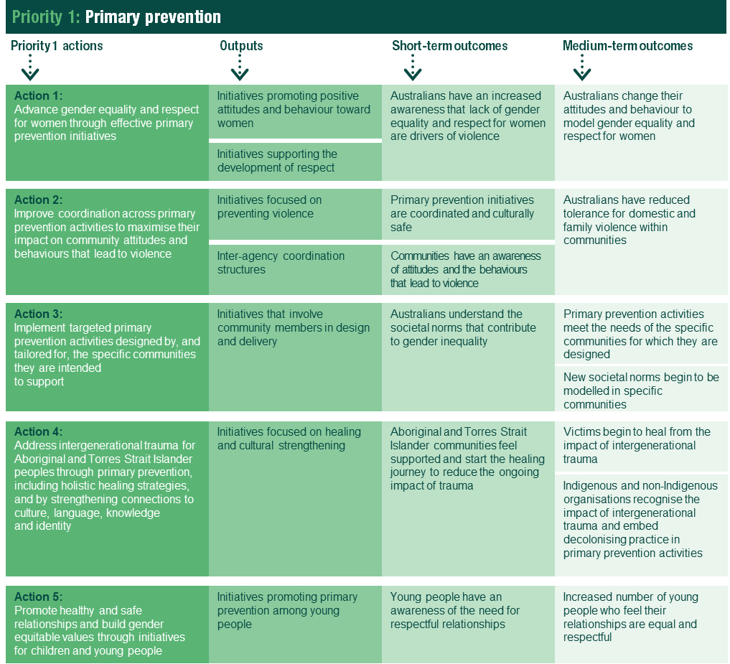

Source: Draft Performance Monitoring and Reporting Framework (PMR)

As demonstrated in the figure below, the majority of initiatives under Priority One are on track, with some delays primarily due to the impact of COVID-19. For example, in the Australian Capital Territory, the DFV Training Strategy has been developed, however delivery of the training has slowed due to COVID-19. Highlights of achievements and case studies under each action are provided in the sub-sections below.

Figure 5: Progress of initiatives under priority 1

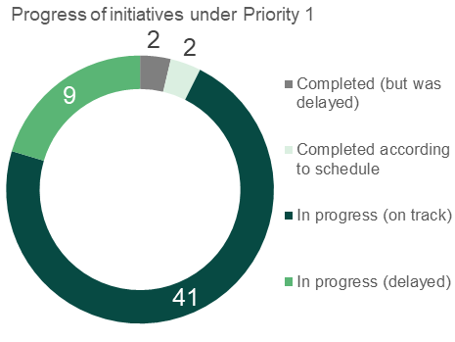

Source: Jurisdictional input

Action 1:   
Advance gender equality and respect for women through effective primary prevention initiatives

Seventeen initiatives from the NIP relate to Action 1 including initiatives related to financial abuse, community awareness raising activities and the development of statewide frameworks to guide activities and focus efforts. The outputs associated with Action 1 are initiatives promoting positive attitudes and behaviours towards women. Of these initiatives, one has been completed according to schedule, 12 are in progress (on track), and four are in progress (delayed).

Key achievements

Some highlights of initiatives being delivered by jurisdictions under this action include:

* An evaluation of Phase 2 of Our Watch’s National Media project, funded by the Commonwealth, was completed in December 2019 and showed the program had increased understanding of domestic and family violence amongst journalists. Our Watch has commenced delivery of newsroom training to support the overall objectives of the project to positively influence the way the media reports on and engages with victims of violence.
* The *Gender Equality Act 2020*, which enshrines gender equality in legislation, was passed in Victoria on 20 February 2020 and commenced on 31 March 2021.
* NSW has developed two action plans under the *NSW Women’s Strategy 2018-2022* with a third currently under development. These initiatives cover three priority areas: economic opportunity and advancement; health and wellbeing; and participation and empowerment.
* South Australia is utilising the Our Watch Workplace Equality and Respect Standards to ensure that participating public sector agencies are equipped to apply best practice approaches to promoting workplace gender equality.
* The Australian Capital Territory has developed and is delivering a range of products under the DFV Training Strategy aimed at enhancing staff capabilities in understanding and responding to DFV. In 2019-20, over 1,400 staff have participated in the Foundation eLearn and over 580 participated in the Foundation Manager face to face training.
* The Northern Territory has released a Gender Equality Statement of Commitment to provide a whole of government and community approach to driving equality for women, men and people with diverse gender identities.
* The Our Watch *No Excuse for Abuse* Campaign appeared across a number of platforms in May and September 2020 to highlight the impact of non-physical violence and support the Commonwealth’s COVID-19 pandemic response.
* Western Australia is rolling out its Respectful Relationships Teaching Support Program to help school staff teach students about healthy and positive relationships in the context of DFV prevention with 28 schools participating in the program to date.

Case studies

|  |  |  |
| --- | --- | --- |
| *No Excuse for Abuse* Campaign | Decorative |  |

Our Watch’s *No Excuse for Abuse* was first launched in 2018. The campaign appeared across a number of media platforms in May and September 2020 emphasising that the stressors of the COVID-19 pandemic, such as unemployment, financial difficulties and social isolation, do not excuse violence.

After the campaign was aired in May, an evaluation was conducted which found No Excuse for Abuse made an impact on viewers. Both men (70 per cent) and women (83 per cent) agreed that the campaign is especially important in the context of the COVID-19 crisis. One in three Australians who had seen No Excuse for Abuse said it prompted conversations with friends and family about non-physical types of abuse. The study did not examine whether changed awareness had any impact on behaviour change.

|  |  |  |
| --- | --- | --- |
| Gender equality legislation | Decorative |  |

Legislation to enshrine gender equality has now been introduced in Victoria. The *Gender Equality Act 2020* was passed on 20 February 2020 and commenced on 31 March 2021. In September 2020, the Victorian Government announced the appointment of the first Public Sector Gender Equality Commissioner, Dr Niki Vincent. Dr Vincent will commence in the role in late October and will be responsible for overseeing implementation of the Act and play a key leadership role in promoting gender equality in the Victorian community and workplaces. Under the Act, the Victorian public sector, universities and local councils with 50 or more employees will be required to demonstrate meaningful progress towards workplace gender equality. These organisations will also be required to consider and promote gender equality across policies, programs and service delivery. In preparation for the Act, 10 local councils and eight public entities are participating in implementation pilots, including piloting gender impact assessment toolkits and workplace gender auditing within their organisations to prepare for their obligations under the Act. These achievements are a significant step towards advancing gender equality in Victoria.

Action 2:   
Improve coordination across primary prevention activities to maximise their impact on community attitudes and behaviours that lead to violence

Eleven initiatives under Action 2 focus on consolidated and coordinated primary prevention activities. These include development of primary prevention models and hubs, proactive policies, and statewide frameworks. The relevant outputs associated with Action 2 are initiatives focussed on preventing violence and initiatives on inter-agency supporting structures. Of these initiatives, one is completed as per schedule, one is completed but was delayed, seven are in progress (on track), and two are in progress (delayed).

Key achievements

Key achievements under this action include:

* Our Watch finalised and published the Commonwealth-funded Prevention Toolkit for Local Government in July 2020 help local governments prevent violence against women in their workplaces and communities.
* Work on the National Primary Prevention Hub, funded by the Commonwealth, commenced in 2019. Our Watch has scoped and mapped the existing prevention workforce including 44 consultations with external stakeholders.
* To improve early intervention and pathways into specialist services, NSW is developing a new expanded program model under the New Street program (a program for children with harmful sexual behaviours under the age of criminal responsibility).
* A Northern Territory Violence Prevention Community of Practice is being established to share lessons of what works in preventing violence.
* South Australia has established a Primary Prevention group comprising a range of community services which will support development of a statewide Primary Prevention Plan.
* The Tasmanian Government, in partnership with Our Watch, has established an Our Watch Senior Adviser Tasmania role.
* Respect Victoria is currently working with the Victorian Crime Statistics Agency on the development of a Prevention Data Platform to be completed in early 2021.
* Queensland’s *Domestic and Family Violence Corporate and Community Forum: Safe* *at home, work and play* was held in September 2019, bringing together 130 organisations who heard from specialists about the DFV sector, and shared best-practice examples of addressing DFV in the workplace. Twenty-four organisations have since taken a public pledge committing to working to end DFV in Queensland. Queensland has also formed partnerships with organisations such as Telstra, the Local Government Association of Queensland and the National Retail Association to initiate programs and projects to further create awareness of DFV and its impacts within their workplaces and networks.

Case studies

|  |  |  |
| --- | --- | --- |
| Primary Prevention Data Platform | Decorative |  |

Victoria's Primary Prevention Data Platform will drive evidence, outcomes and monitoring in violence prevention through the development of a comprehensive and coordinated data platform. The new data platform will provide policy makers, researchers and practitioners with the data and tools to track population-level progress towards the prevention of DFV. The platform will enable monitoring and the evaluation of progress on prevention, as well as the ability to report on trends.

A dashboard will be published on the Crime Statistics Agency's website. A conceptual framework for the dashboard has established the structure and data collections required. The data collection is being progressed against 21 indicators that are informed by Victoria's Primary Prevention Outcomes Framework. The prototype is being developed for launch in March 2021.

|  |  |  |
| --- | --- | --- |
| Dedicated Our Watch Primary Prevention Officer | Decorative |  |

Tasmania has implemented a national-first primary prevention partnership model launched between the Tasmanian Government and Our Watch, establishing an Our Watch Senior Adviser Tasmania role. The successful candidate commenced their role in March 2020. The first priority has been to undertake stakeholder engagement to identify primary prevention gaps, opportunities and community priorities for projects across the State.

The Our Watch Senior Adviser Tasmania will work closely with government and non-government services to implement key Our Watch projects in Tasmania; work with Our Watch Ambassadors to promote primary prevention activities in Tasmania; and provide organisations with advice on building primary prevention capacity and expertise within their organisations and communities. A dedicated resource will support ongoing focus and effort in primary prevention in the jurisdiction.

Action 3:  
Implement targeted primary prevention activities designed by, and tailored for, the specific communities they are intended to support.

Key achievements

A total of 12 initiatives from the NIP related to this action including grants programs and community-led projects such as awareness raising campaigns. The relevant outputs associated with Action 3 are initiatives focussed on engaging with specific communities to ensure messaging is relevant and appropriate. Progress has been positive with 11 of the 12 initiatives in progress and on track and one initiative completed (but delayed).

Some key achievements under this action include:

* NSW has allocated $20 million for 20 innovative projects focused on prevention, early intervention, and crisis response for DFV under the NSW DFV Innovation Fund.
* In the Northern Territory, the *Mums Can, Dads Can Project* is a family, domestic and sexual violence primary prevention project developed by Town Camp community members and delivered in Alice Springs through the Tangentyere Family Violence Prevention Program. It challenges rigid gender stereotypes regarding the roles of men and women in parenting.
* Queensland ran the DFV Help Seeking Campaign from December 2019 to April 2020, targeting adult and young Queenslanders affected by DFV to encourage them to seek support.
* Queensland also partnered with the Queensland Aids Council to design and deliver a training program to the DFV sector – “Queer without Fear” to increase awareness and understanding of DFV in LGBTIQ communities. More than 30 workshops were held across the state with in excess of 400 participants from more than 70 different services.
* Sixteen community organisations across Australia are helping to prevent violence against women and their children in their local communities through the Commonwealth’s community-led Primary Prevention Projects grants.
* Under the Victorian *Primary Prevention Behaviour Change Campaigns,* Respect Victoria has developed and delivered a series of campaigns designed to change the social norms, attitudes and behaviours that allow family violence and violence against women to occur in the first place.

Case studies

|  |  |  |
| --- | --- | --- |
| New engagement and communication strategies including responding to COVID-19 | Decorative |  |

Queensland successfully delivered the DFV Help Seeking 2019-2020 Campaign, which ran from December 2019 to April 2020. The campaign was developed under Queensland's Domestic Family Violence Prevention Engagement and Communication Strategy 2016-2020, which sets a vision to create cultural change within Queensland over a ten-year period, and represents a new approach to DFV engagement and communication, creating an environment that encourages new ways of thinking and innovation. The initiative aims to deliver new communication and engagement responses focused on raising awareness and understanding of DFV. It also aims to increase the visibility of help and support services within Queensland.

The DFV Help Seeking 2019-20 campaign was extended to respond to the immediate need for public safety messaging regarding DFV, due to the impacts of COVID-19 on the community. This campaign extension bridged a gap in advertising, with a specific COVID-19 and DFV Awareness Campaign subsequently launching in May 2020. An evaluation of the DFV Help Seeking Campaign was conducted in April and May, and was found to have positive results.

Queensland’s COVID-19 and DFV Awareness Campaign ran from May to September 2020, promoting critical public safety messaging, highlighting that support services continue to operate, during COVID-19 and encouraging bystander activation.

|  |  |  |
| --- | --- | --- |
| Targeted Behaviour Change Campaigns | Decorative |  |

Under the Victorian Primary Prevention Behaviour Change Campaigns, Respect Victoria has developed and delivered a series of campaigns designed to change the social norms, attitudes, and behaviours that allow family violence and violence against women to occur in the first place. The campaigns have been carefully targeted to address the needs of different cohorts and risks to women in different settings. They have also encouraged people to be active bystanders helping people recognise the signs of danger and how they can step in when safe to do so to prevent the situation from escalating.

Respect Victoria has now delivered four behaviour change campaigns, including ‘Respect Women: Call It Out’ (in two distinct settings), ‘Respect Older People: Call It Out’ and ‘Respect Each Other: Call It Out’ (a dedicated family violence prevention campaign COVID-19). These campaigns have received wide exposure having been highlighted on a range of broadcast, print and digital media statewide. Research on the impact of the campaigns showed that that close to half of all Victorians were able to recall the public transport Respect Women: ‘Call it Out’ campaign and its key messages unprompted.

|  |  |  |
| --- | --- | --- |
| Community-Led prevention projects | Decorative |  |

The Commonwealth’s community-led prevention projects are working to change behaviours and attitudes that contribute to violence against women and children. For example, the RESPECT Program is being delivered to boys up to 15 years of age in schools across Bankstown. It is a school education program that involves a series of talks, exercises and the development of a song and music video that is released online and performed at various domestic violence education related community events, conferences and seminars. The aim is to promote gender equality and help prevent violence-supportive attitudes being developed.

Another project aims to assist Muslim men through delivery of a culturally appropriate ambassador program to over 72 ethnic groups in Sydney, Darwin, Melbourne and Perth. The program focuses on challenging the underlying cultural factors that support violence against women and children.



Action 4:   
Address intergenerational trauma for Aboriginal and Torres Strait Islander peoples through primary prevention, including holistic healing strategies, and by strengthening connections to culture, language, knowledge and identity.

Key achievements

There are four initiatives under the NIP relating to this Action, the outputs of which are initiatives that aim to address intergenerational trauma for Aboriginal and Torres Strait Islander peoples through primary prevention including holistic healings and cultural connections. Of these, three are in progress (on track), and one is in progress but has been delayed.

A key achievement under this action includes:

* Victoria’s *Dhelk Dja: Safe Our Way - Strong Culture, Strong People, Strong Families* remains on track although some initiatives under Dhelk Dja have been impacted by COVID-19.

Action 5:   
Promote healthy and safe relationships and build gender equitable values through initiatives for children and young people

Under the NIP, 11 initiatives focus on education programs for children and young people under Action 5. The relevant outputs associated with this action are initiatives focussed on promoting healthy relationships and embed messages of gender equality. Of these initiatives, one has been completed according to schedule, nine are in progress (on track) and one in progress (delayed).

Key achievements

Key achievements under this action include:

* The Commonwealth has allocated $2.8 million over three years to support uptake of the Respect Matters program to support teachers in educating students about safety, consent and wellbeing.
* Functional Family Therapy - Child Welfare (FFT-CW) and Multisystemic Therapy, Child Abuse and Neglect (MST-CAN) have been fully implemented across NSW.
* NSW’s *Child protection education in school’s* initiative is designed to develop teacher understanding around delivering learning experiences that provide a safe and supportive learning environment.
* Both the Queensland and Tasmanian Governments are continuing to deliver and embed Respectful Relationships education programs in schools.

Case studies

|  |  |  |
| --- | --- | --- |
| Breaking the inter-generational cycle of DFV | Decorative |  |

Among other priorities, the Northern Territory Government aims to promote healthy and safe relationships and build gender equitable values through initiatives for children and young people under the Safe, Respected and Free from Violence Prevention Grants program. The grants program sits under the *Northern Territory’s Domestic, Family and Sexual Violence Reduction Framework 2018-2028 Action Plan 1: Changing Attitudes, Intervening Earlier and Responding Better 2018-2021.*

The grants program supports localised evidence-based prevention and early intervention projects that aim to break the intergenerational cycle of DFV. The Northern Territory Government has invested over $2 million in the Safe, Respected and Free from Violence Prevention Grants Program since 2018 by supporting a total of 28 violence prevention projects across the NT. Grant recipients included community-developed and community-led projects, social media campaigns, workshops, focus groups, pilot programs, and informational resources targeted at community members and young people across the Territory.

|  |  |  |
| --- | --- | --- |
| Respectful relationships education | Decorative |  |

Queensland’s *Respectful Relationships Education* initiative continues to support schools to embed respectful relationship education as well as build a culture of respect and gender equality in schools, by building school and teacher capability and confidence in delivering respectful relationships education.

The Tasmanian Government continues to deliver and embed Respectful Relationships education in all Tasmanian Government schools. These initiatives support children and young people in developing healthy and safe relationships; a critical component of primary prevention.

|  |  |  |
| --- | --- | --- |
| Child protection education | Decorative |  |

The NSW Government provides a proactive and comprehensive program for child protection education which is taught in all schools in NSW as part of the mandatory kindergarten to Year 10 (K–10) Personal Development, Health and Physical Education (PDHPE) syllabus. The syllabus includes strategies for building respectful relationships and resilience, as well as building skills in recognising and responding to unsafe situations, effectively seeking assistance and protective strategies appropriate to their age and stage of learning.

The initiative is on track, with resources being reviewed and updated by the Department of Education's PDHPE K-12 team. In addition, this initiative also aims to build teacher expertise to deliver lessons that address child protection syllabus content. This will help develop teacher confidence to deal with issues that may be considered sensitive or controversial by members of the community.

|  |  |  |
| --- | --- | --- |
| Innovative therapies | Decorative |  |

NSW’s Functional Family Therapy - Child Welfare (FFT-CW) and Multisystemic Therapy, Child Abuse and Neglect (MST-CAN) is a home-based treatment model for families with substantiated physical abuse and/or neglect of a child or young person aged between 0 and 17 years. It provides a family therapy-focused model for at-risk families.

There are currently six MST-CAN® teams in six locations and 18 FFT-CW® teams in 11 priority locations across NSW. Since the initiative commenced in 2017, there have been over 2,800 referrals accepted into the programs, including 787 Aboriginal families. As of June 2020, 1,194 families have completed both programs, including 315 Aboriginal families.



Priority Two: Support Aboriginal and Torres Strait Islander women and their children

Priority two of the 4AP aims to acknowledge and better respond to the unique experiences of violence of Aboriginal and Torres Strait Islander women and children. There are four actions under this priority which acknowledge the disproportionately high rates of violence for Aboriginal and Torres Strait Islander women, children and communities and the ongoing impact of discrimination, racism and intergenerational trauma on Indigenous women.

Figure 6 outlines the proposed program logic for Priority two. Success under this priority will be seen in strong partnerships and collaborations between Aboriginal and Torres Strait Islander communities and services, with initiatives being co-designed and community led in providing culturally safe supports for victims, their children and perpetrators. The actions in Priority two seek to address immediate and underlying drivers of domestic, family and sexual violence in Aboriginal and Torres Strait Islander communities; develop workforce capabilities to work with these communities; and empower communities through the implementation of innovative and community-led solutions. The draft program logic notes the outputs or initiatives that are observable when these actions are put in place as well as identifying short and medium-term outcomes. However, as noted previously, the logic model is under development and it is too early to focus on the outcomes in this report; as such outputs are the primary focus.

Figure 6: Priority 2 Draft program logic

This image shows the draft program logic for Priority 2, mapping actions to outputs to short and medium term outcomes.

Aboriginal and Torres Strait Islander people feel engaged and participate in the development of in community-led solutions

There is collective action with government and service providers to address the needs of Aboriginal and Torres Strait Islander people

Service providers feel confident holistic, trauma-informed and culturally safe supports to Aboriginal and Torres Strait Islander people

Aboriginal and Torres Strait Islander women and children have greater access to culturally responsive, holistic service

Aboriginal and Torres Strait Islander victims and perpetrators are aware of where they can go to access supports for safe healing and behaviour change

Aboriginal and Torres Strait Islander people are central to the design and delivery of services for their own communities

Strong partnerships and collaboration exist between Aboriginal and non-Aboriginal family violence services to share expertise and co-design culturally safe service

All initiatives accessed by Aboriginal and Torres Strait Islander women and their children offer culturally safe support

Aboriginal and Torres Strait Islander people are engaged in and benefiting from Indigenous-led initiatives that strengthen connection to culture, Country and community

Aboriginal and Torres Strait Islander victims feel supported and perpetrators demonstrate behaviour change and contribution to community life and begin the healing process

There is systemic change which embeds prevention of domestic and family violence in Aboriginal and Torres Strait Islander communities

Aboriginal and Torres Strait Islander people are leaders in the development of solutions

Source: Draft Performance Monitoring and Reporting Framework (PMR)

Initiatives under this priority seek to involve Aboriginal and Torres Strait Islander people and communities in the design and delivery and governance of programs, as well as focus on collective action and the co-location of services for greater access. As noted previously, for each priority, it is expected that progress will primarily be observed in outputs; that is, implementation of initiatives under the NIP.

As demonstrated in the figure below, the majority of initiatives are on track, with some delays primarily due to the impact of COVID-19. This is partly because outputs or initiatives under this priority include the involvement of Aboriginal and Torres Strait Islander communities who may be located in a remote or rural part of Australia. Access to these communities has been limited in order to combat the impact of COVID-19. The figure below highlights the achievements and examples of progress under each action are provided in the sub-sections below.

Figure 7: Progress of initiatives under priority 2

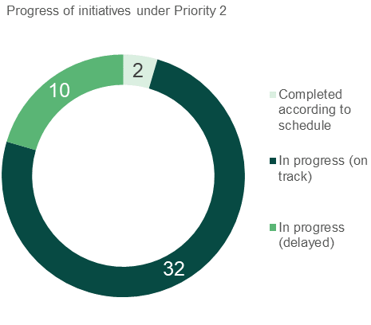

Source: Jurisdictional input

Action 6:   
Value and engage the expertise of Aboriginal and Torres Strait Islander women and men, communities and organisations to lead in the creation and implementation of community-led solutions to build and manage change

Initiatives under this action include efforts to better engage Aboriginal and Torres Strait Islander communities in the responses that impact them. Under the NIP, 13 initiatives relate to action 6, with nine being in progress (on track) and four in progress (delayed). The associated outputs in this action are initiatives that involve Aboriginal and Torres Strait Islander people in the design and delivery and Aboriginal led community solutions to build and manage change.

Key achievements

Achievements under this action include a range of initiatives to empower Indigenous people and communities in developing and implementing solutions that impact their communities:

* The Northern Territory’s *NO MORE campaign* works with men and Indigenous communities to raise awareness and develop local responses to reduce family, domestic and sexual violence across the Territory.
* Queensland is currently engaging with Community Justice Groups in 18 discrete Aboriginal and Torres Strait Islander communities to provide appropriate community based and designed programs responding to DFV in a culturally appropriate way.
* Queensland is supporting two remote Aboriginal and Torres Strait Islander communities to develop community-led DFV action plans from 2019–20 to 2020–21.
* The Western Australian Government’s *Path to Safety Western Australia’s strategy for to reduce family and domestic violence 2020-2030* includes a priority action to work with Aboriginal people and communities to co-design and implement a dedicated Aboriginal Family Safety Strategy.

Case studies

|  |  |  |
| --- | --- | --- |
| Developing local responses | Decorative |  |

The Northern Territory’s NO MORE campaign works with men and Indigenous communities to raise awareness and develop local responses to reduce family, domestic and sexual violence across the Territory. The Northern Territory Government is providing $1.8 million to the NO MORE Campaign from 2019-20 to 2023-24. To date, the NO MORE campaign has established over 60 domestic violence action plans in urban and remote sport clubs across the NT, as well as delivered educational sessions and events across communities such as Kalano, Katherine, Palmerston, Tennant Creek, Wurrumiyanga, Lajamanu. While the initiative has had to change its delivery due to COVID-19, an additional campaign of “now More than Ever” was established to bring further awareness to DFV in response to COVID-19.

|  |  |  |
| --- | --- | --- |
| Elevating women’s voices | Decorative |  |

The Commonwealth Government has invested $1.7 million to support the delivery of Stage Two of the Wiyi Yani U Thangani (Women’s Voices) project under the Fourth Action Plan, led by Aboriginal and Torres Strait Islander Social Justice Commissioner, Ms June Oscar AO.

Stage Two of the project will commence following the launch of the landmark Wiyi Yani U Thangani Report in December 2020. It aims to build on the momentum of the Stage One’s nation-wide consultation of Aboriginal and Torres Strait Islander women and girls to improve partnerships between communities, organisations and governments, engage more communities in additional dialogues and develop tools and resources for Indigenous women and girls to start driving local change.

Action 7:   
Build the workforce capability to ensure delivery of high quality, holistic, trauma-informed and culturally safe supports that respond to the complex needs of Aboriginal and Torres Strait Islander women and their children

Under the NIP, nine initiatives sit within this action, the outputs of which aim to build workforce capability and capacity sit under action 7. Eight of these initiatives are in progress (on track) and one is in progress (delayed).

Key achievements

Highlights under this action include:

* WorkUP Queensland was launched in May 2019 as a workforce capability and capacity building service for a number of sectors.
* In Western Australia*,* two community-based agencies have received funding to improve service pathways and reduce barriers to access support services for women and children from Aboriginal and CALD backgrounds experiencing DFV.
* Under Victoria’s *Strengthening the Foundations: First Rolling Action Plan 2019-22*, work is being done to build the family violence capability in the youth and alcohol and other drugs sector, to support the complex needs of young people accessing these services.
* Development of a Northern Territory Workforce and Sector Development Plan is on track. This will focus on workforce capability, specialist service capacity, and development of the sector.
* NSW Health has commenced a project to increase and improve the capacity of NSW Health’s sexual assault services to provide appropriate therapeutic responses and support to Aboriginal clients. The scoping phase is under way and the NSW Education Centre Against Violence has is expanded its Aboriginal Workforce Development Team to increase the support available to services.

Case studies

|  |  |  |
| --- | --- | --- |
| Workforce capacity building | Decorative |  |

WorkUP Queensland, a partnership between the Healing Foundation and ANROWS, was launched in May 2019 as a workforce capability and capacity building service for the domestic, family and sexual violence and women’s health and wellbeing sectors. Based on significant consultation with specialist services regarding the identified regional priorities, WorkUP has developed unique Regional Workforce Plans to guide local training and development activities.

WorkUP has delivered training and professional development to specialist DFV workers, high risk teams, and generalist practitioners on a range of priority topics, including perpetrator interventions, complex trauma, self-care, strangulation, and inclusive service delivery. Ongoing priorities include building capability in inclusive service delivery for Aboriginal and Torres Strait Islander peoples and people from culturally and linguistically diverse backgrounds.

WorkUP has also launched the Collaborative Workforce Grant program, providing grants of up to $10,000 to support organisations to develop their responses to the workforce challenges of service delivery through collaborative projects.

|  |  |  |
| --- | --- | --- |
| Culturally appropriate programs | Decorative |  |

Under Western Australia’s Culturally Appropriate Family and Domestic Violence Services Grants Program, two community based agencies each receiving grant funding to improve service pathways and reduce barriers to access support services for women and children from Aboriginal and CALD backgrounds experiencing DFV, provide training to increase competency levels for professionals, and build the capacity of community leaders and elders in WA’s Aboriginal and CALD communities to help address DFV.

Notably, grant recipient Langford Aboriginal Association is delivering the Family Safety Project in metropolitan and regional locations which improves safety and wellbeing of Aboriginal women experiencing family violence using a co-designed approach, building cross-cultural awareness of family and domestic violence to help victims get the support they need.

This funding aims to support community organisations with cultural expertise to engage at a local level with victims, perpetrators, community leaders and community members to raise awareness about DFV and support victims to access culturally appropriate supports and services.

|  |  |  |
| --- | --- | --- |
| Targeted workforce recruitment campaign | Decorative |  |

Building from Strength – 10-Year Industry Plan for Family Violence Prevention and Response sets out the Victorian Government’s long-term vision for the workforces that are involved in dealing with DFV. It articulates a plan to build and strengthen the specialist and universal workforce to ensure they can assess and manage DFV risk are skilled at recognising the early signs of DFV and can respond appropriately.

Under this initiative, an attraction and recruitment campaign for specialist family violence and primary prevention workers was launched on Facebook by the Minister for Prevention of Family Violence on 27 May 2020. The campaign video has had 86,773 views, with 620 registered users on the jobs’ portal, 47 of which are employers who have uploaded jobs. The second phase of the campaign, which will target diverse audiences and students and graduates, will commence in 2021.

Action 8:   
Develop innovative and alternative models for victim and perpetrator support that contribute to safe healing and sustainable behaviour change

Under the NIP, 12 initiatives relate to action 8, ranging from culturally appropriate programs to the establishment of specialist positions. These initiatives aim to enable behaviour change through innovative interventions. Of these, two have been completed according to schedule, eight being in progress (on track) and two in progress (delayed).

Key achievements

Some key achievements under this action include:

* Queensland has embedded DFV specialist positions in Aboriginal and Torres Strait Islander Family Wellbeing Services.
* Tasmania has establishedAboriginal Family Safety Workers in Child and Family Centres in each region. These workers provide culturally appropriate support, engaging with Aboriginal families to deliver activities that promote family safety and address family violence and its impact on children.
* In South Australia, funding continues to be used to prevent young Aboriginal people from becoming involved in the youth justice system and to support the community to intervene early in family violence and child protection.
* The Northern Territory Government has invested to implement evidence-based and culturally appropriate men’s behaviour change programs and interventions for perpetrators.
* The Australian Capital Territory Aboriginal and Torres Strait Islander Domestic Violence Reference Group, under the Domestic Violence Prevention Council is conducting consultations to develop a community-led response for Family and Domestic Violence.
* The Western Australian Government is providing $2.6 million to extend the Kimberley Family Violence Service.
* NSW’s Integrated Domestic and Family Violence Services Program delivers a multi-agency response across 11 locations to prevent the escalation of domestic and family violence among high-risk target groups including victims from an Aboriginal and Torres Strait Islander background.
* The National Indigenous Australians Agency is working with nine service providers to co-design family violence reduction activities.

Case studies

|  |
| --- |
| DecorativeSpecialist DFV positions in Aboriginal and Torres Strait Islander community-controlled organisations |

The DFV specialist positions in *Aboriginal and Torres Strait Islander Family Wellbeing Services* initiative is an action under Queensland’s *Framework for Action – Reshaping our Approach to Aboriginal and Torres Strait Islander Domestic and Family Violence*, released in 2019. These positions are embedded within community-controlled Aboriginal and Torres Strait Islander Family Wellbeing Services.

These services work with families that may be experiencing vulnerability to assist them through access to culturally responsive support to improve social, emotional, physical and spiritual wellbeing and build individual capacity to safely care for and protect their children. The positions commenced in June 2020 with workers now recruited and service delivery underway in trial locations in the Gold Coast, Toowoomba, Rockhampton, Townsville and the Bowen regions. A reference group has been formed and meets fortnightly, comprising the five Family Wellbeing Service providers, the department and the Queensland Aboriginal and Torres Strait Islander Child Protection Peak.

|  |  |  |
| --- | --- | --- |
| Men’s behaviour change programs | Decorative |  |

The Northern Territory Government has invested to implement evidence-based and culturally appropriate men’s behaviour change programs and interventions for perpetrators, in Central Australia and the Top End of the territory.

The Northern Territory Government invests $1 million annually for the delivery of two men's behaviour change programs: one each in the Top End and Central Australia.

An evaluation of the two programs will be undertaken in 2020-21 to understand whether the two programs are achieving better outcomes and safety for women and children at risk of or experiencing DFV.

|  |  |  |
| --- | --- | --- |
| Culturally responsive support | Decorative |  |

Aboriginal family safety is a priority issue for Western Australia. The Kimberley Family Violence Service was piloted to support families and communities in the Kimberley by working collaboratively to provide wrap-around responses promoting the safety and recovery of adult and child victims, and reduction or management of the risk posed by the perpetrator. The service employed family violence workers in a number of locations across the Kimberley including Broome, Derby, Halls Creek, and Kununurra.

The Western Australian Government is providing $2.6 million to extend the Kimberley Family Violence Service trial for two years via the Addressing Family Violence in the Kimberley Grants Program. In line with the recommendations from an evaluation undertaken in 2018, proposals are being sought via a competitive grant process to develop place-based family violence evidence-based interventions that are flexible, culturally responsive, informed by local needs, and designed by or in partnership with Aboriginal Community Controlled Organisations. Stakeholders have been engaged to inform service elements with a focus on early prevention and building protective factors to enable wellbeing of individuals and families. This aligns with the Aboriginal Family Safety focus area of *Path to Safety Western Australia’s strategy to reduce family and domestic violence 2020 - 2030*, where actions to prevent and reduce family and domestic violence are flexible, culturally responsive and culturally secure to better meet the needs of Aboriginal people.

|  |  |  |
| --- | --- | --- |
| Co-design with Aboriginal and Torres Strait Islander organisations | Decorative |  |

The Commonwealth’s Practical intervention programs to work with Aboriginal and Torres Strait Islander people is on track. The National Indigenous Australians Agency is working with nine service providers to collaboratively-design (co-design) family violence prevention and reduction activities that meet the 4AP’s Indigenous-specific measures. These providers are located in Kununurra (Western Australia); Port Augusta and Ceduna (South Australia); Gove Peninsula (Northern Territory); Darwin (Northern Territory); Katherine (Northern Territory); Townsville (Queensland); and Mackay (Queensland). The co-design process is currently underway with service providers to develop tailored responses which are community-led, culturally safe, trauma-informed and meet the intent of the Indigenous-specific measures under the 4AP. Service providers have also developed evaluation frameworks and program logics to support future monitoring and evaluation activities.

Action 9:   
Address both the immediate impacts and deep underlying drivers of family violence in Aboriginal and Torres Strait Islander communities through collective action with governments, service providers and communities

Under the NIP, 10 initiatives under action 9 aim to better engage and support Aboriginal and Torres Strait Islander communities in addressing the drivers of violence. Of these, seven are in progress (on track) and three in progress (delayed).

Key achievements

Achievements under this action have included:

* State and territory governments signed the Closing the Gap Partnership Agreement between the National Coalition of Aboriginal and Torres Strait Islander Peak Bodies (Coalition of Peaks) and the Council of Australian Governments (COAG).
* A range of activities funded under the Third Action Plan continue to receive Commonwealth support under the 4AP, including continued funding for a number of providers such as some Family Violence Prevention Legal Services.

Case study

|  |  |  |
| --- | --- | --- |
| Aboriginal-led agreements | Decorative |  |

Victoria’s *Dhelk Dja: Safe Our Way – Strong Culture, Strong People, Strong Families* initiative is the key Aboriginal-led agreement that commits the signatories – Aboriginal communities, Aboriginal services and government – to work together and be accountable for ensuring that Aboriginal people, families and communities are stronger, safer and thrive, living free from violence. This outcome will be achieved in Victoria through five strategic priorities, including: One – Aboriginal culture and leadership, Two – Aboriginal-led prevention, Three - Self-determining Aboriginal family violence support and services, Four – System transformation based on self-determination and Five - Aboriginal-led and informed innovation, data and research.

The 2019-2022 Dhelk Dja 3 Year Action Plan in Victoria was endorsed by the Dhelk Dja Partnership Forum in November 2019. This plan details the actions and investments to give rise to the 10-year Dhelk Dja agreement.

The Dhelk Dja Partnership Forum has endorsed the Aboriginal Access Points Concept Model and the first three local areas where the AAPs will be established. The community-led co-design process, overseen by the Dhelk Dja Priority Four Sub Working Group continues to develop the AAP service model.



Priority Three: Respect, listen and respond to the diverse lived experience and knowledge of women and their children affected by violence

Under the Fourth Action Plan, governments committed to addressing the diversity and lived experiences of women and their children affected by violence. It is important to consider gender inequality together with other forms of social discrimination and disadvantage. Race, sexuality, gender and disability, amongst other forms of identity, can impact the way a woman experiences violence. In recognition of this, the three actions sitting within this priority area range from community-led initiatives, services that respond to high-risk and/or vulnerable groups, and sector capacity building initiatives to respond to cultural and complex forms of violence.

Figure 8 outlines the proposed program logic for Priority three. Priority three will be successful when people from vulnerable communities and at-risk groups are empowered to lead and develop their own initiatives to address domestic, family and sexual violence, with access to culturally appropriate and safe supports. The actions in Priority three seek to implement tailored initiatives to address the unique experiences and needs of communities affected by multiple forms of discrimination and inequality, deliver policies to address this disproportionate impact, and better equip the service system to respond to the unique needs of these groups. This figure also notes the outputs or initiatives that are observable when these actions are put in into place as well as identifying short term and medium-term outcomes. However, as noted previously outputs are the primary focus of this report.

Figure 8: Priority 3 Draft program logic

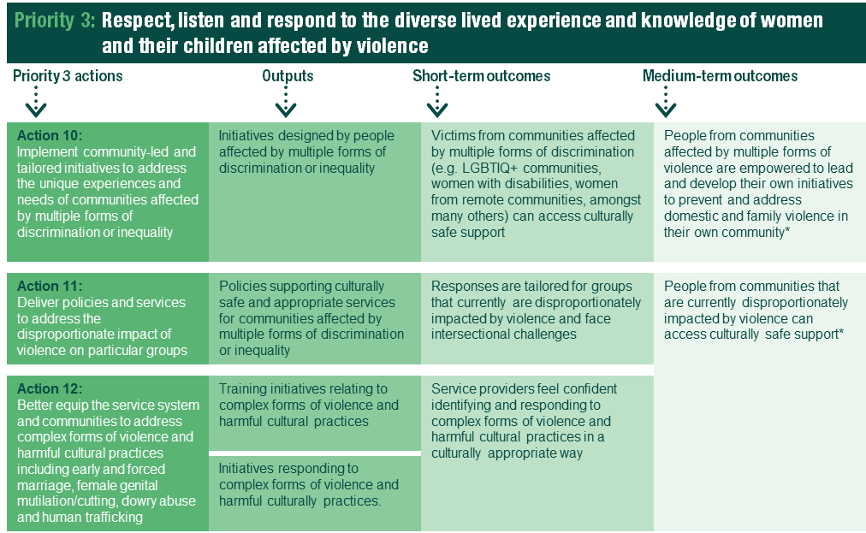

People from communities affected by multiple forms of violence are empowered to lead and develop their own initiatives to prevent and address domestic and family violence in their own community

People from communities that are currently disproportionately impacted by violence can access culturally safe support

Source: Draft Performance Monitoring and Reporting Framework (PMR)

Initiatives under this priority aim to encourage the establishment of programs that are designed and developed by the communities they are targeting to help them develop culturally appropriate and culturally safe services and better equip services to deal with complex forms of violence and harmful cultural practices. As noted previously, for each priority, it is expected that progress will primarily be observed in outputs; that is, implementation of initiatives under the NIP.

As demonstrated in the figure below, the majority of initiatives are on track, with some completed on or ahead of schedule, and minimal delayed initiatives. Highlights of achievements and examples of progress under each action are provided in the sub-sections below.

Figure 9: Progress of initiatives under priority 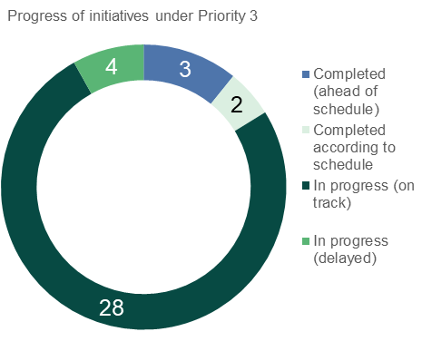 3

Source: Jurisdictional input

Action 10:   
Implement community-led and tailored initiatives to address the unique experiences and needs of communities affected by multiple forms of discrimination or inequality

Initiatives under this action support people from vulnerable groups such as children and young people, people with disability, and people who identify as LGBTIQ. Under the NIP, 11 initiatives relate to action 10, with 10 being in progress (on track) and one being in progress (delayed). The associated outputs for Action 10 are initiatives designed by people affected by multiple forms of discrimination or inequality.

Key achievements

Achievements to date under this action by jurisdictions include:

* The Australian Capital Territory’s Family Safety Hub, in partnership with the ACT Children and Young People Commissioner, listened directly to young people talk about their experiences of domestic and family violence, with a focus on which services and supports helped and which did not. Insights from these consultations have been published and shared at workshops and presentations for government and the service sector. During 2020-21, the Family Safety Hub will lead a co-design process to generate ideas and make changes to responses with the aim of better supporting young people.
* Child and Family Safety Networks are now in place in regions across South Australia to identify and support families with young children at high risk of domestic, family, and sexual violence. The Networks bring together government and non-government services that can support families.
* Tasmania’s Local Support Coordinator in the Safe Choices service provides practical support, information and advice for women with disability. This role has been extended to 30 June 2022.
* As part of the *NSW Sexual Assault Strategy 2018-2021*, the NSW Government is working with ACON to support frontline professionals to work meaningfully and effectively with people from the lesbian, gay, bisexual, transgender, intersex and queer (LGBTIQ) communities regarding sexual assault.

Case studies

|  |  |  |
| --- | --- | --- |
| Multi-agency responses | Decorative |  |

Collaboration is the hallmark of successful support systems for people experiencing violence. Child and Family Safety Networks are now in place in regions across South Australia to identify and support families with young children at high risk of domestic, family, and sexual violence. The networks bring together government and non-government services to support families, with South Australia working to create a holistic system for children’s safety within families experiencing domestic, family, and sexual violence. Another initiative, Australian Capital Territory’s Family Safety Hub - Health Justice Partnership, is in full operation. This service embedded a lawyer into health care sites across Canberra to provide free access to legal information, meaning women and their families can access free and confidential legal advice, practical assistance and targeted support.[2]

|  |  |  |
| --- | --- | --- |
| Responding to the needs of young people | Decorative |  |

The Australian Capital Territory’s Family Safety Hub and the ACT Children and Young People Commissioner ran a series of consultations with young people to hear directly from them about their experiences of domestic and family violence. Consultations were held over a period of six months and involved young people aged 13 to 20. Seventy young people participated, 35 of whom had experienced domestic and family violence.

What was heard during the consultations has been distilled into 13 insights. The insights speak to the unique and complex experience young people have of domestic and family violence.

The Family Safety Hub and Children and Young People Commissioner have shared insights from the consultations across government and the service sector.

The insights will inform a co-design process led by the Family Safety Hub to design and deliver supports and services for children and young people affected by domestic and family violence.

Action 11:   
Deliver policies and services to address the disproportionate impact of violence on particular groups

Under the NIP, 21 initiatives relate to action 11 ranging from innovation funds and program extensions, service gap identification, and program redesigns. These aim to deliver supports to communities and groups that are particularly vulnerable to violence. One of these initiatives has been completed according to schedule, two completed ahead of schedule, 16 are in progress (on track), and two are in progress (delayed).

Key achievements

Achievements under this action include:

* The Australian Research Centre in Sex, Health and Societies at La Trobe University has been engaged to research the quality and availability of services for LGBTIQ people who experience violence. La Trobe are consulting LGBTIQ communities and organisations to understand and identify gaps in service delivery. These findings will be used to develop targeted guidance material to enable service providers to provide appropriate and meaningful services to LGBTIQ people experiencing violence.
* The Specialised Family Violence Service network has been enhanced and expanded with $10 million allocated (over 2019-20 to 2021-22) under the Fourth Action Plan of the National Plan. From July 2020, eight new providers commenced delivering Specialised Family Violence Services. From October 2020, four Aboriginal Community Controlled Organisations in the Northern Territory commenced services, (bringing the total number of providers to 35 nationally). The 23 original Specialised Family Violence Service providers received additional funding to expand or enhance their current services.
* Under the Queensland Government’s plan to respond to DFV against people with a disability, the Government has established a Consultative Working Group comprising members with lived experience of disability and/or DFV or those that work with, or advocate on behalf of people with lived experience. The Consultative Working Group provides informed input to government agencies to support implementation of actions under the Plan.
* The Ageing and Disability Commission commenced in NSW on 1 July 2019, equipped with a range of functions aimed at improving the prevention, identification and response to abuse, neglect and exploitation of adults with disability and older people in NSW, including older women.

Case studies

|  |  |  |
| --- | --- | --- |
| Working with at risk young people | Decorative |  |

The NSW Government’s *Youth Justice Domestic and Family Violence Strategy 2019 – 2022* is a coordinated approach to addressing the needs of young people who commit or are victims of DFV and come into contact with the youth justice system. The *Youth Justice Domestic and Family Violence Strategy* includes a number of actions and projects under the seven key themes of raising awareness, stakeholder collaboration, early intervention and diversion, support in courts, safety planning and referral pathways, workforce capability and programs and interventions.

Current achievements include providing targeted e-Learning training for Youth Justice NSW staff to raise awareness about domestic and family violence via an e-Learning platform, collaboration with cross government reviews to promote the need for supports for young people, including adolescents who use violence, launch of an internal communication platform for Youth Justice NSW staff to keep up to date with the Strategy, additional resources and research, engaging with the University of Sydney to commence Phase 1 of the Understanding Apprehended Domestic Violence Order Conditions project and providing training for clinical staff to develop and deliver a pilot Dialectical Behavioural Therapy program.

|  |  |  |
| --- | --- | --- |
| Specialised Family Violence Services | Decorative |  |

The Department of Social Services has sought to expand the number of Specialised Family Violence Services providers through funding Indigenous organisations in the Northern Territory. The trial, which runs 2020-21 to 2021-22 includes a new approach to service provision.

The purpose of this grant is to contribute to the strategic vision of the National Plan to Reduce Violence against Women and their Children 2010-2022 in terms of its commitment that ‘Australian women and their children live free from violence in safe communities’.

This will be achieved by improving and expanding culturally age appropriate services and supports specifically for Indigenous children and young people who have been impacted by family and domestic violence.

|  |  |  |
| --- | --- | --- |
| Policy and practice leadership | Decorative |  |

Victoria’s Family Violence Multi Agency Risk Assessment and Management Framework (MARAM) aims to ensure professionals and services across the system have a shared understanding of family violence, and provide consistent and collaborative practice

Victoria has now developed the MARAM Framework and Practice Guides for all adult and child family violence victim survivors, which recognise and address experiences of risk across Aboriginal and diverse communities, using a person-centred, trauma-informed and intersectional design approach. The MARAM reform (focussing on victim survivors) is being implemented across a range of organisations. The perpetrator focussed MARAM Practice Guides and tools will be released in February 2021.

|  |  |  |
| --- | --- | --- |
| Supporting innovative approaches | Decorative |  |

Under the *NSW Domestic and Family Violence Innovation Fund* initiative, $20m for 20 innovative projects across two rounds is being delivered. The first round funded seven projects valued at $4.8m over three years (2017-18 to 2019-20) and the second round funded 13 projects worth $12m over three years (2018-19 to 2020-21). All 20 Innovation Fund projects have commenced, including 14 projects focused on prevention and early intervention, and six focused on crisis response. Projects are delivered in high priority local communities including CALD communities, Aboriginal and Torres Strait Islander communities, rural communities, refugees and people with disability.

The Kalypi Paaka Mirika Healing Program, implemented by Maari Ma in western NSW delivers a culturally based healing program within Aboriginal communities to address trauma and prevent DFV. The program has been developed by and for Aboriginal communities incorporating western trauma healing practices within an Aboriginal cultural framework to support participants to manage and cope with stressors that negatively impact their well-being, coping and behaviour and aims to address the varied causes of violence in Aboriginal communities. Program monitoring indicates positive outcomes for participants.

Action 12:   
Better equip the service system and communities to address complex forms of violence and harmful cultural practices including early and forced marriage, female genital mutilation/cutting, dowry abuse and human trafficking

Under the NIP, five initiatives relate to action 12, including partnerships with cultural leaders, and extending specialist programs. These aim to support professionals and communities to better respond to complex and/or cultural forms of violence. Of these, one has been completed ahead of schedule, three are in progress (on track) and one is in progress (delayed).

Key achievements

Achievements under this action include:

* In June 2020, the Tasmanian Government launched the Safe from Violence website to provide accessible targeted information and resources about family and sexual violence.
* The South Australia Government, along with Women's Safety Services SA and Multicultural Communities Council of SA, is preparing information about domestic, family, and sexual violence for faith and community leaders to assist with identifying and responding to DFV. Community consultation will also be undertaken to identify the best way forward regarding potential training and information sharing.
* The Commonwealth’s *Extend the Support for Trafficked People program* has been completed ahead of schedule with the Australian Red Cross delivering the Program nationally since 2009, and additional funding allocated under the Fourth Action Plan for 2020-21 and 2021-22. These initiatives enable development of tailored, culturally appropriate responses for high-risk groups.

Case study

|  |  |  |
| --- | --- | --- |
| Accessible information | Decorative |  |

In June 2020, the Tasmanian Government launched the Safe from Violence website. This website is a key action under the *Safe Homes, Families, Communities: Tasmania’s action plan for family and sexual violence 2019-2022* *(Safe Families, Homes, Communities)* which invests $26 million over three years from 2019-20 to 2021-22 to prevent and respond to family and sexual violence in Tasmania. The Safe from Violence website provides targeted information, online resources and links about family and sexual violence for a range of audiences including victim-survivors, perpetrators, family and friends, children and young people, service providers and the wider community. It aims to increase community awareness about family violence and its underlying drivers; provide family and sexual violence service contact information; and pathways to seeking support. In July, a series of fact sheets in five community languages (Arabic, Karen, Nepali, Oromo and Tigrinya) were uploaded to the Safe from Violence website.

Priority Four: Respond to sexual violence and sexual harassment

Priority four aims to respond better to sexual violence and sexual harassment, both as a form of DFV and as a separate crime. Despite recent changes to legislation, there are still many barriers that make it difficult for women who have experienced sexual violence to report and access services. The three actions in this initiative range from prevention activities, client-centred support for victims, and strengthening the capacity of the sector.

Figure 10 outlines the proposed program logic for Priority four. It shows that responding to sexual violence and sexual harassment will be successful when there are sustained attitudinal changes and new societal norms, when victims are empowered through timely and appropriate service responses, and when there is a sustained reduction sexual harassment in the workplace, schools and other settings. The actions in Priority four seek to promote informed consent, bodily autonomy and respectful relationships to prevent sexual violence before it happens, deliver client-centred, trauma-informed specialist supports, and strengthen the capacity of all sectors to ensure women are safe from sexual harassment in all settings. This figure also notes the outputs or initiatives are observable when these actions are put in place as well as identifying the short term and medium-term outcomes expected to be achieved. However, as noted previously, outputs are the primary focus of this report.

Figure 10: Priority 4 Draft program logic

This image shows the draft program logic for Priority 4, mapping actions to outputs to short and medium term outcomes.

There is demonstrated behavioural change in sectors to reduce sexual harassment in a range of settings (e.g. online, in public, at work, at school)

Through timely, appropriate and consistent support services, victims and survivors of sexual violence have increased empowerment

Australians change their behaviour by adopting new societal norms

Source: Draft Performance Monitoring and Reporting Framework (PMR)

Initiatives under this priority aim to assist perpetrators in taking accountability, establish programs to reduce and address sexual harassment, and provide specialist support for victims of sexual violence. As noted above, for each priority, it is expected that progress will primarily be observed in outputs; that is, implementation of initiatives under the NIP.

As demonstrated in the figure below, the majority of initiatives are on track, with some delays primarily due to the impact of COVID-19. In some of these instances, responding to COVID-19 has had a positive impact. For example, the pandemic progressed South Australia’s forensic sexual violence services becoming available 24 hours in metropolitan Adelaide and at main regional hospitals in Port Lincoln, Whyalla, Berri and Mount Gambier (as outlined below).

Highlights of achievements and examples of progress under each action are provided in the sub-sections below.

Figure 11: Progress of initiatives under priority 4

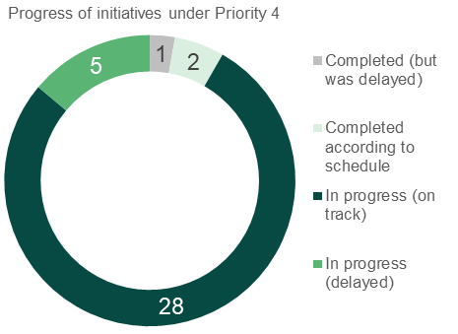

Source: Jurisdictional input

Action 13:   
Prevent sexual violence and sexual harassment before it happens through national and targeted initiatives that promote informed consent, bodily autonomy and respectful relationships

Nine initiatives from the NIP relate to Action 13. These aim to prevent sexual violence and sexual harassment from occurring. Initiatives under this action range from statewide policy frameworks, community awareness activities, and sector training. The associated outputs under this action include initiatives aimed at assisting perpetrators of sexual violence to change their behaviour and be accountable to victims and initiatives that aim at reducing sexual harassment. Of these, two have been completed according to schedule and seven are in progress (on track).

Key achievements

Achievements under this action have included:

* The Commonwealth has engaged Monash University to develop and deliver accredited training for sexual violence responses to build the capability and capacity of workers to recognise and respond to all people who experience sexual violence.
* *Prevent. Support. Believe. Queensland's Framework to address Sexual Violence* was released in October 2019 and outlines the overarching approach to preventing and responding to sexual violence in Queensland.
* The Northern Territory’s *Sexual Violence Prevention and Response Framework and its Priority Actions* was released in July 2020 with implementation of the initiatives under the Framework commencing in 2020-21. These frameworks will provide an important guide for government effort in preventing and responding to sexual violence.
* NSW is currently implementing the *NSW Sexual Assault Strategy 2018-2021*, a whole-of-government framework to improve prevention and response to sexual assault in NSW.
* Victoria’s Raise It! Conversation Starter Toolkits cover sexual harassment in the workplace, discrimination related to pregnancy, parental leave and return to work as well as flexible and part-time work requests. These toolkits have been distributed, and aim to raise awareness of these issues, to public sector agencies, not-for-profits, local government, and creative industries.
* Tasmanian Government agencies, through an inter-agency working group, are working to ensure gender equality and respect are at the centre of all Tasmanian State Service workplaces.

Case study

|  |  |  |
| --- | --- | --- |
| Cross agency collaboration | Decorative |  |

The *NSW Sexual Assault Strategy 2018-2021* is a whole-of-government framework to improve prevention and response to sexual assault in NSW. Implementation of the Strategy is progressing well, with the majority of the 26 activities under the Strategy underway or complete. Significant cross-agency work is underway to deliver the activities set out in the Strategy, with most activities being delivered within the existing resources of the lead agencies. A funding allocation of $800,000 was approved to support the delivery of priority activities responding to the needs of high risk and diverse communities who experience significant barriers to accessing mainstream support. Two organisations funded under the NSW Sexual Assault Strategy will deliver activities aimed at improving sexual assault service delivery for vulnerable cohorts, including LGBTIQ communities and Aboriginal and Torres Strait Islander communities.

Action 14:   
Deliver client-centred, trauma-informed, specialised and consistent support to victims and survivors of sexual violence

Fifteen initiatives from the NIP relate to Action 14. These aim to deliver specialist support for victims of sexual violence and range from service improvement, development and reviews of standards, and improving service access. Of these initiatives, one is completed according to schedule, 13 are in progress (on track) and one is in progress (delayed).

Key achievements

Achievements under this action have included:

* The National Association for Services against Sexual Violence (NASASV) are working with University of New South Wales Gender Violence Research Network (GRN) to update and publish a new (third) edition of the Standards of Practice Manual for Services against Sexual Violence.
* Queensland’s youth sexual violence responses have a strong focus on enhancing the capacity of the local sector to respond to youth sexual violence. A training and mentoring service has been established to upskill services working with young people displaying sexually problematic behaviours.
* Queensland has provided victims of sexual assault the option of having a ‘just-in-case’ forensic examination, whether they have made the decision to report the assault to police or not and trained more nurses around the state in forensic procedures.
* NSW Health has commenced work to improve and increase the capacity of the state’s Sexual Assault Services to provide appropriate therapeutic responses and support to Aboriginal clients and is also developing a strategy to increase access to its existing Sexual Assault Services and New Street Services for people with disability.
* South Australia is on track to improve access to the state’s forensic sexual violence services*,* with services now available 24 hours in metropolitan Adelaide and at main regional hospitals in Port Lincoln, Whyalla, Berri and Mount Gambier.

Case studies

|  |  |  |
| --- | --- | --- |
| Third Standards of Practice Manual for Services against Sexual Violence | Decorative |  |

NASASV and GRN are working to review and update NASASV’s 2015 Standards of Practice Manual for Services against Sexual Violence (second edition). The project is scheduled to be completed in June 2021. NASASV and GRN have completed a review of current the Standards and a literature review of relevant research and service standards to inform their work. Consultation with sexual assaults services and other key stakeholders will also ensure the new Standards developed reflect advances in best practice in primary prevention and service provision in responding to people who are experiencing or have experienced sexual violence.

The Standards aim to provide guidance and confidence to governments, employers and the wider community on the knowledge, skills and attributes they can expect from community and workers in the FDSV field. The Standards will also set a standard for practice competence for the sexual violence services and allied workers and provides guidance also for training providers on the design and development of different levels of training for responding to people impacted by sexual violence.

|  |  |  |
| --- | --- | --- |
| Improving access to services for people with a disability | Decorative |  |

NSW Health is developing a strategy to increase access to its existing Sexual Assault Services and New Street Services for people with disability. The University of NSW is producing a needs assessment to identify promising practice for improving service access. The project has engaged consumers to inform an activities and implementation plan. An evaluation framework will be developed to track NSW Health’s progress in increasing access for people with disability. The Education Centre Against Violence has established a new Disability Portfolio Team to lead this work.

Action 15:   
Strengthen the capacity of all sectors to address sexual harassment to ensure women are safe at work, while studying, in public and online

Twelve initiatives from the NIP relate to Action 15 including sector training, statewide frameworks, and the development of educational resources aimed at addressing sexual harassment. Of these, one has been completed according to schedule, one was completed according to schedule, one was completed but delayed, eight are in progress (on track), and one is in progress (delayed).

Key achievements

Achievements under this action have included:

* The Tasmanian Government is working with the eSafety Commissioner to deliver education and training sessions in Tasmania in response to technology-facilitated abuse.
* The Commonwealth has commissioned La Trobe University to develop an evidence base and a theory of change to inform sexual violence and sexual harassment prevention in Australia. A stocktake of sexual violence primary prevention initiatives has been undertaken by Deloitte.
* The Commonwealth has delivered the easy English guides on technology-facilitated abuse (TFA) for women with disability with further training and support resources to be rolled out over 2020-21. It is also conducting research into experiences of TFA by Aboriginal and Torres Strait Islander Women from regional and remote communities.
* Linking in with the Victorian *Gender Equality Act 2020*, the *Workplace Equality and Respect in the public sector* initiative and its associated activities will assist the Victorian Public Service to meet some of their obligations under the Act. It is anticipated that the rollout of Workplace Equality and Respect initiative in the Victorian Public Service will conclude in 2020, helping to protect women in Victorian Government agencies from sexual harassment.
* *Prevent.Support.Believe. Queensland*’s *Framework to address Sexual Violence* addresses all forms of sexual violence, including sexual assault, sexual harassment, technology-facilitated sexual abuse, child sexual abuse and youth sexual abuse.

Case study

|  |  |  |
| --- | --- | --- |
| Education and training | Decorative |  |

The Tasmanian Government continues to work with the eSafety Commissioner to deliver education and training in response to technology-facilitated abuse. Two series of workshops have been held statewide (Hobart, Burnie and Launceston) in July 2019 and March 2020. Participants included specialist family and sexual violence services, mainstream services and industry organisations. The workshops informed participants about the role of technology facilitated abuse in violence against women and how to help clients protect themselves.



Priority Five: Improve support and service system responses

This priority seeks to address support and service system responses for women and their children affected by violence. The ways that current service systems are set up to respond to violence against women and their children can often be complex and hard for people to navigate. System and service responses must work effectively and collaboratively in order to keep people safe, prevent violence, and better support those who have experienced violence. The five actions under this priority area relate to sector development, collaboration between and integration of services, and improving access to services.

Figure 12 outlines the proposed program logic for Priority five. It shows that improving support and service system responses will be successful when women, their children and men affected by domestic, family and sexual violence have their needs met by services that delivers trauma-informed support that focus on safety and recovery. Success will also be seen when perpetrators have timely access to rehabilitative services, and victims are safely housed in their communities. The actions in Priority five seek to enable workforces to provide trauma-informed supports, improve collaboration across services, improve access to and embed trauma-informed support for perpetrators, build the evidence-base, and improve access to safe and suitable accommodation for women (and their children) who have experienced domestic, family and sexual violence. This figure also notes the outputs are observable when these actions are put in place as well as identifying the short term and medium-term outcomes expected to be achieved. However, as noted previously, the primary focus of this report is outputs.

Figure 12: Priority 5 Draft program logic

This image shows the draft program logic for Priority 5, mapping actions to outputs to short and medium term outcomes.

Service providers have an awareness of how trauma-informed support for perpetrators can prevent reoffending and promote rehabilitation

Increased number of rigorous evaluations of domestic and family violence services

Women who have experienced or are experiencing domestic, family or sexual violence have access to suitable and safe accommodation

Service providers have access to timely and relevant information about family violence risks

Service providers have an awareness of how collaboration and information sharing reduces the need for victims to retell their story

Service providers feel confident about their ability to provide trauma-informed support with a focus on safety and recovery

Women who have experienced or are experiencing domestic, family or sexual violence are safely housed within their communities

An evidence base underpins the policy, planning and delivery of responses to domestic, family and sexual violence

Perpetrators have timely access to rehabilitation services and trauma informed support

Women, children (and men) affected by domestic, family and sexual violence are safe, have their needs met, and their recovery is promoted

Workforce deliver trauma-informed support with a safety and recovery focus

Source: Draft Performance Monitoring and Reporting Framework (PMR)

Initiatives under this priority aim to train professionals in delivering trauma-informed support, improve information sharing, and establish referral protocols with refuges. As noted previously, for each priority, it is expected that progress will primarily be observed in outputs; that is, implementation of initiatives under the NIP.

As demonstrated in the figure below, the majority of initiatives are on track, with some delays primarily due to the impact of COVID-19. For example, Tasmania’s aim to extend forensic medical examinations for adult victim-survivors of family and sexual violence to a state-wide service has been delayed due to the local health system prioritising responses to COVID-19.

Highlights of achievements and examples of progress under each action are provided in the sub-sections below.

Figure 13: Progress of initiatives under priority 5

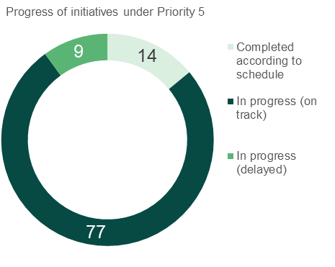

Source: Jurisdictional input

Action 16:   
Enable workforces to provide trauma-informed support with a focus on safety and recovery to victims and survivors of domestic, family and sexual violence

Twenty-three initiatives from the NIP relate to Action 16 including projects that aim to develop and improve risk assessment processes and provide strengthened sector education. The outputs associated with these initiatives are training initiatives relating to trauma informed support. Of these, two have been completed according to schedule, 18 are in progress (on track), and three are in progress (delayed).

Key achievements

Achievements under this action include:

* Our Watch has partnered with two universities to deliver the university-based learning and development pilot. Our Watch has completed initial scoping and planning activities, including a literature review and stakeholder consultations.
* An independent evaluation of the DV-alert program commenced in May 2020. DV-alert, delivered by Lifeline, continues to train frontline workers to recognise, respond to and refer appropriately when working with people experiencing domestic and family violence. Some adaptations to the mode of delivery have been made in response to the COVID-19.
* In the Northern Territory, a new Risk Assessment and Management Framework and Common Risk Assessment Tool have been developed, with training being rolled out to ensure services can understand and effectively use the tools. These tools will guide relevant services in effectively identifying, assessing and managing risk of violence.
* The Western Australian Government is piloting ‘one stop hubs’ to provide an integrated specialist service for victims of DFV, outlined in further detail below.
* The Australian Capital Territory is developing a Common Risk Assessment and Management Framework, currently being tested in several pilot sites. The testing will inform the finalisation of the framework.
* In NSW, tendering and recontracting has been completed to appoint the Women’s Domestic Violence Court Advocacy Service (WDVCAS) providers for the period 1 July 2020 to 30 June 2024. WDVCASs provide information, advocacy and referrals to assist women (and their children) who are or have been experiencing DFV, with their legal, social and welfare needs. WDVCASs assist women to obtain effective legal protection through applications for Apprehended Domestic Violence Orders at local court locations across NSW.
* From 1 July 2020, WDVCAS boundaries have also been realigned with NSW Police Force boundaries, which will streamline and enhance service delivery for victim-survivors and enable WDVCASs to service all local court locations across the state. In 2018/19, WDVCASs assisted 47,902 clients.
* Tasmania is working towards the development of a family violence risk assessment tool to be used across government and non-government family and sexual violence services.
* From 1 January 2019, all NSW Government sector employees will have access to 10 days of paid DFV leave per year. The NSW Government has released a policy to support the provision of this leave.
* Queensland DFV high risk teams access (where relevant) disability service providers and/or professionals with appropriate levels of expertise to support multi-agency complex risk assessment and safety management planning.
* Queensland has also delivered training to the DFV sector in understanding and responding to DFV experienced by people from diverse backgrounds, including people with disability.

Case study

|  |  |  |
| --- | --- | --- |
| One stop service hub | Decorative |  |

The Western Australian Government is piloting ‘one stop hubs’ to provide an integrated specialist service for victims of DFV, with the aim to simplify access to services, reduce trauma for victims re-telling their stories, and provide a comprehensive wrap-around approach to supporting victims across multiple aspects of their lives.

The two pilot sites will establish two hubs to assist victims to get help sooner by providing integrated, wraparound services from various locations across the State. Locations for the two hubs are in metropolitan Perth (Mirrabooka in the northern metropolitan corridor) and regional Western Australia (Kalgoorlie in the Goldfields region).

A comprehensive co-design process was undertaken from December 2019 to February 2020, involving more than 130 participants, including service users, community members, people with lived experience and service providers to assist with establishment of the new hubs. The co-designed models reflect a place-based and community development approach to responding to family and domestic violence with a priority focus on supporting Aboriginal and CALD women through a culturally secure service model.

The procurement process to identify community service providers who will deliver the two hubs in each location commenced in June 2020, with contracts being awarded in November 2020.

Refurbishments of the buildings for the two hubs are on track and will reflect co-design findings and service model requirements. Services are on track to be operational by December 2020.

Action 17:   
Collaborate across services, sectors and workforces to ensure responses to women affected by domestic, family and sexual violence are coordinated, meet women’s needs, avoid women having to retell their story and promote their recovery

Initiatives under this action aim to improve collaboration across services, sectors and workforces and range from specialist integrated services, co-location of services and the establishment of service hubs, and information sharing. Thirty-two initiatives from the NIP relate to Action 17. Of these, six have been completed according to schedule, 22 are in progress (on track), and four are in progress (delayed).

Key achievements

Key achievements under this action to date include:

* The Commonwealth has established the co-location of 22 state/territory child protection and policing officials in Family Law Court Registries. This will facilitate timely access to relevant information and records held by state authorities and other courts, which is crucial to decision-making that promotes the best possible outcomes for children and a court system that is responsive to safety risks.
* Services Australia has developed succinct information on their website to assist customers affected by family and domestic violence to navigate the payments and services offered by Services Australia. This includes a checklist for customers that provides information on ‘things to consider’ when contacting Child Support, Centrelink and Medicare. The checklist has been translated into 30 languages and has also been redeveloped for an Indigenous specific audience.
* The *Northern Territory Sexual Violence Prevention and Response Framework and its Priority Actions* was released in July 2020.
* In Victoria, Specialist Family Violence Courtshave been opened in the Ballarat, Heidelberg, Frankston, Moorabbin and Shepparton Magistrates' Courts, with the aim to improve victim survivor access to legal protection and help hold perpetrators to account.
* The *Family Violence Legislation Reform Act 2020* was introduced in Western Australia in 2020 to include a new offence based around persistent and repetitive acts of violence and abuse.
* Queensland has established an innovative court model with the Specialist DFV Court Model currently operating in Southport, Beenleigh, Townsville, Mount Isa, and Palm Island.
* After a successful trial, Queensland’s *Integrated Service Response* initiative has eight funded locations which involve multiple agencies responding to high risk cases in a timely and collaborative manner. Eight DFV Senior Project Officers work alongside the high-risk teams to provide a cultural conduit for advice and referral to services for Aboriginal and Torres Strait Islander people experiencing DFV.
* Queensland has delivered two new shelters in Caboolture and North Gold Coast, providing an additional 10 places of temporary supported accommodation to women experiencing domestic and family violence in these areas.
* Tasmania’s *Safe at Home* service system continues to provide an integrated, whole of government response to family violence through a range of different services working together.
* Victoria is continuing to deliver the Multi Agency Risk Assessment and Management Framework (MARAM) and Information Sharing reforms. MARAM was made a legal requirement for identified services in September 2018, along with two new information sharing schemes focused on family violence risk and child safety and wellbeing. Approximately 37,500 workers across 850 organisations were made subject to MARAM at that time. A major expansion of MARAM (Phase Two) will occur in 2021 to include health and education services, adding approximately a further 370,000 workers across 7,500 organisations.
* Victoria has also set up a Central Information Point (CIP) which consolidates critical information about a perpetrator or alleged perpetrator of family violence into a single report for frontline workers to assist with family violence risk assessment and management.

Case studies

|  |  |  |
| --- | --- | --- |
| Consolidating information | Decorative |  |

The CIP in Victoria consolidates critical information about a perpetrator or alleged perpetrator of family violence into a single report for frontline workers to assist with family violence risk assessment and management. This allows frontline workers to make a more informed assessment of family violence risk, identify safety needs and enable more tailored service response to keep victims safe. The CIP has supported victim survivors to feel more empowered to make decisions about their safety and increases perpetrator accountability.

Since the service commenced in April 2018, the CIP has provided over 6,450 reports to support family violence risk assessment and safety planning within The Orange Door, a free service for adults, children and young people who are experiencing or have experienced family violence and families who need extra support with the care of children. The CIP has quickly become an essential practice tool in The Orange Door facilitating fast, accurate and consolidated information.



|  |  |  |
| --- | --- | --- |
| Whole-of-government framework | Decorative |  |

The Northern Territory *Sexual Violence Prevention and Response Framework and its Priority Actions* was released in July 2020. This is the first framework of its kind to be released in the Northern Territory and was developed with input from the community and a broad range of stakeholders. Implementation of the initiatives under the Framework will commence in 2020-21 based around the following key areas:

* Sexual violence is recognised, understood, prevented and not tolerated.
* Children and young people who experience sexual violence are safe and supported to heal.
* Children and young people who engage in harmful sexual behaviours are safe and supported to heal.
* Adults who experience sexual violence are safe and supported to heal.
* Adults who commit sexual violence are held accountable through the justice system and have access to programs that change behaviour.
* Services and systems are strengthened to respond to the needs of people who have experienced sexual violence.

|  |  |  |
| --- | --- | --- |
| Improved justice responses | Decorative |  |

*Western Australia’s Family Violence Legislation Reform Act* includes a new offence to respond to the entrenched and repetitive nature of family and domestic violence. The new Persistent Family Violence Offence recognises that perpetrators will typically use a range of abusive behaviour over lengthy periods of time and that the trauma associated with this prolonged abuse can create a barrier to the recall of specific details of individual events. The new offence does not require victims to particularise the details of places and times. This will help to reduce re-traumatisation associated with recalling sufficient information to enable prosecution. Other significant changes being implemented under the landmark reform package include:

* A new specific criminal offence for suffocation and strangulation, which is an important risk factor in the context of family violence
* Introduction of a serial family violence offender declaration (the first in Australia)
* New aggravated penalties for offences which commonly occur in circumstances of family violence
* Introduction of jury directions to counter stereotypes, myths and misconceptions about family and domestic violence
* Requirement for police to record every family violence incident
* A range of amendments to the Restraining Orders Act 1997 and Bail Act 1982 to enhance victim safety and make it easier for victims to obtain protection from violence.

Action 18:   
Improve access to and embed trauma-informed support for perpetrators of domestic, family and sexual violence to prevent reoffending and promote rehabilitation and treatment

Sixteen initiatives from the NIP relate to Action 18. These initiatives aim to improve access to trauma-informed support for perpetrators and range from projects aimed at strengthening perpetrator interventions, the development of statewide frameworks, and hotlines which provide support for men concerned about their behaviour. Of these, three have been completed according to schedule and 13 are in progress (on track).

Key achievements

Achievements under this action have included:

* The Commonwealth’s *Dedicated men’s support workers in Family Advocacy and Support Services* initiative is complete with States and Territories confirming that dedicated workers are now operating out of 16 permanent locations and providing outreach to 7 circuit locations. The support workers assist both male victims and alleged perpetrators to access appropriate support services such as parenting programs and men’s behavioural change programs.
* MensLine’s ‘Changing for Good’ program is a free voluntary program to help men to recognise their abusive behaviours, end their use of violence and make sustained changes in their behaviours and attitudes and help men stop using violence in their families and relationships. The program provides access to specialist counsellors, works with men to identify and work towards their individual goals, and supports them to access additional services. In 2019-20, 443 clients participated in the Changing for Good program, attending over 1,440 sessions
* In South Australia, Kornar Winmil Yunti and Community Transitions have been funded to provide direct local support to perpetrators of DFV to change their behaviours before entering the criminal justice system.
* Tasmania continues to provide early intervention to offenders. A 2014-15 Safe at Home performance review found that the Defendant Health Liaison Service has the most potential to provide early intervention to offenders and assist them to change their behaviour and reduce recidivism.
* NSW continues to progress work towards the Premier’s Priority to Reduce Domestic Violence Reoffending has a goal to reduce reoffending by 25 per cent by 2023, outlined in greater detail below.
* In Victoria, cohort trials continue to build the evidence for trauma informed practice with an improved perpetrator accountability framework. Various intervention trials have been funded from 2018 focusing on fathering, cross-sector coordination, women and gender-diverse people, Aboriginal communities, culturally diverse communities, men with alcohol and other drug issues and men with cognitive impairment have been established and evaluated. Trials have been extended until December 2020.
* In Queensland, a pilot of a DFV perpetrator program in three correctional centres is underway. The program addresses the specialist needs of this high-risk offender cohort prior to their return to the community.

Case studies

|  |  |  |
| --- | --- | --- |
| Early intervention perpetrator responses | Decorative |  |

South Australia’s Statewide Perpetrator Response focuses on organisational and perpetrator accountability, effective earlier intervention approaches and an integrated approach to service delivery. The Response aims to provide organisations with ‘user-friendly’ mechanisms to identify and then provide appropriate responses to perpetrators, regardless of where the perpetrator enters the service system, which is consistent, unified and mutually reinforcing.

Local services Kornar Winmil Yunti and Community Transitions have been funded to provide direct local support to perpetrators of DFV to change their behaviours before coming into contact with the criminal justice system.

Nine crisis accommodation beds are now available for perpetrators to be removed from their homes when safe to do so and receive the support needed to end their abusive behaviours.

Further, as part of the South Australian Government’s response to the COVID-19 pandemic, the Men’s Referral Service has been funded to provide a phone line for men at risk of using domestic, family, or sexual violence or those concerned about their use of abusive behaviours.

|  |  |  |
| --- | --- | --- |
| Changing for Good | Decorative |  |

The Mensline ‘Changing for Good’ program is a series of 6 week blocks with outcomes and progress measured along the way. The program seeks to help men keep a connection with familiar counsellors wherever possible, so that they do not have to repeat their stories.

Within this context, counsellors can challenge damaging beliefs about masculinity.

The program is not designed to work with men who are actively using violence or who are not ready to change behaviours that harm others. If men present in this way, counsellors are able to refer them to appropriate supports in a timely way.

It expanded its intake since December 2018 to include those who are contemplating changing their behaviour in a voluntary way. These clients are entering the program via direct self-referral on the ‘Changing for Good’ website.

This change in intake is designed to catch users/potential users of violence earlier, thereby reducing the prevalence of violence.

|  |  |  |
| --- | --- | --- |
| Reducing reoffending | Decorative |  |

The NSW Premier’s Priority to Reduce Domestic Violence Reoffending has a goal to reduce reoffending by 25 per cent by 2023. Several programs and key actions have been rolled out in NSW under this Priority and will contribute to this goal, with the following achievements noted:

* In 2018, 29 per cent of domestic violence offenders received supervised sentences. In March 2020, this rate increased to 37.1 per cent.
* The EQUIPS Domestic Abuse program delivered in Correctional Centres and Community Offender Services locations show increases in participation from 1,216 in 2018-19 to 1,413 in 2019-20.
* The Remand DV initiative showed an increase in participation of 12 per cent (1,319 compared with 1,173).
* There has been a decrease in the number of reoffenders since the Priority was introduced in 2015; from 1,814 in the year to December 2015 down to 1,778 in the year to December 2019.

Action 19:   
Build the evidence base to inform responses to domestic, family and sexual violence by strengthening the focus on what works to reduce violence, improving data and supporting the Fourth Action Plan priorities

Sixteen initiatives from the NIP relate to Action 19. These initiatives aim to improve the evidence base on domestic, family, and sexual violence and include evaluations and activities which will lead to enhanced data collection and reporting processes. Of these, three have been completed according to schedule, 12 are in progress (on track), and one is in progress (delayed).

Key achievements

Achievements under this action include:

* The Australian Bureau of Statistics (ABS) and the Australian Institute of Health and Welfare (AIHW) have commenced work on strengthening the evidence base on family, domestic and sexual violence (FDSV) through a range of analysis, development and reporting projects. ABS is undertaking a project to develop a statistical evidence base for the Australian legal assistance sector in partnership with the Attorney General’s Department and the Department of Social Services. Outputs from this project will aim to include statistics about persons who receive legal assistance for FDSV related matters. AIHW is examining the health outcomes of violence in order to update and enhance previous estimates.
* Australia’s National Research Organisation for Women’s Safety (ANROWS) has a dedicated grant for research on 4AP priorities. Research and data projects to support the 4AP priorities are underway. ANROWS is also undertaking a ‘what works’ framework to understand how to effectively reduce of FDSV.
* Victoria’s Family Violence Perpetrator Interventions Grants Program has funded 10 trial programs across the Victorian family violence system. An evaluation of the program has been completed with findings informing future innovative perpetrator interventions.
* Queensland is strengthening the Queensland Social Survey, which measures Queenslanders’ attitudes towards DFV, by introducing new questions intended to measure Queenslanders’ awareness of different forms of DFV, their beliefs regarding bystander responsibilities, and support for the social norms and contexts that allow DFV to occur.
* A meta-evaluation on perpetrator interventions is being conducted in Victoria to help improve the evidence base about what works regarding perpetrator interventions.
* In NSW, the Safer Pathway program aims to ensure that all victim–survivors of DFV receive a timely, effective and consistent response to DFV based on the assessed level of threat to their safety and their specific needs. NSW’s Safer Pathway program was evaluated with a report published in 2019. Safer Pathway implementing agencies have progressed a number of recommendations including working to improve risk assessment and data collection and, expand referral pathways for victims who choose not to report to Police.
* In May 2020, La Trobe University commenced work on an evaluation of Our Watch.

Case study

|  |  |  |
| --- | --- | --- |
| Data collection and reporting of violence | Decorative |  |

As part of efforts to build the evidence base to improve support and service system responses to FDSV, the AIHW is currently working on an online dashboard that will collate and display a core set of the latest data on FDSV and present findings using a range of interactive and static graphics.

The dashboard complements the ongoing FDSV in Australia reports that bring together the latest national data to report on the prevalence, impacts and outcomes of family, domestic and sexual violence, including within vulnerable population groups. The next report will be an online update in June 2022.

The dashboard will be the first time that the AIHW has made FDSV data publicly available through this channel. The key benefits of the dashboard include more up to date data and information as streamlined updates and dissemination can occur more frequently.

The main data sources include the two key ABS survey collections - the Personal Safety Survey and the National Aboriginal and Torres Strait Islander Social Survey. Other data includes information on hospitalisations, recorded crime, criminal courts and specialist homelessness services. The first release of the dashboard is scheduled for 2021.

Action 20:   
Improve access to suitable and safe accommodation within their communities for women who have experienced domestic, family and sexual violence

Thirteen initiatives from the NIP relate to Action 20 which aim to improve access to accommodation for people escaping domestic, family, and sexual violence. These range from greater investment in crisis accommodation, building new refuges and expanding programs to allow victims of violence to remain in their home. Of these, 12 are in progress (on track) and one is in progress (delayed).

Key achievements

Achievements under this action have included:

* Funding has been provided for about 700 new safe places for women and children escaping domestic violence across the country under the Commonwealth’s Safe Places initiative for new and expanded emergency accommodation. The grant funding is being provided to 40 projects across all states and territories to create safe emergency accommodation. Projects include building new two- and three-bedroom homes, transforming office buildings into self-contained apartments and establishing small group homes.
* The Victorian Government is building two new Aboriginal family violence refuges, outlined in more detail below.
* NSW’s Staying Home Leaving Violence program currently operates in 33 locations across the state, supporting women and their children to remain safely in their home, with the perpetrator being removed.
* NSW’s Rent Choice Start Safely initiative provides a subsidy to help people who have experienced DFV and do not have stable housing to rent privately.
* Queensland’s *Enhanced Housing Response* has seen person-centred pathway planning implemented for clients experiencing DFV, with a Specialist Response Team being established mid-2020, to support frontline staff to tailor and deliver housing assistance in coordination with specialist DFV, High Risk Teams and mainstream services.
* Tasmania has three housing related initiatives that are on track. The *Keeping Women Safe in their Homes* program continues to be delivered, providing women safety upgrades to enable them to stay safely in their own home or a home of their choice. The *Rapid Rehousing Program* provides supported housing options for families affected by family violence, allowing them access to safe and affordable rental homes. Perpetrators can also access the program. And,the Tasmanian Government is investing in crisis accommodation through the *Affordable Housing Action Plan 2019-2023*.
* As at 30 June 2020, 9,456 women and their children experiencing violence nationally have been supported through the *Keeping Women Safe In Their Homes* program

Case studies

|  |  |  |
| --- | --- | --- |
| New accessible refuges | Decorative |  |

The Victorian Government has begun phasing out communal refuges and moving towards a ‘core and cluster’ model including building two new Aboriginal family violence refuges. This will ensure that refuge accommodation promotes safety, is accessible to people with disabilities, provides private units and enables connections with the community. As refuges are redeveloped, capacity for after-hours support will be provided. To date, 16 of the 19 sites for Victoria’s ‘core and cluster’ model have been secured. There are seven sites currently in the documentation, design and tender stage. The first four refuges are completed and are in operation. The fifth refuge is expected to reach completion by the end of 2020, with construction and early site works currently underway at a further four sites.

|  |  |  |
| --- | --- | --- |
| Private rental assistance | Decorative |  |

NSW’s Rent Choice Start Safely is a private rental assistance product that provides a subsidy and links to supports, to help people rent privately across NSW who do not have a stable and secure place to live due to DFV. A proportion of the rent is paid for up to three years to enable survivors to re-establish stability for themselves and their family following DFV.

Preliminary data has shown the number of households assisted with Rent Choice Start Safely in 2019-2020 is 4,735. The number of children assisted within those households is 8,415 across NSW.

# 03 National Plan progress

At the commencement of the National Plan, a series of national outcomes were identified and agreed on by the Commonwealth, state and territory governments. These outcomes have been used to track progress over the span of the National Plan.

The national outcomes are:

1. Communities are safe and free from violence.
2. Relationships are respectful.
3. Indigenous communities are strengthened.
4. Services meet the needs of women and their children experiencing violence.
5. Justice responses are effective.
6. Perpetrators stop their violence and are held to account.

Measures of progress on the national outcomes can be obtained through indicators of change, extracted from a suite of national time series data collections including for example, the National Community Attitudes Survey (NCAS) and the Personal Safety Survey (PSS):

1. Communities are safe and free from violence, as measured by increased intolerance of violence against women and their children (NCAS).
2. Relationships are respectful, as measured by improved knowledge, skills and behaviour of respectful relationships by young people (NCAS).
3. Indigenous communities are strengthened, as measured by the reduction in the proportion of Aboriginal and Torres Strait Islander women who consider that family violence, assault, and sexual assault are problems for their communities and neighbourhood, and increased proportions of Aboriginal and Torres Strait Islander women are able to have their say within community on important issues including violence (NATSISS).
4. Services meet the needs of women and their children experiencing violence, as measured by increased access to, and responsiveness of services for victims of domestic, family and sexual violence (PSS).
5. Justice responses are effective, as measured by increased rates of women reporting domestic, family and sexual violence (PSS).
6. Perpetrators stop their violence and are held to account, as measured by a decrease in repeated partner victimisation (PSS).

However, monitoring change relies on the availability of national data which is not captured regularly for all measures.

In addition to the six outcome measures, there are four headline measures which indicate change under the National Plan:

1. Reduced prevalence of domestic violence and sexual assault.
2. Increased proportion of women who feel safe in their communities.
3. Reduced deaths related to domestic violence and sexual assault.
4. Reduction in the proportion of children exposed to their mother’s or carer’s experiences of violence.

The most recent data of measures of success and indicators of change against the national outcomes measures was reported in the evaluation of the Third Action PlanP1F[3]P. At the time of this progress report, there is no new data available since the Third Action Plan evaluation to provide an update on progress against the six national outcomes in the National Plan. Reporting on outcome measures will be addressed in the evaluation of the National Plan, including the 4AP.

However, there have been promising results across three of the four national indicators, with data trending in the intended direction. Data on the available indicators of change is provided in the following section.

Reduced prevalence of domestic violence and sexual assault

The figure below shows the proportion of women who self-report sexual violence, cohabiting partner violence, and emotional abuse from a current partner in the last 12 months (as identified in the ABS Personal Safety Survey from 2005 to 2016). There have been statistically significant increases in the proportion of women who report sexual violence and emotional abuse from 2012 to 2016, with the proportion experiencing co-habiting violence remaining stable. Increases in self-reports of emotional abuse may be related to a greater understanding that non-physical forms of violence are also unacceptable.

Figure 14: Prevalence (per cent) of sexual violence and partner violence, Australia

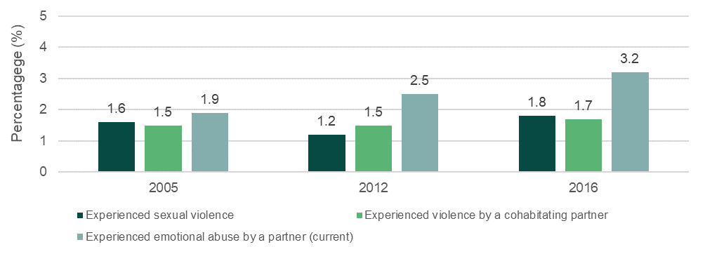

Source: Australian Bureau of Statistics, Personal Safety Survey

Increased proportion of women who feel safe in their communities

Findings from the PSS show that a greater proportion of women reported feeling safe in their communities, from initial reports in 1996 through to the most recent survey in 2016 (see figure below). Most women did not use public transport at night, but of those who did, there have been sustained increases in the proportion of women who felt safe doing so at night and being home alone after dark. Between 2012 and 2016, there were statistically significant increases in the proportion of women who reported feeling safe being home alone after dark, using public transport at night alone and waiting for public transport alone at night.

Figure 15: Women’s feelings of safety in the last 12 months in selected situations, proportion (per cent) who felt safe, Australia

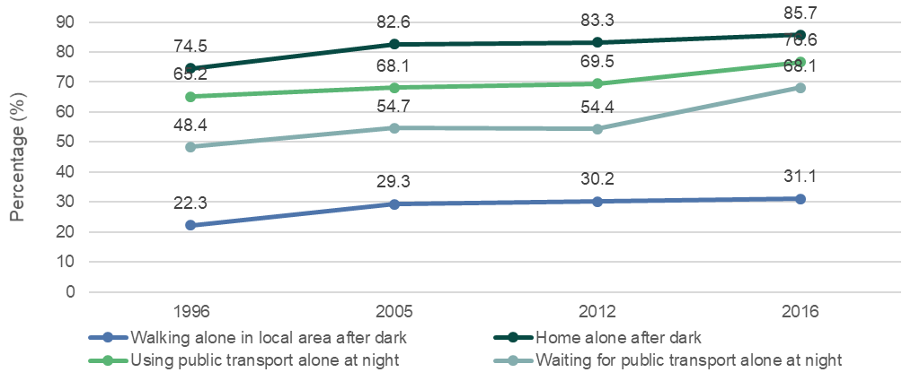

Source: Australian Bureau of Statistics, Personal Safety Survey

Reduced deaths related to domestic violence and sexual assault

In many circumstances, DFV will feature an enduring pattern of controlling behaviours which will prompt contact with formal and informal supports and offer opportunities for intervention.P2F[4]P In other cases, a fatal incident may be the first recorded episode of DFV, recognising that DFV remains under-reported in the community among formal and informal supports.

Data from the National Homicide Monitoring Program, managed by the Australian Institute of Criminology, captures details of all homicides in a domestic relationship. From 2009-10 to 2017-18, there were 859 domestic homicides recorded in Australia, three-fifths featuring intimate partner homicides. As shown in the figure below, there is considerable variability in the total number of domestic homicides each year, particularly among sub-sets of family homicides. Variability in the data somewhat limits the ability to detect trends, however, the number of deaths reported for 2017-18, both intimate partner homicides and all domestic homicides, was the lowest recorded across the ten-year period.

Figure 16: Domestic homicides, by homicide type, Australia, FY 2008-09 to 2017-181T

This chart shows domestic homicides by homicide type (intimate partner, filicide, parricide, siblicide, and other family) from 2009-10 to 2017-18.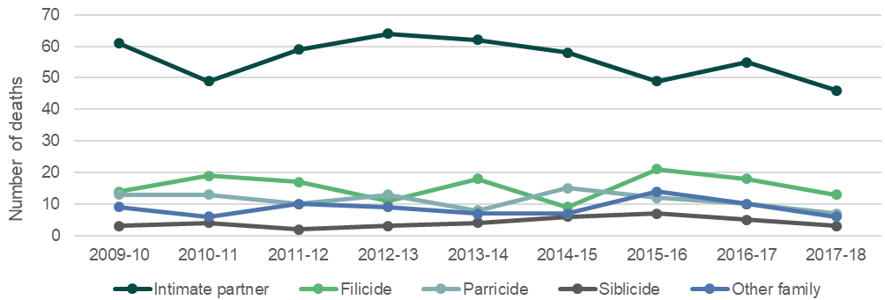

Source: Australian Institute of Criminology, National Homicide Monitoring Program (Bricknell, 2020)

Reduction in proportion of children exposed to their mother’s or carer’s experiences of domestic violence

Data from the Personal Safety Survey from 2005 to 2016 shows that, of women with children in their care at the time they were subjected to violence from an intimate partner, the proportion who self-reported that their children heard or saw the violence has decreased over time for both current and former partners (as shown in the figure below).

Figure 17: Children who were exposed to violence against their mother or carer, proportion, Australia

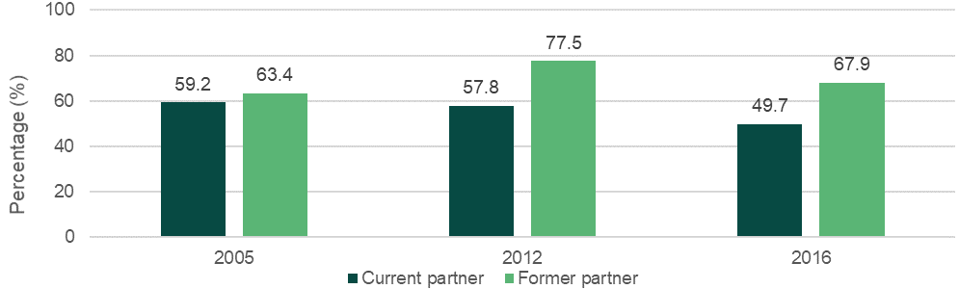

Source: Australian Bureau of Statistics, Personal Safety Survey

# 04 Next steps

This is the first annual monitoring and performance report produced under the 4AP and NIP. The report provides an overview of progress as a whole under the 4AP and allows government to consider what is going well and if modifications are required.

This report has found that implementation is on track and initiatives have responded and adapted to the challenges presented by COVID-19, the vast majority of initiatives and actions are underway under the 4AP. There have been significant achievements with programs established in each of the priority areas.

The second progress report under the 4AP will be finalised in late 2021 and the evaluation of the National Plan will be delivered in 2022. The national evaluation will assess the impact of the National Plan and its effectiveness in meetings its objectives and outcomes and will inform the Australian Government's future approach beyond 2022 to reduce violence against women and their children.

# Appendices

1. : Approach

To support monitoring of progress under the 4AP, Commonwealth, state, and territory governments were asked for information on the progress of initiatives as well as information on service usage, case studies and commentary on the impact of the COVID-19 pandemic.

In monitoring the National Plan, when available, time series data is reported with changes over time highlighted. Key data sources that were accessed in preparing this progress report include:

* The Personal Safety Survey (PSS) - the Australian Bureau of Statistics (ABS) conducts this survey every four years (most recently in 2016) to explore experiences of violence and safety, including partner violence in the past 12 months. The 2020 PSS has been delayed due to COVID-19, with data collection now planned to take place in 2021.P3F[5]
* Other data reports from the ABS (including for example, Recorded Crime Offenders, Criminal Courts) and the Australian Institute of Health and Welfare (for example, Specialist Homelessness Services).

1. : Details of progress

Table 1: NIP initiatives by priority area

| Jurisdiction | Priority area | Action | Initiative | Status |
| --- | --- | --- | --- | --- |
| ACT | Primary prevention | 1 | ACT Government Domestic and Family Violence Training Strategy  *COVID-19 has slowed delivery | In progress delayed* |
| ACT | Improving support and service system responses | 16, 17 | ACT Government Response to the Domestic Violence Prevention Council Report from the Extraordinary meeting 2018  *Minor delays due to COVID-19 | In progress delayed* |
| ACT | Supporting Aboriginal and Torres Strait Islander women and their children | 6, 8 | Co-Design of family-centred responses for Aboriginal and Torres Strait Islander families  *Social distancing restrictions impacted on consultation | In progress delayed* |
| ACT | Improving support and service system responses | 16, 17 | Common Risk Assessment and Management Framework | In progress on track |
| ACT | Improving support and service system responses | 17, 19 | Family Safety Hub | In progress on track |
| ACT | Respecting and responding to diverse lived experience and knowledge of women and their children affected by violence | 10, 11 | Family Safety Hub - Health Justice Partnership | In progress on track |
| ACT | Improving support and service system responses | 19 | Family Violence Death Review | In progress on track |
| ACT | Improving support and service system responses | 16, 18 | Room4Change program | In progress on track |
| ACT | Respecting and responding to diverse lived experience and knowledge of women and their children affected by violence | 10, 11 | Supporting Children and Young People Affected by Domestic and Family Violence | In progress on track |
| Commonwealth | Responding to sexual violence and sexual harassment  Improving support and service system responses | 14, 15, 16 | Accredited training for sexual violence responses | In progress on track |
| Commonwealth | Respecting and responding to diverse lived experience and knowledge of women and their children affected by violence  Responding to sexual violence and sexual harassment  Improving support and service system responses | 11, 14, 17 | Additional funding for 1800Respect | In progress on track |
| Commonwealth | Improving support and service system responses  Respecting and responding to diverse lived experience and knowledge of women and their children affected by violence | 18, 11 | Additional Specialised Family Violence Services | In progress on track |
| Commonwealth | Primary prevention  Respecting and responding to diverse lived experience and knowledge of women and their children affected by violence | 1, 2, 11 | Addressing financial abuse | In progress on track |
| Commonwealth | Improving support and service system responses | 17 | Co-location of state and territory child protection and policing officials in Family Law Court Registries | In progress on track |
| Commonwealth | Primary prevention | 1, 5 | Community awareness and outreach prevention activities | In progress on track |
| Commonwealth | Primary prevention  Respecting and responding to diverse lived experience and knowledge of women and their children affected by violence | 3, 10 | Community-led prevention projects | In progress on track |
| Commonwealth | Supporting Aboriginal and Torres Strait Islander women and their children  Respecting and responding to diverse lived experience and knowledge of women and their children affected by violence | 6, 7, 9 | Continuation of Indigenous specific Third Action Plan projects | In progress on track |
| Commonwealth | Improving support and service system responses | 18 | Dedicated men's support workers in Family Advocacy and Support Services | Is completed according to schedule |
| Commonwealth | Supporting Aboriginal and Torres Strait Islander women and their children  Improving support and service system responses  Respecting and responding to diverse lived experience and knowledge of women and their children affected by violence | 7, 16, 12 | DV-alert  *In March 2020, Lifeline paused face-to-face delivery of training due to physical distancing restrictions. Face-to-face training has now resumed in some locations. | In progress delayed* |
| Commonwealth | Improving support and service system responses | 19 | Enhancing data and reporting | In progress on track |
| Commonwealth | Improving support and service system responses | 19 | Evaluation of Our Watch | In progress on track |
| Commonwealth | Improving support and service system responses | 19 | Evaluation of the National Plan | In progress on track |
| Commonwealth | Improving support and service system responses | 16 | Expansion of the Recognise, Respond and Refer Pilot and National Training for the Primary Health Care Workers | In progress on track |
| Commonwealth | Respecting and responding to diverse lived experience and knowledge of women and their children affected by violence | 11, 12 | Extend the Support for Trafficked People program | In progress on track |
| Commonwealth | Improving support and service system responses | 17 | Faster access to payments and supports | In progress on track |
| Commonwealth | Supporting Aboriginal and Torres Strait Islander women and their children  Respecting and responding to diverse lived experience and knowledge of women and their children affected by violence | 6, 8, 9 | Greater support for Aboriginal and Torres Strait Islander women and children in remote areas of high need | In progress on track |
| Commonwealth | Respecting and responding to diverse lived experience and knowledge of women and their children affected by violence  Improving support and service system responses | 11, 19 | Identification of service gaps for people of diverse sexual orientation, gender identity or intersex status | In progress on track |
| Commonwealth | Improving support and service system responses | 20 | Keeping Women Safe in their Homes program (KWSITH) | In progress on track |
| Commonwealth | Improving support and service system responses | 18 | Mensline Australia | In progress on track |
| Commonwealth | Primary prevention | 1 | National Media Engagement Project | In progress on track |
| Commonwealth | Primary prevention | 2 | National Primary Prevention Hub | In progress on track |
| Commonwealth | Responding to sexual violence and sexual harassment  Improving support and service system responses | 14, 18, 19 | National standards for sexual violence responses | In progress on track |
| Commonwealth | Respecting and responding to diverse lived experience and knowledge of women and their children affected by violence | 11 | Partner Service Pension extension | Is completed according to schedule |
| Commonwealth | Primary prevention  Supporting Aboriginal and Torres Strait Islander women and their children | 4, 6, 8 | Practical intervention programs to work with Aboriginal and Torres Strait Islander people | In progress on track |
| Commonwealth | Improving support and service system responses | 19 | Research on Fourth Action Plan priorities | In progress on track |
| Commonwealth | Supporting Aboriginal and Torres Strait Islander women and their children  Respecting and responding to diverse lived experience and knowledge of women and their children affected by violence  Responding to sexual violence and sexual harassment | 6, 11, 15 | Resources on technology-facilitated abuse (TFA) for Aboriginal and Torres Strait Islander women  *Social distancing restrictions impacted on consultation | In progress delayed* |
| Commonwealth | Respecting and responding to diverse lived experience and knowledge of women and their children affected by violence  Responding to sexual violence and sexual harassment | 11, 15 | Resources on technology-facilitated abuse for women with disability | In progress on track |
| Commonwealth | Primary prevention | 5 | Respect Matters  *COVID-19 has impacted teaching and learning dynamics, and therefore impacted delivery | In progress delayed* |
| Commonwealth | Improving support and service system responses | 20 | Safe Places Emergency Accommodation program | In progress on track |
| Commonwealth | Responding to sexual violence and sexual harassment | 13, 15 | Sexual violence community awareness activities | In progress on track |
| Commonwealth | Primary prevention  Supporting Aboriginal and Torres Strait Islander women and their children | 4, 6, 9 | Stage 2 of the Wiyi Yani U Thangani (Women's Voices) project  *COVID-19 has delayed delivery | In progress delayed* |
| Commonwealth | Primary prevention | 1 | Stop it at the Start campaign  *Paused in order to launch the Help is Here campaign, promoting domestic and family violence support services | In progress delayed* |
| Commonwealth | Improving support and service system responses | 16 | University-based learning and development prevention pilot | In progress on track |
| NSW | Primary prevention | 1 | Ageing and Disability Commissioner | In progress on track |
| NSW | Improving support and service system responses | 16 | Child protection education in schools | In progress on track |
| NSW | Primary prevention | 1 | Child Sexual Offence Evidence Program | In progress on track |
| NSW | Improving support and service system responses | 16 | Counselling in Prison Program | In progress on track |
| NSW | Primary prevention  Respecting and responding to diverse lived experience and knowledge of women and their children affected by violence | 3, 5, 11 | Domestic and Family Violence Innovation Fund | In progress on track |
| NSW | Improving support and service system responses | 16, 17 | Domestic and Family Violence Leave | Is completed according to schedule |
| NSW | Improving support and service system responses | 16, 17 | Domestic Violence Line | In progress on track |
| NSW | Primary prevention  Supporting Aboriginal and Torres Strait Islander women and their children  Respecting and responding to diverse lived experience and knowledge of women and their children affected by violence | 5, 8, 11 | Functional Family Therapy - Child Welfare (FFT-CW) and Multisystemic Therapy, Child Abuse and Neglect (MST-CAN) | Is completed according to schedule |
| NSW | Respecting and responding to diverse lived experience and knowledge of women and their children affected by violence  Responding to sexual violence and sexual harassment | 10, 14 | Improving services working with LGBTIQ communities | In progress on track |
| NSW | Responding to sexual violence and sexual harassment | 14 | Improving specialist Sexual Assault Services | In progress on track |
| NSW | Improving support and service system responses | 17 | Integrated Domestic and Family Violence Services Program | In progress on track |
| NSW | Responding to sexual violence and sexual harassment | 13, 14 | NSW Sexual Assault Strategy 2018-2021 | In progress on track |
| NSW | Primary prevention | 1, 5 | NSW Women's Strategy 2018-2022 | In progress on track |
| NSW | Improving support and service system responses | 18, 19 | Premiers Priority to Reduce Domestic Violence Reoffending | In progress on track |
| NSW | Primary prevention  Improving support and service system responses | 2, 17 | Proactive policing to hold perpetrators accountable and support victim-survivors | Is completed according to schedule |
| NSW | Improving support and service system responses | 20 | Rent Choice Start Safely | In progress on track |
| NSW | Primary prevention  Supporting Aboriginal and Torres Strait Islander women and their children  Responding to sexual violence and sexual harassment | 2, 7, 14 | Responses to children and young people with problematic and harmful sexual behaviours | In progress on track |
| NSW | Improving support and service system responses | 17, 19 | Safer Pathway | Is completed according to schedule |
| NSW | Primary prevention  Supporting Aboriginal and Torres Strait Islander women and their children | 3, 6, 8 | Services for Male Perpetrators | In progress on track |
| NSW | Improving support and service system responses | 20 | Specialist Homelessness Services | In progress on track |
| NSW | Improving support and service system responses | 20 | Staying Home Leaving Violence | In progress on track |
| NSW | Respecting and responding to diverse lived experience and knowledge of women and their children affected by violence  Responding to sexual violence and sexual harassment  Improving support and service system responses | 11, 14, 16 | Violence, Abuse and Neglect Health Redesign Program | In progress on track |
| NSW | Improving support and service system responses | 16 | Women's Domestic Violence Court Advocacy Program | Is completed according to schedule |
| NSW | Improving support and service system responses  Respecting and responding to diverse lived experience and knowledge of women and their children affected by violence | 11, 16, 18 | Youth Justice Domestic and Family Violence Strategy and support programs | In progress on track |
| Northern Territory | Primary prevention  Respecting and responding to diverse lived experience and knowledge of women and their children affected by violence | 1, 11 | Development of a Gender Equality Framework | In progress on track |
| Northern Territory | Primary prevention  Respecting and responding to diverse lived experience and knowledge of women and their children affected by violence | 3, 5, 10 | The Safe, Respected and Free from Violence Prevention Grants program | In progress on track |
| Northern Territory | Primary prevention  Supporting Aboriginal and Torres Strait Islander women and their children | 2, 7 | Development of a primary prevention model and community of prevention practice | In progress on track |
| Northern Territory | Improving support and service system responses | 17 | Information sharing scheme | In progress on track |
| Northern Territory | Supporting Aboriginal and Torres Strait Islander women and their children  Improving support and service system responses | 8, 17, 18 | Men's behaviour change programs | In progress on track |
| Northern Territory | Primary prevention  Supporting Aboriginal and Torres Strait Islander women and their children | 3, 6 | NO MORE Campaign | In progress on track |
| Northern Territory | Supporting Aboriginal and Torres Strait Islander women and their children  Improving support and service system responses | 7, 16 | Northern Territory Workforce and Sector Development Strategy | In progress on track |
| Northern Territory | Supporting Aboriginal and Torres Strait Islander women and their children  Improving support and service system responses | 8, 17, 20 | Reform the service system model for women experiencing domestic, family and sexual violence in remote communities | In progress on track |
| Northern Territory | Improving support and service system responses | 16 | Risk assessment and management framework | In progress on track |
| Northern Territory | Responding to sexual violence and sexual harassment  Improving support and service system responses | 13, 16, 17 | Sexual Violence Prevention and Response Framework | In progress on track |
| Queensland | Primary prevention  Respecting and responding to diverse lived experience and knowledge of women and their children affected by violence | 3, 11 | Community and Engagement response (DPC) | In progress on track |
| Queensland | Supporting Aboriginal and Torres Strait Islander women and their children | 6 | Community-led DFV Action Plans in Aboriginal and Torres Strait Islander communities  *Social distancing restrictions impacted on consultation | In progress delayed* |
| Queensland | Primary prevention | 2 | Corporate and Community Engagement Framework  *COVID-19 has delayed delivery | In progress delayed* |
| Queensland | Improving support and service system responses | 18 | DFV Perpetrator Program Innovation | In progress on track |
| Queensland | Supporting Aboriginal and Torres Strait Islander women and their children | 8 | DFV specialist positions in Aboriginal and Torres Strait Islander Family Wellbeing Services | In progress on track |
| Queensland | Respecting and responding to diverse lived experience and knowledge of women and their children affected by violence  Improving support and service system responses | 11, 16 | DFV Disability Action Plan | In progress on track |
| Queensland | Improving support and service system responses | 20 | Enhanced DFV Housing Response | In progress on track |
| Queensland | Improving support and service system responses | 17 | Integrated Service Responses | In progress on track |
| Queensland | Improving support and service system responses | 17 | New DFV Shelters | Is completed according to schedule |
| Queensland | Supporting Aboriginal and Torres Strait Islander women and their children | 9 | Reshaping our Approach to Aboriginal and Torres Strait Islander domestic and family violence  *Social distancing restrictions impacted on consultation | In progress delayed* |
| Queensland | Primary prevention | 5 | Respectful Relationships Education | In progress on track |
| Queensland | Responding to sexual violence and sexual harassment | 13, 14, 15 | Sexual Violence Prevention and Response Framework | Is completed according to schedule |
| Queensland | Improving support and service system responses | 17 | Skilling Queenslanders for Work initiative | In progress on track |
| Queensland | Improving support and service system responses | 17 | Specialist DFV Court Model | In progress on track |
| Queensland | Improving support and service system responses | 19 | Strengthening the Queensland Social Survey  *COVID-19 has delayed delivery | In progress delayed* |
| Queensland | Supporting Aboriginal and Torres Strait Islander women and their children  Improving support and service system responses | 7, 16 | Workforce Capacity and Capability Building Service | In progress on track |
| Queensland | Responding to sexual violence and sexual harassment | 14 | Youth sexual violence responses | In progress on track |
| South Australia | Primary prevention  Supporting Aboriginal and Torres Strait Islander women and their children | 3, 6 | Aboriginal Affairs Action Plan 2019-20 | In progress on track |
| South Australia | Responding to sexual violence and sexual harassment | 14 | Access to forensic sexual violence services | In progress on track |
| South Australia | Responding to sexual violence and sexual harassment | 15 | Ask for Angela | In progress on track |
| South Australia | Improving support and service system responses | 16 | Awareness raising for health and education professionals in recognising domestic and family violence | In progress on track |
| South Australia | Respecting and responding to diverse lived experience and knowledge of women and their children affected by violence | 12 | Building partnerships with faith and community leaders | In progress on track |
| South Australia | Respecting and responding to diverse lived experience and knowledge of women and their children affected by violence | 10 | Child and family support system | In progress on track |
| South Australia | Supporting Aboriginal and Torres Strait Islander women and their children | 8 | Culturally appropriate women's safety contact program  *Social distancing restrictions impacted on consultation | In progress delayed* |
| South Australia | Improving support and service system responses | 17 | Establishing safety hubs in South Australia | In progress on track |
| South Australia | Improving support and service system responses | 17 | Extension of the Domestic Violence Disclosure Scheme trial | Is completed according to schedule |
| South Australia | Improving support and service system responses | 17 | First or crisis response reform | In progress on track |
| South Australia | Primary prevention  Responding to sexual violence and sexual harassment | 2, 13 | Primary Prevention Plan | In progress on track |
| South Australia | Primary prevention | 1, 2 | Reframed Violence Against Women Collaborations  *Social distancing restrictions impacted on consultation | In progress delayed* |
| South Australia | Responding to sexual violence and sexual harassment  Improving support and service system responses | 14, 17 | Refreshing the Family Safety Framework | In progress on track |
| South Australia | Improving support and service system responses | 18 | Statewide perpetrator response framework | In progress on track |
| South Australia | Supporting Aboriginal and Torres Strait Islander women and their children | 8, 9 | Tiraapendi Wodli Port Adelaide justice reinvestment project | In progress on track |
| South Australia | Primary prevention | 1 | Women's Employment and Leadership Strategy  *Content impacted by COVID-19 | In progress delayed* |
| South Australia | Primary prevention | 1 | Workplace Equality and Respect project | In progress on track |
| Tasmania | Improving support and service system responses | 17 | Centralise management of family and sexual violence services within the Department of Communities Tasmania | In progress on track |
| Tasmania | Primary prevention  Responding to sexual violence and sexual harassment | 1, 13, 15 | Continue to ensure that gender equality and respect are at the centre of all Tasmanian State Service workplaces | In progress on track |
| Tasmania | Improving support and service system responses | 18 | Deliver perpetrator programs for low, medium and high-risk perpetrators | In progress on track |
| Tasmania | Respecting and responding to diverse lived experience and knowledge of women and their children affected by violence | 10 | Deliver Safe Choices | In progress on track |
| Tasmania | Improving support and service system responses | 20 | Deliver the Keeping Women Safe in their Homes program | In progress on track |
| Tasmania | Improving support and service system responses | 18 | Deliver the Men's Referral Service | In progress on track |
| Tasmania | Improving support and service system responses | 20 | Deliver the Rapid Rehousing Program for people experiencing family violence | In progress on track |
| Tasmania | Respecting and responding to diverse lived experience and knowledge of women and their children affected by violence | 11, 12 | Develop a family and sexual violence website | Is completed (ahead of schedule) |
| Tasmania | Supporting Aboriginal and Torres Strait Islander women and their children  Respecting and responding to diverse lived experience and knowledge of women and their children affected by violence  Improving support and service system responses | 7, 12, 16 | Develop and deliver training across identified Tasmanian Government services to respond to family and sexual violence | In progress on track |
| Tasmania | Primary prevention | 5 | Embed Respectful Relationship education in all Tasmanian Government schools | In progress on track |
| Tasmania | Primary prevention  Responding to sexual violence and sexual harassment | 2, 3, 15 | Establish an Our Watch Primary Prevention Officer in Tasmania | Is completed (but was delayed) |
| Tasmania | Improving support and service system responses | 16, 17 | Extend forensic medical examinations for adult victim-survivors of family and sexual violence to a statewide service  *COVID-19 has delayed delivery | In progress delayed* |
| Tasmania | Improving support and service system responses | 16 | Introduce standardised risk assessment processes across government and non-government family and sexual violence services | In progress on track |
| Tasmania | Improving support and service system responses | 20 | Invest in crisis accommodation through the *Affordable Housing Action Plan 2019-2023* | In progress on track |
| Tasmania | Improving support and service system responses  Primary prevention | 19, 1 | Membership of Australia's National Research Organisation for Women's Safety | Is completed according to schedule |
| Tasmania | Supporting Aboriginal and Torres Strait Islander women and their children | 9 | Membership of Our Watch | Is completed according to schedule |
| Tasmania | Responding to sexual violence and sexual harassment | 14 | Resetting the Relationship with the Tasmanian Aboriginal Community Agenda | In progress on track |
| Tasmania | Responding to sexual violence and sexual harassment | 14 | Review the regional sexual assault protocols | In progress on track |
| Tasmania | Improving support and service system responses | 17 | Safe at Home | Is completed according to schedule |
| Tasmania | Improving support and service system responses | 18 | Strengthen the Defendant Health Liaison Service (DHLS) to provide early intervention to offenders | Is completed according to schedule |
| Tasmania | Improving support and service system responses | 19 | Strengthen the Safe Families Coordination Unit (SFCU) | Is completed according to schedule |
| Tasmania | Supporting Aboriginal and Torres Strait Islander women and their children | 8 | Support Aboriginal families through the Aboriginal Family Safety Workers in Child and Family Centres | Is completed according to schedule |
| Tasmania | Primary prevention  Supporting Aboriginal and Torres Strait Islander women and their children | 4, 6, 9 | Support Tasmanian Aboriginal communities with targeted primary prevention, early intervention and service delivery | In progress on track |
| Tasmania | Primary prevention  Responding to sexual violence and sexual harassment | 5, 13 | Support the implementation of the new National Sexual Violence Campaign | In progress on track |
| Tasmania | Respecting and responding to diverse lived experience and knowledge of women and their children affected by violence | 10 | Support women with disability through the Local Support Coordinator | In progress on track |
| Tasmania | Responding to sexual violence and sexual harassment | 13, 15 | Work with the eSafety Commissioner to deliver education and training in response to technology-facilitated abuse | Is completed according to schedule |
| Victoria | Supporting Aboriginal and Torres Strait Islander women and their children  Improving support and service system responses | 7, 16, 17 | Building from strength | In progress on track |
| Victoria | Improving support and service system responses | 17 | Central Information Point  *Subject to funding deliberations | In progress delayed* |
| Victoria | Primary prevention  Supporting Aboriginal and Torres Strait Islander women and their children | 4, 6, 9 | Dhelk Dja: Safe Our Way - Strong Culture, Strong People, Strong Families | In progress on track |
| Victoria | Respecting and responding to diverse lived experience and knowledge of women and their children affected by violence | 10, 11 | Everybody Matters: Inclusion and Equity Statement  *COVID-19 has delayed delivery | In progress delayed* |
| Victoria | Primary prevention  Improving support and service system responses | 2, 3, 19 | Free From Violence - First Action Plan 2018-2021; and building the capacity of diverse communities | In progress on track |
| Victoria | Primary prevention  Responding to sexual violence and sexual harassment | 1, 3, 15 | Gender Equality Act 2020 | In progress on track |
| Victoria | Improving support and service system responses | 19 | Perpetrator Interventions in the Justice System | In progress on track |
| Victoria | Primary prevention | 3 | Primary Prevention Behaviour Change Campaigns | In progress on track |
| Victoria | Primary prevention | 2 | Primary Prevention Data Platform | In progress on track |
| Victoria | Responding to sexual violence and sexual harassment | 13, 15 | Raise It! Conversation Starter Toolkits | In progress on track |
| Victoria | Improving support and service system responses | 20 | Refuges / housing  *Lack of suitable sites in some areas means some projects are behind original schedules | In progress delayed* |
| Victoria | Primary prevention | 1 | Respectful Relationships | In progress on track |
| Victoria | Improving support and service system responses | 17 | Risk assessment and management  *COVID-19 has delayed delivery | In progress delayed* |
| Victoria | Responding to sexual violence and sexual harassment | 14 | Sexual Assault Support Services  *Social distancing restrictions impacted on consultation | In progress delayed* |
| Victoria | Improving support and service system responses | 17 | Specialist Family Violence Courts and Contact Centre | In progress on track |
| Victoria | Improving support and service system responses | 18 | Strengthened perpetrator interventions | In progress on track |
| Victoria | Improving support and service system responses | 17 | The Orange Door | In progress on track |
| Victoria | Improving support and service system responses | 17 | Therapeutic responses | In progress on track |
| Victoria | Primary prevention  Responding to sexual violence and sexual harassment | 1, 15 | Workplace Equality and Respect in the public sector | In progress on track |
| Western Australia | Supporting Aboriginal and Torres Strait Islander women and their children  Respecting and responding to diverse lived experience and knowledge of women and their children affected by violence | 7, 11 | Culturally Appropriate Family and Domestic Violence Services | In progress on track |
| Western Australia | Improving support and service system responses | 18 | Develop a second residential men's behaviour change program | Is completed according to schedule |
| Western Australia | Improving support and service system responses | 16 | Family and Domestic Violence "One Stop Hubs" | In progress on track |
| Western Australia | Supporting Aboriginal and Torres Strait Islander women and their children | 8 | Kimberley Family Violence Service | In progress on track |
| Western Australia | Primary prevention | 1, 3, 5 | Respectful Relationships Teaching Support Program | In progress on track |
| Western Australia | Improving support and service system responses | 19, 20 | Two additional women's refuges | In progress on track |
| Western Australia | Supporting Aboriginal and Torres Strait Islander women and their children | 6 | Valuing and engaging the expertise of Aboriginal and Torres Strait Islander peoples | In progress on track |
| Western Australia | Primary prevention | 1 | WA state strategy | In progress on track |

Source: Jurisdictional reporting

1. Australian Government, Department of Social Services, 2020, National Plan to Reduce Violence against Women and their Children, available at: [https://plan4womenssafety.dss.gov.au/the-national-plan/what-is-the-national-plan/#:~:text=Its per cent20vision per cent20is per cent20that per cent3A,against per cent20women per cent20and per cent20their per cent20children.](https://plan4womenssafety.dss.gov.au/the-national-plan/what-is-the-national-plan/#:~:text=Its%20vision%20is%20that%3A,against%20women%20and%20their%20children.)
2. Health Justice Partnerships are identified in the National Legal Assistance Partnership Agreement. The Commonwealth will provide $51 million for the Domestic Violence Units and Health Justice Partnerships from 1 July 2020 to 30 June 2025 through the National Legal Assistance Partnership.
3. Quadara, A., El-Murr, A., Douglas, W., & Muir, S. (2019). *Process Evaluation of the Third Action Plan 2016-19.* Canberra: Australian Institute of Family Studies.
4. Research from the Queensland Domestic and Family Violence Death Review and Advisory Board indicates that a history of violence may have been established in about three-fifths of domestic and family homicides. The Australian Domestic and Family Violence Death Review Network released a data report in 2018 examining 152 intimate partner homicides that occurred in the context of domestic violence between 2010 and 2014.
5. Australian Bureau of Statistics. (2017). Personal Safety Survey (cat. no. 4906.0). Canberra: ABS.