Evaluation of 1800RESPECT – Final Report

Prepared for: Australian Government Department of Social Services
January 2020
Ciara Smyth, Natasha Cortis, Elena Cama, Gianfranco Giuntoli, Jan Breckenridge, kylie valentine

Acknowledgements
The research team wishes to acknowledge the invaluable contribution of the following: callers to the 1800RESPECT line; MHS; DVConnect, safesteps Family Violence Response Centre and Women’s Safety Services, South Australia staff; community, sector and government stakeholders; and department staff who participated in the research; assisted in the organisation of the data collection; responded to data queries; and provided guidance and feedback on the evaluation research design and reporting.

Research Team
Ciara Smyth, Natasha Cortis, Elena Cama, Gianfranco Giuntoli, Jan Breckenridge, kylie valentine

For further information:
kylie valentine k.valentine@unsw.edu.au

Social Policy Research Centre and Gendered Violence Research Network
UNSW Arts & Social Sciences
UNSW Sydney NSW 2052 Australia
T +61 2 9385 7800
F +61 2 9385 7838
E sprc@unsw.edu.au
W www.sprc.unsw.edu.au

© UNSW Sydney 2020

Suggested citation:
Smyth, C., Cortis, N., Cama, E. Giuntoli, G., Breckenridge, J., & valentine, k. (2020). Evaluation of 1800RESPECT – Final Report. Sydney: Social Policy Research Centre, UNSW Sydney.

Contents
Executive Summary 7
1. Introduction 14
1.1 The evaluation context 14
1.2 Evaluation questions 17
2. Evaluation methodology 19
2.1 Review of literature, policy and program documents 19
2.2 Caller/service user interviews 19
2.3 1800RESPECT workforce survey 20
2.4 1800RESPECT workforce interviews 20
2.5 Sector survey 21
2.6 Stakeholder interviews 21
2.7 Summary of primary data collection sample 22
2.8 Program data analysis 22
2.9 Ethics 22
2.10 Analysis 22
3. The 1800RESPECT model in practice 24
3.1 Principles of the model 24
3.2 Workforce operations and planning 25
3.3 First Response in practice 25
3.4 NGO partners delivering trauma specialist counselling 28
3.5 1800RESPECT online resources and webchat 29
4. Effectiveness of 1800RESPECT in delivering a high quality, accessible and responsive service 31
4.1 Caller perspectives on quality, access and responsiveness 31
4.2 Staff perspectives on quality, access and responsiveness 36
4.3 Community awareness and confidence in the service 41
4.4 Access and appropriateness for diverse groups of people 43
4.5 Impact on sector capacity 56
4.6 The impact of digital platforms 59
4.7 Use of subject matter experts in the development of resources and tools 62
5. Supporting effectiveness and sustainability 64
5.1 Repeat callers with complex presentations 64
5.2 National reach and consistency across the jurisdictions 71
5.3 Perspectives on call waiting and call backs 72
5.4 Perspectives on call transfers 75
6. Funding arrangements and sustainability 77
6.1 Comparison of First Response model and previous model 77
6.2 Growth in demand 81
6.3 The principle contractor model and value for money 88
6.4 Service costings and cost efficiency 90
7. Appropriateness of working from home practices 96
7.1 1800RESPECT workforce survey 96
7.2 Interviews with staff delivering 1800RESPECT 98
8. Preventing vicarious trauma 101
8.1 Arrangements to manage vicarious trauma 101
8.2 Experiences of adversity at work 101
8.3 Support from supervisors 104
8.4 Bullying, harassment, violence or threats 113
9. Qualifications, experience requirements and training 117
9.1 Qualifications 117
9.2 Experience 117
9.3 Recruitment challenges 119
9.4 Training 120
10. Concluding discussion 125
10.1 1800RESPECT service effectiveness 126
10.2 Appropriateness of funding arrangements 127
10.3 Appropriateness of work from home practices 128
10.4 Effectiveness of practices and procedures for preventing vicarious trauma 128
10.5 Comparison of FRC qualifications, experience requirements and training with industry standards 129
10.6 Conclusion 129
References 130
Appendix A Summary of respondent characteristics, 1800RESPECT workforce survey 132
Appendix B Summary of respondent characteristics, sector survey 134
Appendix C Comparison with other services 135
Appendix D 1800RESPECT call management process 140
Appendix E PROGRAM LOGIC FOR 1800RESPECT 141
List of Tables
Table 1.1 1800RESPECT evaluation questions 18
Table 2.1 Summary of participants and data collection methods 22
Table 4.1 Awareness of different aspects of the 1800RESPECT service 41
Table 4.2 People at risk who identified as LGBTQI 47
Table 8.1 Measures of capacity to access support from colleagues 104

List of Figures
Figure 3.1 Proportion of MHS and NGO staff delivering 1800RESPECT who reported that they also work on other programs 27
Figure 4.1 Proportion of staff who felt “very confident” responding to each area of violence or abuse 39
Figure 4.2 Agreement with statements about service delivery 40
Figure 4.3 Proportion of respondents who agreed or disagreed with statements about quality and reliability 42
Figure 4.4 People accessing 1800RESPECT by gender of the caller 45
Figure 4.5 Types of violence reported 46
Figure 4.6 Contacts by age – from 0–15 to 36–40 years old 46
Figure 4.7 Contacts by age – from 41–45 to 61–65 years old 47
Figure 4.8 People at-risk¹ by ethnic background – Oceanian² 48
Figure 4.9 People at-risk¹ by South-East Asian and North-East Asian background² 49
Figure 4.10 People at-risk who also have a disability 50
Figure 4.11 Percentage of contacts by state and territory 51
Figure 4.12 Numbers of contacts by state and territory 51
Figure 4.13 Contacts by regional location 52
Figure 4.14 Proportion of respondents who agreed with statements on access and appropriateness 53
Figure 4.15 Proportion of respondents who agreed with statements on working with 1800RESPECT 58
Figure 4.16 How satisfied respondents were with the 1800RESPECT website 61
Figure 5.1 Repeat callers using 1800RESPECT, 2016–2019 64
Figure 5.2 Respondents’ reports of how often clients expressed frustration about call wait times, staff in MHS and NGO partners 74
Figure 6.1 Annual summary of telephone services offered before and after the first response model 78
Figure 6.2 Percentage of total calls answered before and after the first response model 78
Figure 6.3 Average call wait time (in seconds) before and after the first response model 79
Figure 6.4 Annual summary of online services offered before and after the first response model 79
Figure 6.5 Average handling time, first response and trauma specialist counselling, 2017–2018 80
Figure 6.6 Respondents’ agreement with the statement ‘The service provided by 1800RESPECT has improved in recent years’ 80
Figure 6.7 Variance between MHS forecasts and calls offered and handled, July 2017 to April 2019 82
Figure 6.8 Telephone counselling metrics, first response, 2016–18 83
Figure 6.9 Warm transfers to trauma specialist counselling, 2016–2018 83
Figure 6.10 % of calls offered to Trauma Specialist Counselling service (as % of First Response calls answered) 84
Figure 6.11 Numbers of calls answered and warm transfers to state-based services 84
Figure 6.12 Repeat contacts (total interactions) 85
Figure 6.13 Average handling time, telephone first response and online chat, 2017–18 92
Figure 6.14 Increasing demand for domestic violence telephone hotlines (incoming calls) 95
Figure 7.1 How often MHS and NGO staff delivering 1800RESPECT work from home 96
Figure 8.1 Agreement with statement ‘I feel emotionally drained by my work’ 102
Figure 8.2 How often staff experienced work-related adversity 103
Figure 8.3 Respondents’ receipt of regular professional, clinical or practice supervision 108
Figure 8.4 Whether professional, clinical or practice supervision is individual or in a group 108
Figure 8.5 Proportion of who were satisfied or very satisfied with aspects of their supervision 109
Figure 8.6 Respondents’ perceptions of support 109
Figure 8.7 Proportions of 1800RESPECT staff who experienced bullying, harassment, violence or threats from clients 114
Figure 8.8 Proportions of 1800RESPECT staff who experienced bullying, harassment, violence or threats from colleagues 115
Figure 9.1 Time worked at 1800RESPECT, MHS and NGO staff 118
Figure 9.2 Total years of involvement delivering services to people affected by domestic and family violence and sexual assault, MHS and NGO staff 118
Figure 9.3 Days of training received in the last 12 months, as part of role at 1800RESPECT 121
Figure 9.4 Staff perceptions on the amount of training 121
Figure 9.5 Respondents’ agreement with statements about training 122

Glossary
ATSI Aboriginal and Torres Strait Islander
CALD culturally and linguistically diverse
CSA child sexual abuse
DSS Australian Government Department of Social Services
DV domestic violence
DFV domestic and family violence
FRC First Response Counsellor
FTE full-time equivalent
GVRN Gendered Violence Research Network
LGBTQI Lesbian, Gay, Bisexual, Transgender, Queer, Intersex
MHS Medibank Health Solutions
NGO non-government organisation
NSAG National Sector Advisory Group
RDVSA Rape and Domestic Violence Services Australia
SA sexual assault
SPRC Social Policy Research Centre
TSC Trauma Specialist Counsellor

Executive Summary
The Australian Government Department of Social Services (DSS) commissioned a research team from the Social Policy Research Centre (SPRC) and the Gendered Violence Research Network (GVRN) at UNSW Sydney to undertake an independent evaluation of 1800RESPECT. 1800RESPECT is the National Sexual Assault, Domestic and Family Violence Counselling Service, funded by the Australian Government Department of Social Services (DSS) under the Families and Communities Program. It is a confidential online and telephone counselling, information and referral service available 24 hours a day, seven days a week for individuals who have experienced, or are at risk of experiencing, sexual assault (SA) or domestic and family violence (DFV), their family and friends, and practitioners working with people affected by SA and DFV.
1800RESPECT is funded by DSS and delivered by Medibank Health Solutions (MHS) in partnership with non-government organisations (NGOs) delivering trauma specialist counselling. MHS ‘First Response’ counsellors (FRCs) are responsible for answering all calls to the service, addressing callers’ immediate needs and safety concerns, providing information, and connecting callers to other services for support or transferring calls to the1800RESPECT trauma specialist counselling team. FRCs also provide the online counselling component of the service. The trauma specialist counselling is currently delivered by three NGOs sub-contracted by MHS who employ the ‘trauma specialist’ counsellors (TSCs). These NGO partners are DV Connect, safesteps Family Violence Response Centre and Women’s Safety Services South Australia. The TSCs work with callers to address the effects of trauma they may be experiencing because of violence.
The evaluation was guided by five key questions relating to the program’s appropriateness, effectiveness and efficiency.
The evaluation adopted a mixed-method design, employing quantitative and qualitative data collection methods and analysis. Quantitative data collection included an online survey of staff delivering 1800RESPECT (n=97) and an online survey of frontline agencies in each jurisdiction (n=58), both conducted in February/March 2019. 1800RESPECT program data was also analysed. Qualitative data collection included interviews with callers to the 1800RESPECT line (n=12), MHS (n=21) and NGO partner staff (n=17) involved in the delivery of the 1800RESPECT service, and government and sector stakeholders (n=18). The report notes several caveats with respect to the research methods.
The evaluation was undertaken between October 2018 and May 2019 and the reported findings pertain to 1800RESPECT operations during this timeframe. It does not reflect any operational changes that have been implemented after this time. Ethics approval was granted by the UNSW Sydney Human Research Ethics Committee.
Key findings relating to the evaluation questions are reported below.
How effective is 1800RESPECT in achieving its objectives to deliver a high quality, accessible and responsive service?
The 1800RESPECT workforce survey and qualitative interview findings show that the 1800RESPECT service is considered by callers, MHS staff, NGO partner staff and stakeholders to be an effective service. It is perceived to deliver quality counselling and is valued for being available 24 hours a day, 7 days a week, for being accessible by phone and online, and for allowing clients to remain anonymous.
- The small sample of callers interviewed considered 1800RESPECT to be delivering a high quality, accessible and responsive service, and program data indicates that MHS receives a relatively small numbers of complaints.
- Many counselling staff interviewed felt the service was highly effective for callers dealing with DFV or SA, but less effective for callers with highly complex presentations, including mental health issues.
- The 1800RESPECT workforce survey found that staff generally feel confident in responding to physical and emotional aspects of violence but are less confident in responding to sexual violence, financial abuse, technology-facilitated abuse, and neglect.
- Sector survey respondents and several stakeholders interviewed referred to improvements in call answering rates since the implementation of the First Response model in 2016. Improved call answering rates are also reflected in the program data.
- Program data indicates that call wait times are lower than under previous iterations of the 1800RESPECT model, although callers can still have some difficulty accessing a quick response in periods of high demand.
- Sector survey respondents were more familiar with First Response telephone support than other aspects of the service, but were generally positive about the quality, reliability, and contribution of 1800RESPECT.
- Interviews with some stakeholders emphasised how 1800RESPECT is filling a service gap that state-based crisis lines cannot meet due to insufficient staff and limited hours of operation.
Several factors impinging on service effectiveness were identified.
- The 1800RESPECT workforce survey and the qualitative interviews found that some FRCs answering calls to the 1800RESPECT line work across other phone lines operated by MHS over the course of a shift.
- Working across phone lines may restrict capacity for FRCs to specialise in providing domestic violence support and may compromise their ability to determine the appropriate response. It may explain some inappropriate referrals to TSCs (suicidal and out of scope callers) and to state-based DV crisis lines (requiring a police alert rather than a transfer).
- Working across telephone helplines also impacts on the supervision counselling staff receive. Comments in the 1800RESPECT workforce survey indicated that some MHS staff did not feel they were receiving sufficient 1800RESPECT-specific supervision.
- Interviews with staff involved in delivering the trauma specialist counselling component of the 1800RESPECT service highlighted how a relatively small proportion of callers account for a significant number of calls to the service. Many of these repeat callers have complex presentations that often include mental health concerns in addition or related to experiences of DFV and/or SA.
- Frequent, regular or repeat callers are not unique to 1800RESPECT and comprise a significant cohort of callers to most telephone helplines. However, reliance on the 1800RESPECT service by repeat callers with complex presentations reflects a tension between the needs of some callers and the fact that the counselling support provided by 1800RESPECT is based on a single session approach that is not effective for these callers.
- MHS and NGO managers reported that there were several strategies for addressing repeat callers with complex presentations. TSCs, however, did not feel that they were being appropriately supported to respond to these callers within a single session framework. Some TSCs described feeling anxious about managing these callers, because if they exceeded the recommended time for the call (45–50 mins) and after-call work (8 mins), it would affect their call metrics and would be queried by managers.
- Some counselling staff felt that offering current callers a ‘call back’ option limited service effectiveness, because it increased call wait times. Some also felt that real time calls should be prioritised in periods of high demand, because the caller may not be ready or safe to speak when called back.
Analysis of program data and interviews with stakeholders also indicate limitations of the 1800RESPECT service’s national reach.
- 1800RESPECT program data shows that from late 2017 there has been growth in the numbers of callers from New South Wales, Victoria and Queensland. Call volumes from the other jurisdictions are comparatively lower, with the Australian Capital Territory, Tasmania and the Northern Territory recording the lowest number of calls.
- Several state-based stakeholders expressed concern about the low number of calls from their jurisdiction, and particularly the low number of referrals from the 1800RESPECT service to their state-based crisis lines.
- Several stakeholders raised concerns about the 1800RESPECT website service listings, noting that the directory was out of date and some key services were not listed, which could have implications for the referral pathways provided by FRCs and TSCs.
The question about service effectiveness had several sub-questions and key findings related to these were:
- Sector awareness of the service was high, with most sector survey respondents aware of the phone counselling support offered, and a majority aware of the resources available on the website.
- In stakeholder interviews, the 1800RESPECT service was regarded as appropriate for diverse groups including young people, people with disability, LGBTQI people, and people of culturally and linguistically diverse backgrounds. Perspectives on the appropriateness of the service for Aboriginal people varied, with some considering it appropriate and others not.
- Despite a large number of neutral responses, sector survey responses indicate that the service is generally positively perceived, although some stakeholders queried the low number of referrals they received from 1800RESPECT.
- Perspectives on the 1800RESPECT digital platform gleaned from the sector survey and stakeholder interviews included:
  - positive views on the resources available online
  - benefits and challenges of the webchat counselling offered, positive views on the Daisy and Sunny app, and
  - concerns that the service directory is not up to date and missing key services for some jurisdictions.
- In interviews, MHS staff reported utilising the expertise from within MHS, including the clinical governance team, the expertise of their NGO partners and subject matter experts externally to develop resources and tools. NGO partner staff interviewed also spoke favourably about the use of external experts to develop training modules for staff. Many stakeholders interviewed commented favourably on MHS’ engagement and collaboration with sector experts through the National Sector Advisory Group (NSAG) in order to improve service delivery and accessibility for diverse groups, with several making reference to collaborations with the disability sector focused on service improvements for women with disability.
To what extent are the funding arrangements appropriate? Explore and evaluate the sustainability of the funding model, accounting for growth in demand and compliance with government financial frameworks.
The 1800RESPECT service model is based on a cost-per-contact model and MHS uses a forecasting formula to predict the number of contacts expected in the next 3-month period. The research team was unable to access information about the assumptions underpinning the formula used by MHS to set unit costs or to forecast demand. Key issues identified include:
- Operating on a cost per call basis involves financial risks for government. Service delivery costs will continue to grow as demand for the service increases.
- In the current climate, it is likely that service demand will continue to increase. If service usage shifts from telephone to online contact, the high relative rate paid for online contact could cause further cost escalation.
- Increased public awareness and use of the service can be seen as a success but makes it difficult to forecast costs. Better understanding of the drivers of service usage are needed, along with analysis of ways to alleviate growing pressure on the service, such as ways to coordinate with other helplines and state-based services, or share the costs of service delivery.
To what extent are work from home practices appropriate?
- The majority of FRCs worked from home, while the majority of TSCs worked in their organisation’s office space. The 1800RESPECT workforce survey found that those from MHS who worked from home were largely positive about their working arrangements. Interviews with MHS managers and the FRCs employed by MHS also presented a very favourable picture of working from home arrangements, with an emphasis on the MHS IT infrastructure and the agreements, policies and practices that had to be followed. Downsides to working from home included occasional challenges accessing technical support, a need for more supervision and debrief opportunities, and feeling isolated.
- NGO partner staff and the wider sector had mixed perspectives on working from home practices. While many saw it had advantages for staff and could widen the recruitment pool, some emphasised the risks of staff isolation and vicarious trauma.
- Legitimate concerns were raised by stakeholders in interviews about a need for more supervision to respond to feeling professionally isolated. Supervision and team support are important components of providing a service in this area and staff are arguably more likely to experience vicarious traumatisation without immediate access to debriefing and proper monitoring of staff wellbeing.
- NGO partners were looking into the feasibility of allowing TSCs to work from home, with one reporting having undertaken a successful trial with staff.
To what extent have practices and procedures been effective in preventing vicarious trauma?
- The 1800RESPECT workforce is susceptible to vicarious trauma. Almost 4 in 5 reported experiencing bullying, harassment, violence or threats from callers in the past 12 months, and this was consistent between FRCs and TSCs. This is high by industry standards.
- Access to regularly provided quality supervision can buffer vicarious trauma. FRCs interviewed were positive about the supervision they received. However, survey data indicates not all FRCs or TSCs reported having access to regular clinical, professional or practice supervision. A slightly higher proportion of TSCs said they did not receive regular supervision (25%) compared with FRCs (18%). TSCs were also more likely to say they were unable to contact a supervisor when needed: 17% of TSCs disagreed or strongly disagreed with the statement ‘I can easily contact a supervisor when I need to’ compared to MHS staff (5%).
- Supervision of NGO staff was more likely to be on an individual basis, whereas supervision provided to FRCs is provided in a group and not specific to 1800RESPECT. While most survey respondents were satisfied with the supervision they received, many FRCs want more opportunity to discuss issues relevant to 1800RESPECT. Supervision has been suspended during periods of staff shortages or high demand (such as the Christmas break), to maintain availability of staff to take calls.
To what extent do the current First Response Counsellor qualifications, experience requirements and training compare with industry standards?
- The 1800RESPECT workforce survey findings indicate that staff delivering 1800RESPECT (FRCs and TSCs) are more likely to be degree qualified than the broader domestic and family violence service sector.
- MHS managers reported some challenges in recruiting staff, including the 24-hour nature of the service, the telehealth context and credential requirements, as per the funding agreement. MHS and NGO partners recognised that they compete for a limited pool of candidates.
- The 1800RESPECT workforce survey found that 13% of staff received no training in the past 12 months, and almost a quarter received less than one day of training. Across the wider domestic and family violence sector, 26% received no training in the past 12 months.
- The 1800RESPECT workforce survey findings show that TSCs report better access to training than those working in MHS but are also more likely to feel they have too little training for the work that they do.
What is working well
- 1800RESPECT is delivering a quality counselling service that is highly regarded by callers, staff, the sector and stakeholders.
- 1800RESPECT counsellors (both FRCs and TSCs) are more likely to be degree qualified than the broader domestic and family violence service sector.
- There have been improvements in call answering rates since the implementation of the First Response model in 2016.
- Sector engagement to improve service access for particular groups of callers is reported to be working well.
Service improvement considerations
- Review and implement workable strategies to manage repeat callers with complex presentations. This would include reviewing the current screening, safety, risk and needs assessment processes in place at the First Response stage, and also reviewing current criteria used to inform call transfers to other services and to TSCs. Call transfers from repeat callers appear to be on request with no obvious assessment of the appropriateness of the transfer, or whether an FRC could manage the call.
- Consideration should be given to whether FRCs can undertake a greater counselling role than they appear to be undertaking currently, given the credential and prior work experience requirements for FRCs and the increasing demand for the 1800RESPECT service. This would need to be considered in the context of further evidence about the competing demands for their time to answer calls on other helplines run by MHS, and the circumstances under which calls are transferred.
- To promote transparency, obtain information from MHS about unit costing and the design and assumptions underpinning service use forecasting models.
- Promote sustainable funding arrangements, including equitable allocations for trauma specialist counselling, given the rise in call transfers from FRCs to TSCs.
- To help manage demand and ensure sustainability, improve coordination between 1800RESPECT and other relevant services including mental health services and state-based DFV and SA crisis lines and supports.
- Review call data by jurisdiction with a view to examining why call transfers to state-based crisis lines are low.
- Review and update the service directory on the 1800RESPECT website as this may have implications for state-based referrals by FRCs and TSCs.
- Consider undertaking a comparison of 1800RESPECT service and costing data with similar data from other helplines that receive government funding, noting that none can offer direct comparability. This may include comparing performance data and approaches to reporting, along with information about forecasting methodologies and funding arrangements.
- Review the 1800RESPECT funding model. The current ‘cost per contact’ arrangement does not account for variation in call contact times. Alternatives to a ‘cost per contact’ operating model include:
  - a tiered cost per contact model, which better takes account of call time
  - block funding based on allocation of full-time equivalent staff to the service, and
  - restructuring the governance arrangements for the service, for example constituting it as a government enterprise, perhaps in partnership with the states and territories to ensure coordination with state services and a diversified funding base.
- Consider undertaking external verification of call data, and costing and forecasting methodologies to improve transparency and better account for trends in expenditure.
- Review supervision practice and develop a staff wellbeing strategy to promote consistent, high quality supervision, and immediate debriefing if required to prevent vicarious trauma in a context of increasing demand.

Introduction
The Australian Government Department of Social Services (DSS) commissioned a research team from the Social Policy Research Centre (SPRC) and the Gendered Violence Research Network (GVRN) at UNSW Sydney to undertake an evaluation of 1800RESPECT, the national online and telephone counselling service for people affected by domestic and family violence and sexual assault.
This report presents the evaluation findings and is structured as follows:
- Section 1 provides an overview of the evaluation context and questions
- Section 2 describes the evaluation questions and methodology
- Section 3 draws on data collected to describe the way 1800RESPECT is operating in practice
- Sections 4 to 9 present findings in relation to the evaluation questions and sub-questions
- Section 10 provides a concluding discussion.
Data collection was undertaken between October 2018 and May 2019 and as such, the findings do not reflect changes made or announced since this time, including the addition of two new partner providers announced in September 2019.

The evaluation context
1800RESPECT is the National Sexual Assault, Domestic Family Violence Counselling Service, funded by DSS under the Families and Communities Program, and delivered by Medibank Health Solutions (MHS). It is a confidential online and telephone counselling, information and referral service available 24 hours a day, 7 days a week for individuals who have experienced, or are at risk of experiencing, sexual assault (SA) or domestic and family violence (DFV), their family and friends, and practitioners working with people affected by DFV and SA. Its aim is to provide best practice professional counselling, information, resources and referrals giving effect to National Outcome 4 of the National Plan to Reduce Violence against Women and their Children 2010–2022, services meet the needs of women and their children experiencing violence.
1800RESPECT works in partnership with the domestic violence (DV) and SA sectors to provide callers with access to a range of specialist services including trauma specialist counselling. The remit of the service extends beyond the telephone and online component of the service and has a capacity building mandate, providing resources for DFV and SA frontline workers, specialist and non-specialist sectors, and the community to respond effectively to violence. This includes digital resources, apps, tools, educational webinars and awareness-raising campaigns.

Background to the current 1800RESPECT service
In May 2008, the Australian Government established the National Council to Reduce Violence against Women and their Children, to lead a national conversation and analyse research to produce a plan that would reduce the incidence and impact of SA and DFV perpetrated against women and their children. The Council formally presented Time for Action: The National Council’s Plan for Australia to Reduce Violence against Women and their Children, 2009–2021 to the government in March 2009 (NCRVWA, 2009). Time for Action proposed a framework for social change through the achievement of six outcomes, delivered through 25 strategies and 117 actions. Of these 117 actions, the Council identified 20 actions for urgent implementation which they identified as being able to quickly achieve real benefits for women and their children.
One of the key findings of the Council, ‘Services meet the needs of women and their children’, led to urgent recommendation 3.3.1:
Following consultation with the sector, establish a professional national telephone and online crisis support service for anyone in Australia who has experienced, or is at risk of, sexual assault and/or domestic and family violence. The service should integrate and coordinate with existing services in all states and territories, offer professional counselling, provide information and referrals, use best practice technology, link with other 1800 numbers, have direct links with relevant local and state services, and provide professional supervision and advice to staff in services in isolated and remote areas.
Drawing on Time for Action, The National Plan to Reduce Violence Against Women and their Children 2010–2022 was delivered to provide the framework for action by the federal, state and territory governments to reduce violence against women and their children. 1800RESPECT is explicitly mentioned in the National Plan under National Outcome 4 – ‘Services meet the needs of women and their children experiencing violence’.
In 2010, the Australian Government Department of Families, Housing, Community Services and Indigenous Affairs (FaHCSIA) (now DSS) contracted MHS (formerly Medibank) to manage the operations of the national helpline. As part of their contract, MHS was required to subcontract to Rape and Domestic Violence Services Australia (RDVSA, formerly NSW Rape Crisis Centre) to deliver the counselling component of the service. Over time, calls to the 1800RESPECT line grew exponentially and many calls went unanswered.
In September 2015, as part of the Australian Government’s Women’s Safety Package, $5 million was allocated to 1800RESPECT to respond to the growing demand for the service. As part of the new funding, an independent review of the service was undertaken by KPMG (2016). The review explored how 1800RESPECT could manage increasing demand, and address the high call wait times and abandonment rates that were putting women at risk. It was recommended that 1800RESPECT implement a First Response triage model to ensure all calls were answered quickly and callers got the help they needed, when they needed it.
In response, a First Response model was introduced on 16 August 2016, with services subcontracted to RDVSA. From 29 October 2017, a panel of subcontracted providers was introduced, and this model remains current. It involves the use of a prime provider conducting the First Response and enables a panel of specialist not-for-profit providers to focus on their core business of providing trauma counselling. MHS, the prime provider, focuses on ensuring calls are answered and triaged and provides a First Response, such as needs assessment, information, referral and some counselling. It also provides managerial support in monitoring and managing demand and providing IT infrastructure (DSS, 2017). Using a prime provider model for subcontracting enables DSS to contract with a single provider for delivery of a service by several organisations, delegating responsibility for managing the supply chain to a key contractor (Sanderson et al., 2018). Engaging MHS as the prime provider has also ensured IT and digital capacity and workforce planning capability, while harnessing the expertise of specialist counsellors in the NGO sector.
In 2017, service provision for the specialist trauma counselling was put out to tender and a new arrangement with three NGOs was established (DVConnect in Queensland, Women’s Safety Services in South Australia, and safe steps Family Violence Response Centre in Victoria). RDVSA declined an offer to join the panel. Each of the three NGOs was subcontracted by MHS and funded to engage 16 full-time equivalent (FTE) staff, comprising specialist counsellors, senior practitioners, a manager and, in one service, an administration assistant. In practice, many of the staff engaged by the three trauma specialist counselling providers work part-time. In early 2019, DVConnect employed 23 staff, safesteps Family Violence Response Centre employed 23 staff and Women’s Safety Services, South Australia employed 29 staff. Staff numbers fluctuate due to attrition and timing of recruitment, however funding increases from late 2018 enabled increases in FTE up to 86 in 2019–20.
In addition to providing the First Response counselling service, information and referral (telephone and online), and managing the contracts with non-profit providers, MHS is responsible for:
- providing and maintaining all IT infrastructure for the partnership (including for clinical records)
- providing and maintain operational policies and plans
- ensuring that supervisors and counsellors have access to ongoing clinical supervision, professional development and training,
- ensuring that best practice support and debriefing incorporates reflective practice and manages vicarious trauma,
- ensuring that staff have wellbeing plans
- managing the overall quality and responsiveness of the service
- managing and reporting on complaints, and
- workforce planning.
In addition, it has developed digital tools including its website and the Daisy app (which connects users to local supports) and Sunny app (for women with disability), along with resources and tools for frontline workers.
In September 2017, the Parliament of Australia referred the service to the Senate Finance and Public Administration Reference Committee for inquiry and report by November (the Senate Inquiry). The Senate Inquiry focused on the way National Outcome 4 of the National Plan, that ‘services meet the needs of women and their children experiencing violence’ is given effect by 1800RESPECT, in particular the adequacy and quality of counselling provided, procurement arrangements, evaluation arrangements, best practice and other related matters. The Senate Inquiry made a series of recommendations, which related to the qualifications, experience and work environment of FRCs and TSCs, the structure of the model and use of a principal contractor, accountability and evaluation, and privacy. Concerns about resources and capacity to meet growing demand was also a theme, reflected in historical service usage metrics provided by MHS to the Senate Inquiry, and contained in the ongoing analysis reported to DSS by MHS on a regular basis.
The questions guiding this evaluation address some of the issues noted in the Senate Inquiry as requiring further review, including questions relating to the program’s appropriateness, effectiveness and efficiency (see section 1.2).
The service has had several funding top-ups; most recently in November 2018, the Australian Government announced an additional $10.9 million funding for 1800RESPECT to increase the numbers of counsellors and service capacity. In March 2019, the Australian Government announced that 1800RESPECT would receive an additional $64 million over two years as part of the government’s investment in the Fourth Action Plan of the National Plan, providing funding for the service to 30 June 2021.

Community awareness of DFV and SA
To put this evaluation into context, it is worth noting that political and social awareness of DFV and SA has shifted quite dramatically since the Time for Action in 2009 and the development of the National Plan. Extensive media reporting of DFV and SA, including high profile cases, have heightened public awareness of the prevalence and range of possible impacts. Related advocacy efforts and an increasing evidence base have shifted policy and practice in these areas (valentine and Breckenridge, 2016). Increasing awareness and specific encouragement to disclose, exemplified by the most recent #MeToo social media campaign, arguably contribute to an increasing demand for a response from services such as 1800RESPECT. Indeed, research from the US and Canada indicates that the #MeToo movement prompted increased reporting and awareness of sexual assault (Rotenberg & Cotter, 2018; Caputi, Nobles & Ayers, 2019).
Additionally, the Royal Commission into Institutional Responses to Child Sexual Abuse and the arrest and conviction of Cardinal George Pell have also put a spotlight on the issue of the experiences of adult survivors of child sexual abuse (CSA). It is now usual to issue trigger warnings with a referral to 1800RESPECT on all forms of media, adding to this demand and creating difficulties for planning service response. The lack of a specific 24/7 1800 line for adult survivors of CSA can also mean that they are directed towards 1800RESPECT, as other telephone counselling available to adult survivors has more limited availability in the evenings or at weekends. As many adult survivors of CSA have complex support needs, the potential for the increasing number of callers from this cohort affecting service usage and increasing service demand is important to consider and monitor. Elsewhere services have noted substantial demand from adult survivors of CSA, with the Rape Crisis England & Wales service reporting that 42% of adult service users in 2017–2018 were adult survivors of CSA (Rape Crisis England & Wales, 2018).

Evaluation questions
The evaluation was guided by five key questions, set by DSS. These address issues identified in the Senate Inquiry relating to the appropriateness, effectiveness and efficiency of the service. Evaluation questions are detailed below in
Table 1.1.
Table 1.1 1800RESPECT evaluation questions
1800RESPECT evaluation questions
- How effective is 1800RESPECT in achieving its objectives to deliver a high quality, accessible and responsive service?
  - What is the extent of community awareness and confidence in the service?
- To what extent does 1800RESPECT provide services that are accessible and appropriate to diverse groups of people in Australia (people of CALD background, Indigenous people, young people, people with a disability, people of different religions, people of different sexual orientation or identity, people of different socio-economic groups, people from rural and remote locations, family and friends of people who have experienced sexual assault, domestic or family violence)?
- To what extent has 1800RESPECT increased the generalist and specialist services sectors’ capacity to respond effectively to people who have experienced, or are at risk of sexual assault, domestic/family violence?
- To what extent has the 1800RESPECT digital platform influenced the way that frontline workers access information and support relating to sexual assault, domestic/family violence work? In what way?
- To what extent has 1800RESPECT appropriately used subject matter experts in the development of resources and tools to support workers?
- Consider whether other service delivery models exist which would support the program’s sustainability.
- To what extent are the funding arrangements appropriate? Explore and evaluate the sustainability of the funding model, accounting for growth in demand and compliance with government financial frameworks.
    - To what extent does the current service delivery model (principle contractor with subcontractors) represent value for money and best practice?
    - Please provide a full service costing for the current 1800RESPECT service (based on market rates) and indicative costings for other service models explored in 1f, including where changes to the model may offer cost efficiency improvements.
- To what extent are work from home practices appropriate?
- To what extent have practices and procedures been effective in preventing vicarious trauma?
- To what extent do the current first response counsellor qualifications, experience requirements and training compare with industry standards?

Evaluation methodology
The evaluation adopted a mixed-method design, employing both quantitative and qualitative data collection methods and analysis. This design ensured the evaluation would capture perspectives of service users, staff in MHS and NGO partner organisations, and government and sector stakeholders to answer the evaluation questions. The quantitative data collection and analysis included primary data collection (a 1800RESPECT workforce survey and a DFV sector survey) and data scoping and analysis of existing 1800RESPECT program data. The qualitative data collection included interviews with 1800RESPECT callers/service users, individual and group interviews with staff delivering 1800RESPECT, and interviews with key stakeholders from community, DFV, SA and government sectors. As all data collection methods have strengths and limitations, findings from each source of data were triangulated with others to provide more robust findings. The methods are explained in more detail below, before findings in relation to the evaluation questions are presented, using information from across these components. It is also important to note that the numbers reported (of staff, for example) are based on the information provided to the research team during the evaluation but may have changed subsequently.

Review of literature, policy and program documents
This component was included to ensure a thorough understanding of the service model and its history. It involved reviewing relevant literature relating to the model and provision of 1800RESPECT and included a review of costing information reported in section 6.4. A summary of the program logic for 1800RESPECT, informed by a review of key documents relating to the model, is in Appendix E.

Caller/service user interviews
The research team invited the three NGO partners delivering the trauma specialist counselling to ask their TSCs to invite callers, where appropriate, to participate in a telephone interview with members of the research team. Each service was asked to recruit approximately seven callers to participate in an interview and ideally, by seven different TSCs to reduce selection bias. To facilitate the relay of information, a script was developed for TSCs to read to callers over the phone about the research. Callers interested in participating in an interview were invited to leave a message on a freephone number, indicating when they would like to be called by members of the research team to be interviewed. On advice from MHS, a safety plan was also developed if a third party answered the phone or if a client hung up during the call. Interviewers attempted contact with the nominated individual only twice, and to ensure that perpetrators were not inadvertently made aware of their partners’ participation in the research, no messages were left on their telephones when the potential interviewee was unavailable. If the call was not answered on the first attempt, only one more attempt was made, resulting in a small number of potential participants not being included due to non-response. Between February and March 2019, 12 callers were interviewed. Most interviews were recorded with participants’ permission and transcribed in full, although two opted not to have their interview recorded, so notes were taken.
Interviews with the small sample of callers provided largely positive assessments of 1800RESPECT. However, it should be noted that these findings may not be representative of all callers who engage or try to engage with the 1800RESPECT service, and several caveats should be noted. First, the callers were recruited via just two of the three NGO partners that deliver the trauma specialist counselling. Second, callers were invited by the TSCs at the conclusion of their calls with the counsellors, so it is probable that counsellors only invited callers with whom they had a positive interaction. A third limitation of the selection process is that callers provided limited information about their interactions with the FRCs as they engaged with the TSCs to a greater extent. Nevertheless, the interviews provide important insights into callers' views on their interactions with the 1800RESPECT service.
A survey was also developed to gain perspectives on the 1800RESPECT service from service users. Despite efforts to promote the survey, the low response rate precluded its inclusion in this evaluation.

1800RESPECT workforce survey
Staff working in the four organisations that deliver the 1800RESPECT service were invited to complete an online survey which captured their experiences of working for 1800RESPECT, their qualifications, work experience, training and support. The survey link was emailed to MHS and the three NGO partners, who were each asked to distribute it to staff involved in delivering 1800RESPECT as counsellors, or in supervisory roles. In total, 97 responses were completed in the four-week period. Based on there being approximately 210 staff working on the service across MHS and the NGO partners, this suggests an indicative response rate of 46%, which is high for an online practitioner survey. Of respondents, 89 respondents were female, one was male and seven either said they had a different gender identity or preferred not to report this information. Almost half of respondents (45 people, 46%) were employed in MHS, while the remainder (52 people, 54%) were from the NGO partner organisations. This group consisted of 19 staff from Women’s Safety Services, SA (20%), 18 from safe steps (19%), and 15 from DVConnect (15%). As flagged by the MHS management team, it is reasonable to hypothesise that MHS counsellors did not have the time in their schedule to prioritise completion of the survey. Summary tables showing respondents’ experience and work characteristics, and their demographic characteristics, are in Appendix A. Due to relatively low numbers from each of the three NGO partners, and in order to explore any commonalities and differences between experiences and perceptions of those delivering first response and trauma specialist counselling functions, breakdowns are presented for MHS staff separately and for NGO partner respondents as a group.

1800RESPECT workforce interviews
Individual and group interviews were conducted with managers, clinical leads, senior practitioners, FRCs and TSCs in the four services delivering 1800RESPECT. An email invitation was sent to managers in the services and they were asked to forward the invitation to other staff. This mode of recruitment introduces potential for bias, as it allowed managers to select the individuals involved, however it was the only option available to the researchers as it was not possible to contact the population of 1800RESPECT workers other than via their organisation. A total of 19 interviews were conducted with 38 staff - 21 MHS staff and 17 staff from the NGO partners in February and March 2019. The rationale for offering the group interview option was to allow for more staff to contribute to the evaluation within the project timeframes. A limitation of the approach was that the research participants were selected and invited by their managers, which may introduce bias.
The majority of the 21 MHS staff interviewed held senior roles either in 1800RESPECT or within MHS. Some of the MHS staff worked exclusively on the 1800RESPECT service, while others had responsibilities that spanned the breadth of the telehealth services delivered by MHS. Some had worked with MHS for several years, while others were relatively new employees. Only a few had frontline experience answering calls to the 1800RESPECT line and the interviews with the FRCs were limited to 30 minutes to comply with the MHS work schedule. The 17 staff from across the three trauma specialist counselling NGO partners occupied a range of roles including: program leads/managers (n=8), senior practitioners (n=3) and TSCs (n=6).

Sector survey
Frontline agencies in each jurisdiction were invited to participate in an online survey. The survey aimed to capture the impact of 1800RESPECT on sector capacity and responsiveness, the ease and effectiveness of referral of callers, and how the service complements other agency responses. The survey link was emailed to contacts in 356 agencies on the Service Referral Database provided to the research team by MHS. Email addresses bounced and could not be replaced for 27 addresses, leaving a sample frame of 329. Completed surveys were received from 58 sector representatives over the three-week period the survey was open. The low response to the survey is typical of a survey of this type, which sought to engage busy practitioners working in other services, among whom 1800RESPECT may be a taken for granted service, or one with which practitioners have had little direct contact, causing them to give very low priority to the invitation to participate. Several staff and stakeholders interviewed for the evaluation referred to the fact that the information in the service directory on the 1800RESPECT website was incomplete or out of date (see section 5.2). This may also explain the lower than optimal response. Notwithstanding, the responses received provide some insight into perceptions of the service, and the impact it has had on sector practitioners.
Among the 58 respondents, 43 (74%) were practitioners, 11 (19%) were in managerial or CEO roles, three were in other roles such as administration, and one did not indicate their role. Respondents included people with experience of different aspects of 1800RESPECT services. A breakdown showing respondents’ involvement with 1800RESPECT is in Appendix Table 3. The results show that 2 in 3 accessed the 1800RESPECT website (64%) and almost 2 in 5 (38%) had had telephone contact with 1800RESPECT. In addition, around 2 in 3 (67%) said their service refers clients to 1800RESPECT. Many also said their service received referrals from 1800RESPECT (38%). As such, the sample of stakeholder respondents was well informed to advise on different aspects of the service.

Stakeholder interviews
A list of potential stakeholders was collated in consultation with DSS. It included:
- specialist SA and DFV response services in each jurisdiction
- government stakeholders in each jurisdiction
- members of the National Sector Advisory Group
- similar services that provide telephone counselling, and
- other peak bodies and NGOs.
By late May 2019, a total of 18 stakeholders participated in a phone interview.

Summary of primary data collection sample
In total, evaluation data was collected from a total of 231 service users, workers, and stakeholders. A summary of participants across each data collection method is shown in Table 2.1.
Table 2.1 Summary of participants and data collection methods
Participant group | Data collection method | Number of participants
Service users | Interviews  Survey^ | 12  8
1800RESPECT workforce | Interviews  Survey | 38  97
Sector stakeholders | Interviews  Survey | 18  58
Total participants |  | 231
Note: Low response for the service user survey meant this data was excluded, as outlined in section 2.2

Program data analysis
In addition to the data collection methods outlined above, DSS provided the research team with weekly, monthly and quarterly data on 1800RESPECT key performance and service delivery data about online and telephone counselling services, including data collected prior to the implementation of the First Response service model in August 2016. This data was analysed to explore the extent to which 1800RESPECT provides services that are accessible and appropriate to diverse groups of people in Australia and any changes before and after the implementation of the First Response service model in the percentage of calls answered, the number of calls abandoned, and average call wait times.

Ethics
All research projects undertaken by SPRC and GVRN researchers are submitted for review by the UNSW Human Research Ethics Committee. Approval was granted in late November 2018 (Ref. HC No. 180813).

Analysis
Where consent was given, interviews were recorded, transcribed in full and analysed thematically in NVivo. The survey data was analysed in SPSS. The findings are presented under each evaluation question and sub-question in turn. For some questions, the findings are drawn from several data sources, while for others the findings may be drawn from just one data source. Where relevant, findings from the different data sources are integrated into the findings, and illustrative quotes from interviews and surveys are presented in italics. In some cases, the same issues were raised by callers, staff delivering 1800RESPECT and stakeholders, and therefore lend themselves to integration. In other instances, the different data sources elucidate different aspects of the research question and are therefore presented separately, as denoted by such headings as ‘Interviews with staff delivering 1800RESPECT’ and ‘program data’.
The findings presented in this report pertain to 1800RESPECT operations during October 2018–May 2019. It does not reflect any operational changes implemented after this time.

The 1800RESPECT model in practice
This section draws on data collected from service users, practitioners, and managers to provide an account of the way the service operates in practice. This helps to contextualise the material presented in subsequent sections, which presents the evaluation findings in relation to each evaluation question.

Principles of the model
MHS is funded by DSS to provide the 1800RESPECT service, which operates through a subcontracting network, or prime provider model. MHS FRCs are responsible for answering all calls to the service, addressing the immediate need and safety concerns of callers, providing information and connecting them to other services for support, and providing online counselling. They also transfer calls to the1800RESPECT trauma specialist counselling team. The trauma specialist counselling is delivered by three NGOs sub-contracted by MHS. As prime provider, MHS also provides managerial support by monitoring and managing demand, and providing technological infrastructure for the whole service, including for the sub-contracted organisations. Using a prime provider model for subcontracting enables DSS to contract with a single provider for service delivery spanning several organisations.
The trauma specialist counselling is delivered through a single session model. This involves working with the caller in the moment and addressing their presenting issue. The trauma specialist counselling is not intended to provide case management for callers. Calls to the service are free and callers can choose to provide their name or remain anonymous. The single session model has been increasingly adopted as a therapeutic approach since the 1990s, however some researchers have noted the limited research evidence of its effectiveness.
Research studies of single session models have tended to focus on ‘walk-in’ therapy rather than telephone or online sessions. In the context of face-to-face therapy, the strengths of the single session model have included improved access and timeliness of responses, increased client-focus (as counsellors must maximise the impact of each encounter they have with clients, however brief), and effectiveness in meeting the needs of many clients (O’Neill, 2015; Ewen et al, 2018). In mental health contexts, research has identified strengths of accessibility, reduced symptom severity, and increased client satisfaction (Ewen et al, 2018). However, some research has pointed out that while the use of a single session model can be both cost effective and clinically effective for many client groups, its adoption may be based on resource capacity rather than rigorous research evidence and appropriateness to the needs of particular client groups (Hymmen, Stalker and Cait, 2013).
Indeed, single sessions are likely to be more effective for clients with lower levels of need. A study of walk-in counselling clinics, for example, highlighted that people dealing with psychotic illness, suicidal thoughts, child protection issues and DV would usually require more intensive support than offered by a single session model (Hymmen, Stalker and Cait, 2013). In relation to 1800RESPECT, it may be that single sessions are suitable for FRC contacts but not the TSC callers. However, service data should monitor the nature of calls to better understand caller need and the appropriate response to this. Hymmen, Stalker and Cait (2013) also note that services were likely to continue to adopt and expand single session therapy in contexts of limited resources.

Workforce operations and planning
MHS employs a program team to manage the 1800RESPECT service. This team comprises a General Manager, National Program Manager, Communications and Marketing Manager and a Partner Manager. The 1800RESPECT frontline workforce comprises FRCs employed by MHS and the TSCs employed by the NGO partners that provide the trauma specialist counselling.
The MHS Workforce Planning Team is responsible for all telehealth services delivered by MHS. This includes the 1800RESPECT line, the Beyond Blue line and other telehealth services (including Health Direct, Afterhours GP, Nurse on Call). The calls to all of these lines, including the 1800RESPECT line, are answered by the FRCs, who are part of MHS’ Mental Health Counselling Team. The MHS Workforce Planning team undertakes scheduling and forecasting for the Mental Health Counselling Team and for the three NGO partners that deliver the trauma specialist counselling.
The Workforce Planning Team monitors call data on an hour by hour basis. The team keeps track of the queues of incoming calls and webchats to the different telehealth services. The Workforce Planning Team is linked to other areas of MHS, including the communications and marketing teams. When events such as the George Pell verdict hit the news, as it did in February 2019, the communications team will alert them and “they'll reach out to the team to see if anyone wants to do additional hours”, in anticipation of a spike in demand. Similarly, if the marketing team plan a campaign for some months later, they will communicate this to the Workforce Planning Team to ensure that staff are available to meet any increase in demand. The Workforce Planning Team forecasts are discussed monthly with DSS. MHS clinical staff gave very positive appraisals of workforce planning, and of the IT infrastructure provided by MHS, and the policies and procedures in place.
MHS meets via teleconference with the program leads of all three NGO partners three times a week, for what they refer to as ‘YTT meetings’ – Yesterday, Today and Tomorrow. The purpose of these meetings is to go through “performance, key statistics for what happened yesterday, what that means for today and tomorrow going forward.” This data, tracked and analysed by MHS service level planners daily, is used to determine how many FRCs and TSCs will be needed for each 1800RESPECT shift. It involves analysing call arrival patterns over a 24-hour period, drawing on five years’ worth of call arrival data, with greater weight given to most recent call arrival patterns. It is worth noting that program data provided by MHS to DSS frequently under-estimates the number of calls. This is discussed further in section 6.2.1.

First Response in practice
Callers' first point of contact is with the FRCs who answer calls to the 1800RESPECT line (Appendix D). The FRCs are employed by MHS and are drawn from the MHS Mental Health Counselling Team that works across 1800RESPECT, Beyond Blue and other telehealth services. The FRCs, most of whom work from home, are drawn from a pool of approximately 90 FTE counsellors, comprising approximately 135 individuals. FRCs also deliver the online webchat counselling available through the 1800RESPECT website since 2016. The processes to be followed in delivering the service are set out in the 1800RESPECT Service Delivery Manual (SDM) (Version 3.0, 2019).
The data collected during the evaluation provides insight into how the First Response model operates in practice. FRCs often answer calls made to different lines over the course of a shift. The FRCs reported that they only work on lines that they are “skilled and trained in”. If working on more than one line, the FRCs reported that they can see on their screen whether the incoming call is for 1800RESPECT or Beyond Blue, for example. Additionally, when they answer the call, they hear an automated voice saying ‘1800RESPECT’ or ‘Beyond Blue’ so that they know what line they are answering:
We’d get a little pop-up on the screen saying that a call’s coming through. We’d pick up the phone. Then you hear a whisper. What that is, it just says the line that the call’s coming through on. Because sometimes you don’t look at the screen. You don’t want to give the Beyond Blue greeting on 1800RESPECT and vice versa. There’s a little whisper which will say what line the call’s coming from and what state the call is coming. Then you answer, so you know, “1800 RESPECT. This is [name]. How can I support you?” Then just go from there.
This model of delivery, whereby FRCs work across lines, was corroborated in the survey of 1800RESPECT practitioners (the workforce survey). When asked if their role delivering 1800RESPECT was the only role they had in their organisation, a high proportion of MHS respondents indicated they also worked on other services or programs (67%). By contrast, among the NGO respondents delivering trauma specialist counselling, 92% said their only role in the organisation was delivering 1800RESPECT, with only 8% working on other services or programs. This is shown in Figure 3.1. From MHS’ perspective, having a pool of trained counsellors to work across several telehealth lines generates efficiencies, cost savings and builds staff engagement and skills by allowing MHS to move counsellors across different lines to meet changes in service demand.

Figure 3.1 Proportion of MHS and NGO staff delivering 1800RESPECT who reported that they also work on other programs
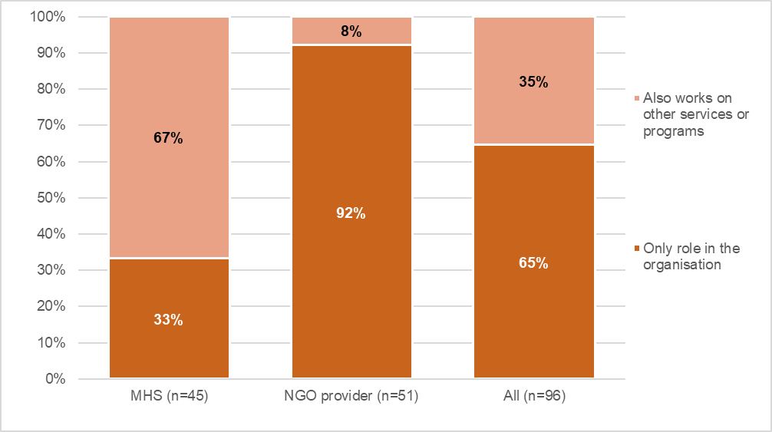Source: 1800RESPECT Workforce survey
In the interviews, FRCs described how, when answering a call, they first ask whether the caller is safe (“The only question, really, that we have to ask every caller is just are they safe right now to speak with us”), and whether they want to provide their name or remain anonymous. If callers are new to the service, FRCs “talk to them a little bit about the service, so they know what they can expect” and then undertake a needs assessment. The FRCs spoke about following protocols (“This is protocol. Everything I’ve told you, there’s a protocol for it which is part of the training”) when determining how to respond to callers but said that they do not use structured needs assessment tools:
I think the way the needs assessment sounds like a set tool, but we don’t have a structured needs assessment. We are trying to definitely establish what’s going on for them in the here and now. What they’re hoping to get. That’s the baseline and when we gather information about the presenting issue and then the intervention. Then we can transfer or I provide the counselling support that I can offer.
Interviews with callers to 1800RESPECT confirmed that the FRCs always checked on their safety and asked whether it was safe to talk, followed by whether they would be willing to provide any information to identify themselves, such as a name and phone number. Callers are given the option of remaining anonymous. Some callers reported that they choose to either identify themselves or remain anonymous depending on how they were feeling on the day or what the purpose of their call was. When calling for the first time, callers can provide personal information so that a file can be started. The purpose of creating this file is to reduce the number of times a caller needs to relay their story. Callers who were interviewed described the benefits of having their file on record as it allowed the FRCs and TSCs to have “a picture of my situation” (Caller Interview 11) and to avoid the “exhausting” process of “retelling your story” (Caller Interview 7).
The type of brief assessment process described by FRCs and select callers would conform to definitions of ‘screening’, which is victim-focussed and enables front-line practitioners to frame questions naming the possibility of current risk and attend to the immediate safety of the client, and provide appropriate referrals should that be required. Screening differs from the more comprehensive risk assessment protocols, which also include an assessment of specific risk factors for a client, as is the case in various jurisdictional tools, such as the Common Risk Assessment Framework (CRAF) in Victoria and the Domestic Violence Safety Assessment Tool (DVSAT) in NSW. Screening and risk assessment tools have been more commonly implemented with clients disclosing DFV and the evidence of their effectiveness is focused on face-to-face service delivery, as opposed to telephone counselling. It may be that further assessment of risk is conducted by the TSCs where engagement with the client is more in-depth.

FRCs reported that within the first few minutes of a conversation they can determine whether the caller may need some information or referrals, or to be transferred to a TSC. They reported that there is a protocol when dealing with callers, learned through their training. This includes encouraging callers to call the police or calling police on the caller’s behalf if they are in danger or transferring them to a state domestic violence service if they are leaving an abusive situation and need practical assistance. Other points of referral include state-based crisis lines and other non-crisis services for specific issues raised by the caller. These transfers are expected to take place via a 'warm transfer', whereby the caller, the FRC and the other service have a three-way conversation and the FRC explains the reason for the referral. If the caller has a file on record, the TSCs can take some time to read through the notes. Discussions with FRCs confirmed that when regular/repeat callers request to be transferred directly to a TSC, they check that they are safe (screen) before making the transfer. In these instances, the FRCs do not undertake a needs assessment or provide counselling before making the transfer:
If they ask to be fast-tracked, the protocol is just to put them through. So… I’d answer the phone, and then they’d say, “Hi. I’d like to speak to a specialist counsellor, please.” Then I’d just say, “Are you safe to talk at the moment,” and they’ll say, “Yes.” Then I’ll ask if they’d like to give a name, or if they’d prefer to be introduced anonymously, and they would make that decision, and then I’d put them through. We don’t engage in what their reason for calling is for callers like that. I think the rationale behind that is that if they’re asking to be fast-tracked to a specialist, it’s because they’re speaking to a specialist before and they found it useful.
This appears to be consistent with best practice because it means callers do not have to repeat their story, which is one of the primary benefits of integrated service provision.

NGO partners delivering trauma specialist counselling
The trauma specialist component is delivered by three NGO partners. The three partners were initially funded to each employ 16 FTE staff, comprising a program manager, clinical leads/senior practitioners and a team of TSCs (48 FTE in total). The additional funding announced in November 2018 would fund 81 FTE staff in 2018–19, and MHS were finalising the outcomes of a tendering process for expanding service provision for the trauma specialist counselling component during the evaluation.
The program lead in each of the partner NGOs is responsible for the day-to-day clinical and organisational management of the program, for staff supervision and coaching, and meeting with MHS to discuss staffing, resourcing and issues related to call transfers or complex calls. They attend program lead meetings with MHS, the clinical stream meetings and ‘YTT’ workforce planning meetings. They are also involved in the development of induction and training modules.
The main role of the senior practitioner is to support the TSCs by providing debriefing after challenging calls, supporting staff if matters need to be reported elsewhere (e.g. if there are child protection concerns) or if a caller is in crisis. Over the course of a shift, senior practitioners log on to MHS systems to keep track of the number of counsellors on calls, how many are available to take calls and to check if case notes are completed. Senior practitioners also participate in the clinical stream meetings and workforce planning meetings. In times of high demand, senior practitioners also answer calls and provide counselling support.
The role of the TSCs is to provide counselling within a single session framework to callers transferred by the FRCs. Some TSCs had been working with the NGO prior to the new partnership arrangement established with MHS under the model introduced in 2017, while others had joined when the partnership commenced. Some staff were relatively new to 1800RESPECT, having only commenced working for the service in the last few months. Staff had a range of prior work experiences, with many working in the NGO sector, in the government sector and in private practice before starting with 1800RESPECT. All had counselling experience, and several had worked on other helplines/crisis lines before joining 1800RESPECT. Many TSCs worked part-time. The experience and qualifications of staff is discussed in more detail in section 9.

1800RESPECT online resources and webchat
The 1800RESPECT website was redesigned in early 2018 following trauma-informed principles and hosts many resources including information about:
- responding to people impacted by violence
- a Frontline Workers Toolkit
- a service directory
- inclusive practice, resources and tools (e.g. risk assessment frameworks, workplace safety)
- training and professional development
- leadership and management
- a range of issues (e.g. technology and safety, alcohol and other drugs, child safety)
- events and webinars, and
- information and support for stress-induced stress and trauma.
The website also hosts a webchat function, which allows web users to communicate with 1800RESPECT FRCs. The online chat function has been available since 2016. With input from sector collaborators, MHS also developed the Daisy app (which connects users to local supports) and the Sunny app (for women with disability), which can be downloaded from the 1800RESPECT website, and the App store. The website provides information in a range of languages and information about the National Relay Service, the Translating and Interpreting Service, web tools for people with disability and a video in Auslan (see section 4.4). The website also includes a service directory that allows people to search for a range of services in each of the states and territories. However, as noted elsewhere in this report (see section 5.2), some of the service information is out of date or incorrect.

Effectiveness of 1800RESPECT in delivering a high quality, accessible and responsive service
Through the remainder of the report, findings are presented in relation to each evaluation question, drawing on interviews, survey and other data. This section provides evidence collected from service users, staff and sector representatives in response to the first key question: ‘How effective is 1800RESPECT in achieving its objectives to deliver a high quality, accessible and responsive service?’ and related sub-questions (see Table 1.1)

Caller perspectives on quality, access and responsiveness
As outlined in section 2.2, the small sample of service users who participated in the interviews were recruited via the trauma specialist counselling component of the 1800RESPECT service. While clearly not representative of callers generally, these callers (n=12) were very positive about their experiences of accessing counselling support through 1800RESPECT and spoke primarily about their interactions with the TSCs, because their interactions with the FRCs tended to be quite brief and limited. The participants’ focus on their interactions with the TSCs means that there is almost no comment on the FRCs and the service they provide, which is a limitation of this evidence.
The callers interviewed had been accessing the telephone counselling service for various lengths of time, ranging from two months to four years. For some, 1800RESPECT offered a key point of contact during times of crisis, such as when they were experiencing current domestic and family violence, or when they were attempting to leave a violent situation. For these people, the frequency with which they accessed the service was largely dependent on what was going on in their life. For example, one caller indicated that she could call on consecutive days during a time of crisis, followed by an extended period without accessing the service. Many of the callers interviewed had complex trauma histories, which meant that they might turn to the service at times when memories surfaced:
I use it a lot. I seem to go through stages, depending on what’s going on. (Caller Interview 8)
Callers reported that the FRCs were always friendly, caring, considerate, and professional:
I can’t praise them enough. The way they handle it. They’re always there for me. They’ll do everything they can... I’m just happy with how they go about it. They’re always thoughtful and considerate. (Caller Interview 8)
You speak to somebody that's on an intake line and I have just at times, spoken to those people, where you can just get some information and referral stuff… It's fairly basic info that you can get, what services are in your area, that sort of thing. Yeah, they're always really friendly and really nice. (Caller Interview 10)
Some callers who had complex trauma histories described how they asked the FRCs to transfer them immediately to speak to a TSC. As such, their interactions with the FRCs were brief. For these callers, the trauma counselling component of 1800RESPECT filled a service gap when other services were not available. The 24/7 nature of the service meant that callers were able to access counselling support any time they needed it, including overnight. Callers were appreciative that the TSCs were willing to spend time talking with them. Some described how important it was to not feel that they were being rushed off the phone, and therefore how positive their interactions with the TSCs were:
It’s been amazing being able to know that I can call someone up at one o’clock in the morning, and there’s someone there to take the call... having someone to talk to in the middle of the night, because I can’t really call my family or anything at that time of the night. So, it’s been really beneficial, because I’m not completely alone, even though I feel it, I’m not actually completely alone. So, it is quite powerful in that way. (Caller Interview 9)
Because they don’t hang up on you. They’ll spend time with you. If you’re serious, if they need to spend 15 minutes with you, they will. If they need to spend an hour with you, they will spend an hour with you... It’s not a thing like, “I’m sorry each client has only got 15 minutes and we’ve got to wrap it up now.” … They're available, and they give you the dignity to listen to you. (Caller Interview 7)

Callers value counsellors’ expertise
The TSCs were described as being sympathetic, empathetic, caring, compassionate, respectful, understanding, knowledgeable, gentle, and helpful. One participant praised the TSCs for asking what the caller wanted to get out of the call, while another highlighted that the TSCs differed from those at other services because they never offered opinions. Many described how TSCs often stressed to callers that they could always call the service again at any time if they needed. Attending to emotional and psychological safety in this way and providing choice and empowerment for clients about service access is consistent with principles of trauma-informed practice. For some callers, this option was critical as they were anxious about being perceived as annoying by calling regularly. One participant described how the TSCs looked at her as a “whole person” rather than focusing on isolated incidents of abuse:
I just feel heard, I guess, listened to, respected and they're really important things for me. (Caller Interview 10)
I think primarily it is that notion of just being heard, and being understood, and reassured and comforted, to some degree, because obviously, there’s a whole variety of emotions you go through when you’ve been through DV. So, having that support and someone who, I guess, normalises some of the feelings that you have got, and you’re going through, is really positive. (Caller Interview 9)
Callers valued TSCs’ understanding and non-judgmental approach. They described how specialist counsellors never questioned why they didn’t leave abusive relationships as they understood why women don’t leave, and the challenges that they are faced with if they do. TSCs also simultaneously validated callers’ feelings and confirmed that what they were experiencing was indeed abuse. This was particularly important for callers who had no other supports and were very isolated:
They never make me feel bad about it. They understand why women don’t just leave. (Caller Interview 8)
It made me feel a lot better, that at least I had someone that I could talk to that isn’t judging me… I actually felt like for once throughout this whole process, I had someone on my side. They may not be physically next to me or whatever, but they actually understand what I’m talking about. There’s no question about what I’m telling them. (Caller Interview 3)
Callers commented on and valued TSCs’ training and expertise. TSCs were described by multiple callers as being trauma-informed, and as really understanding domestic and family violence, and sexual assault. As the following caller describes, this prevents the caller from feeling like they have to explain a lot of things:
I really get the feeling that they really understand this stuff, that stuff. The sexual assault and family violence stuff, that they're really aware of that and that means that I don't have to explain a whole lot of things. They're really good at, I don't know, helping me figure things out for myself in a way. Does that make sense?... So, they're not offering solutions or anything, they just talk me through it in a way that helps me come up with a way forward. (Caller Interview 10)
After speaking with the TSCs, callers described feeling calmer than they had before they called. TSCs helped them to process what they had experienced or what they had been feeling. Some callers described the TSCs as helping them to put things into perspective.
A number of participants described the 1800RESPECT service as being life-saving. Some of these callers indicated that they had suicidal thoughts or had attempted suicide, and that the 1800RESPECT service had enabled them to carry on with life. As one participant said, “[I]t has basically given my life back or a life that I didn’t have” (Caller Interview 6). Multiple participants stated that they did not know what they would have done without the service:
Without that line and speaking to those professionals I wouldn’t have got through some of those nights… I think that they’re brilliant and I’m very grateful because I’ve lived another day. (Caller Interview 2)
For me, they’ve saved me from suicide at least three or four times. (Caller Interview 7)
Without their service I don’t know where I’d be. They’ve really saved me, so many times. (Caller Interview 8)
In addition to listening to callers, the TSCs also imparted information and psychoeducation to callers. This included information about DFV, and SA, referrals to other services, and coping and management strategies. While some callers may already possess some of the skills needed to manage their feelings, speaking to the counsellors was described as a good reminder to utilise or refresh those skills. For some callers, the TSCs helped them to see that their relationships were abusive or to identify particular abusive behaviours, such as ‘gaslighting’. The counsellors didn’t necessarily treat the interaction as an education session, but callers nevertheless identified that they were receiving valuable information. One caller described the interaction as “real support not just, ‘I’m sorry that you went through what you went through’” (Caller Interview 5).
The ladies are great. I transfer through and I can go through whatever I want to talk about. They’ve told me about certain things about domestic violence that I didn’t even know about. (Caller Interview 4)
These girls are giving me the skills to help myself. A good coach is someone who is going to do themselves out of a job. That’s what I believe 1800RESPECT specialist counsellors are. They’re not there to have you become needy and depend on them. That’s what has made it work for me. (Caller Interview 6)

Preference for 1800RESPECT over other services
Many callers expressed a preference for accessing support from 1800RESPECT over other services. There were a variety of reasons for this, including knowing the TSCs would be female and that the approach would be trauma-informed. Callers valued TSCs’ validation of their feelings and non-judgmental approach. One caller described the TSCs as having “specialised understanding and knowledge” of DFV and SA (Client Interview 9). Participants felt that the TSCs were willing to listen to them in a way that other mental health professionals had not done before. Further, some callers felt that many mental health professionals were only concerned with ensuring that the caller would not self-harm or attempt suicide, whereas 1800RESPECT TSCs listened and talked through the underlying issues and tried to work towards alternative solutions:
I guess it's the sense of safety around the people that work there; the trauma awareness is a lot greater than a lot of other places… I just feel heard, I guess, listened to, respected and they're really important things for me… I get a feeling that the people at 1800RESPECT know more or understand more about this specific stuff whereas with the others, that's really just general mental health and don't necessarily get the trauma thing. (Caller Interview 10)
As well as preferring it over other services, callers indicated that 1800RESPECT “filled a gap” in the service system, and many used it when they could not access their usual mental health professional or other services, or when they could not seek support from family and friends.
1800 can help fill in the gaps... I would call outside of business hours, so when everything else is closed that’s when I call. (Caller Interview 11)
[T]hey're available… It's not a 9:00 to 5:00 go to an office type thing so I can call them from wherever I am, whatever time if things are going really downhill, that it has been huge lifeline in a way for me at times. (Caller Interview 10)
I thought, Wow. I can ring any time and something like this is available to me, because I didn’t have anything for years. (Caller Interview 5)

Caller criticisms of 1800RESPECT
When asked whether there were any aspects of the service that they did not like, many callers were quick to state that they had nothing bad to say about the 1800RESPECT service. Some who had accessed the telephone service over a number of years identified that the operational model had changed, resulting in improvements, although some had had an occasional negative experience, relating to individual counsellors or wait times.

Alternative counsellors and the single session model
For callers who reported negative experiences with a TSC, it was often related to feeling like they did not “match” with the particular counsellor. In many circumstances, the caller ended the conversation and called the service again so they could speak to someone else. This is not an unusual choice for DFV and SA clients seeking a counselling service. Evidence suggests the match of counsellor and client is critical to engagement, even for a single session. However, callers also navigate the ‘single session’ model to speak to an alternative counsellor and by accessing the service through a series of ‘sessions’, the model may become inappropriate and costly. 1800RESPECT program data indicates that a relatively small proportion of individuals account for a substantial number of interactions (phone and online) with the service. Quarterly data shows that in Q3 2018–19, 7.1% of the people who contacted the service accounted for 25.7% of interactions (see Figure 6.12). This data suggests that for callers with complex needs a single session may not be adequate.
Some callers who had experienced CSA reported negative experiences where the counsellor suggested that 1800RESPECT was not an appropriate service for them, or refused to speak about the ongoing effects of childhood abuse. The caller quoted below had experienced this three times in a year, but had simply phoned back in order to speak to a different TSC:
I actually got onto three women who were quite rude and said, “We’re not that type of service.” They then went on to lecture me that that's not the type of service they provide. Me being a strong-minded woman, I stood my ground. I didn’t actually put in a formal complaint, but I let them know that I wasn’t impressed… I just hung up and phoned back. (Caller Interview 6)
Another caller felt that it would be beneficial to have the same TSC when she called the service, even though this is outside the scope of the service.
It is important to note that the 1800RESPECT Service Delivery Manual (SDM) (Version 3.0, 2019, p.81) reports that specialist counsellors complete Enhanced Training Modules within their first six months of service. This includes a 60-minute module on ‘Adults who experienced sexual abuse during childhood’. The module covers five key topics, one of which is “how to support a caller within a single session approach, using your trauma specialist skills”. This training information suggests that MHS sees adult survivors of CSA as in scope, despite this not always being conveyed by all TSCs when responding to this group of callers. It is also important to consider whether a single session model suitably addresses the needs of this cohort.

Wait times and call backs
It is important to recognise the very small number of caller participants who participated in the evaluation and that these perspectives, while important, may not represent the majority of callers accessing 1800RESPECT and the TSCs.
The callers who participated in interviews spoke about the potential lengthy waiting times to speak to a TSC, with one indicating that about half the time she calls, she has to wait. Often, the FRC will attempt to put the caller through to a TSC a few times and there may be a short wait time, or alternatively the FRC will request to take down the caller details so that the TSC can phone them back. For the most part, callers understood there would be peak times, however, some said they would have liked an indication of when they could expect to be phoned back. Interviews highlighted that the wait times had significantly reduced since the changes to the operational model, with previous wait times ranging from 24–48 hours, and current wait times ranging from just a few minutes to a couple of hours. A couple of callers reported that it had been very busy on the line recently, with one suggesting that was potentially linked to media reporting on cases of CSA acting as a trigger for people. However, one caller mentioned speaking to the FRC in the interim period because they understood she was going through distress and could offer her support for a brief period of time (half an hour). Despite these complaints about waiting times, participants were quick to highlight that the counsellors always called back:
If there could be any one thing, last night I had to wait 40 minutes before they answered it and I went on two waitings to get through and they couldn’t get me through, but they promised to ring me back, and they honour that too, and they do ring back. (Caller Interview 2)
I think they're doing the best job they could do. They’ll always get back to you, if they’re busy, they won’t keep you waiting, they don’t hang up on you, they don’t tell you, “I’ve got to go, we’ve been on the phone now for 15 minutes, I better let you go.”. They take care, and they will always say to you, “If you’re not feeling right, if you need to call us again, call us straight back any time.” You feel like, “Okay. I’ve spoken to you guys for 40 minutes, and you’re still inviting me to call back if I’m still not feeling well.” That’s a big relief. (Caller Interview 7)

Staff perspectives on quality, access and responsiveness

Staff consider 1800RESPECT to be high quality
Like the service users who were interviewed, staff interviewees also tended to feel 1800RESPECT was providing a high-quality counselling service. The service was seen to be effective because it:
- provided quality counselling by staff with counselling qualifications and experience
- was trauma informed
- was DFV informed
- was accessible with respect to availability (operating 24/7) and mode of delivery (phone rather than face to face)
- was free
- allowed callers to remain anonymous
- elicited positive feedback from callers.
These benefits of the services were reflected in comments from staff:
I can’t tell you how many people I’ve worked with that needed support out of hours or to access free counselling and just not been able to or they’ve been able to access two or three sessions and it’s been three bus rides away and they’ve got kids with them. For me, the core of what we deliver is really, really well done.
I think that there are some calls where it is magic. There are moments that have a lot of healing for people, that being there when someone chooses to phone up, that there's a sense of honesty through the phone line. It's a counselling that's not – people can call in anonymously, so they can speak more freely and genuinely.
Other comments from 1800RESPECT managers concerned how the various teams within MHS work together to improve the responsiveness of the service:
We're a very responsive service because all those different parts work so well together and we can address increasing need across a range of platforms. So, through our social media, through the website, if we need to flex up our staffing, but also think about our clinical responses.
This was echoed by managers in NGO partners, who valued the commitment from MHS in ensuring service responsiveness:
They’re an extraordinary team to work with in dedication in ensuring this is not just a successful purpose, but that it meets the needs of those that we’re speaking to.

Staff feel 1800RESPECT makes a difference
1800RESPECT workforce survey respondents also saw the service as effective. They explained how they had a strong sense it was making a difference. Staff almost universally agreed or strongly agreed with the statement ‘My work makes a difference in people’s lives’ (98%), with only one respondent disagreeing and another being neutral. Comments made by staff in the survey also indicate they value it for its quality, accessibility, responsiveness, and the opportunity it gives them to work closely with women to improve safety and wellbeing outcomes. When asked to comment on what they value about the work they do, many said they valued the accessibility of the service, for example:
I value the fact that people have instant access to assistance when they need it - they are no waiting lists, money is not an issue, gender is not an issue and people's geographical location is not a barrier either. (NGO respondent, 1800RESPECT workforce survey)
I value being able to support people where they are at. Some people experiencing DFV are not able to connect to other services, and I love that they are still able to access support through us. (MHS respondent, 1800RESPECT workforce survey)
Several referred to the accessibility of 1800RESPECT, and underlined that the availability of the service when callers needed it was something they strongly valued:
That people can reach out 24/7 and someone will be there to validate them, support to manage risk and help them to be safe. (MHS respondent, 1800RESPECT workforce survey)
I value working for a service that is offered after hours and is able to provide therapeutic support via immediacy. (MHS respondent, 1800RESPECT workforce survey)

Staff are confident in delivering the service
As further evidence of quality, the 1800RESPECT workforce survey asked staff about how confident they felt addressing issues of violence. High proportions said they feel confident with respect to physical, emotional and other forms of violence and abuse (see Figure 4.1). For physical violence, 88% of NGO respondents said they were ‘very confident’ in responding, as did 71% of MHS staff. Ninety percent of NGO respondents were ‘very confident’ with respect to addressing psychological violence, as were 79% of MHS respondents. Respondents were least likely to feel ‘very confident’ with respect to technology-facilitated abuse.

Figure 4.1 Proportion of staff who felt “very confident” responding to each area of violence or abuse
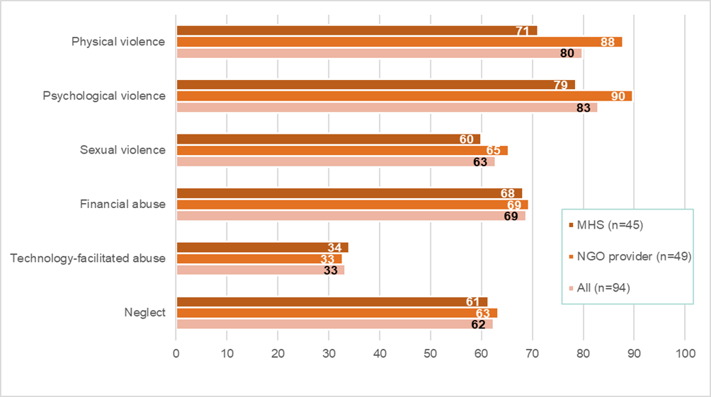
Source: 1800RESPECT Workforce Survey
High quality is also reflected in that 95% of respondents reported using a model or therapeutic framework in their practice. Most commonly, they mentioned using trauma-informed or strength-based models or frameworks. Feminist, narrative, person-centred or client-centred practices were also commonly mentioned.
Further, 1800RESPECT counsellors also feel generally able to deliver the standards of service that callers need (see Figure 4.2). High proportions agreed they were able to spend enough time with each client (88% of MHS respondents and 81% of NGO respondents). This is high in comparison with the equivalent figure from the National Survey of Domestic and Family Violence and Sexual Assault Workers, in which 66.3% agreed or strongly agreed they are able to spend enough time with each client. High proportions also agreed they can work creatively to meet callers’ needs (79% of those in MHS and 91% of NGO respondents), which was close to the figure from the National Survey (88.8%). However, most staff (63%) disagreed with the statement ‘There are enough staff in the service to get the work done’, and whereas 47% of MHS staff disagreed and 30% were neutral, over three quarters (77%) of NGO staff disagreed with the statement, and a smaller proportion were neutral (15%). Indeed, only 8% of NGO staff agreed with the statement, compared with 23% of MHS staff. By contrast, a higher proportion of respondents agreed with the statement that ‘There are enough staff in the service to get the work done’ in the National Survey compared with 1800RESPECT counsellors. This is shown in Figure 4.2.
Figure 4.2 Agreement with statements about service delivery
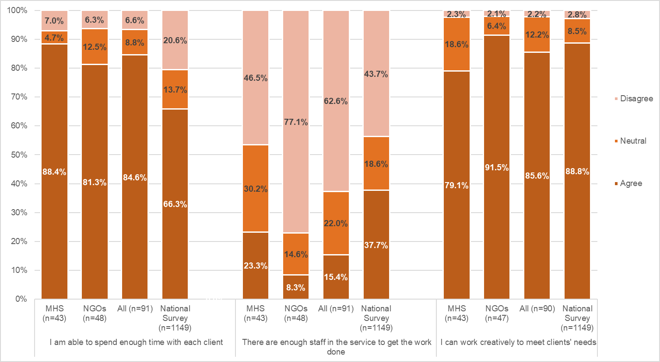
Source: 1800RESPECT Workforce Survey. Data from the National Survey is drawn from Cortis et al (2018)

Community awareness and confidence in the service
This evaluation sub-question asked: ‘What is the extent of community awareness and confidence in the service?’ This was explored primarily through the sector survey and stakeholder interviews.
Sector survey findings
To capture ‘awareness’, respondents were asked to report with which resources offered by 1800RESPECT they were familiar. Most but not all were familiar with telephone support by a ‘first response’ counsellor (83%). The next most familiar resource was the information on the website, with which 55% of respondents said they were familiar. A little under half (47%) said they were familiar with specialist trauma counselling by phone offered by 1800RESPECT, with fewer familiar with the Daisy App (the online chat function on the website), and other resources (see Table 4.1).
Table 4.1 Awareness of different aspects of the 1800RESPECT service
 | n | %
Telephone support by a 'first response' counsellor | 48 | 83
Information on the website | 32 | 55
Specialist trauma counselling (telephone) | 27 | 47
The Daisy App (which connects users to local support services) | 18 | 31
Online chat function on the website | 12 | 21
Webinars | 8 | 14
Digital frontline workers toolkit | 4 | 7
The Sunny App (for women with disability) | 4 | 7
Source: Sector Survey
To capture sector confidence in the service, the survey asked how strongly respondents agreed or disagreed that 1800RESPECT provides a quality service, and that the information it provides is reliable (see Figure 4.3). On both measures, many respondents were neutral, but much higher proportions agreed than disagreed. While a third were neutral on the statement that ‘1800RESPECT provides a quality service’, 60% agreed or strongly agreed, and only 7% disagreed. Similarly, while a quarter were neutral, 71% of respondents agreed that information from 1800RESPECT is reliable, and only 6% disagreed. This indicates strong confidence in the sector in relation to the quality and reliability of 1800RESPECT.

Figure 4.3 Proportion of respondents who agreed or disagreed with statements about quality and reliability
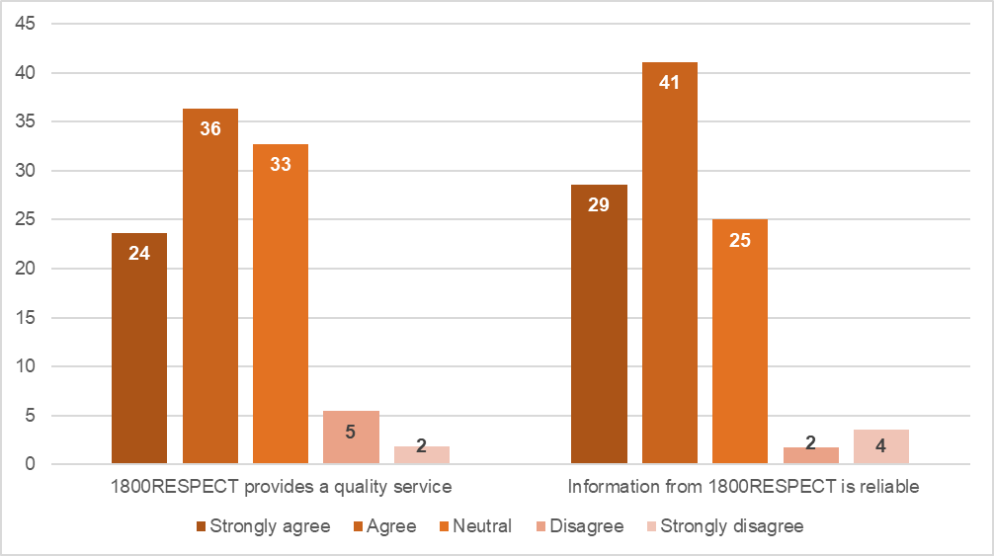
The sector’s broad confidence in the 1800RESPECT service is also reflected in comments left in the sector survey. Some focused on the telephone component of the service, and underlined the important role 1800RESPECT played for their clients, for example:
They are a resource that is reliable. (manager, QLD)
To be available night and day for clients in crisis. To be trauma informed meaning I can trust the response to be appropriate and client focused. (practitioner, QLD)
They always patch through the callers respectfully and provide a good handover. (practitioner, ACT)
Some, however, underlined that they could not be consistently confident in the 1800RESPECT service:
From what clients tell me, they have felt rushed and not listened to very well - like the listener was in a hurry to move them on. (practitioner, VIC)
Clients have said they don’t like long winded intro recordings on helplines and tend to hang up due to nerves if not responded to quite quickly, so maybe this could be slightly reduced/improved. With sexual violence victims, access and swift responsiveness is the crucial difference. Glad we do have a 24-hour service tool. (practitioner, QLD)

Stakeholder interviews
Stakeholder interviews also provide insight into awareness and confidence in the 1800RESPECT services. Stakeholders were generally confident in the service, but some expressed critical perspectives. Information provided by stakeholders in the interviews highlighted how state/territory DV crisis lines are not able to offer the suite of counselling options that 1800RESPECT provides. Stakeholders reported funding constraints that restricted operating hours and insufficient staffing levels to meet demand, resulting in jurisdictional services prioritising crisis calls rather than additionally being able to offer more in-depth counselling support. In this context, practitioners working on the state and territory crisis lines referred to the importance of being able to refer callers to the 1800RESPECT line once their “crisis and practical logistical support” needs had been met, such as for those in crisis accommodation:
We know that a critical time for women disengaging is that first, second night in the motel. Because, they’ve gone out of survival mode into an eerily quiet place. A lot of women really struggle with that. For the first time, they’re really able to ruminate on those very negative thoughts... And in the motel, for the first time, they’re very alone. 1800RESPECT for us is really critical. Sometimes we can’t sit with women for a lengthy time…. Being able to refer that to 1800RESPECT… is very critical… We aren’t picking up a lot of the calls that we’re getting already. For example, overnight we’ve only got one worker on. It’s predominantly a funding issue, that we don’t have enough funding to hire more people... If I’m in the after hours space and a woman is calling for counselling, but I’ve got [00:13:22] with a woman who’s just been assaulted on the other line, I have to prioritise that. There’s just no one else to pick up what would otherwise be a counselling call.
We promote it because of circumstances here… in terms of a lack of a specialist domestic violence service and to some extent, a sexual violence service that wasn’t about that direct response to recent sexual assault outside of those core working hours.
This suggests that the 1800RESPECT service is filling a service gap for which state crisis services are not funded. This interview data also partially explains the repeat callers who may feel as if they have no other option but to re-contact 1800RESPECT.
Discussion with stakeholders also highlighted how MHS has collaborated with a range of different specialised services, which they felt has led to greater awareness of and confidence in the 1800RESPECT service, as reported in the next section.

Access and appropriateness for diverse groups of people
This evaluation sub-question asked how accessible and appropriate the service is to diverse groups of people, such as people of CALD background, Indigenous people, young people, people with disability, people of different religions, people of different sexual orientation or identity, people of different socio-economic groups, people from rural and remote locations, and family and friends of people who have experienced sexual assault, domestic or family violence. This was addressed through analysis of program data and client demographics, as well as stakeholder interviews.
The homepage of the 1800RESPECT service provides several links to enhance the accessibility of the service. These include ‘Accessibility options’ (https://www.1800respect.org.au/accessibility/); clicking on this link takes the user to a page the provides information and links about:
  - the National Relay Service
  - the Translating and Interpreting Service
  - web tools for people with disability
  - an Auslan video ‘Sexual assault and domestic and family violence: How to get help and support’.
The homepage of the 1800RESPECT service includes the link ‘Languages’ which takes the user to a page that lists 28 languages, including Arabic, Bengali, Simplified Chinese, Croatian, Dari, Dinka and more. The pages explain what 1800RESPECT is, getting help, getting information, how family and friends can get information, information for professionals, and how to contact the service. Users are also advised to call police on 000 if they are in danger. The page also includes a link to ‘About domestic and family violence’. This takes the user to a video in English with subtitles in the target language. These pages were developed with the Ethnic Child Care, Family and Community Services Co-operative, however the link provided on the 1800RESPECT website was not functional.
The homepage also includes numbers for ‘NRS’ and ‘Interpreter’.

Analysis of client demographics
Program data provides important insight into the extent to which 1800RESPECT is accessible and appropriate to diverse groups. Data provides insight into which groups of people are using the service and their needs, and the extent to which it is used by people from each state and territory. Additional data is reported for the ‘person at risk’ for each call (which may not be the caller). In interpreting the data, it should be noted that gender is the only mandatory demographic variable collected, the others depend on what is disclosed by callers and follow-up questions asked by FRCs. It is also important to interpret information about client demographics with caution given that CALD, LGBTQI and disability status is only collected from callers who choose to disclose that information to 1800RESPECT, which in 2018–19 was between 1 and 3% of callers.

Gender
Gender is recorded for all callers to 1800RESPECT. Figure 4.4 shows that, from the implementation of the first response service model to December 2018, women represented the largest proportion of in-scope contacts handled by 1800RESPECT.
Figure 4.4 People accessing 1800RESPECT by gender of the caller
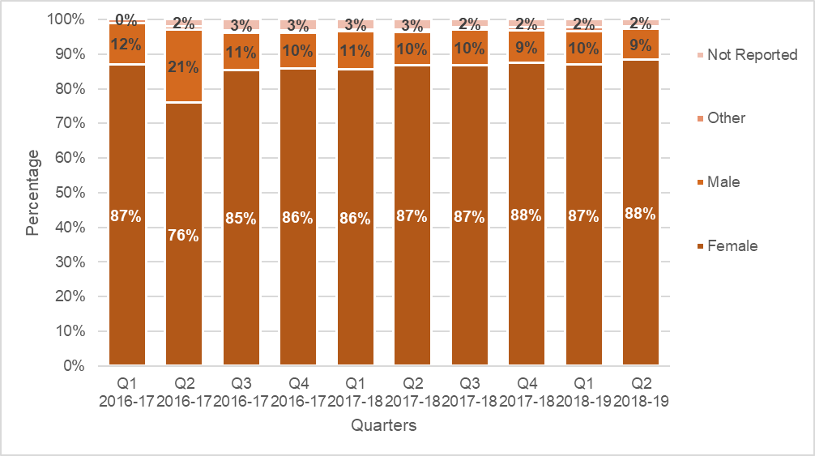
Source: 1800RESPECT program data.

Types of violence reported
Since the start of the First Response service model to December 2018, the vast majority of in-scope contacts were people who themselves were at risk of and/or experiencing violence. Mothers, friends, people in other relationships with the person at risk, and health professionals, also made contact but only in much smaller percentages. Figure 4.5 shows the types of violence reported. Notably, the proportion with no reported violence has increased from 24% from Q3 2016–17 to 37% in Q2 18–19. Correspondingly, smaller proportions of callers have reported physical violence or sexual assault over the period. The content of calls where there is no reported violence is unclear; this may include people wanting information about violence but who have not reported that it has occurred, survivors of historical violence, practitioners, or those contacting the service who are out of scope. As this is a growing proportion of calls, further investigation is warranted.

Figure 4.5 Types of violence reported
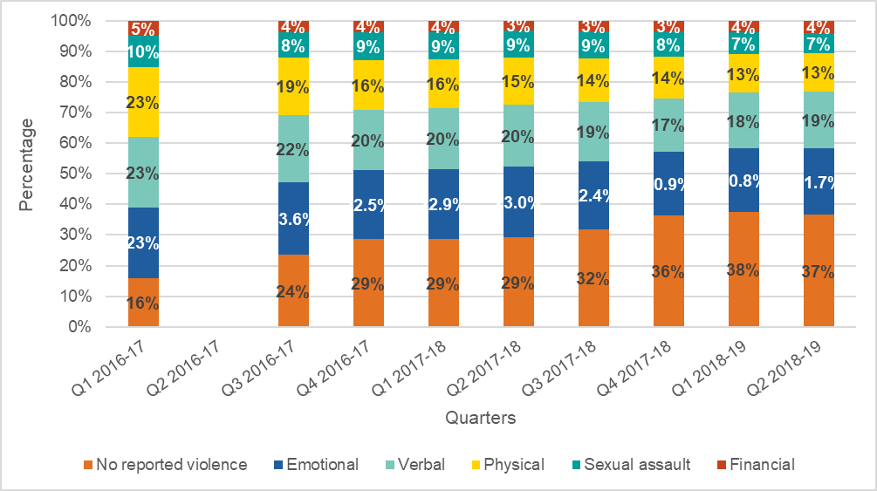Source: 1800RESPECT program data. Data was missing for Q2 2016-17.

Age
Figure 4.6 shows a trend towards an increase in contacts with 1800RESPECT from people aged 36–40 years (MHS, 2019), whereas all other age groups presented more or less the same number of contacts over the last year. The percentage of contacts from people in the age groups over 66 were small and did not show major variations.
Figure 4.6 Contacts by age – from 0–15 to 36–40 years old
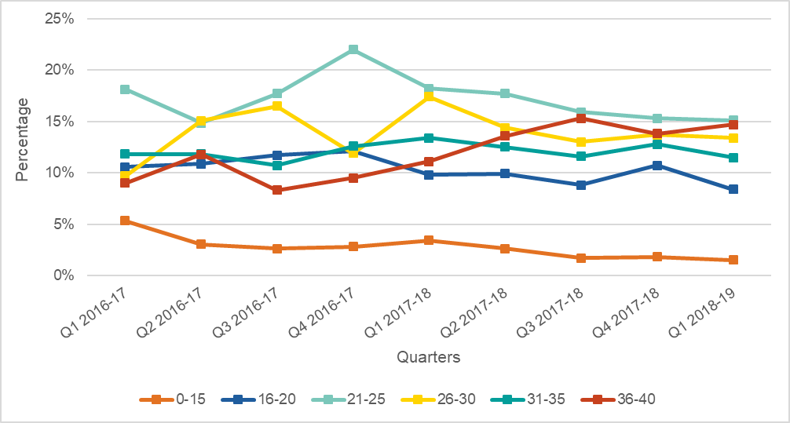
Source: 1800RESPECT program data
Figure 4.7 Contacts by age – from 41–45 to 61–65 years old
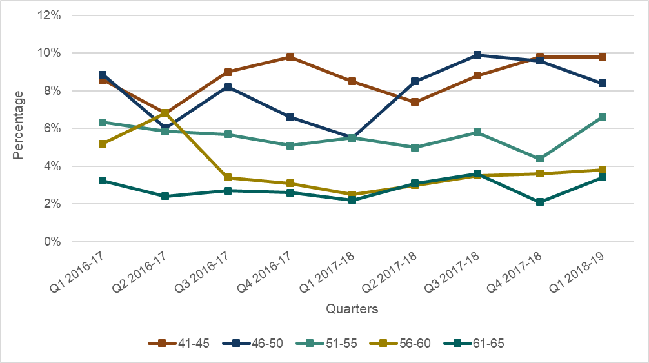
Source: 1800RESPECT program data

LGBTQI
Table 4.2 shows that the proportion of people of different sexual orientation or identity accessing 1800RESPECT services varied from 0.6% to 1%, as reported in the 1800RESPECT program data, noting that this is based on a small sample. Overall, LGBTQI people represented from 0.5% to 1.7% of the contacts identified as being at-risk. It is important to recall that this demographic information is only collected from the small proportion of callers who choose to disclose their sexual identity (between 1–3% of callers).
Table 4.2 People at risk who identified as LGBTQI
 | 2016–17 |  |  |  |  | 2017–18 |  |  |  |  | 2018–19
 | Q1 | Q2 | Q3 | Q4 |  | Q1 | Q2 | Q3 | Q4 |  | Q1 | Q2
Contacts | 1.0 | 1.0 | 0.8 | 0.7 |  | 0.6 | 0.7 | 0.6 | 1.0 |  | 1.0 | 0.7
Person at risk | 0.8 | - | 1.3 | 1.7 |  | 1.0 | 1.0 | 0.5 | 0.5 |  | 0.6 | -
LGBTQI as risk factor | 2.0 |  | 2.1 | 1.4 |  | 2.2 | 2.1 | 1.7 | 2.4 |  | 2.1 | 0.9
Notes. All callers are assessed for risk with every in-scope call evaluated as (Low, Medium or High). This is a mandatory field and must have a level of risk assigned once both caller and counsellor’s perception of risk is identified. ‘Person at risk’ consists of those assessed as such following assessment. Quarterly profiles were created on contacts at-risk; one contact may have multiple characteristics or none. Source: 1800RESPECT program data.

Cultural background
While the data is based on a very small sample, Figure 4.8 shows an increase in the percentage of contacts classified as at risk from people who identified as Australian, while the number of contacts classified as at risk from people who identified as Aboriginal and Torres Strait Islanders and as New Zealanders remained stable. Figure 4.9 shows some minor variations in the percentage of contacts from people of Chinese background, while the number of people who identified with Filipino and Vietnamese backgrounds remained stable over the last year. Only small percentages of contacts were registered as at-risk for people who identified with other ethnic backgrounds, including English, American, Thai, Indian, Pakistani, Indonesian, Greek, Italian, Turkish, and Lebanese. In many cases data for these groups were available only in some quarters and consisted of very small percentages.
Figure 4.8 People at-risk¹ by ethnic background – Oceanian²
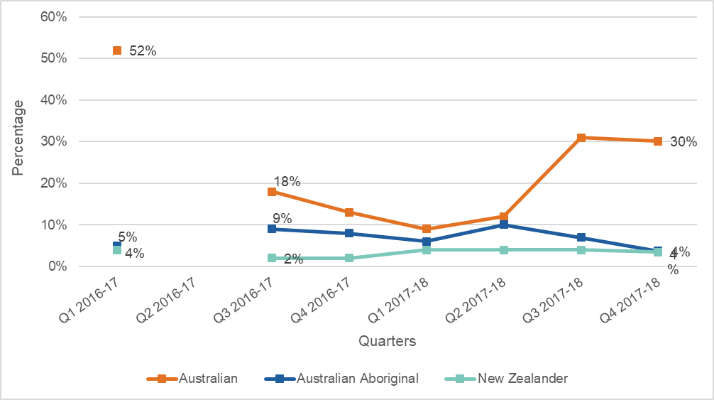
Source: 1800RESPECT program data
Notes. ¹ All callers are assessed for risk with every in-scope call evaluated (Low, Medium or High) in MHS’ data management system. This is a mandatory field and must have a level of risk assigned once both caller and counsellor’s perception of risk is identified. At risk evaluation included every caller, not just those experiencing physical violence.² Australian Standard Classification of Cultural and Ethnic Groups, 2016 (ABS, 2016).

Figure 4.9 People at-risk¹ by South-East Asian and North-East Asian background²
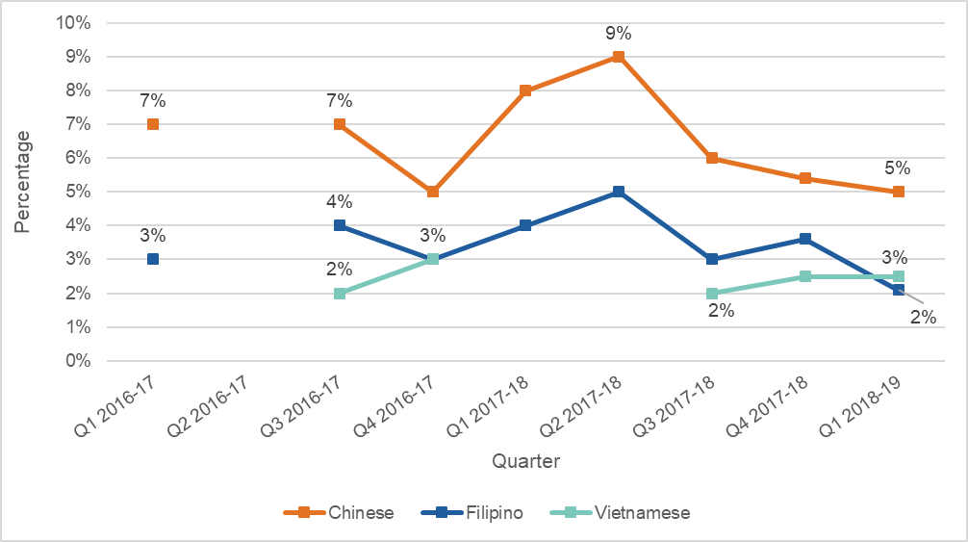
Source: 1800RESPECT program data
Notes. ¹ All callers are assessed for risk with every in-scope call evaluated as (Low, Medium or High). This is a mandatory field and must have a level of risk assigned once both caller and counsellor’s perception of risk is identified. At risk evaluation will include every caller, not just those experiencing physical violence.² Australian Standard Classification of Cultural and Ethnic Groups, 2016 (ABS, 2016)

Disability
Figure 4.10 shows the proportion of people at risk that reported having a disability. It is important to recall that this demographic information is only collected from the small proportion of callers who choose to disclose their disability (between 1–3% of callers). The most common was a chronic mental health condition, which comprised an increasing proportion since Q3 2017–18. This was followed by physical impairments or chronic conditions. There has been an increase in the percentage of at risk people with a chronic mental health condition.
Figure 4.10 People at-risk who also have a disability
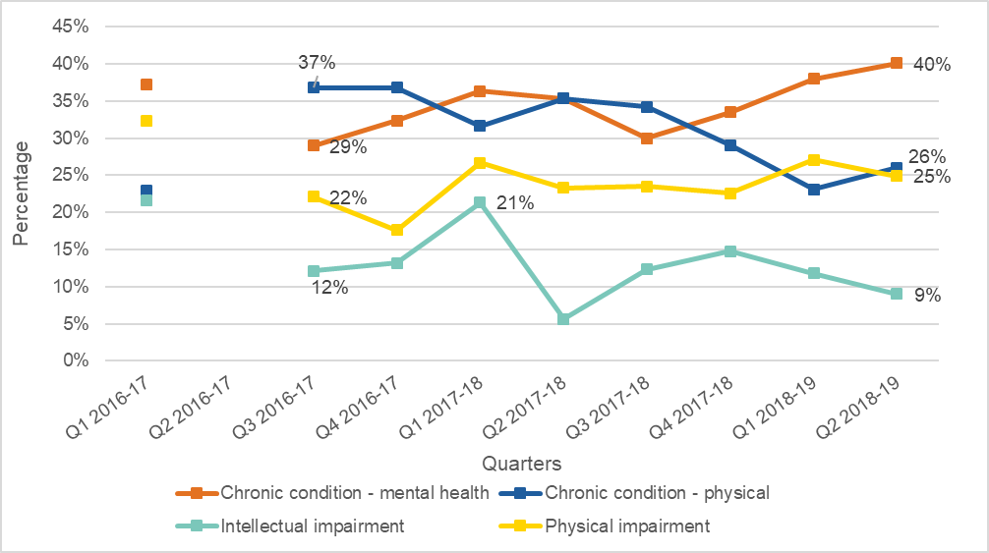
Source: 1800RESPECT program data.
Notes: 1. All callers are assessed for risk with every in-scope call evaluated (Low, Medium or High) in in MHS’ data management system. This is a mandatory field and must have a level of risk assigned once both caller and counsellor’s perception of risk is identified. At risk evaluation included every caller, not just those experiencing physical violence.2. Australian Standard Classification of Cultural and Ethnic Groups, 2016 (ABS, 2016). Note that data was missing for Q2 2016-17.
Location
Figure 4.11 shows that the percentage of contacts from the state and territories has been stable from the start of the First Response service model to December 2018. Calls volumes reflect population distribution and calls from New South Wales (NSW), Queensland (QLD) and Victoria (VIC) comprise the majority of calls to 1800RESPECT. Growth in the numbers of callers has been most apparent in the more populous states, particularly in NSW, VIC and QLD from late 2017. Call volumes from the other jurisdictions are comparatively lower, with the Australian Capital Territory (ACT), Tasmania (TAS) and the Northern Territory (NT) recording the lowest number of calls.

Figure 4.11 Percentage of contacts by state and territory
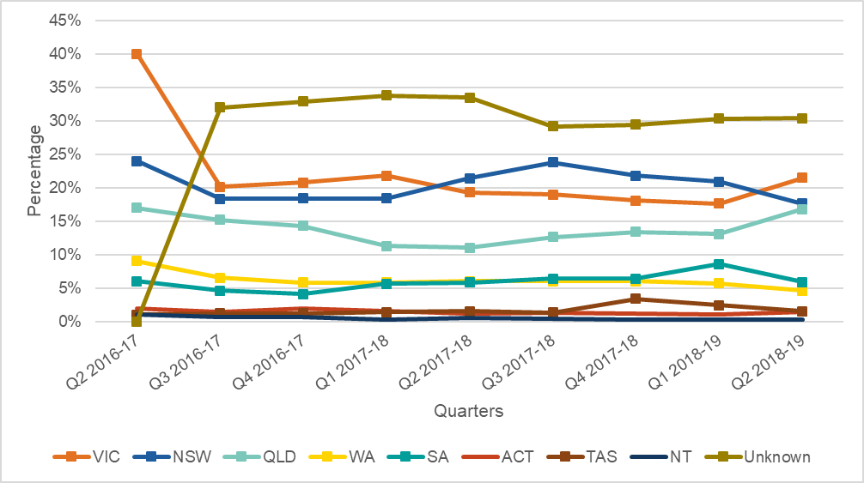
Source: 1800RESPECT program data
Figure 4.12 Numbers of contacts by state and territory
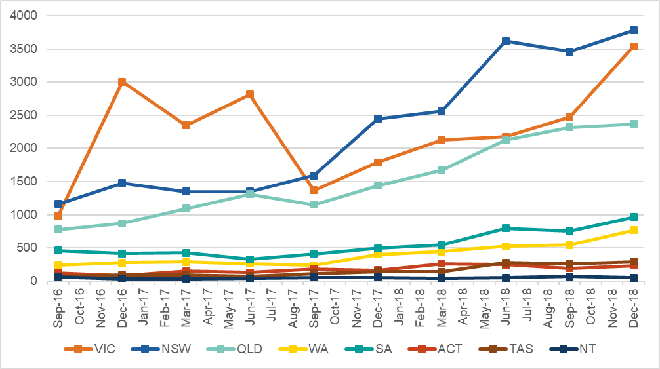
Source: 1800RESPECT program data
Figure 4.13 shows the proportions that were from major cities, inner regional, or outer regional Australia. The proportion from major cities hovered between 69%–74% over the period. Contacts from remote and very remote Australia had only very small variations from 2.0% (second quarter 2016–17) to 0.7% (fourth quarter 2017–18 and first quarter 2018–19).
Figure 4.13 Contacts by regional location
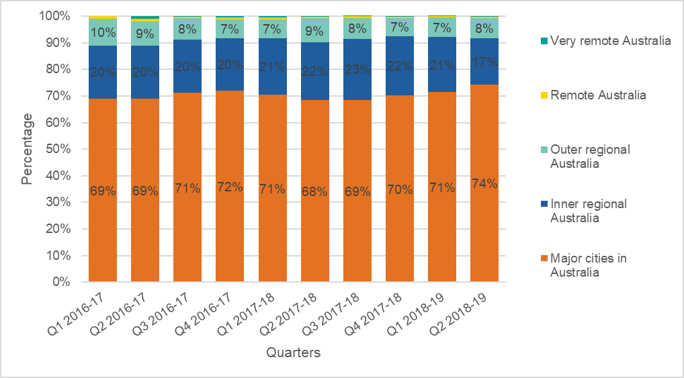 Source: 1800RESPECT program data

Sector perspectives on access and appropriateness
In addition to the program data outlined above, information about accessibility and appropriateness was captured in the sector survey. This asked respondents to rate, on a 5-point scale ranging from ‘strongly agree’ to ‘strongly disagree’, whether they felt 1800RESPECT caters to the needs of diverse groups, and that the service is easy to access (see Figure 4.14). On both questions, relatively large groups were neutral which suggests respondents felt unable to comment more broadly, however, more agreed than disagreed.
- When asked about their level of agreement with the statement ‘1800RESPECT caters to the needs of diverse groups’, almost half selected ‘neutral’ rather than ‘agree’ or ‘disagree’ (46.4%). However, the same proportion combined either ‘agreed’ (34%) or ‘strongly agreed’ (13%). Very few respondents disagreed (7.2%).
- For the statement ‘1800RESPECT is easy to access’, a quarter (25.5%) were neutral, while the majority either agreed (38.2%) or strongly agreed (25.5%), (equating to 63.7% combined). Only 11% disagreed with the statement.
Figure 4.14 Proportion of respondents who agreed with statements on access and appropriateness
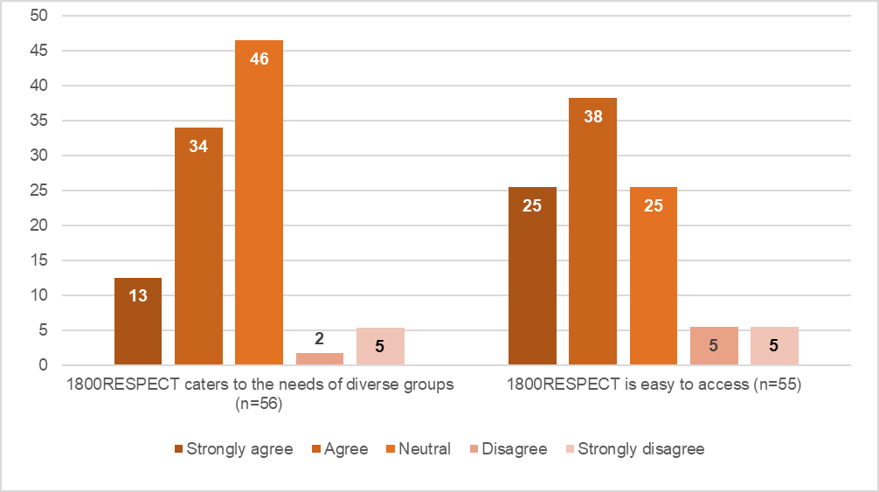Source: Sector Survey
The issues of accessibility and appropriateness were also discussed in the stakeholder interviews.

Stakeholder perspectives on access and appropriateness for CALD populations
A stakeholder working for a regional migrant organisation commented on the inaccessibility of helplines for many women from linguistically diverse backgrounds, many of who are vulnerable. She said that she could not comment on the 1800RESPECT website, but in her experience, she has found that some websites that promote helplines often did not make it immediately obvious that service users could use interpreter services as this information was often “five navigations clicks away”. She also commented that there is an assumption that women know how to use interpreting services. She suggested that information could be made more accessible to people from linguistically diverse backgrounds by providing information online in audio format, rather than translating it:
If you have information on a website or a video saying, “What can you expect when you call us? What do we do? What do we don't do? Who are we?” If you had a YouTube, or an audio recording of that in English, just do a little voiceover version, and you just pay someone to record the script in their language. “Click here to listen in this. Click here to listen in this.” You’ve got that. It can recognise your language and get the information.
She noted that if services were aware that this information was available in a range of languages, workers could refer service users to it. The 1800RESPECT website does, in fact, provide some written information in 28 languages (including Khmer, Thai, Urdu, Farsi, Dari), although finding a way to highlight this better could be valuable (e.g. through the use of flags) or providing the information via audio format. There may, however, be safety risks associated with providing information in audio format and so this strategy requires careful consideration before any implementation.

Stakeholder perspectives on access and appropriateness for people with disability
A stakeholder working in the disability sector spoke about the improvements to the 1800RESPECT service since the change in operational model in 2016. She reported that MHS had worked collaboratively and respectfully with sector experts to identify how the service could be improved for women with disability. She spoke about how the service had become more inclusive of, and responsive to, women with disabilities, noting in particular the development of the Sunny app. However, she felt that there was still a way to go in rebuilding trust in the service among women with disabilities. While she felt that service delivery had vastly improved under the new model, she felt that it was problematic that the trauma specialist counselling is only available by phone because “there are some women who can’t use a telephone. It’s not just women with disability”. The exclusion of some groups of women from being able to access phone counselling also extended to web-based counselling. For this reason, she felt that it was important that face-to-face counselling is available where possible:
Do we have in each state and territory free face-to-face counselling for women have experienced violence or are at risk of experiencing violence? If we do, then that information needs to be heavily embedded and marketed and all that. If we don’t, we need to work out why not.
It should be noted, however, that face-to-face services funded by state and territory governments are primarily crisis-oriented which may mean that they are not able to provide the length of time required for helpful engagement with clients with a disability. It is also questionable whether providing face-to-face counselling in addition to phone and online counselling is reasonable or feasible.

Stakeholder perspectives on access and appropriateness for Aboriginal and Torres Strait Islander people
A stakeholder working with Aboriginal and Torres Strait Islander communities spoke very highly of MHS’ efforts to try to identify how 1800RESPECT could better engage Aboriginal and Torres Strait Islander women. She described how MHS has sought her ideas and sent information and pamphlets to her organisation. She takes these to remote communities and leaves them in women’s services in order to help raise awareness of the service among Aboriginal and Torres Strait Islander women:
I really appreciate the way that they reached out to me. They're trying to reach out to indigenous women. Look not everything is going to be good for everyone and whatever but like I said I've seen their number up at the Torres Strait so obviously their message is getting out there. It's a very hard barrier to break down for indigenous women talking about this but at least 1800 are having a go.
This stakeholder reported that they hoped to invite 1800RESPECT to attend a domestic violence workshop with Aboriginal and Torres Strait Islander women “so that they can showcase to indigenous women that that's who they can go to.”

Staff perspectives on access and appropriateness
The interviews also found that staff generally felt that the service was accessible and appropriate to diverse groups of people in Australia, but many questioned whether any service could meet the needs of everyone:
As long as people have choices and knowledge of the service that is provided or available, that’s the important thing. Whether they reach out or not, I don’t know that we could model it to suit everybody.
Staff felt the service was accessible due to its 24/7 hours of operation, it was free and because individuals could choose to call or use the webchat option. MHS staff also referred to the National Sector Advisory Group (NSAG) established by MHS to consult with stakeholders from a range of backgrounds to improve service delivery and identify ways to better engage diverse groups. Some felt that it would be beneficial if TSCs could offer Skype or other webchat options as they felt that this might make it easier to engage with callers.
Disability: As indicated in the program data, a significant proportion of callers to 1800RESPECT are people with a disability, with around 40% of callers recorded as having a mental health condition in Q2 2018–19. In the interviews, some staff reported having spoken with callers who used the National Relay Service for people with hearing impairment. Several TSCs who used the National Relay Service reported that it was cumbersome, and one felt that it would be helpful if TSCs had access to a webchat option. A comment was also made about the Sunny app developed by MHS to increase accessibility for women with disability who have experienced violence or abuse. MHS staff referred to work being undertaken at the time of the interview to increase awareness of the service among women with disability through the Disability Pathways Project.
CALD: Staff reported that they received calls from people from culturally diverse backgrounds who often did not know “their rights in Australia". With respect to linguistically diverse callers, staff reported that there was a process whereby FRCs would engage an interpreter for callers who did not speak English before transferring them to the TSCs. For the most part however, only some reported using an interpreting service for a small number of calls. Some felt that it would be beneficial if the service could provide counsellors who spoke different languages. There was a sense that 1800RESPECT was not getting calls from people from CALD background despite the apparent need:
I spoke to first respondents and the answer was that they deal with callers from different backgrounds at first responder level...They’re more after practical information... but it needs to change. I know that all the state-wide partners who have done the crisis response services, they know what’s in their state… they all deal with high rates of people from non-English speaking backgrounds and all different backgrounds. I know they all refer them to 1800 RESPECT. Once they’re physically safe, we need to make sure they have psychological support. I don’t know what the challenge is; I haven’t had an answer and I don’t understand, but we just don’t get them.
Age: TSCs reported speaking with callers of all ages.
Aboriginal and Torres Strait Islanders: TSCs reported getting calls from Aboriginal and Torres Strait Islander callers but did not feel that these cohorts comprised a large number of calls. Performance data for people at risk indicate that around 7% are from an Aboriginal and Torres Strait Islander background. One TSC commented on the value of the induction training she did with Blue Knot around working with people from Aboriginal and Torres Strait Islander backgrounds. Another felt that more could be done to encourage engagement from Aboriginal and Torres Strait Islander people in remote and regional areas.
Men: TSCs reported that they get calls from men, with one estimating that approximately a fifth of the calls she received were from men. According to data on contact demographics, around 10% of contacts are with men. Another TSC felt that the resources available to support their work were very much focused on women and felt that this needed to be addressed, particularly with respect to referral resources.
LGBTQI: TSCs reported getting calls from LGBTQI callers but did not feel that they comprised a large number of calls. One TSC reported that the induction training she had undertaken about working with LGBTQI people was particularly helpful.

Impact on sector capacity
This sub-question asked ‘to what extent has 1800RESPECT increased the generalist and specialist services sectors’ capacity to respond effectively to people who have experienced, or are at risk of, sexual assault and domestic and family violence.

Sector survey
Respondents to the sector survey were asked about their experience of working with 1800RESPECT, and their perceptions of how it affected the capacity and effectiveness of their service. While many respondents were neutral on the questions, there were higher proportions agreeing than disagreeing with the statements, indicating the service is generally positively perceived. This is shown in Figure 4.15. More than half (54%) agreed or strongly agreed that 1800RESPECT enhances the capacity of their service, while only 9% disagreed (36% were neutral). Almost half (44%) agreed or strongly agreed that 1800RESPECT is easy to work with, while only 7% did not. Similarly, 41% agreed that 1800RESPECT provides a rapid response, compared with 11% who disagreed.

Figure 4.15 Proportion of respondents who agreed with statements on working with 1800RESPECT
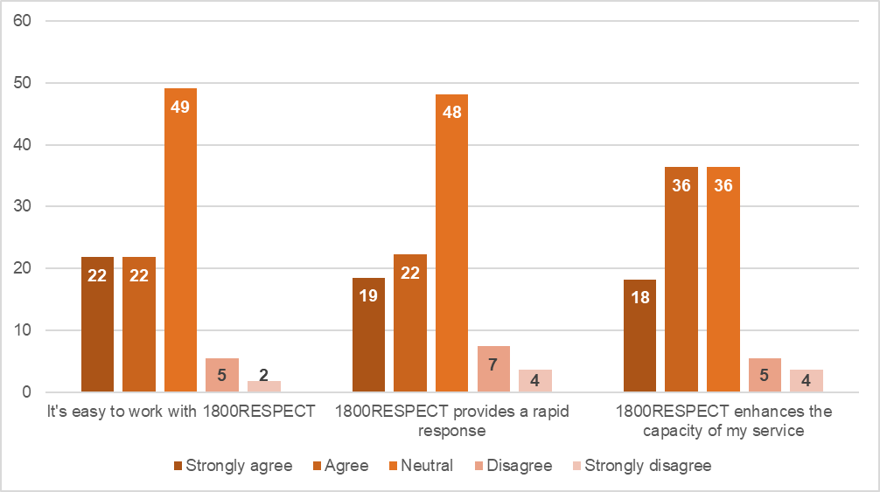 Source: Sector Survey
Some highlighted how 1800RESPECT impacted on the level of support their callers received, and their understanding of violence and their own circumstances and wellbeing:
Availability of the service as a 24/7 service is great. Telephone counselling service is a good tool for clients to use as they wait for services to respond such as counselling wait times. Some clients need to just be heard and my role doesn't allow me the time to do much holding work so 1800RESPECT fills that gap in service. (practitioner, VIC, sector survey)
Women who call after they have a discussion through 1800RESPECT can identify what family violence is and how this is impacting on their mental health. (practitioner, VIC, sector survey)
Respondents also commented on ways 1800RESPECT could improve its impact on their service. Some perceived that the referrals they received were low or were not always appropriate:
Clients are not always referred to the correct service. (practitioner, VIC, sector survey)
We are unsure as to why referrals are low from this service and we are never kept informed of the referrals. (manager, TAS, sector survey)
They are usually inappropriate and have no cultural context – there are few support services available in the NT. (manager, NT, sector survey)
However, it is not clear how the level of referrals from 1800RESPECT, or their perceived appropriateness, compares with other services that may refer callers.
Respondents also used the survey to share comments on ways the service could be improved for their callers and their service:
It sometimes appears the workers have no local knowledge which makes the referrals less appropriate and at times incorrect. (practitioner, VIC, sector survey)
More contact with state-based agencies and monthly referral information. (manager, TAS sector survey)
If a client consents to it, it would be useful to have brief notes. Some clients really struggle with having to retell their story each time they call. (practitioner, VIC sector survey)
Improving how pages print out that less paper is required [from the website]. (practitioner, TAS, sector survey)
Whereas the 1800RESPECT workforce survey indicated most staff felt able to spend enough time with callers to meet their needs, this was not necessarily the view of those using 1800RESPECT, or the services that support them:
From what clients have told me - it would be helpful if they felt treated like people - not a 'case' to 'move along as fast as they can'. (practitioner, VIC, sector survey)
Some sector survey respondents did, however, corroborate the perspectives of 1800RESPECT practitioners that there are not enough workers to get the job done:
More workers to pick up calls. Face to face counselling for FV victims! if that is possible? (practitioner, VIC, sector survey)

The impact of digital platforms
This section addresses the evaluation question: ‘to what extent has the 1800RESPECT digital platform influenced the way that frontline workers access information and support relating to sexual assault, domestic/family violence work? In what way?’
The main components of the 1800RESPECT digital platform are the website which hosts a suite of information for people experiencing, or at risk of experiencing, DFV and/or SA, and resources for professionals. The website also hosts webchat counselling function. Other digital resources include the Sunny and Daisy apps and other digital communications (social media, online ads) (see section 3.5).

Perspectives of staff delivering 1800RESPECT on the digital platforms
FRCs noted some challenges and benefits of the webchat counselling that they provided. Challenges included the protracted nature of the communication if someone typed slowly, if they got distracted, if English was not their first language and if they had a lot they wanted to communicate. The challenges of building rapport without verbal cues to indicate emotion was also noted. It was also recognised that webchat provided another option for people who might not otherwise get any support:
They’re reaching out over web chat because the idea of picking up a phone and talking on it about whatever they’re going through is just too daunting. I think if we didn’t have web chat, some people just would get no support. It’s probably better than nothing, certainly.
The FRCs reported that they followed similar steps when engaging with someone via webchat as they would via the phone. The first step was to establish that the person was safe and could continue chatting, then “type up an introductory to what our service provides” and ask them what they need. FRCs reported that they also provide referrals via webchat if appropriate. The FRCs commented that the goal of webchat was to encourage users to call the support line:
The aim of the web chat would be to try and get them to actually call in. Sometimes that’s the first step for a caller to feel confident to access support. They might just be testing the waters by going on a web chat. Then we encourage them to actually call our support line, let them know they can be completely anonymous. That’s usually the goal.
Some of the TSCs felt that it would be beneficial if they could use the webchat option available to the FRCs to give them another mode of communication with callers who face difficulties using phone-based counselling.
IT infrastructure: Generally, the NGO partner staff were very positive about the MHS-provided IT infrastructure and support available 24 hours a day:
We have a [service] internal server added onto them, but the Medibank systems are incredible and fantastic, and they have 24-hour MHS support. Whilst it’s a bit clunky sometimes in getting things resolved, 90 percent of things get resolved in five minutes on the phone at all hours.
The great thing about the MHS system is that because of the variety of services that they already deliver... the systems that go in place in support of a workforce that works from home means that they’re really well set up and there is always the online chat function from each counsellor to someone at Medibank. So, there is a great deal of support available.
TSCs reported on the benefits of the instant messaging service for communicating with other counsellors on a shift. One manager felt that reliability of the IT and staff confidence in IT reduces the potential impacts of vicarious trauma "because all of those systems make the workplace a lot easier, so there’s not that added layer of complexity and difficulty to their day after a difficult call.”
Some NGO partner staff, however, identified a number of issues with the IT infrastructure. One reported that it was often difficult and time-consuming to resolve IT issues and that they had difficulties with registering their organisation emails with MHS. Some TSCs also highlighted difficulties that they had with the IT systems. One reported that the operating system they used to record notes was running very slowly, which she found very frustrating, particularly in a context where call times were being monitored (see section 6.2.2), a point echoed by another TSC:
There have been a lot of problems with it of late and it is super slow. If you’ve got to hang up, you have to go in and you have to mark it as a disconnect. Previously that would take maybe one or two minutes. That can take up to ten minutes. It’s a real frustration. We know that our call times are monitored. We know that our after-call work is monitored and that’s okay. I have no issue with that but when you have a system that is actually causing you to take a long time in your after-call work and you’re being monitored for that, it’s not okay.

Sector perspectives on web resources
The survey explored the sector’s awareness and use of the website, and the resources on it. As indicated above, 64% of respondents used the website. However, few used it regularly. Only 1 in 9 used it weekly or more often (11%), while 9% used it around every fortnight, and 10% used it approximately once a month. As MHS are working on the service directory during early 2019, future assessments should track awareness and use of it, as these figures may improve following improvement and promotion of the directory.
The main reasons practitioners used the website were to find relevant services, reported by 40% of respondents, while the next most common uses were to access resources and tools (19%) and to find out about training and professional development (19%). Fourteen percent said they used it to learn more about responding to people impacted by violence, and 12% said they used it to find out about a particular issue, e.g. technology and safety, alcohol and other drugs, child safety.
Overall, three quarters of those who used the website were very satisfied or satisfied with it, while the remainder were neutral, and only one respondent (3%) was dissatisfied.
Figure 4.16 How satisfied respondents were with the 1800RESPECT website
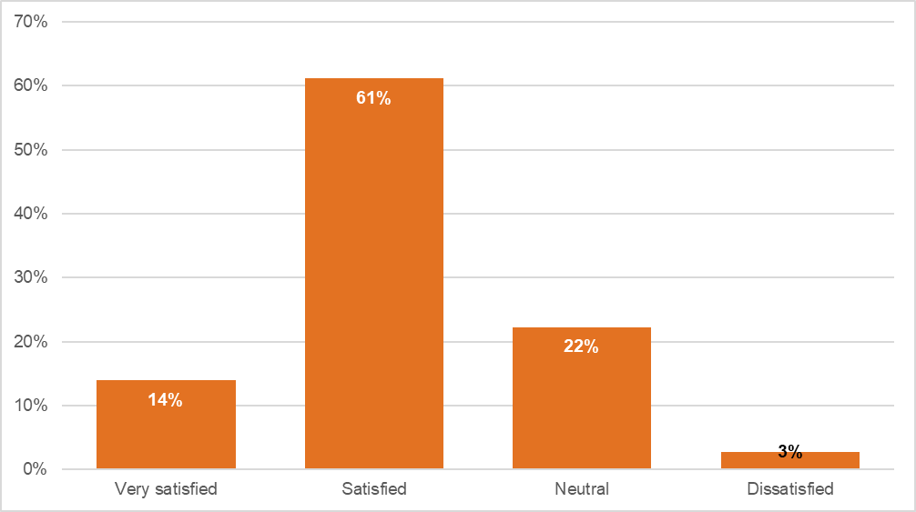Source: Sector survey, n=36 (those who used the website only).

When asked if they had any comments about the website, responses included:
Very useful information. (manager, SA, sector survey)
I know that it is user friendly and accessible for clients. (manager, QLD, sector survey)
I regularly encourage clients to access the 1800RESPECT website or print out sections for them. The website could be improved by making printouts more user-friendly. For example, the section Physical Abuse prints out as three pages. It would be good if these pages printed in a more compact form. (practitioner, TAS, sector survey)
Discussion with a stakeholder suggested that 1800RESPECT had a very broad reach among frontline workers as evidenced by the number of people joining their webinars:
In terms of sector participation or the sheer volume of participants in those webinars, they are the biggest webinars that are currently run by anyone as far as I’m aware because they’re national.
This stakeholder also felt that the 1800RESPECT line was used by frontline workers working in the DFV and SA sectors for debriefing purpose although she could not comment on uptake.

Use of subject matter experts in the development of resources and tools
This section addresses the question: ‘To what extent has 1800RESPECT appropriately used subject matter experts in the development of resources and tools to support workers?’

Interviews with staff delivering 1800RESPECT
NGO staff reported that MHS had engaged external experts to develop training modules for staff and felt that this had been done “really well”. One TSC reported that they occasionally received emails that covered clinical guidelines about certain issues. She found these to be "really good quality" but reported that they were receiving them less frequently than when the service commenced. Other NGO partner staff felt that they had not received much content that had been developed by subject matter experts:
I get the occasional dot point document about call control, but I would say that that’s not developed by a subject matter expert at all. Well, sorry. I shouldn't say it like that. We don't know if they're a subject matter expert or not. It doesn't appear to be anything other than someone's personal approach to managing difficult calls.
MHS staff reported utilising the expertise from within MHS (including the clinical governance team), the expertise of their NGO partners, and using subject matter experts externally. The NSAG is an excellent example of MHS leveraging external expertise in the development of their processes and procedures. In addition, MHS staff reported that a service delivery manual that was currently under review was developed by "external consultants that were engaged as experts in the field". It was also reported that MHS had "linkages in the community with sector experts" that contributed to the development of resources, most recently in the development of resources for women with disability:
They helped us to put together the language for that app...and helped us deliver some manualised material as well.
The clinical governance framework that guides the delivery of 1800RESPECT was developed by the clinical governance team at MHS:
These are highly experienced individuals who drive teams to look at every aspect of the service and everything we do has that clinical lens. There's a framework within that which they operate and it's quite incredible.
This also came through in the stakeholder interviews where many commented favourably on MHS’ engagement and collaboration with sector experts through the NSAG in order to improve service delivery and accessibility for diverse groups; “It’s a model of willingness to communicate”. However, NSAG is currently positioned as an MHS Committee rather than as a committee providing expert advice on the 1800RESPECT service directly to the funding body (DSS), in addition to MHS. This structure means NSAG and DSS do not have a clear line of communication.

Supporting effectiveness and sustainability
As discussed in the previous sections, staff and the sector were generally positive about the quality, accessibility and responsiveness of 1800RESPECT. However, data collected also provides evidence that the effectiveness of the service was seen to be limited. This section discusses the factors limiting effectiveness and addresses the question of whether other models exist which would better support the program’s sustainability.

Repeat callers with complex presentations
Most telephone helplines receive a significant volume of calls from regular, repeat or frequent callers (Middleton et al. 2014). In their analysis of frequent caller data to Lifeline, Spittal et al. (2014) report that 2.6% of callers accounted for 60.1% of calls to the service. 1800RESPECT similarly receives a large proportion of calls from repeat callers, but comparatively fewer than Lifeline. 1800RESPECT program data indicates that in Q3 2018–19, 7.1% of callers had called more than once, and this group of callers accounted for 25.7% of service interactions. Changes in these figures between 2016 and 2019 are shown in Figure 5.1.
Figure 5.1 Repeat callers using 1800RESPECT, 2016–2019
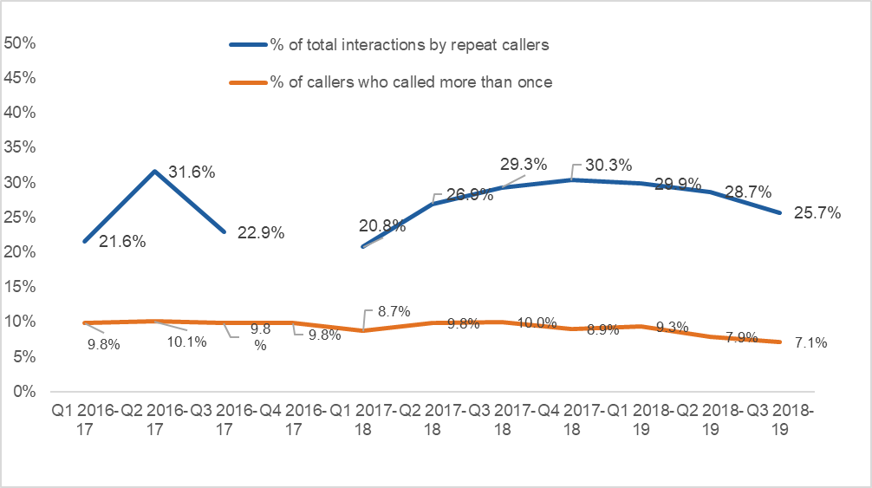Note: data was missing for Q4 2016-17.
Frequent or repeat calling is not problematic per se, and many issues related to gender-based violence are unlikely to be addressed through a single episode of support. However, repeat calls may be indicative of unmet needs and difficulties counsellors face in supporting callers to access the more intensive supports they need.
Interviews with callers identified how 1800RESPECT filled a gap. It was used by callers even when they accessed other support services. Reliance on the service by some callers reflects a tension between the needs of some callers and the nature of the service as operating within a single session model. The phone counselling is intended to provide support for callers’ immediate needs. Callers with complex presentations, such as adults who experienced sexual abuse during childhood, may be better supported by longer-term and consistent interactions with a mental health professional. However, given that many of these callers regard 1800RESPECT as their preferred and trusted support service 24/7, even while simultaneously accessing psychologists or counsellors during business hours, 1800RESPECT still plays an important role in providing access to support by those who request it. The reluctance of some callers to access other support services may be partly due to previous negative experiences and a lack of trust in other services. This finding potentially suggests a need for clear referral pathways from the 1800RESPECT telephone support to longer-term support services.
It is important to note that 1800RESPECT was established as a sexual assault, family and domestic violence counselling and support service, not a mental health support service. At the same time, however, it is well established that experiencing childhood sexual abuse, sexual assault and domestic and family violence can contribute to poor mental health (Campbell, 2002; Moore et al. 2012 Ayre et al. 2016). Counsellors reported that the single session model offered by 1800RESPECT was often not appropriate where callers were experiencing mental health issues. For this reason, an alternative model of support for dealing with callers with more complex mental health-related presentations is recommended.
Use of the service by repeat callers with complex presentations was also discussed in the staff interviews. For staff, the most significant challenge for service effectiveness identified was that, although intended for people experiencing or at risk of DFV or sexual assault, increasingly many service users are presenting with complex mental health issues, often peripherally related to experience of DFV or sexual assault, and their support needs do not fall within the scope of the service. Many of these callers are repeat callers and appear to account for a significant proportion of calls to the 1800RESPECT service.
As noted in section 4, staff explained how the counselling support provided by 1800RESPECT is based on a single session model, which involves working with the caller in the moment and addressing their presenting issue. It does not encompass developing treatment or care plans "because we're not a mental health service. We don't do a complete assessment and we really respect people's right to access us anonymously as well." Given that the service provides confidential and often anonymous phone counselling, one counsellor commented that it would not be feasible to offer anything other than a single session counselling model:
The fact that it’s done over the phone actually excludes a lot of therapies that one would do to work with trauma. Not being able to see someone’s face, body language and all that sort of stuff is super important. That’s why the single session model works in this way.
Staff in NGO partner organisations reported that the majority of callers to the service are now repeat callers. They reported that many repeat callers have very complex presentations that include DFV or sexual assault at some stage in their lives, but that many had mental health problems that the single session counselling offered through 1800RESPECT was not capable of addressing, particularly with the expectation that calls be kept to under an hour:
That was the biggest shock coming into the job. Actually, the domestic violence and sexual assault calls we get are the easiest to manage. They are very straightforward. We can resource them, we can give them support, we can help them and see them along their journey... The regular callers often have mental health complexities, often from historical trauma, and trauma that is not being addressed sufficiently and supported through local services. They’re frequently unable to access local services, it might be because of issues around their location, but it also may be that they, for example, won’t leave their house.
Some of those challenging help seeking behaviours, they're not fitting nicely into a one-hour session. I won't say we don't meet the needs of those callers, but I think it's probably something that needs attention.
Staff offered several reasons why the 1800RESPECT service received so many repeat callers. The key reason was that callers report that they value the support they get from 1800RESPECT, which they cannot get from any other service:
The callers' feedback to us is that those services don't… meet their needs as well as we do.
Other reasons included:
- long waiting times to access other services: I’ve had callers that are waiting six weeks to two months to get appointments with the sexual assault unit.
- a lack of mental health support services: We get some really tough clients who are in crisis, but a lot of them are just in that mode all the time. There’s no moving forward with them, so they’re stuck.
- the accessibility of the service: I do think it's because we're available 24/7.
- referrals from other services: Lifeline sometimes put them through, also Beyond Blue and psychologists.
- some are dependent on helplines: Some of them are addicted to crisis lines, literally addicted. They ring every crisis line, constantly, all day, every day.
- it was free.
Many of these reported reasons were borne out by the interviews with callers.
Repeat callers with complex presentations were recognised as a challenge for the single session model with one MHS staff member commenting "we have to wonder about the efficacy of what we're delivering if we're not supporting people to build resilience and distress tolerance.” This challenge is not unique to 1800RESPECT, with Middleton and colleagues (2014; 89) acknowledging that “[c]risis helplines struggle to know how to best respond to frequent callers as they challenge the conventional crisis model of care with their contacts”.
Staff at all levels across the three NGO partners spoke about the complexity of the calls they received, often from repeat callers. Estimates varied, but some staff felt that repeat callers comprised between 50–80% of their calls. However, as noted above in Figure 5.1, Q3 2018–19 figures show that approximately 7% of the individuals who contact 1800RESPECT account for a quarter of all interactions with the service – this includes online and phone interactions, with the latter handled by both FRCs and TSCs. Due to the smaller number of TSCs relative to FRCs and their more intensive interactions with callers, it is possible that they are more aware of repeat callers:
It can feel really frustrating sometimes to talk to someone who's called through for the sixth time that day and there's no movement there and maybe the issues are more around mental health rather than much that we can actually do, other than provide a safe space and a kind and caring relationship.
Many staff felt that the 1800RESPECT single session framework is not effective for these callers, and so raises questions about whether the service model should use this framework. Indeed, clients with complex needs may appreciate the engagement with a particular counsellor and may seek that option more obviously and with greater determination. Staff, however, understood the rationale behind the single session model design of the service and felt that it was effective for other callers:
I can use a single session model if the treatment is based around needs such as psychoeducation, resourcing, supporting in the moment for sexual assault and domestic violence. When you’re working with complex trauma, and the calls are coming in repeatedly on a daily basis, it needs a very different approach, and that approach is not acceptable to clinical governance.
But there's quite a significant amount of callers who call every day or every couple of days. Sometimes the single session model can feel a little bit difficult to navigate in terms of you have to obviously acknowledge that you spoke to this person before and last time you were speaking about this but then they might call through as anonymous and then I guess they've got the right to do that as well. So it can just be a bit of an elephant in the room.
Discussions with partner NGO staff about the effectiveness of the 1800RESPECT service often drew a distinction between callers dealing with DFV or SA and callers with experience of DFV or SA and mental health problems. Many TSCs and partner NGO managers felt that the service was highly effective for the former groups, but less effective for callers with complex presentations including mental health issues:
Sometimes it’s more rewarding when you’re talking to a person who is in that domestic violence situation, they’re calling because they need support and you feel you can really absolutely give it to them, as opposed to talking to a client that you talked to two days ago, who are still ruminating and stuck. You know that no matter what you offer – psychologists will tell clients to call us.
They’re often women that have quite severe mental health issues that come from historical childhood trauma, so it’s not necessarily current DV or current sexual assault. So, often the relational capacity to have a conversation has been compromised, so they’re not actually able to enter into a counselling session. They want to vent or often be very aggressive with the counsellor blame, other counsellors or the system.
Some staff reported that the assumptions underpinning service use when 1800RESPECT was first established no longer matched the reality of service use, with repeat callers presenting a significant challenge, largely because many had complex mental health problems and the service did not appear to have a specific strategy for handling repeat out-of-scope callers. TSCs did not feel that MHS was supporting them to deal with these increasingly complex callers:
We have a large number of complex callers who are repeat callers with very complex needs, including mental health needs, and our model doesn’t fit what they need. There’s a very high level of frustration about the constant conversations of clinical governance. I know we’re not a mental health service, but this woman is at very high risk of death, not from intent of suicide, but because her behaviours are risky and it’s likely to be accidental.
You’ve got a for-profit organisation who are expecting us to operate as a call centre, who have no idea what we are working with, who don’t understand the client base that are coming in, who have provided us with a model which is not appropriate for the service users. It does not meet the needs of the service users. We are being told to weed out those people, when in fact they’re the majority of the people that are using the service.
A key concern about repeat callers with complex presentations was the resource intensive nature of supporting them, which meant that other callers that might benefit from the single session counselling would not get through. An additional challenge with the repeat callers was that fact that some seemed to ignore, or not have capacity to act on, cues from the counsellors that it was time to end the call. This was noted as being problematic for TSCs in a context where call times were monitored, and they were regularly asked to explain why they had spent longer on calls than recommended. It is also problematic in the context of a funding model based on a flat rate of payment per call, as pressure to not go beyond a certain time is unrealistic and may be harmful for this group.

Strategies for managing repeat callers with complex presentations
Lifeline and other telephone helplines have also experienced increases in frequent callers, and there is no simple strategy with which to respond. In their research on frequent callers to Lifeline, a 24-hour Australian crisis support helpline, Pirkis and colleagues (2016) describe how typical models of crisis support helpline service delivery do not assist frequent callers, because features of the model (the fact that callers remain anonymous and can call as frequently as they wish) reinforce their calling patterns. They proposed that responses to repeat callers should focus on behaviours (frequent calling) not individuals (frequent callers), offer flexibility and choice, and recognise multiple service use in addition to telephone helplines, and could involve allocation of frequent callers to specialists who would help them work towards goals and link to other services (Pirkis et al, 2015, Pirkis et al, 2016). 1800RESPECT management and counselling staff recognised that the service needs a strategy for managing repeat callers, especially those with complex presentations. Staff felt that the scope of the service should be reviewed to better meet the needs of the actual rather than the intended service users:
We have this single session approach, but the reality is that a lot of the callers don't use the service single session approach. So, do we doggedly keep going ahead with this single session approach when it's not the message that we're receiving from the community about the needs that they have.
It's a good opportunity for this review to be opening up the conversations about that in a different way and certainly that tender process for Medibank to take on this role in the first place was around what approach could they put forward and at that time, it probably wasn't known so much, about how many regular callers would be calling through; but that was three or four years ago.
Staff at management level reported several strategies for addressing the challenges presented by repeat callers with complex presentations. An MHS staff member reported that a strategy was to develop care plans “so we can make sure that we're building good relationships with them and empowering them rather than getting them to become dependent on the service”. Clinical leads and senior practitioners in the NGOs also reported that repeat callers with complex presentations are regularly discussed in the Clinical Stream Meetings to try to ensure a consistent response for them. Strategies discussed included explaining the scope of the service and strengths-based counselling, and referrals to other organisations and scripts to assist counsellors with responding to repeat callers:
Something like, if a caller comes in it might be 'We think that the service that we're able to offer you may not be meeting your needs at this time so we would be really interested in exploring with you a referral to another service or if you should feel like you need to contact us again, what we'd really recommend is contacting the people within your therapeutic care team who you're already connected with', that kind of stuff.
Counselling staff, however, did not feel that they were being appropriately supported by management to respond to callers with complex presentations within the single session framework. One noted that she was aware that complex callers were discussed at Clinical Stream Meetings and that a care plan would be developed for some “but nothing seems to have come of that for a lot of these callers, no directions really provided." Another counsellor reported that the clinical governance team advised that counsellors should be "pressuring [repeat callers] to get in to face-to-face services", which she felt was unhelpful because it assumed that face-to-face services were available for these callers or that they had capacity to access them. Another felt that the lack of support offered by clinical governance to help counsellors manage these complex callers was a key reason for vicarious trauma and staff burnout.
The interviews highlighted some suggestions for managing repeat callers with complex presentations. The first was to offer them weekly counselling sessions, which one counsellor said had been discussed, but not taken any further. This could involve sessions booked with a particular counsellor and would not necessarily preclude calling between sessions and speaking to another available counsellor.
An interview with a stakeholder also emphasised the importance of providing face-to-face counselling for callers with complex trauma. She felt that it was unsurprising that 1800RESPECT would receive large numbers of repeat callers, but that it was problematic that the system “can’t note that that’s happening” and does not permit counsellors to provide ongoing support. This stakeholder felt that this group of repeat callers in extreme psychological crisis need to be given a different number to call (a recontacts number) and leave their details, so that a counsellor can look up their file notes, including their case plan and treatment to date, and then call them back. She felt that in its current form, the 1800RESPECT model cannot provide that level of support and that 1800RESPECT should undertake case management for these callers and engage with local providers, however, this assumes that such services exist and are accessible in the regions the callers are from. The kind of intense case management response suggested by this stakeholder is not usual for a telephone/online service albeit recognising the differing needs of callers who may be experiencing complex trauma. Repeat callers are not the majority of the callers but may take up a disproportionate amount of service resource. It is not clear that simply providing a different recontact number would better manage the complexity of this group’s issues if services within their jurisdiction do not exist or are not easily accessible. It is also unlikely that such a model could or should be offered within the existing funding arrangements.
The third suggestion was that the First Response stage of the call was a key point for intervention to redirect callers to other more appropriate services, particularly from callers who may not be the intended service users for 1800RESPECT. Discussions with NGO partner staff suggest that the First Response process is not working as well as it might. Some staff felt that the FRCs were not undertaking proper risk assessments, because high-risk callers were being transferred to the TSCs. These issues should be monitored properly and managed in clinical supervision – underscoring again the importance of clinical leadership for service effectiveness.

Others referred to callers experiencing mental health episodes or crisis being transferred to the TCSs without proper consideration of whether the issues could be managed by FRCs or better managed via referral. One stakeholder suggestion was that FRCs should always conduct an assessment even in short form upon request to be transferred, and that FRCs should ask enough questions and transfer callers to other services if their needs cannot be met by 1800RESPECT:
If people have to go to an assessment every time they rang, then maybe the first respondent could direct them back to their mental health service or to whatever they need.
Last Friday night I had two suicidal callers. One was actively trying to harm, the other is chronic suicide… The one who was actively seeking to harm themselves should not have come through to me. Questions would have shown that.
They’re never asked why they are calling, what prompted them to call in, if there is a specific issue that they’re calling in about. They are not assessed for risk. We have callers coming through who are suicidal and in the process of suiciding. We have callers who are in high risk domestic violence situations who should’ve been triaged for domestic violence and we have callers who also come in who are not within the scope of service. I’ve even had a first responder say to me, “This client is lonely.”
Staff also recognised that many regular callers had become familiar with the service and knew how to bypass the First Response screening stage, by saying they were safe when they called and requesting to be transferred to a TSC. While they understood that this meant that some callers did not have to retell their stories and relive their trauma, some felt that this fast-tracking of calls from FRCs to TSCs should be reviewed. A suggestion was that FRCs should do a needs assessment with callers every time they rang, rather than fast-tracking them through to TSCs. It was felt this might allow them to refer the caller to mental health triage services in their area, to Lifeline or to emergency services, rather than to the TSCs.

National reach and consistency across the jurisdictions
Staff in the NGO partners discussed some factors that they felt impinged on the effectiveness of the 1800RESPECT service. One challenge identified by counsellors (FRCs and TSCs) related to the national reach of the service. They commented that they could talk to callers about local state-based services and legislation, but that this was more difficult in the context of national service delivery. Indeed, national knowledge appeared a gap in training and professional development:
I think there’s a few gaps in our knowledge and that probably revolves around the fact that we are dealing with an Australia-wide service. Certainly in [state], I’ve got all the ammunition and I know a lot of it… Legislation for DVOs, for example, are different in every state. Child protection is different in every state... I don’t know what it is in every other state. There’s a really big challenge…I don’t want to give a person the run-around, so I want to have knowledge around what’s available in each state.
I think a weak point that we have – and I know this from when I was supervising the team, a lot of people said the same thing – is referrals. Our referral database on the website is just absolutely abysmal. The links are wrong, the numbers are wrong. Often, results don’t come up that do exist. That system is an ongoing nightmare. A lot of us don’t really know of what services are out there to support callers, and it’s hard to search them using the 1800RESPECT website.
When asked if they used the service directory on the 1800RESPECT website, one TSC reported not knowing about it. Several stakeholders also commented that the service directory was not up to date (which was evident when used to distribute the sector survey for the evaluation). Following an interview, a state/territory government stakeholder emailed to say that the state-based domestic violence helpline that she worked with was not listed on the 1800RESPECT website (“I’m very surprised we don’t appear”). This suggests issues with the currency of information and coordination with the states and territories that is limiting national reach and consistency.
The majority of state/territory government stakeholders felt that the 1800RESPECT was a critical service and expressed a desire for greater collaboration and engagement, but several also voiced concern about aspects of the service. Some state/territory government stakeholders expressed concern about how FRCs and TSCs were making decisions about service referrals in their states. This concern was prompted by data on the relative low number of calls for their jurisdiction and also by the fact that the service directory was not up to date. One described undertaking a service mapping exercise to provide 1800RESPECT with information about appropriate referrals in her jurisdiction. Since that time, she has tried to get information from 1800RESPECT about referral pathways for calls from her jurisdiction, but that she had not received a response:
They need to be updated, it’s been a constant feedback. In particular as well with the link to the Daisy app when that was developed, we provided a lot of information on the services which was then transferred through the service directory, but it’s out of date. We’ve been asking how to update that again over this period of time and haven’t had answers on that.

Other state/territory government stakeholders commented on the low number of calls from their jurisdictions, with one commenting that the very low numbers suggested that “we’re getting no value from this whatsoever”. A number of state/territory government stakeholders also queried the very low number of calls from their states that were classified as crisis calls, often amounting to less than half of one percent of the total number of calls from their jurisdiction.
Program data also indicates that coordination with services in the states and territories may not be optimal. For example, only 222 transfers to state and territory hotlines were made in the three months of Q3 2018–19, a period in which over 33,000 calls were answered and over 15,000 warm transfers offered. This is discussed in section 6.2.1.
The national reach of the service was also raised by another NGO partner staff member who spoke of the difficulties of integrating a 1800RESPECT response with different jurisdictional requirements. By way of example, she spoke about how agencies in her jurisdiction use a common risk assessment tool to assess risk for women and children who are living with DFV. The score they get determines which referral pathway they follow. If counsellors working on the 1800RESPECT line identify a high level of risk for callers, they are not undertaking the same risk assessment as they would if working on a state DV line (a generic risk assessment is used based on the Victorian Common Risk Assessment Framework). This manager felt that this posed a risk for the callers and also for the organisation:
What I would like to see is the ability for our specialist trauma counsellors to be connected into the state responses around that stuff. What would happen in [state] in any other program is that a referral would be made through to our family safety framework, which would result in an interagency discussion around that family that would seek to develop an action plan to reduce risk, increase safety, hold the perpetrator of the violence accountable, a whole lot of stuff would happen. So, it concerns me that 1800RESPECT is not part of that and that we’re not looking at that work.

Perspectives on call waiting and call backs
Some staff also felt call wait times and the call back process limited service effectiveness. When asked in the 1800RESPECT workforce survey how often, in the previous week, clients had expressed frustration about call wait times, 14% said ‘often’, although this was higher among NGO partner staff, compared with respondents from MHS (17% compared with 12%). Responses are depicted in Figure 5.2.

Figure 5.2 Respondents’ reports of how often clients expressed frustration about call wait times, staff in MHS and NGO partners
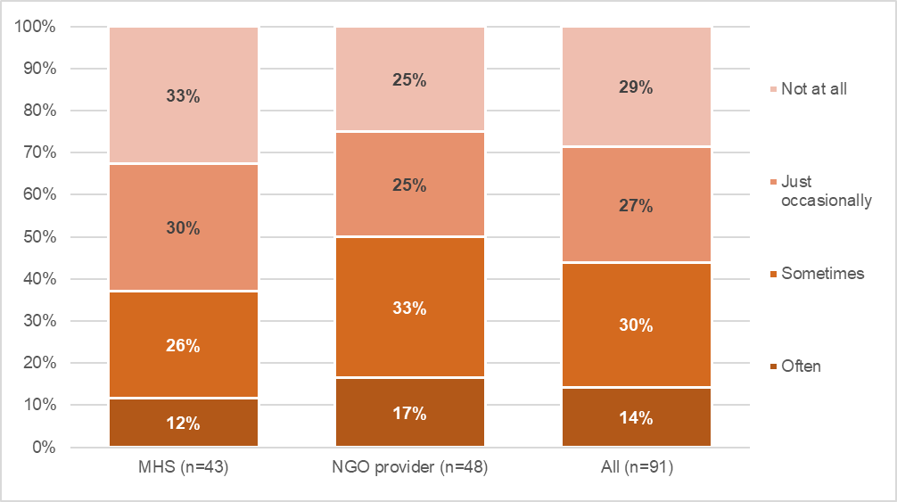
Some respondents to the 1800RESPECT workforce survey also made comments about call wait times. While a few MHS respondents mentioned that callers commented how quickly calls were answered rather than call wait times, others saw wait times to be a source of frustration for callers, especially at particular times. Some commented that accessing TSCs could be difficult before 9am EST, or overnight, or through the Christmas period. For example:
Call wait times for specialist counselling services can be very long. I am not sure why there are so few Specialist counsellors working overnight as this is often a time that callers experience increased trauma experiencing symptoms and require more support. (MHS respondent, 1800RESPECT workforce survey)
Callers have been making complaints about the time it takes to get through particularly in the night space, caller would benefit from less call backs and clients are ready to talk when they call and may not be ready or safe when we call back (NGO respondent, 1800RESPECT workforce survey)
Sometimes it is so busy that people have had to wait 20 mins for their call to be picked up. We were so busy during Christmas that I don't recall seeing any counsellor available for longer than seconds before they had to take the next call. (MHS respondent, 1800RESPECT workforce survey)
Some mentioned that call waiting times interfered with the counselling process, as it took time from sessions, contributed to client distress, and highlighted the need for more TSCs to be available during peak times:
More recently (2-3 months) callers have expressed their frustration with wait times and have stated that more counsellors need to be available. This has been difficult as a portion of that caller’s session is dedicated to talking about wait time frustrations. As a 1800RESPECT counsellor it is difficult to hear that our service, due to being understaffed, has contributed to further distress to our callers rather than providing available and accessible support. (NGO respondent, 1800RESPECT workforce survey)
A few respondents reported that frequent callers using the service had prevented them from answering calls from first time users:
As a Specialist Counsellor, some callers have said they have called several times and not been able to get through. During these times we have been on the phone to frequent callers whose use of the service can foster dependency in them and tie up the lines for first time users (who could really benefit from the service). This reduces access to the service. (NGO respondent)
Other comments highlighted the impact of workload on worker health and wellbeing:
There never seems to be enough staff to handle the amount of calls we receive, we are always asked to do extra hours which is not beneficial to our mental health and general wellbeing. (MHS respondent)
Increased call volumes are increasing abandonment rate and staff are aware of call backs waiting to be actioned and no-one being available in the queue which adds to risk of vicarious trauma. (NGO respondent)
In the interviews, some NGO partner staff expressed concern about the efficacy of providing a call back option to callers who could not get immediate access to a TSC. When callers call the 1800RESPECT service and make a request to speak to a specialist counsellor and none is available, the caller is asked by the FRC if they would like a call back. If they say yes, they leave their number and when a TSC becomes available, they call them back. One TSC reported feeling conflicted about whether call backs were the best approach in the context of high call demand and whether counsellors should be prioritising those calls, rather than taking calls coming in in real time.

Perspectives on call transfers
Section 5.1.1 reports on some TSCs’ concerns about inappropriate call transfers from FRCs where callers were experiencing mental health episodes, were suicidal or were in high risk domestic violence situations. Interviews with state/territory government stakeholders in two jurisdictions also highlighted concerns about call transfers from 1800RESPECT to their state-based DV crisis lines. In both instances, the stakeholders referred to safety concerns for callers whose calls were transferred to their crisis line, but which should have been transferred to police. In the second example, the stakeholder reported having to advise the 1800RESPECT counsellor not to continue trying to contact the caller, fearing it might put her at greater risk:
If a woman has rung them and she's asking for assistance and the man's in the house and where my staff are coming from is that she is at a high risk … rather than [the1800RESPECT FRCs] saying "Can we put the call through to the police, can we ring 000?" the call is put through here.
The 1800RESPECTcalled back and asked if we’d been successful in speaking to the caller and if they should continue to try and contact her. We had to tell them, “No. Don’t persist in calling this lady because it may actually put her at risk.” I think sometimes what happens, and I’m saying they’re generally a very good service, but there are so many new people, new staff, who may be quite unfamiliar with the process… 1800RESPECT later got back to us and said they’d managed to get back in touch with the lady and they’ve called the police and that they were standing by to manage the situation until the police arrived.
These inappropriate call transfers happened only occasionally and the stakeholder who provided the second example reported informing 1800RESPECT about the incident and that she found them to be very responsive to feedback:
The service has always been very approachable, and I’ve developed some really good contacts of the service and I appreciate them reaching out and being receptive to issues that arise. They’re always very receptive.
Program data on call transfers from FRCs to TSCs, and transfers to state helplines, are discussed in section 6.2, in relation to sustainability issues.

Funding arrangements and sustainability
This section addresses the question: ‘To what extent are the funding arrangements appropriate? Explore and evaluate the sustainability of the funding model, accounting for growth in demand and compliance with government financial frameworks.’ This draws on program data analysis, interviews with staff, analysis of the model, and comparison with other services. The research team was provided with costing data for the purposes of the evaluation. However, at DSS’ request, these figures have been removed from this report as they are considered ‘commercial in confidence’.

Comparison of First Response model and previous model
This subsection reports on any changes concerning the percentage of calls answered, the number of calls abandoned, and the average call wait times before and after the implementation of the First Response service model. To achieve this comparison the analysis uses the program data for 1800RESPECT collected by MHS and considers data and trends before and after the introduction of the First Response model in August 2016.
Figure 6.1 shows steady growth in demand for telephone services. There has also been growth in demand for online support (see Figure 6.4). At the same time, the data shows a decrease in the number of abandoned calls (both telephone and online) and voicemail messages (which was a feature of the previous model). Figure 6.2 shows an increase in the percentage of calls answered (both telephone and online), reaching 90% after the implementation of the First Response service model. Figure 6.3 shows much shorter average wait times under the new model (data is missing from January 2016 to June 2016). From this information, reduced wait times are a major strength of the model and indicate effectiveness in comparison to the previous model. There was also less fluctuation in call waiting times, indicating reliability of the service.
Data on average time spent with clients is important to understanding service performance and resourcing. While monthly data on average talk time does not appear to feature in the program data which is regularly provided to DSS, it is evident in the MHS Volume/Funding proposal (October 2018), which was provided to the research team. Figure 6.5 shows changes in average talk time, measured in minutes over the last year, with the average being 12.9 minutes for FRCs, and between 43.8 and 52.8 minutes for trauma specialist counselling. The difference between first response and the trauma specialist component is not surprising given the different nature of calls received by each group.
Figure 6.1 Annual summary of telephone services offered before and after the first response model
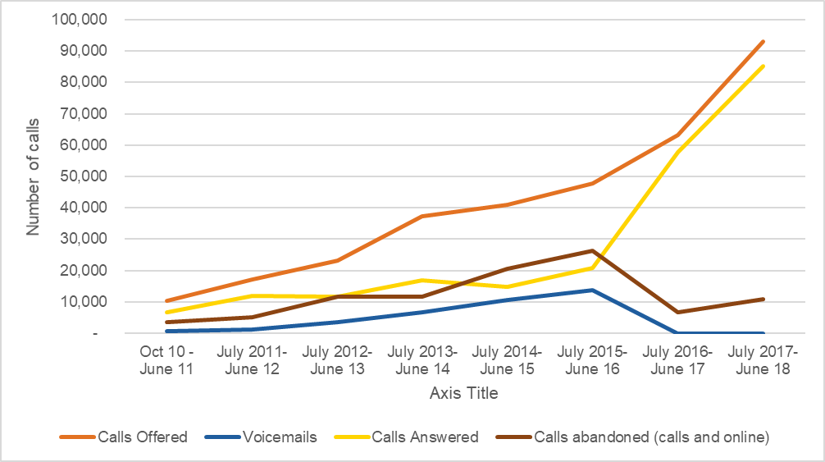
Source: 1800RESPECT program data. New model in effect from August 2016, does not include voicemail.
Figure 6.2 Percentage of total calls answered before and after the first response model
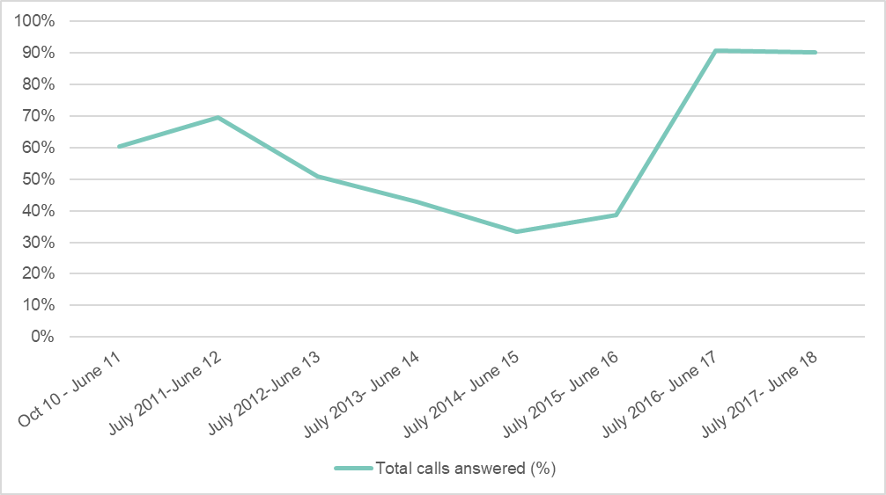
Source: 1800RESPECT program data. New model in effect from August 2016.

Figure 6.3 Average call wait time (in seconds) before and after the first response model
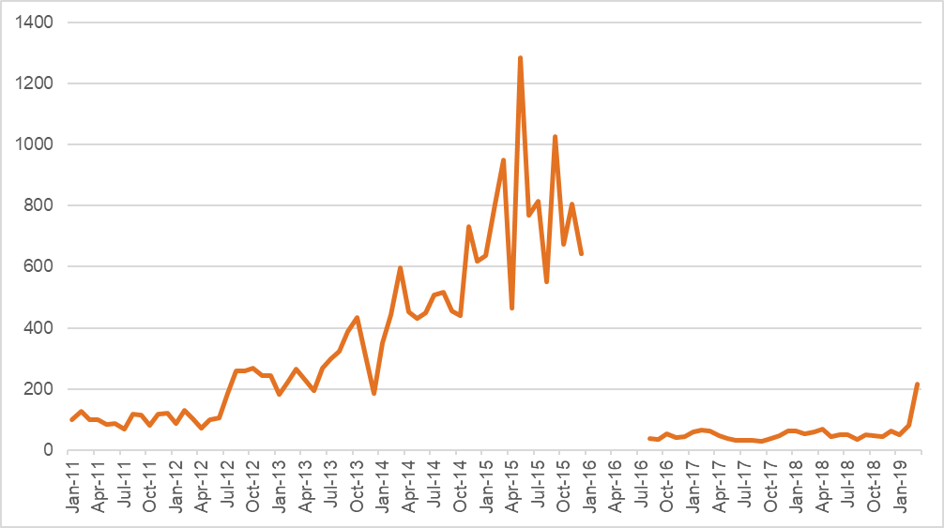
Source: 1800RESPECT program data. New model in effect from August 2016. Data unavailable for Jan-June 2016.
Figure 6.4 Annual summary of online services offered before and after the first response model
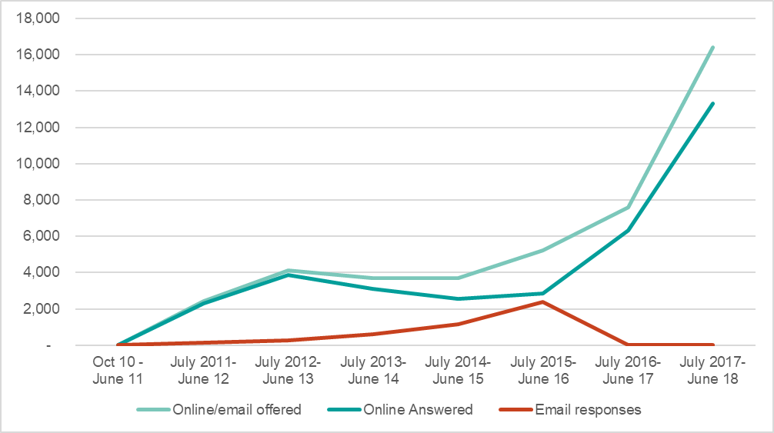
Source: 1800RESPECT program data. New model in effect from August 2016. Note also that email responses ceased under the new model.
Figure 6.5 Average handling time, first response and trauma specialist counselling, 2017–2018
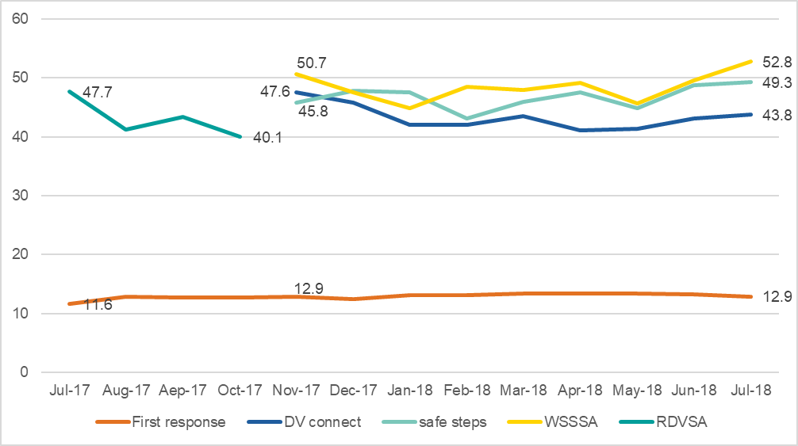
Source: 1800RESPECT Service Evolution Volume/Funding Proposal
Corroborating the improvement in responsiveness in the program data, more sector respondents agreed than disagreed that the service had improved in recent years. While the majority (64%) were unsure, 31% either agreed or strongly agreed, compared with only 6% who disagreed or strongly disagreed (Figure 6.6).
Figure 6.6 Respondents’ agreement with the statement ‘The service provided by 1800RESPECT has improved in recent years’
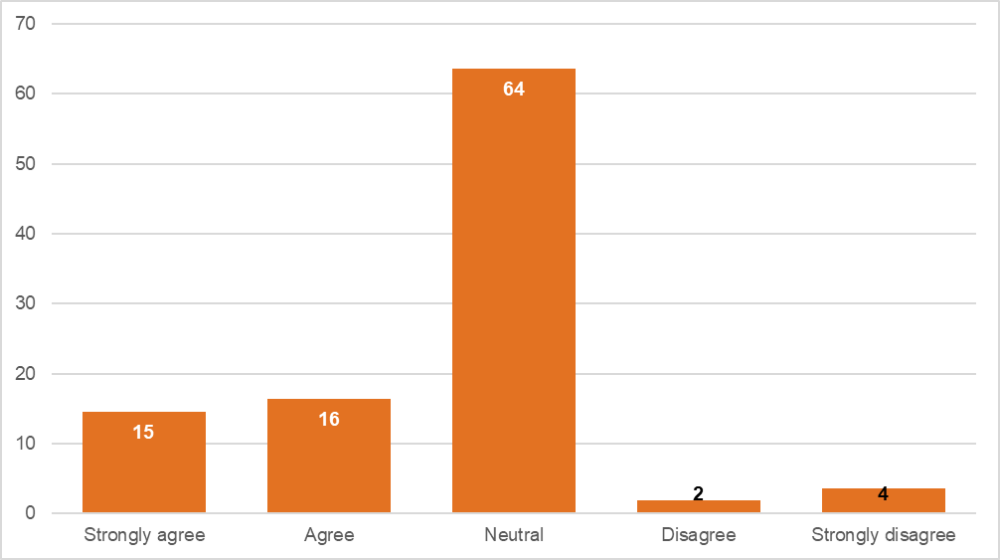
Source: Sector survey

Growth in demand
Globally, demand for DV and SA services and supports appears to be on the increase. Services in the US and the UK have reported growing demand, which is likely affected by increased media reporting of DV and SA, contributing to growing community awareness and reporting of DV and SA more generally, as reported in section 1.1.2. The 2018 annual report of the US National Domestic Violence Hotline shows growth in demand between 2016–2017 (National Domestic Violence Hotline, 2018), increasing again in 2018 by 36% (Lawrence, 2019). Similarly, the Rape Crisis England and Wales service reported a 17% increase in the number of individuals accessing the service in 2017–2018 compared with 2016–17 (Rape Crisis England and Wales, 2018). Refuge, the largest single provider of specialist services to survivors of domestic abuse, rape and sexual violence and other forms of gendered violence in the UK, reported a 9% increase in the number of individuals supported in 2017–2018 over the previous year (Refuge, 2018). Growth in demand for telephone counselling in Australia appears particularly high in comparison, with the total numbers of contacts to 1800RESPECT increasing by over 50% from 2016–2017 to 2017–18.

Projections of increased demand
MHS forecasts demand and in late 2018 provided a funding proposal to DSS which highlighted that volumes are increasing at unprecedented levels, and above contracted levels. In response, the Australian Government allocated additional funds to cover the projected shortfall. Further funds were announced in early 2019. The assumptions underlying the MHS forecasting model are unclear. Indeed, a stakeholder noted that while the MHS forecasting model was relied on for KPIs and funding allocations, it had been significantly inaccurate on many occasions, raising issues of transparency and accountability for DSS, who were unable to independently verify either the actual data or the forecasts. This perspective is corroborated by the program data which shows that MHS projections frequently underestimate the number of calls made to the 1800RESPECT line. Variance between calls handled and offered and MHS forecasting of each is shown in Figure 6.7. Since October 2017, forecasts have underestimated demand in all but one month (November 2018). In many cases the underestimation has been significant, for example, the calls offered and handled were over 70% higher than forecast in July 2018 (Figure 6.7). Over the 22-month period for which data was provided, actual calls handled were over 20% more than forecast in eight different months. In terms of calls offered, these exceeded forecast levels by more than 20% in 10 of the 22 months.
Figure 6.7 Variance between MHS forecasts and calls offered and handled, July 2017 to April 2019
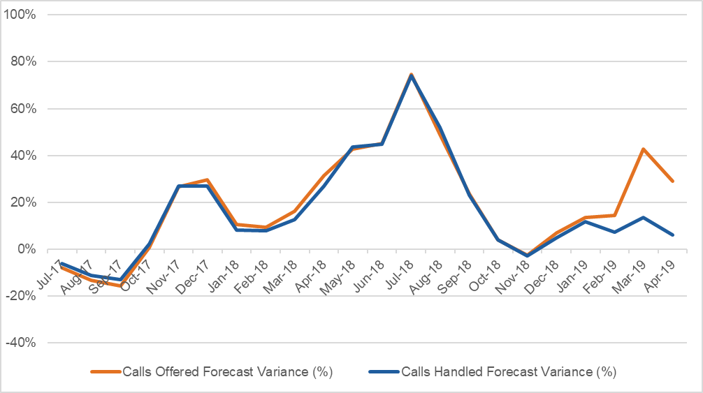

Forecasting is likely to be difficult in the context of increasing demand, which may be hard to predict. The data available on actual call metrics shows clear growth. Interviews with staff, discussed below in section 6.2.2, also indicate growing demand.
Simple linear projection of trends, based on trends in monthly call metrics since the First Response model was introduced in August 2016, indicates ongoing growth trends (shown in the figures below). While linear trends are indicated, estimation is difficult as growth in service demand could be expected to plateau at some point, although this is unlikely to be under the current service agreement (due for renewal in December 2019). As well as showing an overall growth in demand for telephone counselling (Figure 6.8 and Figure 6.9), the data also shows an increasing proportion of calls are being transferred for specialist counselling (Figure 6.10). Although there has been some fluctuation in the proportion of calls transferred from FRCs to TSCs, the proportion rose quite rapidly in a relatively short space of time, from 16.4% in August 2016 when the model was launched, to 47.1% in October 2018. There was substantial growth after August 2017 (see Figure 6.10). The reasons for this are unclear, and the rate of call transfer is an area requiring further scrutiny. Indeed, a stakeholder raised concerns about the high transfer rates, indicating that they may suggest unnecessary referral given the use of trained and qualified FRCs, whose high-quality responses could be expected to preclude the need for transfer.
While the transferral data shows an increasing proportion of calls are transferred to TSCs, there is very low utilisation of options to refer callers to state-based services. Figure 6.11 shows that in a context of rapidly increasing numbers of calls being answered, the number of warm transfers to state-based services has remained static. This may suggest sub-optimal coordination and use of referral options. Along with the high transferrals to TSCs, low numbers of transfers to state-based services are also worthy of further investigation.

Figure 6.8 Telephone counselling metrics, first response, 2016–18
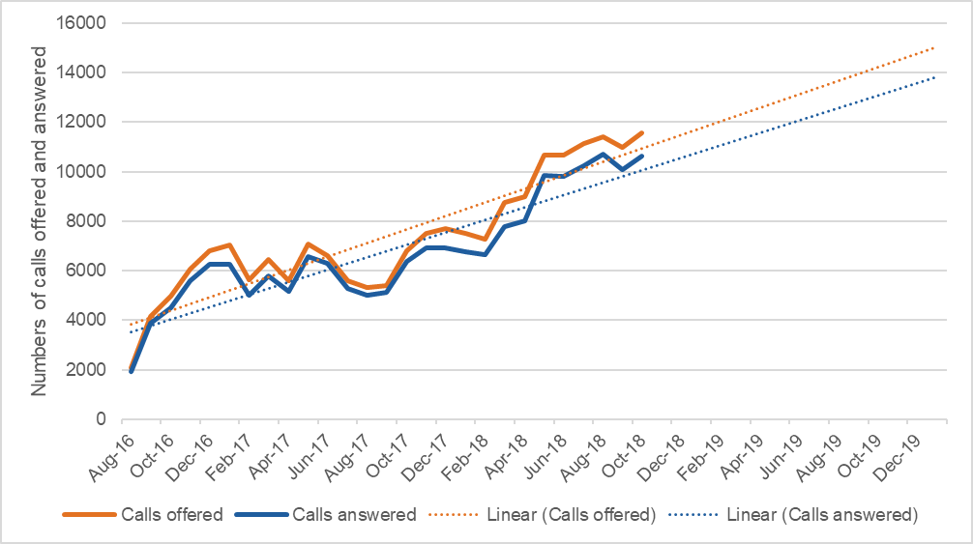
Source: 1800RESPECT monthly program data.
Figure 6.9 Warm transfers to trauma specialist counselling, 2016–2018
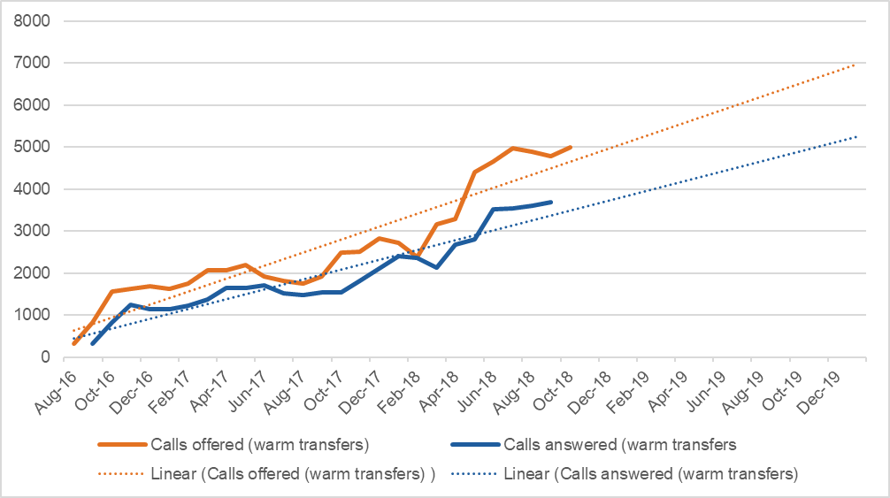
Source: 1800RESPECT monthly program data.

Figure 6.10 % of calls offered to Trauma Specialist Counselling service (as % of First Response calls answered)
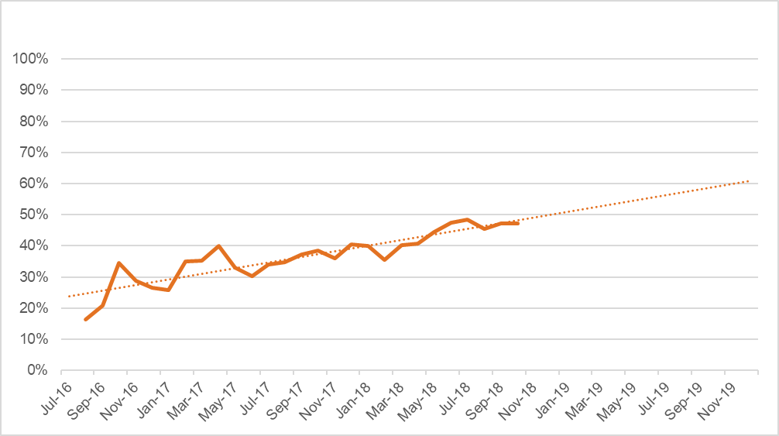
Source: 1800RESPECT monthly program data.
Figure 6.11 Numbers of calls answered and warm transfers to state-based services
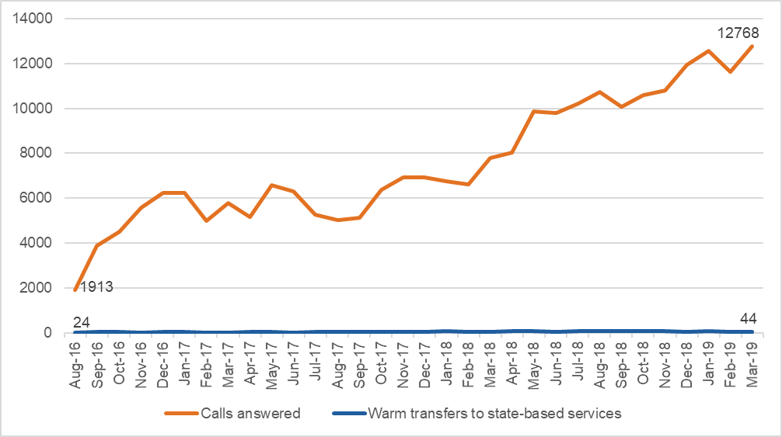
Figure 6.12 shows that in Q1 2018–19, 70% of interactions were from people using 1800RESPECT for the first time, down from 79% in 2016–17. Nine percent had used the service more than 10 times, and a further 7% had used it more than five times, which is much higher than in 2016–17. Interpreting repeat calling is complex. It can mean that callers found the 1800RESPECT service effectively met their needs and so they chose to call again in a different crisis or where abuse is ongoing. At the same time, it may reflect that alternative services are not available or accessible in their jurisdiction. As 1800RESPECT is a single session model intended to refer those needing ongoing support to other services, the growing share of repeat callers indicates growing pressure on the sustainability of the service.
Figure 6.12 Repeat contacts (total interactions)
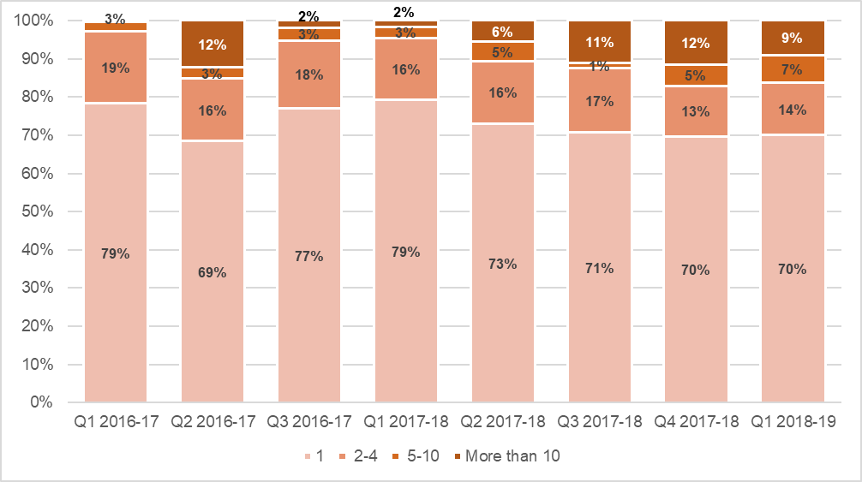
Source: 1800RESPECT monthly program data.

Interviews with staff delivering 1800RESPECT

Impact of growth in demand on staff in NGO partner organisations
A noted challenge was ensuring staff levels were sufficient to meet changes in demand. MHS was able to draw on a wider pool of staff to meet the forecasted FRC numbers required to cover shifts. The need for additional capacity was managed through workforce planning functions. These staff described how managing capacity in a call centre environment involves building in “a certain amount of planned what we call shrinkage at any one stage which includes active cues such as coaching and training.” ‘Shrinkage’ of capacity, such as staff absence from direct service delivery to participate in training, performance development, supervision, or leave, was put on hold when there was an increase in demand. Within the NGO partners, additional capacity could be provided by TSCs taking on extra shifts during periods of high demand. However, the fixed FTE meant existing staff could feel under pressure to take on extra shifts.
Both MHS staff and NGO partner staff at all levels spoke about the challenges they faced in meeting the growth in demand for the 1800RESPECT service. MHS staff reported that over the last 2.5 years, “If we look at...monthly workload or monthly volume we've more than doubled”. MHS staff reported that trying to anticipate and understand the continuous growth in demand has been a key challenge. To explain this, some staff referred to greater awareness of sexual assault and domestic violence resulting from the #MeToo movement and media coverage generated by significant cases of violence and abuse (as described in section 1.1.2). Another assumed driver in demand for the service is the increase in the number of repeat callers with complex presentations (see section 5.1). Attempts to manage demand, such as through coordinating with other helplines, or ensuring appropriate listings of the helpline in the media, did not come up as potential strategies.
In the context of high and increasing demand, discussions with the NGO partner staff touched on the issue of calls going unanswered. They reported that the unanswered call statistics were reported back to them by MHS and many felt concerned that many callers were not getting through. The increase in calls also meant that there was often no time between calls to allow staff time to debrief with a supervisor or "just to recharge your batteries and be really refreshed for the next call." Given the nature of the work, some felt that this led to vicarious trauma, compassion fatigue, exhaustion and staff burnout.
When I first started, I could do a shift and maybe only do between one and three calls. It has slowed down a bit but still now in a shift you might take five, six or seven calls. It just depends now. In that period December, January, February it was just crazy. There was no time in between calls at all. You would hang up the phone, go unavailable. You hadn’t even stopped looking screen and they were there.
NGO partner staff expressed concern that service demand was not being driven by people who had experienced (recent), or were at risk of experiencing, DFV or SA, but from repeat callers with complex presentations (discussed in section 5.1):
Sometimes my fear is that those people, whilst they absolutely deserve a service, maybe use this service, which will mean that other people who may need the specialist support may not get through.
They noted that the issue of repeat callers with complex presentations had been discussed with MHS and that there were few alternative services available for some of the callers. It was noted that the issue of who was in scope for 1800RESPECT services was "not a comfortable conversation to have" (see section 5.1.1).
NGO partner organisation managers commented on the challenge of answering double the number of calls without any increase in staffing levels. A consequence of the increasing demand without any increase in staffing was that clinical lead staff were under pressure to take calls rather than focus on supporting TSCs. Another consequence of the increase in demand reported by one of the NGO partners was that some YTT meetings had been cancelled and communication had become more sporadic; "some of the day-to-day partner supports, I feel, has dropped off slightly".
In discussions about managing demand, the efficacy of offering call-backs was raised (see section 5.3)

Time on calls
While the single session approach is premised on expectations that counsellors will plan sessions according to the time available, MHS does not formally allocate fixed amounts of counsellor time, or cap time spent on each call. Feedback from the FRCs about expectations relating to length of time on calls was contradictory, with one reporting that there was no limit and the another saying that they had guidelines they tried to stick to. Both, however, reported that they could spend longer on a call if the caller needed more support.
The TSCs reported that they were advised to keep counselling calls to 45–50 minutes and after-call work (writing case notes) to about eight minutes. MHS compiles the call and after-call work time statistics of each counsellor which are shared with program leads and line managers. If the statistics show that TSCs spent longer than recommended in any particular activities, program leads/line managers might email or speak with the TSCs to query the data (“they get those weekly reports and then they talk to us as they need to, I guess”). Most TSCs reported that they are very conscious of their statistics and will email their line manager to explain why a particular call may have run over time.
TSCs reported that call times can range in duration, from relatively brief to over an hour, but that on average they managed to keep calls to around 45–50 minutes. Most felt that this was a reasonable expectation when working within a single session framework:
When we first started, they said, “You take as long as you want with a call,” but in reality, a counselling session is normally about an hour anyway. It’s probably helpful given the single session model to keep it within 45 minutes or an hour. We don’t always need that.
By contrast, several TSCs spoke of the pressures they felt to keep calls and after-call work within a certain timeframe and that it was monitored by their clinical leads and senior practitioners:
Last week my after-call work time was a bit high because it was so busy, so I got an email from my boss saying after call work time was a bit high, try to keep it to eight minutes. So I guess you just feel a little bit of pressure around keeping it to that length of time.
Another TSC felt that there was an "assumption that we function like a call centre". She spoke of the pressure and anxiety that many counsellors felt, knowing that their call times were being watched and that they would be asked by managers to explain why their call times exceeded expected times. She mentioned that she had been warned on occasions that her job was “on the line”. She felt that the scrutiny of call times appeared to come down the chain of command from MHS, down to clinical leads and senior practitioners who then questioned the TSCs. She felt that many of the callers with complex presentations that she and her colleagues were supporting could not be effectively supported in a 50-minute call, but that when this was raised with management the feedback was that the TSCs were not doing their jobs properly:
These callers can have very complex needs, very high demand in the calls and will frequently not adhere to the request from us to end the call. This is really significant with the 1800RESPECT Line. We are put under scrutiny about that. The message that we receive every time we report this to anybody, supervisors, senior practitioners, team manager or clinical governance is that it’s a problem with us as clinical practitioners, that we as practitioners are not doing our jobs.
The pressure to keep calls to under an hour was raised by another counsellor who questioned how effective it was for callers with complex presentations.

The principle contractor model and value for money
This section addresses the question of the extent to which the current service delivery model (principle contractor with subcontractors) represent value for money and best practice. It draws on surveys and interviews with staff delivering 1800RESPECT and stakeholders.
While the 1800RESPECT workforce survey did not ask practitioners directly about their perceptions of value of money and best practice under the model, some of the comments left in the survey provide insight into their views on the model. Some were very positive about the model overall, for example:
I think the 1800RESPECT model is excellent - IT, CL [clinical leadership], management, supervision, resource line, access to referral resources, OCS [Office Communications Server] for communication with colleagues all dovetail well so I can do my work competently & efficiently. I enjoy my work & am grateful to work from home. (MHS respondent)
Others had good confidence in the service model but felt further supports were required to ensure quality. For example:
I believe so fully that this service is essential, and I think with more staff, internal reviews on processes and how to address repeat callers, and more staff support (i.e. better wages in the night space, consistent supervision) we can continue to deliver an incredible service. (NGO respondent)
Others queried evidence for the single session model or were unsure of the implications of domestic and family violence services being operated as a “call centre”. A recurring theme, discussed in section 5.1, related to the triage work of FRCs, and the treatment of repeat callers with complex presentations. Comments mentioned concerns about the number of people calling who were perceived to need services other than or in addition to 1800RESPECT (such as those who are isolated or not in scope) but have no alternative source of support, and the numbers of callers who accessed the service frequently and appeared to become dependent on the service. In terms of ways to improve the model, some pointed to triage practices, others to time capping, reflected in the following comments left in the survey by staff delivering 1800RESPECT:
I believe the triage work by First Responders needs to be revisited as callers that come through sometimes don't fit the scope of practice and specialist counsellors are having to deal with additional issues regarding same on top of our work demands. (NGO respondent)
I feel the calls we take should have a time cap. I know this wouldn't suit everyone and may be considered controversial. Many hours can be spent on people calling in who start out within scope, but then the conversation goes "rogue" and we end up talking about their dog. If they were told from the outset I can give you 20 minutes, then the conversation may be more controllable. (MHS respondent)
Ensuring more careful triage so there was certainty that callers were in scope, and capping call times at least in some instances, were thus seen as ways to ensure conversations were focused and therapeutic outcomes achieved more efficiently.
A few other respondents commented on cultures within 1800RESPECT, including relationships between the NGO partners and MHS. Some comments from NGO staff reflected their perceptions that as the prime provider, MHS could be more supportive and less focused on call management:
I enjoy my work with the clients and feel that I am making a difference. However, I have not found Medibank to be a supportive funding body. They are not supportive in professional supervision or ongoing training. The emphasis seems to be on answering calls and not the wellbeing of the SC. I do not find call coaching useful or strength based. I find it a form of performance management. Listening to a call is not the same as being the worker present in the call. I do not find the pie graphs sent to us useful, again another means of big brother keeping an eye on SC I feel that we are cogs in a big organisational wheel. I don't feel my practice is valued by Medibank although clients do appreciate our work. and that’s why I stay. (NGO respondent)
1800RESPECT is a DFVSA crisis and counselling phone service. Not a call centre…. …We work with [disadvantaged] callers, many of whom are unable to vocalise their needs or even identify why they are calling. There are many possible options to manage the call demand and redirect calls from better first responder triage to opening up alternatives for regular callers. However, the pressure within the 1800RESPECT community, from the top down, is so extreme that the senior staff are more concerned with the call volume than the welfare of the staff. This is troubling in a workforce who predominantly deal with extreme trauma and ongoing DFVSA. (NGO respondent)
Discussions with the stakeholders revealed differing views on the appropriateness of the model. One did not support the First Response model and was dismissive of the idea that some people only call for a referral and do not need a more extensive response. The stakeholder argued that this view is not trauma-informed, and does not recognise that some callers who are apparently asking for a minimal service, may in fact be testing the waters to try to work out what kind of support they might be able to get:
When someone builds up the courage to ring a sexual assault or domestic violence service, we have an obligation to provide, and they have every right to expect, the best possible response that we can offer. That’s not a triage. That’s a trauma specialist response.
It is not clear from this comment why providing a referral as requested by the caller would not be an effective and respectful response consistent with a trauma-informed service. However, the view this person expressed, that people contacting the service should expect the best possible response, is consistent with the commitment to quality built into the service model via the requirement for FRCs to be qualified to provide counselling, as well as triage and referral.
Another stakeholder felt that the First Response and TSC model was appropriate and that few organisations would be able to provide the 1800RESPECT service on the scale and with the infrastructure of MHS, however, the triage process could better ensure specialist counselling was used only where needed:
I think that not everybody does need to go through to the specialist counsellors and I think the model where specialist counsellors are providing specialist counselling rather than dealing with your average query is really important. I haven’t been able to come up with a model that I think works better and I think this model certainly works astoundingly better than the previous model.
In her comments on the current model, another stakeholder felt that service delivery had improved significantly under the new model:
I just look at the statistics. They just go up and up and up. The call rates remain really high. Nothing like the way it was. They continue to professionalise, as I see it. More than that, they’ve become very nimble about finding different and better ways to do things that will more professionally address the needs of certain sectors.
This stakeholder felt that there was little choice other than to accept a “funding by volume costing model” but that it was important to review the funding basis and question the statistics. Indeed, another stakeholder similarly indicated the need to better understand the drivers of spikes in demand and the ways call data were counted, to ensure transparency and that data could not be “gamed” for commercial advantage. Comparing MHS call data with third party call data, such as Telstra or other provider data, could make the service operations more transparent and assist with planning.
Others also indicated the need to review the funding model and performance data. For example, one stakeholder accepted that the First Response model was much needed and overall had resulted in improved responses to client need. However, continued growth in demand meant it was now questionable whether the model remained fit for purpose, and that it had reached a point where it required review to ensure it was fit for a future of likely sustained growth in demand:
The fact that phone calls are being answered is an incredibly important success to acknowledge…. triage has enabled us to handle so much of the growth and we’re probably at a point now where we need to reconsider it because that growth has sustained. (Stakeholder interview)
This stakeholder felt areas to review included pathways for repeat callers. She pointed out that this element of the model was not consistent with best practice in face-to-face counselling. For example, counsellors were not able to “ration” repeated contact (e.g. by weekly appointments). Moreover, the structure of the 1800RESPECT practice framework, means that no practitioner is allocated primary responsibility for any of the individuals who were calling repeatedly, which would not be recommended practice with clients with complex needs following trauma. These factors, along with the increasing proportion of calls transferred to TSCs, were seen as areas which could be more effectively managed through the performance standards applying to the service, and which underlined the need to review the model.

Service costings and cost efficiency
This section responds to the evaluation sub-question: ‘Please provide a full service costing for the current 1800RESPECT service (based on market rates) and indicative costings for other service models explored in 1f, including where changes to the model may offer cost efficiency improvements’. To do this, we reviewed documents relating to funding and costs, including the DSS funding agreement for 1800RESPECT, and material publicly available, such as annual reports, which outline costs and funding arrangements for comparable telephone-based counselling services. It should be noted that available data is limited to information publicly presented by the other organisations and also what was provided by MHS to the evaluation team.

Summary of funding arrangements
A total of $140.3 million has been paid or committed to MHS between FY2010–11 and FY2019–20, including around $63 million for not-for-profit subcontractors to deliver trauma specialist counselling. DSS provides funding for the service in three ways. First Response is funded on a cost per contact basis. TSC partners are funded on an FTE staffing basis. This covers wages, supervision and management. In addition, the department pays core operational costs. This includes IT, telephony, training, workforce planning and quality assurance, digital platforms (including website, mobile phone apps and webinars), communications and marketing, stakeholder management, operations team wages and corporate support.
Part of the model is funded on a cost per contact basis. This is based on a unit price set for each call or online counselling session, regardless of its duration. DSS pays MHS at either the agreed forecast or actual calls and online chats handled – whichever is the highest amount. As discussed in section 6.2.1, MHS’ forecasts have tended to underestimate demand since late 2017. Under the funding agreement, MHS must advise DSS in writing where forecasting indicates demand will exceed a certain number of contacts, and work with DSS to determine how to manage increased demand.
As prime provider, MHS provides funds to the NGO partners. This is done quarterly and in advance, to assist with cashflow and stability of service provision and staffing. Many administrative costs are borne by MHS, such as IT, induction training and professional development, clinical and quality assurance activities. This is built into the funding agreement. MHS claims that the benefit to NGOs of working with them is that they provide the infrastructure on which services can be run—workforce planning, reporting, clinical governance. An element of risk in the funding model relates to the balance between funding for FRCs and TSCs, who provide a more intense and longer service to clients. The difference in the complexity of caller need between the two groups is also a training and clinical support issue, and the surveys and interviews with TSC suggest that additional resources need to be provided to the TSC’s professional support and development.

Unit costings
The funding agreement between DSS and MHS specifies arrangements for the First Response component and the trauma specialist counselling component, including financial and reporting arrangements and processes for forecasting and review of service levels. For TSC, the funding agreement between DSS and MHS sets out Panel arrangements, and an agreed service level, which is regularly reviewed by the department. The MHS funding proposal dated October 2018 set out the cost per call for First Response (which includes counsellor availability, induction, professional development, support and infrastructure). Online chats were costed per session, however, MHS reduced this cost from January 2019. In addition, the unit cost per call was reduced as a result of review of average handling time.
The higher cost of online counselling (i.e. online chats) compared with phone counselling reflects higher average handling time, which is around double that of a First Response call (24 minutes compared with 13 minutes, based on the MHS funding proposal provided to DSS in October 2018, see page 9). This is depicted in Figure 6.13. The different times required may reflect the particular cohort using online chat which may differ from those using telephone services. It also reflects the longer time required for text compared with talk-based exchanges. The higher costs of webchat may present a source of risk, if there is a shift to online support seeking over time, or if patterns of service use involve initial use of online chat, followed by use of the phone service, i.e. if online service usage results in higher use of the phone service.
Figure 6.13 Average handling time, telephone first response and online chat, 2017–18
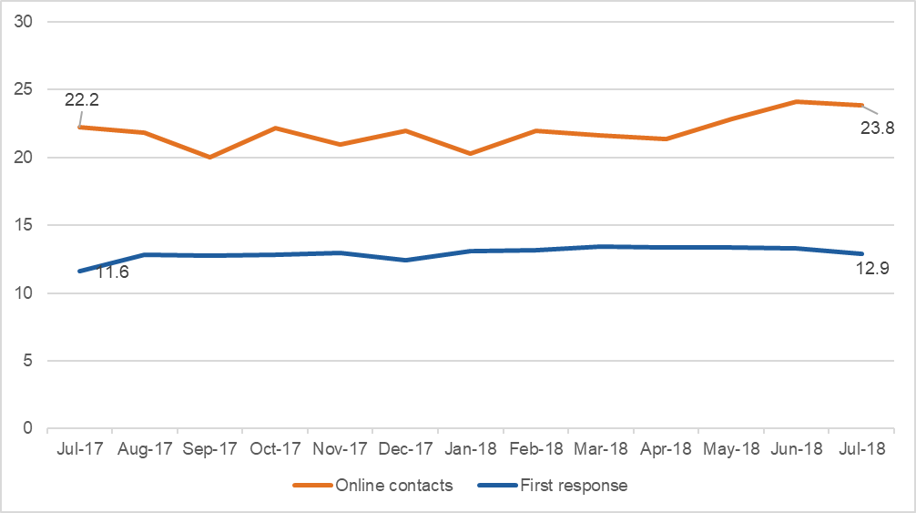

Alternatives to a unit-costing model
There are risks associated with a unit-based model of funding, compared with alternative approaches. Funding based on units of service require government to allocate the same amount of resources to the provider for short and long sessions. This may present an incentive for providers to ‘churn’ callers rather than spend longer to more fully understand and address needs and reduce subsequent repeat calls. A unit-based model of funding also means that, as demand increases, the government has a continued commitment to provide increased levels of funding. This does not reflect different efficiencies at different volume levels. Further, it sets up funders for escalation in funding commitments, unless increased costs are offset by efficiencies. Risks are further exacerbated as funding levels are determined by the providers’ measurement of the actual or projected units of service.
Reconsideration of the funding structure in any future service agreement is needed to mitigate risks. Where spending depends on provider-controlled performance data, external verification of measurement and forecasting methodology to ensure escalation in spending can be fully accounted for.
In terms of alternative funding arrangements, one option would involve supporting the service through a tiered cost structure. This could involve a different rate for different types of inquiries (such as information, crisis response, referral, repeat callers with complex presentations) or setting funding levels according to the length of calls. For example, different rates could apply to calls falling into five tiers. Rates would need to be set carefully to minimise the risk providers may game arrangements by, for example, lengthening calls to reach higher rate thresholds. Tiered arrangements would also need to balance considerations of service effectiveness with priorities of ensuring very high proportions of calls are rapidly answered, which many participants in the evaluation have seen to be a strength of the current model. This approach also has limitations as it may encourage FRCs and TSCs to prolong calls which could then affect call waiting times and accessibility.
A second alternative could be based on an FTE block funding model, which is a traditional model for funding external service delivery. This would support services for a specified amount of staff time with a flat rate of funding paid for the required allocation of dedicated counsellor time, rather than per call, as, multiple short calls currently result in higher hourly payments. Under an FTE model, the hourly rate could conceivably be lower than under this per-contact model. While helping to contain costs, it could also be used as a means to develop quality by ensuring staff delivering 1800RESPECT were focused solely on delivering the service rather than taking calls from a mix of services during a shift. As well as ensuring a workforce dedicated solely to 1800RESPECT, this option also offers to minimise risks of providers cross-subsidising other services. However, the model would need to ensure sufficient flexibility to accommodate fluctuating demand and maintain incentives for efficient and effective responses to callers while maintaining high call answer rates. An additional advantage to a dedicated 1800RESPECT workforce is the opportunity to build capacity within a team of designated counsellors by providing targeted de-briefing/clinical supervision and professional development.
A third alternative could involve an alternative governance model, for example, a partnership arrangement involving contributions from the states and territories in addition to Commonwealth support. Rather than changing the service agreement for the model or providing an additional pathway, this would constitute a more significant transformation of governance arrangements. Consideration would need to be given to accountability arrangements, and to securing sustainable funds for the service. A strength of this model would be capacity to spread costs across the levels of government which benefit from the service, capacity to manage demand and reduce duplication through enhanced coordination with the jurisdictions, and enhanced accountability, for example to a Board.
Any alternative will need to consider ways to alleviate pressure on the system overall. This could be achieved by more effectively coordinating callers’ pathways to 1800RESPECT and their referral to other services, as a strategy for managing those with highly complex needs which cannot be effectively addressed through a single session model.

Benchmarking service costs
Assessment of funding arrangements, and discussion of alternatives such as those mentioned above, can be informed by consideration of arrangements in other helpline services. This section attempts to benchmark 1800RESPECT costings and funding arrangements with comparable services. Benchmarking of costs and performance against similar services offers a potentially promising comparative method for assessing effectiveness and value for money. However, comparisons are highly constrained by limited financial and performance information available in the public domain or reporting by different services in different units and formats. In attempting to provide indicative comparisons of service models and unit costs, we found there is very limited information available for telehealth services used by people affected by domestic and family violence and sexual assault. Other services providing supports are not identical to 1800RESPECT, precluding meaningful comparisons.
Recognising the limitations of this approach, we nonetheless sourced information to establish indicative comparisons of cost, performance, demand levels, and strategies for managing demand. To do this, we examined publicly available annual reports published by safesteps, Womensline (the state-based telephone service run by DVConnect), the Blue Knot Foundation, Kids Helpline, Reach Out, Lifeline, and Rape Crisis England & Wales. This exercise produced select insights but did not provide sufficient information to provide a comprehensive comparison. In particular, there is no comparative information about client experiences of services, and client outcomes.
In comparing the services, we focused on costs, funding arrangements, performance, demand and staffing. A summary is shown in Appendix C. Little information about costs of services was available, and no information about unit costs was available. In any case, cost comparisons would need to account for differences in the structure of services, service activities, the complexity of client need, use of volunteers and skilled staff, and other factors. In terms of funding models, it is evident that helplines run by non-profit organisations, such as Lifeline and Kids Helpline, tend to be supported by a mix of revenue streams, including government funding, donations and fundraising, and commercial revenue. There is little information with which to reliably compare cost efficiency. Based on the call answering and call waiting metrics, it appears that 1800RESPECT is more responsive than Lifeline. However, an important caveat is that there are limitations in making comparisons of this type without a thorough assessment of workforce characteristics (for example Lifeline is staffed by a volunteer workforce and has considerably more referral options), service activities and contexts, client group, and client outcomes. Information about duration of phone and webchat sessions is not comparable as the information is from sessions with children and young people (Kids Helpline).
Like 1800RESPECT, other services are confronting increasing demand. The rate of demand in the last few years is fairly similar for 1800RESPECT, safesteps and Women’s Line (see Figure 6.14). This is based on information from various annual reports. Further investigation could be undertaken to examine the relationship between demand to 1800RESPECT and state lines, and in particular, whether increases to 1800RESPECT take pressure from state lines and vice versa.
To address rising demand, services have implemented a range of strategies. DVConnect, for example, experienced rapid increases in demand and needed to recruit more staff with all resources available, for which they received state government assistance. For Lifeline, the low cost of training volunteers (estimated at $4,000 per volunteer) indicates low barriers to responding to increased demand. Lifeline has undertaken research to improve their capacity to respond to frequent callers (Pirkis et al, 2015; Pirkis et al, 2016). They proposed a model to better meet the needs of frequent callers which involved access to dedicated and specially trained staff who would develop rapport with callers, establish rules about timing and duration of calls and help callers work towards clearly defined goals. They would also link callers to other services (Pirkis et al, 2016). An intervention for frequent callers was trialled by Lifeline in 2017/18 and evaluated (unpublished report). Lifeline presently is using the resulting data to underpin the development of an ongoing service offering for those who call frequently.
This underlines the opportunity for better exchange of knowledge among helplines to improve coordination and responses to common challenges. Lifeline is also trialling SMS crisis support and has reduced the hours of online chat due to resource demands. Further information about Lifeline’s experience with online chat, and the need to decrease operating hours for this component of the service, may be helpful for considering the future of 1800RESPECT’s online chat services, especially given the cost implications of expansion of online service delivery, noting previous research indicating the long duration of online interactions. Overall, there does not appear to be an easy way to manage and respond to the increasing levels of demand for helplines.
It is worth noting that increased demand for the 1800RESPECT service can be seen as a proxy indicator effectively responding to National Outcome 4 of the National Plan to Reduce Violence against Women and their Children 2010–2022, services meet the needs of women and their children experiencing violence. What also needs to be considered is the uptake and publicity of the line across multiple media which drives demand for the service across the community.
Figure 6.14 Increasing demand for domestic violence telephone hotlines (incoming calls)
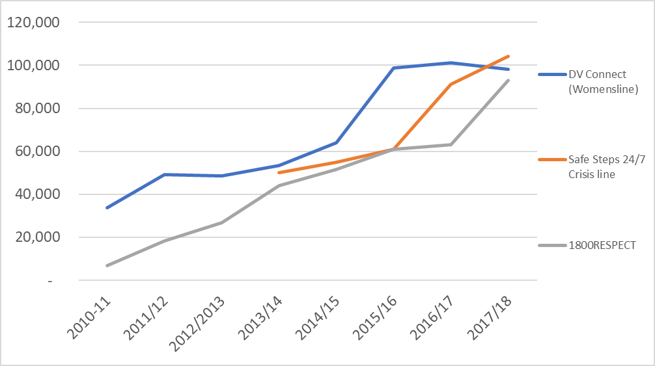
Sources: 1800RESPECT program data, various annual reports for DV Connect and Safe Steps.
Owing to the limitations of benchmarking exercises using publicly available service data, it may be advisable for DSS to consider undertaking a comparison of 1800RESPECT service and costing data with similar data from other helplines that receive government funding, noting that none can offer direct comparability. This may allow for a comparison of performance data and approaches to reporting, along with information about forecasting methodologies and funding arrangements between other helplines and government departments.

Appropriateness of working from home practices
This section addresses the evaluation question: ‘to what extent are work from home practices appropriate?’ This focus arises from the Senate Committee’s recommendation that the government ensure that 1800RESPECT counsellors and trauma counsellors have an appropriate work environment, and specifically, that the practice of working from home among FRCs employed by MHS cease (Recommendation 1). Working at home was explored in the 1800RESPECT workforce survey, and in interviews with staff.

1800RESPECT workforce survey
The 1800RESPECT workforce survey captured practitioners’ experiences of working at home, in the context of the Senate Committee’s recommendation that working arrangements be reviewed by government, and that working from home practices cease among FRCs. Respondents were asked how often, in their work with 1800RESPECT, they worked from home, with response categories being ‘all of the time’, ‘most of the time’, ‘some of the time’, ‘a little of the time’, and ‘none of the time’. Among MHS respondents, 88% said ‘all of the time’, and a further 2% said ‘most of the time’. In contrast, 90% of NGO respondents said they never worked at home, and a further 6% said they did ‘a little of the time’. As such, working at home appears to have remained central to the first response model. This is shown in Figure 7.1.
Figure 7.1 How often MHS and NGO staff delivering 1800RESPECT work from home
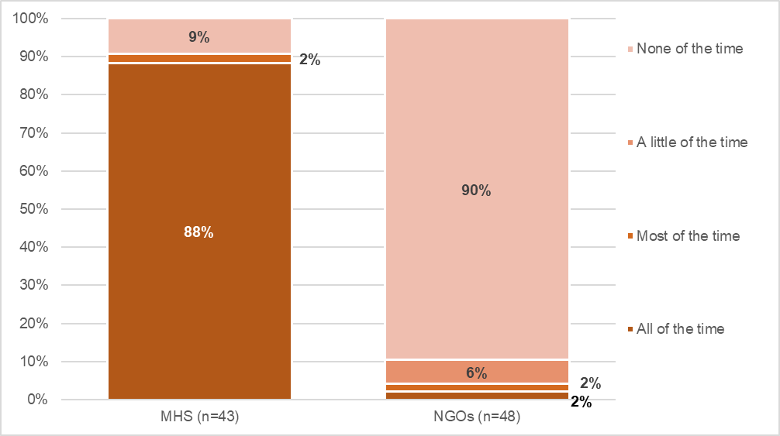
Respondents were asked if they had any comments about working from home to deliver 1800RESPECT. Comments from MHS survey respondents who worked from home were generally (but not unequivocally) positive. Many said it made it practical for them to work overnight, that they valued the safe, quiet workspace free from distractions, that it could save time and money on commuting, but that it could be isolating, especially after difficult calls or if there were not opportunities to debrief. Typical comments were:
It is convenient. I don't have to get dressed up and sit in the traffic for hours at a time. However, it can be isolating. I don't have the opportunity to meet up with other counsellors and cannot put faces to the people I work with. We have Office Communicator but sometimes that doesn't work. There are supports though, which is good. (MHS respondent, 1800RESPECT workforce survey)
Love it. Yes at times I feel a little isolated, but overall the rapport between staff on shifts is great. The things we are hearing wouldn't suit me in an office environment particularly. Prefer to handle things my way in the privacy of my study. (MHS respondent, 1800RESPECT workforce survey)
I really think that I would struggle doing my job from an office. It can at times be a stressful and challenging role but working from home enables me to have balance in my life that I'm sure I would not otherwise have. I'm in a position where I can create a private, confidential, quiet environment for the calls, and when I have had to work in the office (due to IT issues) I actually found it more distracting due to the noise. (MHS respondent, 1800RESPECT workforce survey)
Other comments of those who worked at home acknowledged the risks of doing so. However, the counsellors generally felt that they had good individual capacity to manage vicarious trauma and access support, for example:
I am ok with it because I worked in the office for over 10 years, so I know what steps I need to take to manage [vicarious trauma] and have ongoing support. (MHS respondent, 1800RESPECT workforce survey)
On the other hand, a couple mentioned that while technical support was generally good, issues were sometimes considered an individual responsibility.
Others suggested ways that supports for staff working at home could be improved, including increased support with respect to supervision:
Because we work from home, I think there is a greater need for more supervision, in a month a counsellor may only get to spend about 10 minutes bringing up any issues they have in the group due to having other members in the group session also needing time to discuss their questions/issues etc. ten minutes per month for such intense, complex at times aggressive presentations is really not enough. (MHS respondent, 1800RESPECT workforce survey)
Colleagues who work from home need to be offered additional support including payment in accessing external supervision - the organisation needs to review current literature research and recommendations on vicarious trauma and burn out and working from home in the trauma sector. (NGO respondent, 1800RESPECT workforce survey)
In contrast to MHS staff, comments from NGO providers discussed working at home as a possibility. Some specialist counsellors said they would welcome the option to work from home, especially to cover overnight shifts or times of lower demand when they may otherwise be working alone in the office. It was seen as attractive as it would reduce travel time and costs:
I welcome the opportunity to work from home to deliver 1800RESPECT. This would most certainly be of benefit to staff who travel long distances to work and do night shift/early mornings. If work from home was an option I would be more willing to cover additional hours as factoring travel time, costs (travel/parking/food) would not be an issue. The service is set up well for a work from home delivery and communication via Office Communicator allows for team connection. Further, I sometimes am the only person working in the office, thus in this instance a work from home option would be useful. Working from home would also limit the spreading of germs which contributes to sick leave. (NGO respondent, 1800RESPECT workforce survey)
Other comments reflected NGO staff’s preferences to keep work and home separate, and to work in a strong team environment where they could have strong face-to-face connections with colleagues, especially in the context of high risks of vicarious trauma:
As a Specialist Counsellor I enjoy working within a team environment for debriefing and support, I believe this a strong protective factor against VT and helpful with staff retention. (NGO respondent, 1800RESPECT workforce)
There were also concerns that delivering trauma counselling from home was not an evidence-based service delivery model:
I have raised concerns regarding colleagues working from home as the literature suggests that higher levels of support are required in these circumstances - this support does not appear to be in place. Specialist trauma counselling is an area that is difficult to transfer to the home context. (NGO respondent, 1800RESPECT workforce survey)

Interviews with staff delivering 1800RESPECT

FRCs
As indicated in the 1800RESPECT workforce survey findings above, the majority of the FRCs work from home, with a small number based in an office. MHS managers reported that staff working from home are required to sign a work from home agreement which requires them to comply with a range of set up requirements with respect to their workspace. Staff are also required to complete an annual workplace home assessment activity to ensure that their work at home practices comply with MHS requirements.
The benefits of working from home reported by MHS managers were:
- cutting out commuting time
- infrastructure enabled staff working from home to remain in contact with one another
- staff felt that they were more productive
- confidentiality maintained on par with call centre standards
- staff working from home is cost-effective from a service delivery perspective.
MHS installs phone and internet lines and provides all staff with a kit "that’s got everything that you would need in it from a technological point of view". Several MHS managers commented on how the IT infrastructure enables staff to maintain regular communication:
What I've been amazed by…is that the way that we're actually set up and the technology that they actually have access to they are very engaged with each other. So they'll use online tools which basically is instant messaging. They'll talk through the day. They'll chat. They'll say they're on shift. They'll say when they go off shift. So the team actually really do stay really well connected and even in locations they'll get together on a personal level.
The only limitations of working from home reported by MHS managerial staff was the challenge of not being able to observe staff in their workspace in order to monitor their wellbeing. One clinical supervisor reported that she had to check in with staff regularly instead.
The FRCs interviewed were satisfied with their work from home arrangements. Despite their physical separation, the FRCs reported feeling that they were well-connected with colleagues and supervisors. This included an instant messaging service (the OCS system) that allowed staff communicate with colleagues. This was used for both urgent and non-urgent communications:
I can ask counsellors to help me out and they can call 000 on my behalf because I’m on call with this caller… We have this instant message space where I can contact the team and whoever is available will be able to help me.
We have a Messenger kind of chat, almost, with colleagues online. If we need, there’s always a few text boxes going on where you say hi, and bye, check-in. If you need somebody to help you out, or if you’re wanting to know a good referral, colleagues jump in and give suggestions and tips. That’s really good. That’s why working from home works. You’re not just in your own little bubble all the time.

TSCs
The trauma specialist counselling provided by 1800RESPECT is available on a 24-hour basis. The three NGO partners deliver this counselling through three shifts over a 24-hour period. The overnight shifts are nine hours (plus one hour of breaks) and the other two shifts are 7.5 hours. Each of the three NGO partners delivers 10 overnight shifts per fortnight. Given the 24 hour, 7 days a week nature of the service, the TSCs typically worked several shifts over a fortnight period. These shifts sometimes included a mix of morning, afternoon, evening and night shift. Some worked part-time hours whilst others worked full time.
The majority of the TSCs worked in their organisation’s offices. A manager in one of the NGO partners reported that this was a conscious decision they took at contract commencement, but that they would be looking into work from home arrangements.
One TSC reported that she was in the process of negotiating a work from home arrangement that would enable her to undertake some of her shifts from home, particularly when she had back to back shifts (with a 10-hour break in between). She reported that MHS and her organisation provided guidelines around working from home and required that she complete paperwork to document her compliance with work from home policies.
MHS reported that they had initiated a small-scale work from home trial with a view to exploring whether it was a viable means of addressing peaks in demand that would be difficult to meet if staff were required to commute to work (particularly in the middle of the night).
Giving staff the option to work from home was also identified by MHS and the NGO partners as a means of addressing recruitment challenges by expanding the pool of eligible candidates. Staff in regional and remote areas could obtain positions they would otherwise be precluded from if required to work in a metropolitan area.

Preventing vicarious trauma
To explore vicarious trauma, the 1800RESPECT workforce survey included several questions about work-related adversities which may be experienced, such as feeling upset from work with callers, and practitioners’ perceptions of connections with other staff and access to collegial support.

Arrangements to manage vicarious trauma
The FRCs are part of the Mental Health Counselling Team and they respond to calls to the 1800RESPECT line and other MHS managed telehealth lines they are trained in (see section 3.3). They are supervised by clinical leads who manage teams of approximately 15–20 counsellors and have access to an employee assistance program. The clinical leads work in 8-hour shifts between 8am and 10pm. After 10pm senior clinicians are available to support the team. FRCs who were interviewed were very positive about the supervision they received:
I have a clinical lead. We chat frequently. She checks in with me all the time. We have a really good relationship. I feel very comfortable to reach out to her. Having said that, also, while we’re online doing our shifts, if my manager’s not on, so my clinical lead’s not on, there’s enough support there that you can just jump on and say, “Hey. I’m having a bad call. I’m stressed out.” You can speak to one of the seniors on the resource line.
Medibank is a really, really supportive workplace, and they try to do a lot of initiatives to make sure that we know that we’re appreciated. They do encourage us to look after our well-being.

Experiences of adversity at work
To capture experiences of adversity at work, the 1800RESPECT workforce survey asked how strongly respondents agreed or disagreed with the statement ‘I feel emotionally drained by my work’. Almost half agreed or strongly agreed (47%), which is on par with the figure found in the National Survey (48.2%, see Cortis et al, 2018, p 62.) (see Figure 8.1). For 1800RESPECT staff, the proportion who agreed with the statement was higher among NGO providers (53%) than MHS staff (40%). This difference may reflect the different types of work done in each context, and the focus of staff in NGOs on working with people affected by trauma. Differences in the nature of the work performed may also account for differences in MHS and NGO staff perspectives evident in the data. Figure 8.2 provides four measures of staff responses to their work: how often they felt upset thinking about their work with callers, how often they felt like avoiding going to work, how often they felt overwhelmed by their workload, and how often they felt upset because of the trauma they hear about at 1800RESPECT. Across each item, higher proportions of MHS staff than NGO staff said ‘never’.

Figure 8.1 Agreement with statement ‘I feel emotionally drained by my work’
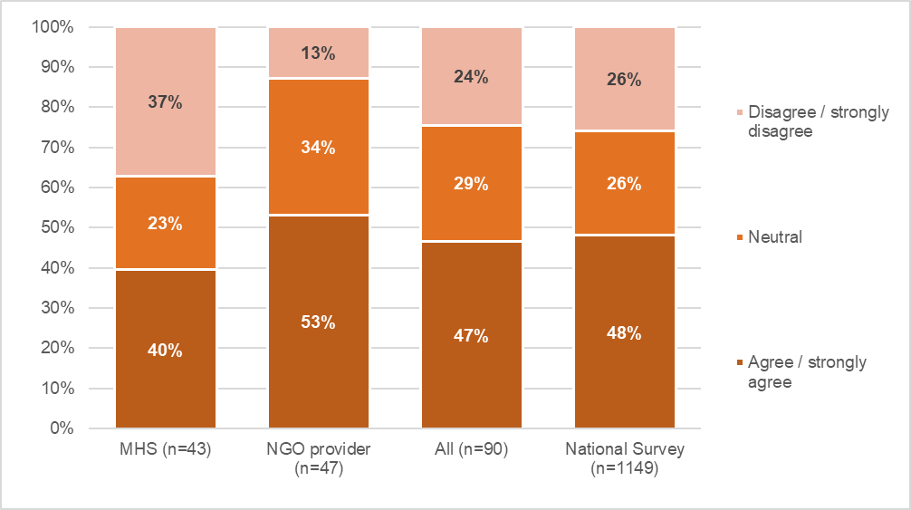

Figure 8.2 How often staff experienced work-related adversity
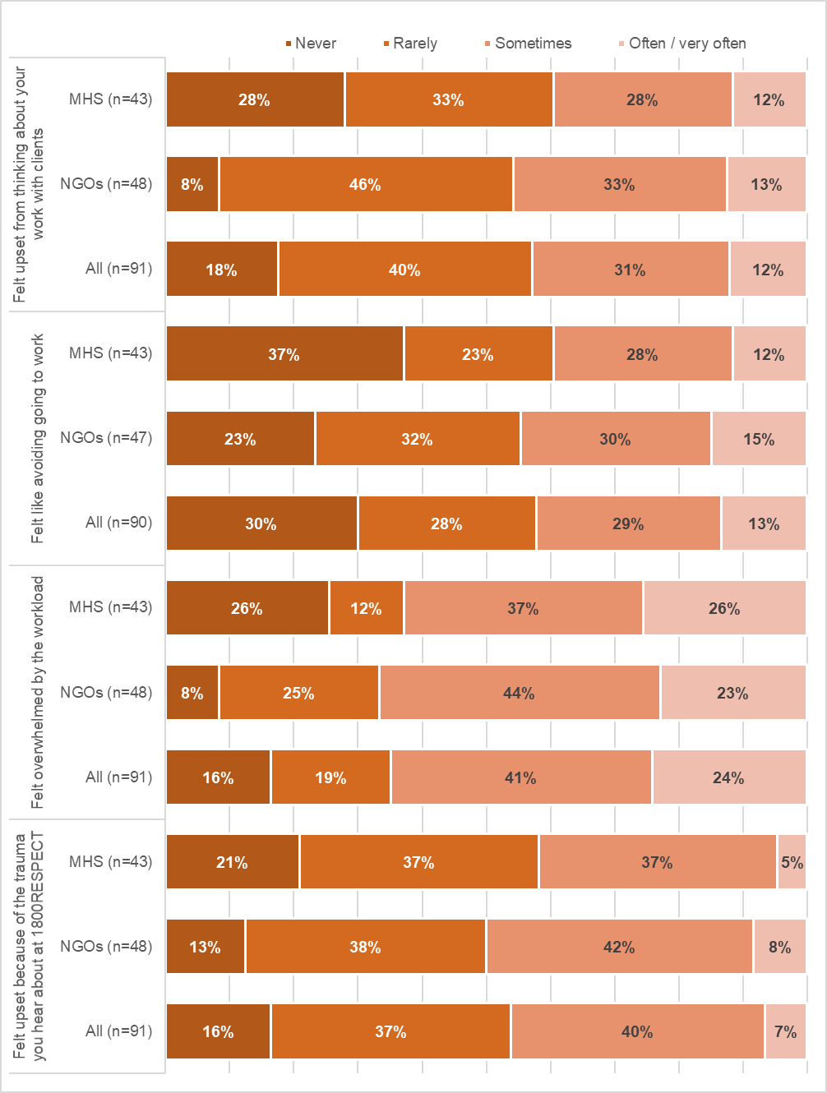
Access to quality supervision and support from colleagues can buffer vicarious trauma. Table 8.1 contains information about practitioners’ agreement with statements about the support they received from colleagues. Overall, around two thirds felt they had adequate opportunities to discuss work with colleagues, and a similar proportion agreed they are able to engage colleagues to assist with more complex cases (66%). While higher proportions of MHS than NGO staff agreed they can easily contact a supervisor when needed, lower proportions of MHS staff agreed that the feel well connected to staff in their organisation, most likely reflecting their working at home arrangements. Across all respondents, most disagreed they are well connected to staff delivering 1800RESPECT working in other organisations (54%).
Table 8.1 Measures of capacity to access support from colleagues
 | MHS (n=43) | NGOs (n=48) | All (n=91)
I have adequate opportunities to discuss my work with colleagues
Agree / Strongly agree | 67% | 63% | 65%
Neutral | 13% | 22% | 18%
Disagree / Strongly disagree | 20% | 14% | 17%
I am able to engage colleagues to assist with more complex cases
Agree / Strongly agree | 72% | 60% | 66%
Neutral | 19% | 21% | 20%
Disagree / Strongly disagree | 9% | 19% | 14%
I can easily contact a supervisor when I need to
Agree / Strongly agree | 77% | 67% | 71%
Neutral | 19% | 17% | 18%
Disagree / Strongly disagree | 5% | 17% | 11%
I feel well connected to 1800RESPECT staff in my organisation
Agree / Strongly agree | 53% | 85% | 70%
Neutral | 26% | 10% | 18%
Disagree / Strongly disagree | 21% | 4% | 12%
I feel well connected to 1800RESPECT staff working in other organisations
Agree / Strongly agree | 35% | 8% | 21%
Neutral | 26% | 25% | 25%
Disagree / Strongly disagree | 40% | 67% | 54%
Note: Some figures may not sum exactly to 100% due to rounding.

Support from supervisors
The senior practitioners in the NGO partners reported that a key part of their role was to monitor staff for signs of trauma due to the calls they were taking. Debriefing with staff, noting exhaustion and patterns of sick leave were means of keeping track of how staff were managing the potential stresses and personal impact of the work.
TSCs recognised that the nature of their work meant that they were susceptible to vicarious trauma, but several commented that they did not feel that the bi-monthly supervision was sufficient with the result that some staff were paying for additional supervision/counselling.
TSCs have access to different forms of supervision: internal supervision, which includes group and individual supervision and external supervision, whereby MHS provides six sessions a year for TSCs. The group supervision is undertaken by teleconference with all NGO partners with an MHS-appointed psychologist and was not specific to 1800RESPECT or staff delivering 1800RESPECT, with matters relating to work on other lines also discussed. MHS staff reported that group supervision is held on a monthly basis, but NGO partner staff reported that it happened every two months. The group supervision sessions cover a range of issues related to clinical practice and discussing challenging calls. Staff found the group supervision sessions to be generally helpful although not always interactive:
Sometimes I might not have anything to bring in the agenda, but we all know and go through the same things. I may not think of it at the agenda, but then someone brings it up and the clinical supervisor will give us directions or suggestions and that could be good and we could use it for the next time. We just listen.
TSCs also have access to individual supervision which appears to comprise mainly of call coaching sessions with the program leaders during which the counsellor and program leaders listen to the TSC's recorded call together and discuss it. These sessions are scheduled by MHS. Staff had mixed views on the value of these call coaching sessions with some finding them helpful and others not.
In addition to these formal supervision sessions, TSCs also have access to supervision during their shifts. Clinical leads and senior practitioners are present during daytime and evening shifts and on call overnight if staff need to debrief with them. One clinical lead referred to her role as being both a risk mitigation and a support role:
It’s to ensure clinically correct practice on the floor at all times and to ensure duty of care to caller and to the counsellors. That might take the form of debriefing, coaching, supervision, consultation on a risk, so in a senior practitioner role, that’s actually what it is. Senior practitioners also do the work, so they pick up the phone, they take calls, they remain connected to the work that they then advise.
Clinical leads and senior practitioners reported that in busy periods there was greater pressure on them to take calls, which reduces the amount of time they are available to support staff:
There seems to be a bit more pressure of actually being on the phone, which is actually really difficult because you've got to make sure that counsellors are on calls that they're not going to need somebody there to action other events.
TSCs on night shifts can call a phone line provided by MHS (the Hypercare Line) if they require clinical advice from a senior clinician. One TSC reported using the line following two calls from suicidal callers (see section 5.1.1):
[Debrief is] a status that we can go into when we need to talk to someone about the call that we’ve had... I had to ring my clinical lead to get some advice and support through the case to see whether I had done what my duty of care says I need to do and what is appropriate to do... I rang her and we went through the care plan together. She looked at the file and we came to the conclusion that I didn't need to call emergency services. It was fine.
The TSCs valued being able to access this support outside non-standard work hours, however, one TSC reported that with the shift to daylight savings in some jurisdictions, there was an hour gap where some staff fell between supervisory shifts and no supervisors were available “and we just seem to get a lot of suicide callers right in that time. We've had a few lately where there's no shift supervisor that you can talk to”.
As supervision can support self-care and professional growth, the survey asked whether respondents receive regular professional, clinical or practice supervision that is separate from their line manager. Among respondents, 78% said they received this kind of supervision, and 22% did not. The largest group (45%) said they received it monthly, while 8% received it more often.
Among 1800RESPECT staff, there were some differences in responses from MHS and NGO staff, shown in Figure 8.3. Compared with MHS respondents, higher proportions of NGO respondents said they didn’t receive supervision (25% compared with 18%), or that they received it less than once a month (17% of NGO respondents compared with 7% of MHS respondents), or at times that varied (17% compared with 7%). Those who reported receiving supervision were asked if it was delivered on an individual basis, in a group, or both. Figure 8.4 shows that while the majority of MHS respondents (67%) received group supervision only, most NGO respondents (72%) received both individual and group supervision.
Figure 8.5 shows satisfaction for each of four aspects of supervision: frequency, time with supervisors, quality of support, and helpfulness for dealing with vicarious trauma. Across each measure, most respondents were satisfied. Eighty percent were satisfied (or very satisfied) with the quality of the supervision received, and this was consistent across MHS and NGO respondents. Slightly fewer MHS staff were satisfied with the amount of time supervisors spent with them, compared with NGO staff (78% compared with 69%), but a higher proportion was satisfied with the frequency of supervision sessions (63% of MHS staff compared with 53% of NGO respondents).
Figure 8.6 shows respondents’ perceptions of support at work through their level of agreement or disagreement with two measures: ‘Ensuring staff feel supported is a priority at 1800RESPECT’ and ‘I can easily contact a supervisor when I need to’. Across each, higher proportions of MHS staff agreed compared with those employed by an NGO provider, and smaller proportions disagreed.

Figure 8.3 Respondents’ receipt of regular professional, clinical or practice supervision
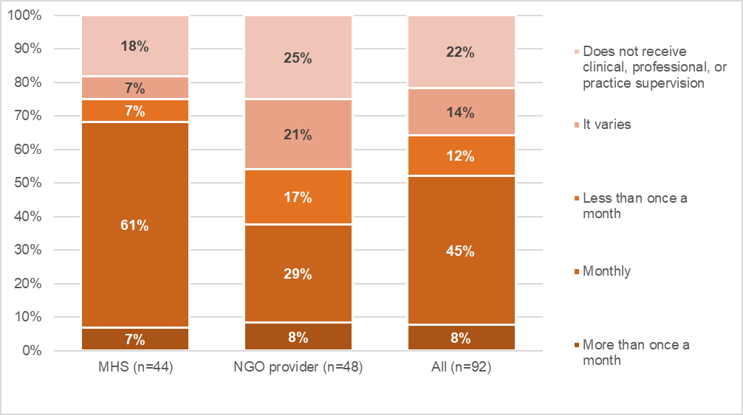
Source: 1800RESPECT Workforce Survey
Figure 8.4 Whether professional, clinical or practice supervision is individual or in a group
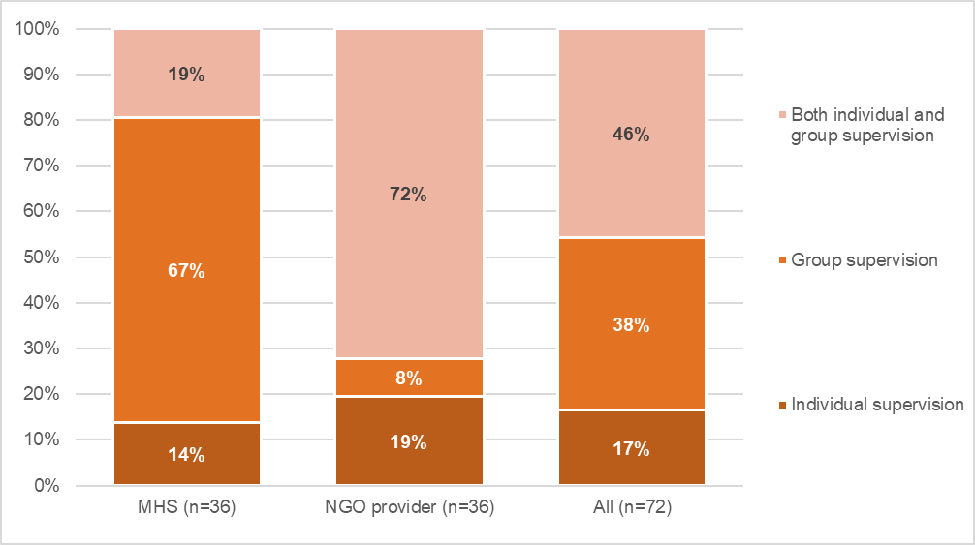
Source: 1800RESPECT Workforce Survey

Figure 8.5 Proportion of who were satisfied or very satisfied with aspects of their supervision
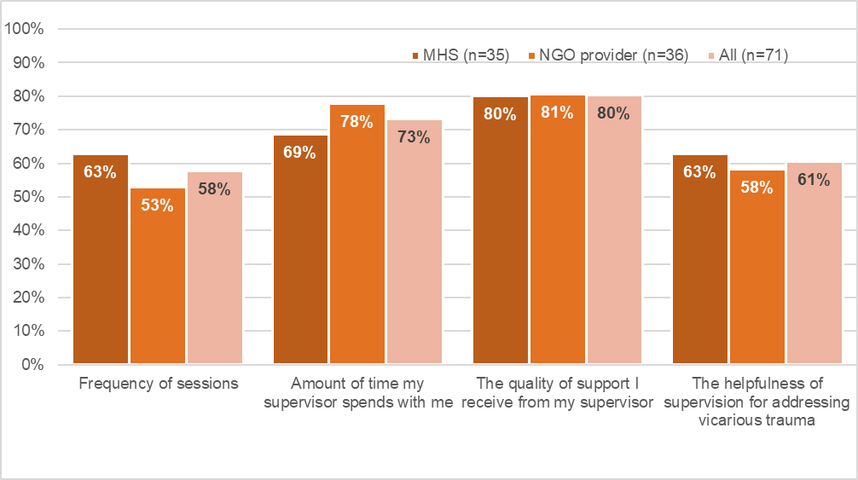
Source: 1800RESPECT Workforce Survey
Figure 8.6 Respondents’ perceptions of support
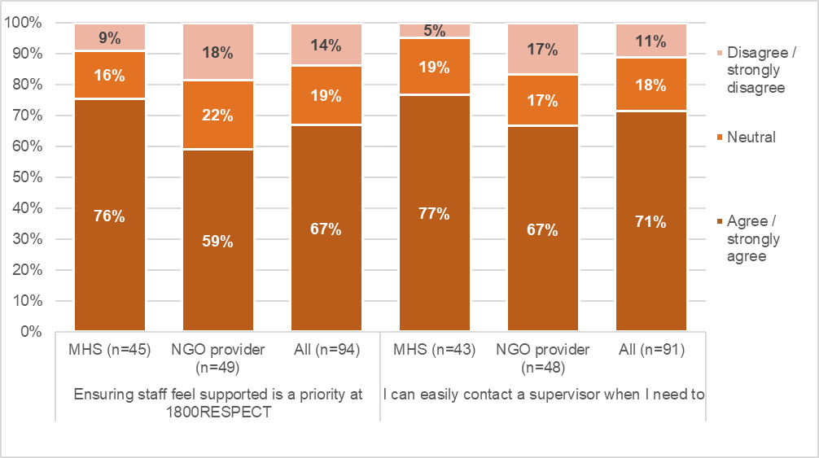
Source: 1800RESPECT Workforce Survey
Some of the comments reflected practitioners’ experiences of receiving high quality supervision, although this was sometimes put down to serendipity in having a good supervisor. Respondents from MHS and NGOs highlighted the high quality of their supervision:
It is excellent, best I have had from any organisation I have worked with. (MHS respondent)
I have been lucky to have a great Supervisor, and Clinical Lead. Both helpful and supportive. I know other counsellors are not so fortunate. (MHS respondent)
My individual supervisor is great. Very supportive on many levels. Not all supervisors are as skilled or helpful. (NGO provider)
[My organisation] is a fantastic organisation to work for as they actively work to buffer the impacts of the work on staff through strong supervision practices, transparent processes and supportive workplace culture. (NGO respondent)
Others had different experiences and made comments that the supervision they received did not fulfil their needs. Some MHS staff noted that they didn’t receive supervision specific to 1800RESPECT, for example:
It is not specific to one line so mixed with all groups, can be helpful or less helpful depending on the mix each month. (MHS respondent)
The focus is most often not on 1800RESPECT as I am on other lines also. (MHS respondent)
Others found group supervision was not available at the times they worked, that the time available was too little and groups too big to allow discussion of issues relating to 1800RESPECT in the depth they felt was needed, for example:
The hours I work are often outside of the group supervision times offered, and when I do attend group supervision, there is not enough time or capacity to go in as deeply as I would like into some of the issues that arise with 1800RESPECT callers. I feel adequately supported by my team to handle my queries/issues on the floor at the time, however I think more specifically focused 1800RESPECT group supervision would be really useful. (MHS respondent)
Some felt individual supervision as well as group supervision was necessary:
I think with the current call volumes (increasing, high demand) on a service that has such impact on myself as a counsellor (regarding the experiences of the callers of abuse/neglect/assault) not much is being done other than being told "we know that call volumes have been crazy, we are working on this through recruitment please take breaks" is not really sufficient. I really think individual supervision is a necessity in this line of work. (MHS respondent)
Some also felt concerned about confidentiality during supervision, and that debriefing could be confused with performance rather than professional development, such that they didn’t feel ‘safe’ to fully participate.
Differing views of the effectiveness of supervision were also expressed during interviews. Some TSCs were very positive about the supervision available:
They encourage us to have private supervision and then we also have coaching. We can also access supervisors, program leaders and ask around if they have another leader that’s on that you can contact. There’s always somebody to have a chat with plus our colleagues around us. It’s quite a supportive environment.
Conversely, some were unhappy with the level of clinical supervision available and felt that staff should be able to access external clinical supervision once a month. One TSC acknowledged that they were fortunate to be able to access six sessions of clinical supervision per year, but she felt so strongly that TSCs needed this on a monthly basis that she paid for her own additional sessions. She also felt that it was inappropriate that direct line managers were providing clinical supervision. These sentiments were shared by another TSC who also reported paying for additional external supervision because she felt that it was inappropriate to be receiving this from her direct line manager:
Just say for instance I had an issue with somebody that I work with who was above me, I wouldn't be able to talk to anybody above me about that. It wouldn’t be appropriate. If that happened, I would have my external supervisor to talk to about that and maybe come up with some strategies.
Many respondents commented that supervision had been cancelled or suspended over the Christmas and New Year period due to staff shortages and high levels of demand, and the need to maintain availability to take calls. This was not seen as acceptable practice, as the busy period meant it was a time staff needed supervision the most. As the examples below show, lack of supervision over the holiday period was mentioned by both MHS and NGO respondents:
During times when the lines are very busy, such as Christmas/NY period and into February, everyone is working on the phones, including all leads and supervisors. At the time we may need support the most, it isn't there. Supervision and coaching schedules are cancelled due to the workload. We're all in the same boat, but counsellors experience a lot of tiredness and at time vicarious trauma, which is not addressed. People can't cope, they resign. (MHS respondent)
I would like more regularly scheduled-in supervision. The fact that Medibank 'cut' our supervision over the December/January holiday period due to short staff, had a huge impact on me personally. The holiday period was one of the most intensive and busiest times in terms of callers, substance use and general fatigue - there is no way that supervision should be de-prioritised when our service demands are increasing. I felt the impacts personally and was experiencing symptoms of vicarious trauma. (MHS respondent)
Access to supervision has not been a priority at 1800RESPECT. Over the holiday period we were not provided with any supervision, at a time when the call volume was highest and the types of calls most complex. (NGO respondent)
Frequency varies a bit with the demands of the service (i.e. busy, short staffed times, supervision is cancelled) and I think supervision should ALWAYS be offered. Also, if group supervision is missed due to being on a call, we are not always given a replacement session. (NGO respondent)
Not enough supervision was a consistent theme in the comments. Respondents explained, for example:
Supervision was not deemed a priority and was discarded for December. In January, we were only offered 30 mins. This is not adequate or responsible practice to debrief or reflect on our professional capacity. (MHS respondent)
I haven't had any form of supervision for 4 months now which is not ideal. (NGO respondent)
Some explained how they sought to respond to inadequate supervision by supplementing the supervision available in their organisation with external supervision:
I believe that six hours clinical supervision per year for those who work in trauma is manifestly inadequate and it is not appropriate for a line supervisor to provide clinical supervision. I pay for any additional supervision I need as well as the out of pocket expenses for each session. (NGO respondent)
In the interviews, MHS management staff appeared to have the impression that TSCs had access to supervision on a more frequent basis than they reported that they had. MHS staff reported that TSCs had access to monthly supervision with a psychologist and fortnightly supervision with their clinical lead. MHS staff also reported that in busy periods professional development opportunities and team meetings were put on hold, but not supervision. Conversely, staff commented that opportunities for supervision are put on hold in periods of high demand. The decision to limit supervision sessions is made by the MHS Workforce Planning team. Clinical leads are informed, and no time is allocated for supervision in the work schedules developed by Workforce Planning. Opportunities for supervision were limited in December, January and into February 2019:
When things get busy, and they’re increasingly getting busy, the MHS-offered support is put on the backburner, really. We haven’t had call coaching scheduled for quite some time. Group supervision has just started up again, late-January, early-February, having been sidelined because of the busyness that they need to have people on phones.
During busy periods when supervision is on hold, clinical leads are advised that supervision or call coaching can be arranged for staff on a case-by-case basis if it is needed, but that it will not be scheduled regularly for all staff. Some staff commented that this is counterintuitive, because staff often require more support during particularly busy periods.
As well as using external supervision to obtain ‘more’ supervision, this was also a strategy used by practitioners to access better quality supervision. This is reflected in the following comments:
The supervision I receive from my external clinical supervisor (which I co fund) is outstanding, the supervision I receive from the group supervisor through the organisation is inadequate - basic support is provided and basic information for example basic counselling skills discussed. (NGO respondent)
I receive individual supervision outside of work which I pay for out of pocket. I think the work we do here is very intense and I need more support. Sometimes I enter group supervision without being able to address my needs because there is so much already on the table that needs to be addressed from others. We have only 1 hour. Yes, I have been working as a counsellor for 15 years now but I still need support. I am affected by the work I do. I am human. (MHS respondent)
NGO respondents explained receiving a subsidy to access six sessions of external clinical supervision each year, although they would prefer 12 to ensure it could be undertaken on a monthly basis. This was seen as more appropriate given the nature of the work and potential for vicarious trauma.

Bullying, harassment, violence or threats
Workers’ reports of exposure to bullying, harassment, violence or threats at work from clients and colleagues also provides insight into their experiences of work-related trauma, the sources of it, and the effectiveness of arrangements in place to prevent it.

1800RESPECT workforce survey
As shown in Figure 8.7, 78% of respondents to the 1800RESPECT workforce survey had experienced bullying, harassment, violence or threats from callers in the last 12 months, and the remaining 22% had not. This was consistent between MHS and NGO providers. However, the proportion of staff delivering 1800RESPECT who reported experiencing bullying harassment, violence or threats from callers in the last year is higher than found in a survey of the wider domestic and family violence and sexual assault workforce (Cortis et al, 2018) which found half (51%) had not experienced bullying, harassment, violence or threats from a client in the last year. This may be explained by the level of contact, that is, the high numbers of clients that staff delivering 1800RESPECT are in contact with in the course of their work, given their delivery of a helpline rather than a face-to-face client load, which would generally involve contact with smaller numbers of clients per hour. In addition, the apparent anonymity of telephone and online modality may provide a distance which enables clients to transgress the usual norms of face-to-face civility.
By contrast, the proportion of staff delivering 1800RESPECT exposed to bullying, harassment, violence or threats from colleagues was similar to those in the wider domestic and family violence sector nationally (see Figure 8.8). In addition, there were large differences between the proportions of MHS and NGO staff who experienced it. Only 9% of MHS respondents reported bullying, harassment, violence or threats from colleagues in the last year, compared with 48% of NGO providers. This may reflect that MHS staff delivering 1800RESPECT have a lower level of contact with colleagues than their NGO counterparts, due to the high proportion of MHS staff working at home.
Figure 8.7 Proportions of 1800RESPECT staff who experienced bullying, harassment, violence or threats from clients
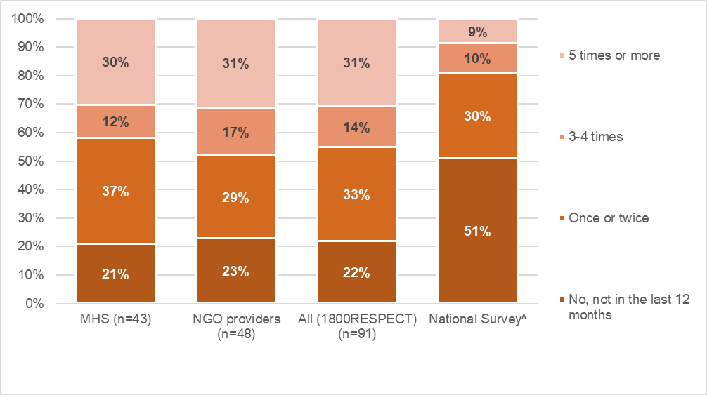
Source: 1800RESPECT Workforce Survey. ^Data drawn from Cortis et al (2018, p. 68). Sample size for National Survey was 1,157.

Figure 8.8 Proportions of 1800RESPECT staff who experienced bullying, harassment, violence or threats from colleagues
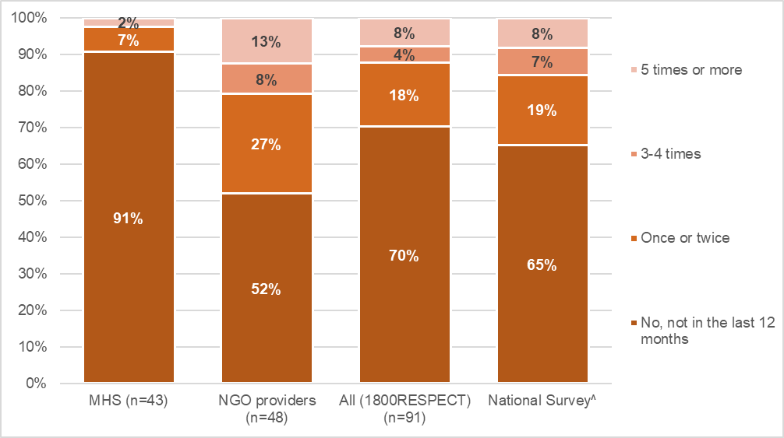
Source: 1800RESPECT Workforce Survey. ^Data drawn from Cortis et al (2018, p. 68). Sample size for National Survey was 1,157.
In the 1800RESPECT workforce survey, practitioners gave more detailed examples of abuse and trauma encountered while delivering 1800RESPECT. Some described how this was very frequent, and the most challenging aspect of their work:
I would argue there is not a fortnight that goes by without some covert or overt abuse from our callers. I find this to be the most challenging aspect of the work, and one that is perhaps not acknowledged as much as it should be. I have never in any previous role (or indeed, any life situation) experienced this level of verbal abuse from clients (and I have worked in retail and hospitality years ago). In a face-to-face setting we may call security under those circumstances, but on a helpline we have to keep picking up the phone and listening to repeat abusive callers which can be very discouraging when you are just trying to help people. (MHS respondent, 1800RESPECT workforce survey)
While the Service Delivery Manual (Medibank, 2017, p 69) indicates 1800RESPECT has a procedure for notifying police of life threatening and unwelcome calls, it does not provide guidance around terminating calls involving lower levels of abuse. It is also reasonable to expect that issues such as this would be discussed and explored in supervision contexts, however, the opportunity to do so may be constrained by the brevity and infrequency of supervision.
In the survey, some practitioners commented that they felt the difficulty of their work was not fully recognised within the community or by MHS, and that there was not sufficient support for workers experiencing abuse as part of their work, including because they had to move quickly onto the next call:
I just don't think the community recognises the work we do. It's not valued as much. It's hard work. We are required to be empathic, establish rapport (in seconds), assess risk, manage needs, and be there for the caller every step of the way. Circumstances can change in the call and new information is provided each moment. This requires us to think on our feet. We hear things that most cannot stomach. We are yelled at and abused. Sometimes we are praised for the work we do. I don't know if there is ever enough support for that. Not in this system. (MHS respondent, 1800RESPECT workforce survey)
This is not a call centre, we are exposed to vicarious trauma daily. I was told that the average number of calls per shift was 4 however there is an expectation that we answer call after call as every minute is recorded and as professionals we should be able to gauge when we are ready to answer a call after a particularly traumatic one. But we are not given that leeway. SC are all very mature, professional and skilled adults sometimes it feels like we are typists or children. (NGO respondent, 1800RESPECT workforce survey)
Difficult work as SC can't prepare themselves for next call, not like face to face and ongoing counselling where you can pace yourself and prepare prior to appointment. Level of complexity to this work in attempting to build a rapport quickly with callers. (NGO respondent, 1800RESPECT workforce survey)

Qualifications, experience requirements and training
The Senate Inquiry recommended that “the 1800RESPECT first response triage service is staffed only by counsellors with a minimum three-year tertiary degree in counselling or equivalent and a demonstrated minimum three years' experience in specialised counselling in family domestic violence and sexual assault counselling and working with clients from diverse backgrounds and locations.”

Qualifications
Among respondents, all but one respondent had a bachelor level degree or higher. As such, staff delivering 1800RESPECT (FR and TSC) appear more likely to be degree qualified than the broader domestic and family violence service sector, in which 66% of workers were estimated to be degree qualified (Cortis et al, 2018 p. 34).
There were high proportions of staff with degree level qualifications among both MHS and NGO workers delivering 1800RESPECT. Among MHS respondents, all said they had a Bachelor degree or higher. Of the 42 MHS respondents who answered the question (three skipped the question), most (60%) had a postgraduate degree. The largest group of MHS staff had qualifications in psychology (38% of MHS respondents), social work (29% of MHS respondents), or community services, youth work or counselling (26% of MHS respondents).
Similarly, all but one respondent from the NGO providers had a bachelor level degree or higher. Of the 52 NGO respondents who answered the question (four did not), 64% had a postgraduate degree. The largest group were qualified in social work (33%), while 19% were qualified in community services, youth work or counselling, and 17% were qualified in psychology.
Data suggests the qualification requirements recommended by the Senate Inquiry are being met. However, the limitations of the survey methodology should be considered and in particular, that survey data is less definitive than human resource data which may be held by services.

Experience
The 1800RESPECT workforce survey collected information about the experience of staff. Staff in the NGO partners had less experience delivering 1800RESPECT compared with those in MHS, to be expected given their relatively recent involvement in the model.
Figure 9.1 shows that very few TSCs had worked on the service for two years or more, whereas this was the case for 31% of MHS staff. However, while many respondents had not been involved with 1800RESPECT for long, they tended to have many more years of experience delivering services to people affected by domestic and family violence and sexual assault (see Figure 9.2). Almost a third of respondents had over 10 years of experience (31%), and a further quarter (25%) had 5–10 years of experience. This was similar among those employed at MHS and in the NGO providers (see Figure 9.2).
Figure 9.1 Time worked at 1800RESPECT, MHS and NGO staff
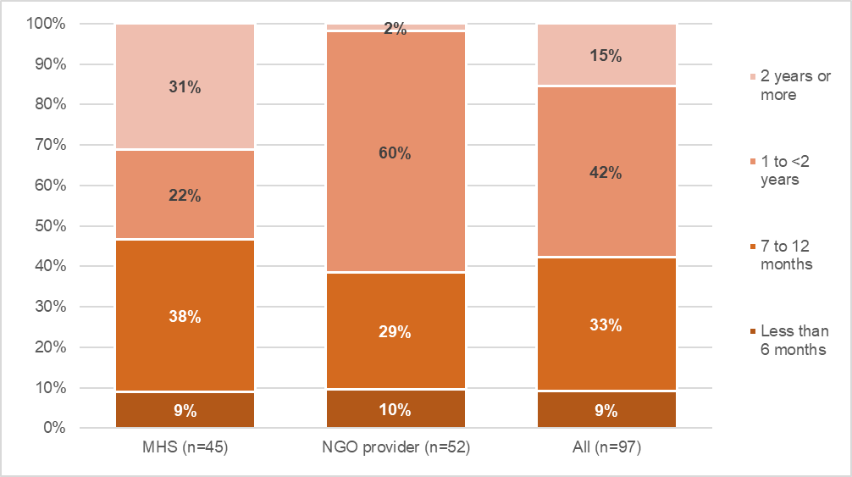
Source: 1800RESPECT Workforce Survey
Figure 9.2 Total years of involvement delivering services to people affected by domestic and family violence and sexual assault, MHS and NGO staff
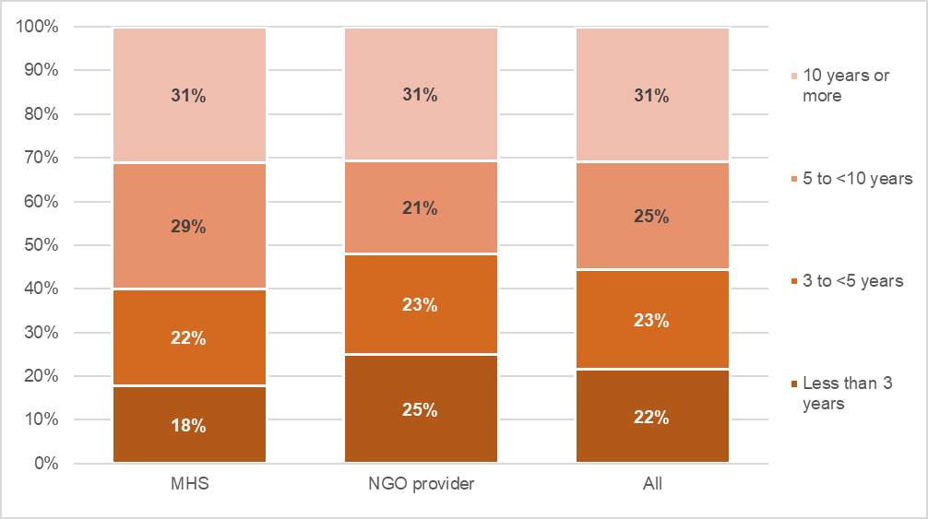
Source: 1800RESPECT Workforce Survey

Recruitment challenges
MHS staff spoke of some of the challenges in recruiting staff to work on the 1800RESPECT line. Factors that narrowed the pool of potential candidates included the 24-hour nature of the service (as it was difficult to recruit for night shifts), the telehealth context and the credential requirements as outlined in the terms of their contract with DSS. MHS and NGO partner managers recognised that they were competing for a limited pool of suitable candidates who had the requisite qualifications and who would be happy working in a telehealth environment and possible/occasional shift work:
I think it's a small pool and I think when we look at experienced qualified counsellors that are interested in doing trauma informed work and shift work, a lot of them I think are interested in face to face work over phone shift work.
Some spoke about how the qualification requirement for staff working on 1800RESPECT was higher than the expectations for individuals working in the wider counselling sector, which they felt made recruiting staff to 1800RESPECT even more challenging. Some felt that there should be greater emphasis on relevant experience, skills and competencies rather than the undergraduate qualification, as is often the case in the wider counselling sector. One felt that the training and ongoing monitoring of staff would provide quality assurance in the event that the qualification requirement was relaxed. Others commented that this was something that still needed to be worked out internally at MHS:
It's going to be an ever-decreasing pool of people that we're going to have access to. So, we just need to be a little bit more flexible as to how that works but obviously then we've still got to work through how that would work internally so it's just talks at this stage.
The option of working from home was recognised as a means to broaden the pool of qualified suitable candidates for the trauma specialist counselling component of the service because it would open up possibilities for candidates in regional and rural locations. MHS reported that a small-scale work from home pilot that they trialled with one of their NGO partners proved very successful and there appeared to be plans to roll this out more widely.
An MHS staff member made the point that if FRCs were expected to hold a tertiary qualification and have three years’ experience, they could perhaps take on a larger counselling role than focusing on the intake role that she currently observed them to do:
I think they could potentially handle more calls to do a bit more of the actual counselling. I think, well if you’re really just doing a first response and passing all counselling to the specialist counsellors, then why do you need that qualified first response people?
She felt that expanding the scope of FRCs’ role would enable them to deal with more calls in their entirety and reduce demand on the TSCs. Doing this, she suggested, would require a 'whole operational redesign'. At the same time, she felt that the requirement that FRCs had a degree in addition to two years’ experience limited the potential recruitment pool and reduced the scalability of the model. She also felt that with this requirement, the bar was set higher for 1800RESPECT counsellors compared to the broader counselling sector. Across the broader domestic and family sector nationally, around 2 in 3 staff are degree qualified, however, figures are not strictly comparable as national data is for a range of activities other than counselling (Cortis et al, 2018, p32). In addition, it should be noted that national figures indicate that 22% of service leaders feel the proportion of degree qualified staff in their service is ‘too low‘, given the nature of the work they do (Cortis et al, 2018, p 85).

Training
Respondents were asked how many days of training they had received in the last 12 months, and their perceptions of the amount of training they received. They were also asked how strongly they agreed or disagreed with statements about training, to capture their experiences of induction, and perceptions of the priority placed on staff learning and development.
Many staff are not receiving regular training. In the survey, 13% of respondents said they received no training in the last 12 months, and 18% saying they received less than one day of training (see Figure 9.3).The proportion receiving less than one day training or no training combined was higher among respondents from MHS (40%) than NGOs (23%). Higher proportions of NGO respondents also received three days or more: this was the case for 44% of NGO respondents compared with 31% of MHS respondents. Although they received less training than those delivering 1800RESPECT in the NGOs, MHS staff were more likely to agree they were receiving the right amount of training (23% compared with 13% of NGO respondents) and less likely to say they received too little (43% compared with 65% of NGO respondents). This is shown in Figure 9.4.
In addition to capturing the amount of training received and perceptions of this, the survey asked about levels of agreement or disagreement with statements about training. Results are shown in. This shows that across MHS and NGO, three quarters of respondents agreed that when they started working at 1800RESPECT, they received appropriate induction and training (76%). Perspectives were more mixed on whether 1800RESPECT prioritised training and development. Only half agreed that staff learning and development is a priority, and 19% disagreed. This differed for MHS and NGO respondents: whereas 60% of NGO respondents agreed and 16% disagreed, among NGOs, 41% agreed, and 22% disagreed. For both groups, substantial proportions were neutral on this measure (24% of MHS respondents and 37% of NGO respondents).

Figure 9.3 Days of training received in the last 12 months, as part of role at 1800RESPECT
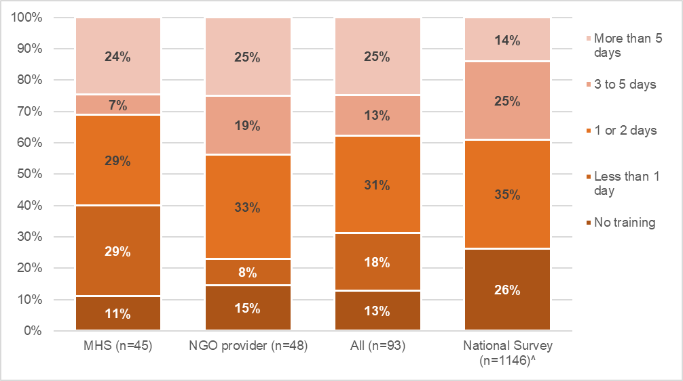
Source: 1800RESPECT Workforce Survey. ^Note that National Survey did not offer the category ‘less than 1 day’.
Figure 9.4 Staff perceptions on the amount of training
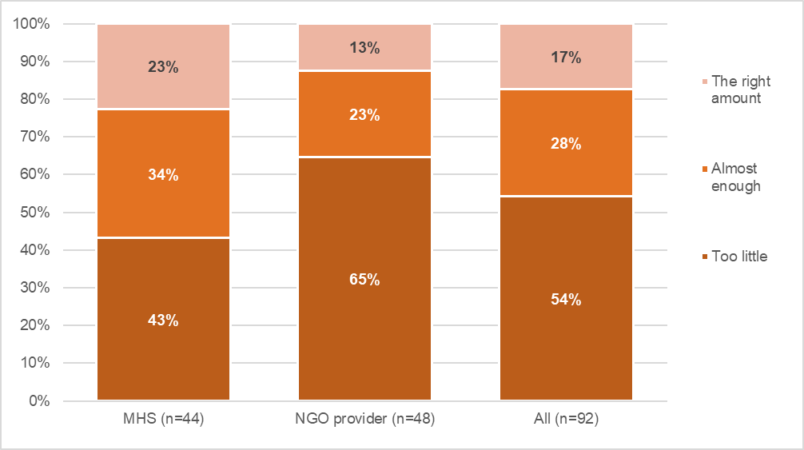
Source: 1800RESPECT Workforce Survey

Figure 9.5 Respondents’ agreement with statements about training
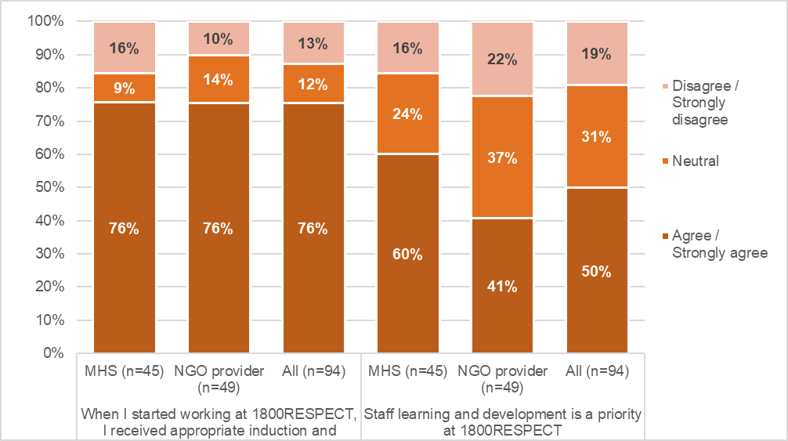
Source: 1800RESPECT Workforce Survey
The survey asked for comments about training. Some had positive experiences:
I enjoy training and find it very valuable-always learning new information and ways to assist and new services for referrals. (MHS respondent)
However, more often respondents’ comments outlined issues related to a lack of access, or poor-quality training. Some noted that access to training was impeded as it was difficult to obtain time away from their usual role, due to staffing levels. Access was particularly difficult for those working evening shifts, and a few commented that there was not a transparent, equitable process for allocation developmental opportunities in their organisation.
Many pointed to the need for more face to face training rather than virtual training, which was described as rushed and stressful, and some comments noted the move to online training was going to be difficult, and further reduced time to talk with colleagues. Some said that in their experience, there had not been sufficient opportunity to discuss the material received through training or to integrate it deeply into their work:
Training is on line and rushed, just ticking boxes, so opportunity to discuss and let it sink in before jumping back on the phone. (MHS respondent)
Trauma informed training was excellent. However, I had no computer training or specialised interventions training or written materials on my first day at work. I was immediately just put on the phones. (NGO respondent)
Others noted their use of their own resources (time and financial) to travel to undertake training. A respondent from MHS described being “cross trained from another line” and as a result received less comprehensive training than peers, which lacked some practical elements. Other comments related to the appropriateness of the training to the unique context of service delivery at 1800RESPECT or to telehealth settings more generally.
In terms of the training or models of training that staff thought should be prioritised, some mentioned the need for an individualised program focused on the needs of each practitioner, in house training which staff could attend within work hours (recognising the needs of shift workers), and specific training, such as training related to:
- legal issues such as apprehended violence orders (AVOs) and domestic violence orders, intervention orders and parenting plans
- complex trauma including adult survivors of CSA and older women disclosing for the first time
- mental health and suicide
- people with disabilities
- cultural appropriateness for CALD populations and Aboriginal and Torres Strait Islander people
- LGBTQI people
- cyber abuse
- children who perpetrate abuse and violence towards parents
- working with men
- working with perpetrators, and
- how to manage abusive callers and regular callers who are out of the scope of the service.
Through all of these suggestions, many underlined their need for face-to-face training that provides opportunities for discussion with peers. One MHS staff pointed out the need for specific training related to DV, such as visits to local refuges, or training specific to AVOs or the family court.

Interviews with staff delivering 1800RESPECT

MHS staff reported that staff delivering 1800RESPECT have access to an education assistance allowance, which can be used for external seminars or courses, or skill development, and that they can access study leave towards. MHS staff also reported that they were working with Blue Knot to develop additional face to face and online professional training opportunities. NGO partner staff reported being involved in the development of training and online induction models with MHS, with the virtual training designed with a work at home workforce in mind. NGO partner managers were pleased with the development of the online training as it would allow staff to undertake it individually as they joined the organisation.
Comments from MHS managerial staff presented a very positive picture of their opportunities for professional development, whereas comments from NGO partner staff presented a very mixed picture. On the one hand, several TSCs reported undertaking training or enrolling in professional development courses. One TSC reported undertaking training about working with callers from Indigenous and LGBTQI communities and with women in rural communities, which she found very useful. Other TSCs reported enrolling in or attending professional training opportunities. On the other hand, some TSCs reported that they did not have any professional development opportunities, while another reported that they were not provided with sufficient funds or time to undertake professional development.
One of the key challenges with respect to offering staff professional development and training opportunities identified by NGO partner managers related to finding the time given the levels of demand:
If we were to take our team off the phone lines for a day to do some professional development, then the other partners would need to pick up those shifts, so that’s a real challenge. It’s not only those shifts that they would need to pick up, but it’s also what that then means in relation for the entirety of shifts, the day before and after, because people need to have breaks between shifts and all that sort of stuff. It becomes complicated from a rostering perspective, but I think it’s really important and I think all of the partners and Medibank working together to really firm up and finalise some agreement on how regularly partners would have professional development at a local level is really important.
Some NGO partner managers also felt that they should be able to access more than two days per year of professional development and had identified a list of issues they wanted to see covered in professional development.
I think members of the public might be surprised to know that as the national specialist service, we only have one or two days of professional development over a 12-month period. To me, the acceptability of training and development is not commensurate with the responsibility that we have by making sure our knowledge is the most accurate, the closest to best practice and the most relevant as what it possibly can be.

Concluding discussion
This evaluation of the 1800RESPECT service was guided by several evaluation questions set by the Department of Social Services. This section discusses the key findings and highlights issues requiring further consideration. Taken together, the evaluation findings highlight many strengths of the 1800RESPECT service and that the service is fulfilling its brief specified by National Outcome 4 of the National Plan to Reduce Violence against Women and their Children 2010–2022, that “services meet the needs of women and their children experiencing violence”. The evaluation findings also raise further questions about the operation of the service and “procurement and accountability issues” as noted by the Senate Inquiry.
Overall, the evaluation found that the 1800RESPECT service is considered by callers, MHS and NGO partners, and stakeholders to be an effective service, primarily because it offers quality counselling and is able to demonstrate increased accessibility over the previous arrangement (see sections 4.1, 4.2, 4.3, 0). However, several factors affecting service effectiveness were identified. These related to how the 1800RESPECT service manages repeat callers with complex presentations (see section 5.1), limitations on the service’s national reach (see section 5.2) , and the efficacy of providing call backs (see section 5.3).
The evaluation also highlighted a number of issues of concern with respect to the operation of the 1800RESPECT service. An unexpected finding was that many of the staff employed by MHS to work on the 1800RESPECT line are drawn from the MHS Mental Health Counselling Team which works across several helplines managed by MHS. This means that, over the course of a shift, FRCs are answering calls to different lines. Working across phone lines may restrict capacity for FRCs to specialise in providing domestic violence support and may compromise their ability to determine the appropriate response. It may explain some inappropriate referrals to TSCs (suicidal and out of scope callers) (see section 5.1.1) and to state-based DV crisis lines (requiring a police alert rather than a transfer) (see section 5.4). Working across telephone helplines also impacts on the supervision counselling staff receive. Comments in the 1800RESPECT workforce survey indicated that some MHS staff did not feel they were receiving sufficient 1800RESPECT-specific supervision (see section 8.3). Given the scale of its operations and the multiple telehealth services it operates, MHS staff emphasised their ability to leverage the wider MHS infrastructure to 1800RESPECT’s advantage, because costs are shared across services and not all borne by 1800RESPECT. However, the quality of 1800RESPECT service delivery may also be compromised by these arrangements.
Any reconfiguration of the model should prioritise strategies to maintain quality standards while alleviating pressure on the system overall. The evaluation has noted some risks associated with the unit-based funding model (see section 6.4.3), which provides funding per contact regardless of the duration of each episode. As well as risking escalation of costs in a context of growing demand, arrangements also call for external verification of call data, costing and forecasting methodology, to improve transparency and better account for likely upward trends in expenditure. The evaluation also notes the need to develop more effective responses to callers with complex presentations using the service but whose needs may be better or additionally met, through other intervention models offered by other services rather than a single session model.
Findings with respect to each evaluation question are summarised below.

1800RESPECT service effectiveness
The key factors that callers and staff identified as contributing to service effectiveness were: the quality counselling provided (trauma and DFV informed), it was accessible (24 hours a day, seven days a week, by phone), it was free, and callers could remain anonymous (section 4.2).
The small sample of callers (n=12) interviewed for the evaluation were overwhelmingly positive about their engagement with the 1800RESPECT service (see section 4.1). The callers considered the service to be a vital source of support, and many credited it with saving their life. Callers valued the counsellors’ expertise, empathy, understanding, respect, care and non-judgemental approach. Many had accessed other phone-based counselling services and felt that the 1800RESPECT service was far superior. Caller criticisms of the service were limited.
Staff delivering 1800RESPECT felt that the work they did made a difference and they were confident in the service they were providing (section 4.2). Sector confidence and awareness in the service was also found to be high and MHS’ engagement with the sector was highly regarded, particularly with the disability sector (section 4.3). Feedback from the sector also highlighted some areas for improvement, including the need for more or improved referrals from 1800RESPECT and the need for improved knowledge of local services (see section 4.5.1). Feedback also identified that the website was out of date lessening its effectiveness for clients wanting to source their own referral options.
The service was regarded as being appropriate for diverse groups including young people, people with disability, people of different religions, people of different sexual orientation or identity (see section 4.4). A key factor identified as limiting service effectiveness was the lack of appropriate strategies for responding to repeat callers with complex presentations (see section 5.1.1). It was reported that a relatively small proportion of callers account for a significant number of calls to the 1800RESPECT service and are a factor driving demand for the service. Indeed, program data indicates that the proportion of callers using 1800RESPECT for the first time has fallen since Q1 2017–18, with around 16% of callers having called five times or more, and 9% having used the service 10 times or more in Q1 2018–19 (see section 6.2.1).
Some of the callers interviewed identified themselves as repeat callers. Many of these callers had complex presentations that included DFV or SA at some stage in their lives, but many also had mental health problems that the single session counselling offered through 1800RESPECT was not capable of addressing. While MHS managers reported that there was a range of strategies to address these callers with complex presentations, counselling staff did not feel that they were being adequately supported to manage these calls with supervision and immediate debriefing. Three suggested strategies for managing these callers included offering callers counselling on a weekly basis; providing face to face counselling opportunities; and using the First Response point of contact to undertake needs assessments, redirect callers to more appropriate services (see section 5.1.1) or that FRCs should undertake a more substantial counselling role (see section 9.3). With demand for the service increasing, this is an issue that requires an urgent response. However, it should be recognised that frequent calling has also been noted in other helpline services such as Lifeline. Consideration should be given to whether a similar model as proposed by Pirkis and colleagues (2015, 2016) should be implemented for the 1800RESPECT service to manage repeat callers (see section 6.4.4.)
It must also, be recognised, however, that 1800RESPECT service demand is driven in large part by a lack of access to alternative services and supports – unless mental health and state-based DV and SA crisis lines and supports are better funded, demand will continue to grow. It is also important to recognise the extent to which 1800RESPECT is provided in trigger warnings as a referral option across various media and in training/education. At times, this may be known to MHS and at other times not, which affects service planning.
Other factors limiting service effectiveness related to the national reach of the service, given knowledge gaps about services available and actual service gaps in some jurisdictions and that it was difficult to integrate 1800RESPECT responses with different jurisdictional requirements. Limited knowledge about the services available in some jurisdictions affected counsellors’ confidence in making appropriate referrals in other jurisdictions and may be reflected in the data by the very, very small number of calls transferred to state-based services reported in the program data (as shown in Figure 6.11). The low number of referrals to state based services could also be a driver of repeat callers. It is likely that the limited national reach is related to the location of the counselling staff, with the TSCs operating out of Queensland, Victoria and South Australia. Partnering with a provider in each jurisdiction could improve this.

Appropriateness of funding arrangements
The 1800RESPECT service model operates on a cost per contact basis and MHS uses a forecasting formula to predict the number of contacts expected in the next 3-month period. The research team was unable to access information about the assumptions underpinning the formula used by MHS to set unit costs or to forecast demand (section 6.4). Key issues identified include:
- Operating on a cost per call basis involves financial risks for DSS. Service delivery costs will continue to grow as demand for the service reportedly increases.
- In the current climate, where awareness of DFV and SA has grown significantly (see section 1.1.1), it is likely that service demand will continue to increase. If service usage shifts from telephone to online contact, the high relative rate paid for online contact and the longer period of time per contact compared with telephone First Response could cause further cost escalation.
- Better understanding of the drivers of service usage are needed, along with analysis of ways to alleviate growing pressure on the service, such as ways to coordinate with other helplines or share the costs of service delivery.
- The high rate of call transfers from FRCs to TSCs is also a source of pressure on the service and may require further consideration of the equity of a flat call rate and whether calls are being put through to TSCs to relieve pressure on FRCs who are working across other MHS telephone help lines.
- Current funding arrangements do not account for variation in call contact times. While some contacts are very short, average time for first response is 13 minutes and for trauma specialist counselling is around 48 minutes (Figure 6.5). A tiered cost structure could involve different rates for types of inquiries or categories of client need or could set more varied funding arrangements for calls of different durations.
- Under the service agreement, payment arrangements rely in part on MHS forecasts. However, there is a lack of transparency and the full methodology used for forecasting has not been provided to the evaluation team or department.
- Alternatives to a ‘cost per call’ operating model include tiered cost per contact model, which better takes account of call time, block funding based on allocation of full time equivalent staff to the service, and restructuring of the governance arrangements for the service, for example constituting it as a government enterprise, perhaps in partnerships with the states and territories to ensure coordination with state services and a diversified funding base.

Appropriateness of work from home practices
The majority of FRCs worked from home, while the majority of TSCs worked in their organisation’s office space. From an MHS perspective, enabling staff to work from home was considered to be an important strategy for attracting and retaining qualified staff, particularly in the context of the 1800RESPECT line operating 24 hours a day, seven days a week. MHS managers and the FRCs interviewed presented a very favourable picture of working from home arrangements, with an emphasis on the MHS IT infrastructure and the agreements, policies and practices that had to be followed (see section 7). Yet in the survey, the FRCs identified pros and cons to working from home – pros related to the convenience, while cons included occasional challenges accessing technical support and a need for more supervision and de-briefing. The partner organisations delivering the trauma specialist counselling reported that they made a conscious decision at contract commencement that staff should work in the service’s office, on the basis it facilitated staff access to supervision and de-briefing and thereby better addressing the possibility of vicarious trauma.
More recently, working from home has been trialled with one of the partner organisations delivering the trauma specialist counselling and may be rolled out more widely in the coming months. Levels of support accessible to staff working at home, and the wellbeing outcomes for staff working under these arrangements should be closely monitored, given the previous recommendation by the Senate Committee that practices of working from home among FRCs cease. It would be preferable that such monitoring moved beyond self-report by the counsellors and involved some greater assessment by clinical supervisors during regular supervision and de-briefing sessions.

Effectiveness of practices and procedures for preventing vicarious trauma
The survey findings showed that almost half of the FRCs and TSCs reported feeling emotionally drained by their work and a quarter reported feeling overwhelmed by their workload, which likely reflects the increasing demand for the service (see section 8.2). TSCs reported higher levels of adversity at work than FRCs which is likely a reflection of the nature of the work that they do, with the TSCs having more intensive interactions with callers than the FRCs. In this context, supervision and support to manage vicarious trauma is critical.
While 1800RESPECT is covered by MHS’ Clinical Supervision Framework, some staff reported that it is not easy to contact supervisors especially at certain times, and many felt the supervision via group teleconferencing available to them was inadequate. Further, several reported that supervision had been cancelled or suspended during peak times. This was the case over the Christmas/New Year period, when it was used as a strategy to maintain staff numbers on the phone lines, arguably despite greater counsellor need for debriefing and support during this period.

Comparison of FRC qualifications, experience requirements and training with industry standards
Staff delivering 1800RESPECT are more qualified than the broader domestic and family violence sector, however, any comparison needs to take into account the nature of roles, and that nationally, many service leaders feel qualification levels in the broader sector are too low (see section 9). They are also highly experienced. Almost a third of survey respondents had over 10 years of experience, and a further quarter had 5–10 years of experience, a figure which was similar across MHS and NGO staff. MHS staff felt that recruitment was challenging as the pool of potential candidates was narrowed by credential requirements, the 24-hour nature of the service and the telehealth context. However, others felt there should be greater emphasis on relevant experience, skills and capabilities, or that the expertise of first response staff could be better utilised, interpreting increased call rates of transfer to TSCs as indicative of underutilisation of qualified first response staff. There is also room to improve training, with many receiving only small amounts of training or lacking access altogether (see section 9.4).

Conclusion
As noted in section 1.1 the establishment of the 1800RESPECT service was a response to the National Council’s recommendation 3.3.1 to establish a national service telephone and online crisis support service for anyone in Australia who has experienced, or is at risk of, sexual assault and/or domestic and family violence. For the most part, the1800RESPECT service appears to be fulfilling this remit effectively and the increase in usage of the service demonstrates ongoing need and suggests that for many callers the service has been experienced as effective. However, the evaluation has highlighted concerns about transparency and risks of escalating costs relating to funding the service on a payment-per-contact basis in a context of increasing demand. There is a need to consider ways to alleviate pressure on the service, including managing differently the high numbers of repeat callers with complex presentations. Better integration and coordination with state/territory and local services is needed, with a view to providing more appropriate referral pathways.

References
Australian Government. (2011). National Plan to Reduce Violence against Women and their Children 2010‐2022. Retrieved from: https://www.dss.gov.au/sites/default/files/documents/08_2014/national_plan1.pdf
Ayre, J., Lum On, M., Webster, K., Gourley, M., & Moon, L. (2016). Examination of the burden of disease of intimate partner violence against women in 2011: Final report (ANROWS Horizons, 06/2016). Sydney, NSW: ANROWS.
Baulch, M., & Goldsmith, E. (2015). ‘Young people, domestic & family violence’. Paper presented at the YFoundations Recharge Conference, Sydney, 6 August 2015.
Campbell, J. C. (2002). Health consequences of intimate partner violence. The Lancet, 359 (9314), 1331-1336.
Caputi, T.L., Nobles, A.L., and Ayers, J. W. (2019). Internet Searches for Sexual Harassment and Assault, Reporting, and Training Since the #MeToo Movement. JAMA Internal Medicine, Volume 179, Number 2, pp. 258-259.
Cortis, N., Blaxland, M., Breckenridge, J., valentine, k. Mahoney, N., Chung, D., Cordier, R., Chen, Y., and Green, D. (2018). National Survey of Workers in the Domestic, Family and Sexual Violence Sectors (SPRC Report 5/2018). Sydney: Social Policy Research Centre and Gendered Violence Research Network, UNSW Sydney. http://doi.org/10.26190/5b5ab1c0e110f
Department of Social Services (DSS) (2017). Submission to the Senate Inquiry into the Delivery of National Outcome 4 of the National Plan to Reduce Violence Against Women and Their Children 2010-2022. Canberra: DSS.
Ewen, V., Mushquash, A.R., Mushquash, C.J., Bailey, S.K., Haggarty, J.M, Stones, M.J. (2018). ‘Single-session therapy in outpatient mental health services: Examining the effect on mental health symptoms and functioning’, Social Work in Mental Health, 16:5, 573-589.
Hymmen, P., Stalker, C.A., & Cait, C. (2013) The case for single-session therapy: Does the empirical evidence support the increased prevalence of this service delivery model?, Journal of Mental Health, 22:1, 60-71.
KPMG (2016). Options to enhance the 1800RESPECT Operating Model. Final report revised for Department of Social Services.
Lawrence, L. (2019). ‘The national domestic violence hotline impact report shows 2018 was a record-setting year for the organization’. Hispanic PR Wire, June 19, retrieved from https://search.proquest.com/docview/2242894083?accountid=12763.
MHS (2019). Quarterly report. 1 October – 31 December 2018. Medibank Health Solutions, Sydney.
Middleton, A., Gunn, J., Bassilios, B. and Pirkis, J. (2014). Systematic review of research into frequent callers to crisis helplines. Journal of Telemedicine and Telecare, Vol. 20(2), 89–98.
Moore, S. E., Scott, J. G., Ferrari, A. J., Mills, R., Dunne, M. P., Erskine, H. E., . . . Whiteford, H. A. (2015). Burden attributable to child maltreatment in Australia. Child abuse & neglect, 48, 208-220.
National Council to Reduce Violence against Women and their Children (NCRVWA) (2009). Time for Action: The National Council's Plan for Australia to Reduce Violence against Women and their Children 2009–2021 - A Snapshot. Canberra: Australian Government.
National Domestic Violence Hotline (NDVH) (2018). A Year of Impact: National Domestic Violence Hotline and loveisrespect. Austin, Texas: NDVH Annual Impact Report. NDVH
O'Neill, I. (2017), What's in a name? Clients’ experiences of single session therapy. Journal of Family Therapy, 39: 63-79.
Pirkis J, Middleton A, Bassilios B, Harris M, Spittal M, Fedszyn I, Chondros P, Gunn J. (2015), Frequent callers to Lifeline. Melbourne: University of Melbourne; 2015.
Pirkis J, Middleton A, Bassilios B, Harris M, Spittal M, Fedszyn I, Chondros P, Gunn J (2016), Frequent callers to telephone helplines: new evidence and a new service model. International Journal of Mental Health Systems, 10:43.
Rape Crisis England and Wales (2018). Trustees’ Annual Report and Financial Statements for the year ended 31 March 2018. Leeds: Rape Crisis England and Wales.
Refuge (2018). Annual Report and Financial Statements 2017/2018. London: Refuge.
Rotenberg, C.& Cotter, A. (2018). Police-reported sexual assaults in Canada before and after #MeToo, 2016 and 2017. The Canadian Centre for Justice Statistics. Catalogue no. 85-002-X ISSN 1209-6393. Ottawa: Statistics Canada.
Sanderson, M., Allen, P., Gill, R. and Garnett, E. (2018). New Models of Contracting in the Public Sector: A Review of Alliance Contracting, Prime Contracting and Outcome‐based Contracting Literature. Social Policy & Administration, Vol. 52, (5), pp. 1060-1083.
valentine k, Breckenridge J, (2016) Responses to family and domestic violence: supporting women?, Griffith Law Review, Vol. 25, pp. 30 - 44.

Summary of respondent characteristics, 1800RESPECT workforce survey
Appendix Table 1 Summary of respondents’ experience and work characteristics
 | MHS |  | NGO providers |  | All
 | n | % | n | % | n | %
Years of relevant experience
Less than 1 year | 1 | 2.2 | 0 | 0 | 1 | 1.0
1 to <3 years | 7 | 15.6 | 13 | 25.0 | 20 | 20.6
3 to <5 years | 10 | 22.2 | 12 | 23.1 | 22 | 22.7
5 to <10 years | 13 | 28.9 | 11 | 21.2 | 24 | 24.7
10 to <20 years | 11 | 24.4 | 9 | 17.3 | 20 | 20.6
20 years or more | 3 | 6.7 | 7 | 13.5 | 10 | 10.3
All | 45 | 100 | 52 | 100 | 97 | 100
Years working for 1800RESPECT
6 months or less | 4 | 8.9 | 5 | 9.6 | 9 | 9.3
7 to 12 months | 17 | 37.8 | 15 | 28.8 | 32 | 33.0
1 to <2 years | 10 | 22.2 | 31 | 59.6 | 41 | 42.3
2 years or more | 14 | 31.1 |  | 1.9 | 15 | 15.4
All | 45 | 100 | 52 | 100 | 97 | 100
Hours worked for 1800RESPECT each week
15 hours or less | 6 | 13.3 | 8 | 15.7 | 14 | 14.6
16 to 34 hours | 30 | 66.7 | 32 | 62.7 | 62 | 64.6
35 hours or more | 9 | 20.0 | 11 | 21.6 | 20 | 20.8
All | 45 | 100 | 52 | 100 | 97 | 100
Contract type
Permanent | 36 | 80 | 20 | 39.2 | 56 | 58.3
Fixed term | 7 | 15.6 | 30 | 58.8 | 37 | 38.5
Casual | 2 | 4.4 | 1 | 2.0 | 3 | 3.1
All | 45 | 100 | 52 | 100 | 97 | 100
Works on other services or programs
Also works on other services or programs | 30 | 66.7 | 4 | 7.8 | 34 | 35.4
Only works on 1800RESPECT | 15 | 33.3 | 47 | 92.2 | 62 | 64.6
All | 45 | 100 | 51 | 100 | 96 | 100
Note: Totals may be less than 97 due to item non-response.

Appendix Table 2 Summary of respondents’ demographic characteristics
 | MHS |  | NGO providers |  | All
 | n | % | n | % | n | %
Gender
Female | 42 | 93.3 | 47 | 90.4 | 89 | 91.7
Male / Other identity / Prefer not to say | 3 | 6.7 | 5 | 9.6 | 8 | 8.3
All | 45 | 100 | 52 | 100 | 97 | 100
Age
25 to 34 | 6 | 14.3 | 13 | 27.7 | 19 | 21.3
35 to 44 | 19 | 45.2 | 12 | 25.5 | 31 | 34.8
45 to 54 | 9 | 21.4 | 15 | 31.9 | 24 | 27.0
55 and over | 8 | 19.0 | 7 | 14.9 | 15 | 16.8
All | 42 | 100 | 47 | 100 | 89 | 100
Other characteristics
Person who speaks a language other than English at home | 10 | 22.2 | 10 | 19.2 | 20 | 20.6
Person with carer responsibilities | 10 | 22.2 | 8 | 15.4 | 18 | 18.6
Person with lived experience of domestic violence | 11 | 24.4 | 19 | 36.5 | 30 | 30.9
Note: Totals may be less than 97 due to item non-response.

Summary of respondent characteristics, sector survey
Appendix Table 3 Frequency of contact respondents had with 1800RESPECT by telephone and web
 | Telephone contact |  | Access the 1800RESPECT website
 | n | % | n | %
More often than fortnightly | 3 | 5% | 6 | 10%
Every fortnight or so | 7 | 12% | 5 | 9%
Approximately once a month | 2 | 3% | 6 | 10%
Less often | 10 | 17% | 20 | 34%
I don't have contact with 1800RESPECT in this way | 36 | 62% | 21 | 36%
Total | 58 | 100% | 58 | 100%

Comparison with other services
Appendix Table 4
 | Lifeline | Blue Knot | Kids Helpline | Reach Out | DV Connect (Womensline, Mensline) | Safesteps | Rape and Sexual Abuse helpline (Rape Crisis England & Wales)
Costs | $11,844,145 allocated to phone line; $1,123,934 to online chat (FY18)  Cost of taking a call estimated at $39, including the hourly value of contributions of volunteer time. | Unknown | In 2017, Kids Helpline cost $12.3 million to operate. | Costs close to $8 million (2016-2017). Aims to increase funding and capacity of the service (to $12 million) | The QLD govt provides $34.6 million for state-wide services including DV Connect (unclear how much is for state helpline service) (KPMG, 2016) | Unknown
Funding | Mix of government funding, community donations and fundraising, corporate sponsorship. | Mix of government funding, grants, donations, fundraising, funds from training programs, membership. | Fundraising, federal and state governments; corporate partner sponsorships and donors, trusts or other supporters. | Government grants; donations; non-government grants; interest income; consultancy and other income. | QLD Government | Unknown | Funding from grants and donations. The national Rape & Sexual Abuse helpline does not receive any significant funding from national government.
Evidence of cost efficiency | 41% of calls answered within 90 seconds. Average call duration 14.6 minutes.  Immediate return on investment estimated at $2.92 for every dollar spent. Federal Government contributes $15.5 million, quantifiable value to the community is $45.3m (Lifeline, 2019, p15)  2014 data indicates that every dollar invested in Online Crisis Support, there is a ‘return’ to the Australian community of $8.40 (the ratio falls in a range of $7.40 and $9.40) | Unknown | Over the last decade web chat sessions averaged 39 minutes compared to 8 minutes for phone sessions. | Unknown | Unknown | Unknown
Demand | 893,128 calls received and 82% answered. 62,400 chat requests made, 39,707 conversations via online crisis support chat engaged in.  No projections publicly available. Annual reports suggest increasing number of calls and online chats but level of growth in demand is not specified.  Approximately 160,000 calls went unanswered in FY18. There were almost 2,500 calls per day to telephone line. | Helpline provided over 5,000 occasions of service to callers, most are survivors of childhood trauma, also family members, friends, professionals. Also had almost 5000 attendees at 270 training days and provided consultancy and supervision.  Signs of increased demand from older people with complex trauma. | 2017- 154,868 contacts (108,160 phone, 34,401 web chat, 12,307 email).  On average, a child or young person makes contact with the Kids Helpline counselling and support service about every 88 seconds. In 2017, overall response rate dipped to 46% as they focused on the web chat service. | Accessed by 132,000 people in Australia every month. Young people spent 782,000 minutes on the forums according to the 2016-2017 annual report.  Service is primarily the website and forums, rather than phone or web-based counselling. | 2017-18: 98174 calls received through state phone line services Womensline and Service Line. Also 14,860 requests for service (phone calls and referrals) through Mensline. 237 pets were provided with safe accommodation. 145,503 outgoing calls were made for safety arrangements.  The number of calls roughly doubled in five years. | 2017/18 again saw a sharp spike in the number of calls made to the 24/7 Family Violence Response Line – climbing to 104,189 for the year – a jump of 14%.  14% growth from 2016-17 to 2017-18.  131% increase from 2012-13 to 2016-17. | In 2017-18, Rape Crisis specialist services were accessed by 78,461 individuals - an increase of 17% from 2016-17.  At end of FY18, 6300 people were waiting to access support, with waiting lists for counselling ranging from 3 to 14 months.  High demand from people with complex trauma. 42% were adult survivors of child sexual abuse. 29% were people with a disability. There were increases in service usage by people aged 15 or under.
Managing demand | Operating hours for online chat reduced from 7pm-4am to 7pm-12am during FY18, due to resource constraints. This reduced chat answer rate from 87% to 64%.  Trialing SMS crisis support.  Low cost of training volunteers (estimated at $4000 per volunteer) suggests low barriers to expanding the service, and responsiveness | Unknown | Web sessions increased from 2009-2015 then decreased 2015-2016 then increased again 2016-2017. The decrease was believed to be due to technical issues, rather than a decrease in demand.  Focused on web chat service in 2017, which resulted in an increase in meeting demand. However, decrease in meeting demand for the phone counselling service. | Unknown | Very high increase in calls to DVConnect from Oct 2014, particularly Womensline, which went from receiving 100-150 calls a day to 200-250 calls a day with some days reaching into 300. This came very suddenly. The DVConnect board made the decision to recruit more staff which was done immediately using all available resources. The department subsequently provided extra funding to help maintain extra staffing level for two years. | Unknown | All frontline sexual violence and abuse services have seen an unprecedented rise in demand in recent years, which shows no sign of slowing. A number of Centres have had to close their waiting lists. Funding has not kept pace with rising demand.
Staffing | Nationally, Lifeline has around 1,000 paid staff and an estimated 10,000 volunteers (including 4,000 Crisis Supporters) operating from Lifeline offices and 40 Lifeline Centres across Australia. National Volunteer Standards and Best Practice Guidelines do not specify minimum qualifications/ experience for volunteers, but do specify that employees who have direct involvement with volunteers have ‘relevant’ qualifications/ experience. | Staff employed at Blue Knot have relevant qualifications, such as in psychology and social work.  Helpline staff are referred to as ‘specialist trauma counsellors’ but does not specify their qualifications. | Staff are required to undergo mandatory training on mental health, and there is ongoing specialist training. Over time, they have also required counsellors to achieve relevant tertiary qualifications. | Unknown | Unknown | Unknown

1800RESPECT call management process
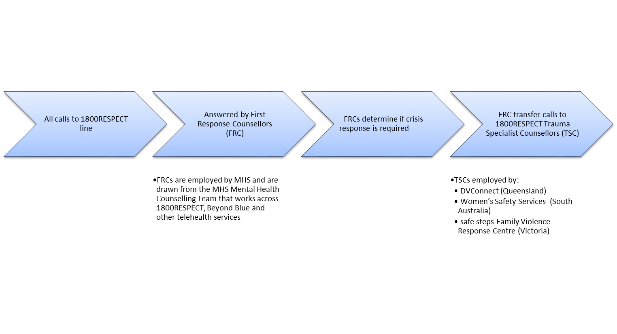

PROGRAM LOGIC FOR 1800RESPECT
Program Need: One in 6 Australian women and 1 in 16 men have been subjected, since the age of 15, to physical and/or sexual violence by a current or previous partner (ABS, 2017). Domestic and family violence is the leading cause of homelessness for women and children, and has serious impact on health, mental health, and financial status, especially for women. While victims and perpetrators can seek assistance from a number of services, 1800RESPECT responds to the need for free information and trauma-informed responses which are available 24 hours a day over the phone and online. The service gives effect to Outcome 4 of the National Plan to Reduce Violence Against Women and Their Children 2010-2022 that ‘Services meet the needs of women and their children experiencing violence’.

Program Objectives: High level objectives are to strengthen relationships, support families, improve children’s wellbeing, increase participation in community life, and reduce the costs of family breakdown. The service uses a First Response triage model to provide best practice professional counselling, information, resources and referrals to individuals affected by domestic and family violence and sexual assault, and their family and friends. It also seeks to build capacity for frontline workers and others to respond effectively to violence, including through provision of online resources and tools.

INPUTS | PROVIDERS and STAKEHOLDERS | ACTIVITIES | OUTPUTS | OUTCOMES *
 |  |  |  | Immediate | Intermediate | Longer Term
Policy framework:  - National Plan to Reduce Violence Against Women and Their Children 2010-2022 and subsequent action plans.  Governance:  - DSS Funding agreement  - MHS contracts with NGO partners  - Service Delivery Manual, clinical governance framework and policies and procedures  Resources and infrastructure:  - DSS funding  - IT infrastructure, including telephony and clinical record system provided by MHS. | Providers:  - Medibank Health Solutions (Prime Provider)  - Specialist not-for-profit providers DVConnect (QLD), Safe Steps (VIC), Women’s Safety Services South Australia (SA)  Stakeholders:  - National Sector Advisory Group (NSAG)  - People experiencing or at risk of experiencing domestic and family violence and/or sexual assault  - Peak bodies  - State and Territories’ DV/SA crisis lines & services  - Subject matter experts  - Frontline workers  - Other services working with people affected by violence | MHS service delivery:  Counselling and support  - First response / triage by experienced, qualified counsellors  - Assess need & risk; safety planning; crisis intervention; emotional support /counselling  - Facilitate access to appropriate services & specialist counsellors, including through warm transfers  - Provide information  - Specialist counselling focusing on trauma informed practice.  - Best practice oversight & quality assurance, incl. induction, clinical supervision, professional training & debriefing  - Workforce planning  - Reporting incl. call numbers, wait times  Online platforms  - Website & online resources, tools, apps  - Online counselling  Targeted projects / Other  - Work targeting cohorts: disability, CALD, ATSI and LGBQTI  - Stakeholder engagement  - Service enhancement  - Complaints | - Timely, appropriate telephone and online information, resources, referral and counselling to support target groups including people at risk of or experiencing DV/SA, family and friends of victims, and frontline workers.  - Deliver service at specified levels, including 80% of calls answered within 20 seconds, 70% of online contacts responded to in 60 seconds  - Maintenance of national referral database  - Inclusive appropriate for people with disabilities, Indigenous people, young people, LGBTQI callers, and people from CALD backgrounds  - Provision of online resources and apps  - Provision of support to frontline workers through the toolkit, webinars and support with vicarious trauma. | - When violence occurs or when people detect early warning signs, they and their family and friends can access 1800RESPECT which provides high‐quality, accessible and responsive service.  - People feel supported after calling 1800RESPECT or after online 1800RESPECT counselling.  - People get referrals to appropriate services. | - People have access to information about DFV/SV and understand what violence is.  - People have greater awareness of DFV/SV.  - People know where to go for additional support.  - People have a safety plan in place.  - Frontline workers have the knowledge and skills to work with clients and understanding of vicarious trauma and how to get support. | - National outcome 4 – services meet the needs of women and their children experiencing violence.  - 4.1: enhance the first point of contact to identify and respond to needs  - 4.2 support specialist domestic violence and sexual assault services to deliver responses that meet needs.  - – recognise individual needs English language proficiency, disability, sexuality and prior victimisation.
 |  |  |  | 1800RESPECT works with governments in all jurisdictions to ensure that state-based services are receiving appropriate referrals from 1800RESPECT.

External factors: Levels of gender inequality and violence in the community; community capacity to recognise violence; trends in reporting; capacity and responsiveness of the wider service system.

Sources: ABS (2017) Personal Safety Survey 2016. ABS cat. no. 4906.0. Canberra: ABS. Australian Government. (2011). National Plan to Reduce Violence against Women and their Children 2010‐2022. Retrieved from: https://www.dss.gov.au/sites/default/files/documents/08_2014/national_plan1.pdf DSS (2018) Variation of Grant Agreement for 1800RESPECT, Families and Communities Program.

Including people of CALD background, Indigenous people, young people, people with a disability, people of different religions, people of different sexual orientation or identity, people of different socio-economic groups, people from rural and remote locations, family and friends of people who have experienced sexual assault, domestic or family violence.
All callers are assessed for risk with every in-scope call evaluated (Low, Medium or High) in MHS’ data management system. This is a mandatory field and must have a level of risk assigned once both caller and counsellor’s perception of risk is identified. At risk evaluation included every caller, not just those experiencing physical violence.
Questions about supervision were asked differently in the National Survey so are not directly comparable. However, for purposes of broad comparison, the National Survey found 42% received individual supervision monthly, while a further 24% received it more often. It also showed that 22% received supervision as part of a group at least monthly, while a further 15.7% received it more often than this (see Cortis et al, 2018, p59).

